Press Kit for

Hillary Clinton On the Couch

By Dr. Alma H. Bond
Contact Info:
Publicist
Twenty One Public Relations
Matt Aversa, CEO
Matthew@TwentyOnePR.com
Work: (212) 537-6395
Cell: (646) 924-5733
www.TwentyOnePR.com

Author
Dr. Alma H. Bond
almahb@aol.com
(717) 944-5195
(786) 301-4035 (cell)
http://almabondauthor.com

Publisher
Bruce L. Bortz, Publisher
Bancroft Press
PO Box 65360
Baltimore, MD 21209
410-358-0658
410-627-0608 (cell)
bruceb@bancroftpress.com

Hillary on the Couch: A Quick Overview

LOGLINE: Hillary Clinton, likely the first woman president of the United States, comes for psychiatric help in dealing with her husband’s latest affair. Dr. Darcy Dale encourages her to open up and to reveal her past—the good and the bad. Much information about the First Lady is revealed during the 69 fictionalized sessions that follow.

RESULT: An in-depth and detailed look at the life of Hillary in a way that’s more interesting than a typical biography/autobiography because the author is really able to make Hillary come to life and seem human. She’s more than the nickname she was given during her early years―“Sister Frigidaire.” She has many emotions and even cries, not only during sessions, but states she cried during other difficult points in her life. She’s funny, a bit sarcastic, and very intelligent. Bond provides interesting insights into Hillary’s state of her mind from a psychoanalyst’s point of view.

BOTTOM LINE: It’s easy to get to know the essential Hillary Clinton and want to hear her story.

Twelve Questions the Author Seeks to Answer in the Book

- What were Hillary Clinton’s parents like, and what lasting effects did they have on her?

- How did her upbringing make her the person she became?

- How does she deal with her womanizing husband, and why will she never divorce him?

- What role does religion play in her life . . . and in her approach to policy?

- As a public official, what are her strengths and weaknesses?

- When she served as First Lady, what was she truly trying to accomplish . . . and did she succeed?

- As a U.S. senator, why was she so effective in working with members of the opposite party?

- As Secretary of State, how well did she get along with President Barack Obama?

- In what ways, if any, was her tenure as Secretary of State different from that of all her predecessors?

- To what extent is she a hawk when it comes to foreign policy?

- Was she truly at fault in the tragedy known as Benghazi?

- In her mind, how crucial is it to advance the cause of women around the world?

Praise for Hillary Rodham Clinton On the Couch

“Every American should read this book, as should every world leader. In fact, so should the people in every country around the world, because it seems evident to me that she will be America’s next president.”
―Dr. Abe Bortz, Historian

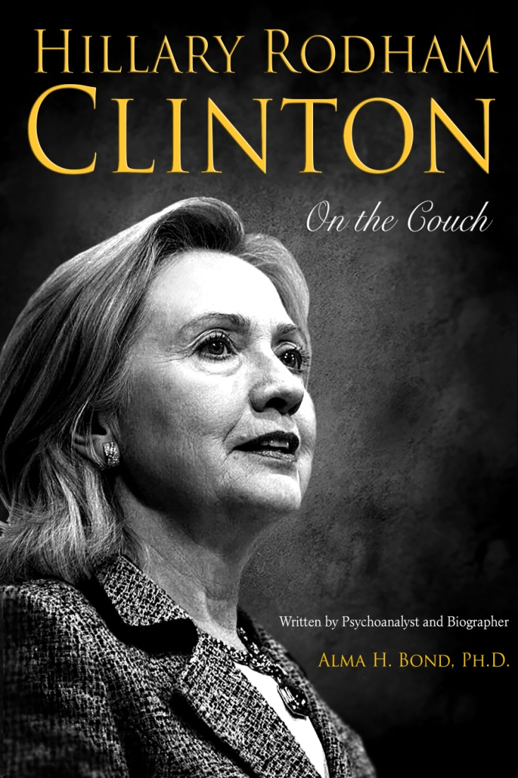
“With her most recent tome, Hillary Rodham Clinton On The Couch, Dr. Alma H. Bond has once again used her skills as a psychoanalyst, combined them with extensive research, and put together a fascinating look at the life of her subject, this time the former first lady, Hillary Rodham Clinton . . . She has skillfully assembled a vivid chronicle of a strong woman who has faced immense challenges throughout her life and was able to pull through no matter how painful the journey. Bond's take on the details of this captivating woman are compelling and convincing, even if you, like many, don't like Hillary and, as many will do, question her accomplishments if she decides to run for President.”
―Norm Goldman, Publisher, Bookpleasures.com

“In the fourth installment of her ‘On the Couch’ series, famed female biographer Dr. Alma Bond looks inside the head and life of the presidential frontrunner and informs voters what she’s found. This is the most original concept I’ve come across! And what an extraordinary read! I felt like a fly on the wall in Dr. Darcy Dale’s office, as the author has a gift for depicting a situation as if it is actually occurring. Every chapter was an open doorway to a room full of intimate details about the former First Lady, which made the sessions more realistic. From birth to Benghazi, and beyond, this novel explores Clinton in a most enjoyable, and sometimes heartbreaking, manner. I’m not a colossal fan of politics, but Hillary Rodham Clinton has always intrigued me. I’ve read several articles in the past, but her story has more depth than I originally considered. The bibliography is quite extensive; therefore, this was getting several points of reference at once. When you consider what this woman has been through and how she persevered, it’s hard not to admire her. Alma H. Bond, Ph.D. has delivered a powerful interpretation of an enigmatic figure! An extraordinary book and a great read. I think it’s brilliant!”
―Literary Melting Pot

“Hillary Clinton comes for psychiatric help in dealing with her husband’s latest affair. Dr. Darcy Dale encourages her to open up and to reveal her past —the good and the bad. Much information about the First Lady is revealed during these fictionalized sessions. RESULT: An in-depth and detailed look at the life of Hillary in a way that’s more interesting than a typical biography/autobiography because the author is really able to make Hillary come to life and seem human. She’s more than the nickname she was given during her early years ―"Sister Frigidaire." She has many emotions and even cries, not only during sessions, but states she cried during other difficult points in her life. She’s funny, a bit sarcastic, and very intelligent. Bond provides interesting insights into what Hillary could have been thinking about this or that, and the state of her mind from a psychoanalyst’s point of view. It’s easy to get to know Hillary and want to hear her story.”
―Book Readers

“There have been so many books written about our former First Lady of Arkansas, First Lady of our country, Senator, and Secretary of State Hillary Clinton. Not all put her in a good light, I might add. If you look at the picture on the cover of this book, you will see an older lady. The lines on her face are there because she has given almost her whole life to helping others. Look into her eyes and you will find the love she has for our country and her family. The author shows us what has made her the woman she is today, starting from her early years growing up with her parents. Her father ruled with an iron hand. He made no concessions when it came to his children. Hillary was the only girl but was treated like her brothers in many ways. When it came to school work, a B was not accepted in the Rodham home. It had to be all A’s. I lived in Arkansas for a few years and read what reporters said about her. She was ripped apart on many things―everything from the way she dressed, to why she put up with Bill Clinton and his women. Hillary is a strong woman, but she is human just like the rest of us. She feels pain; she cries when no one is around. People seem to forget her many accomplishments. This book has opened my eyes so that I can see who, and why, Hillary is the person she is, and how she has managed to overcome so many obstacles that have come her way. In my own opinion, some men are intimidated by her. Hillary has never been one to pull any punches that are thrown at her. Who has the most experience to become our next President? Who has the tenacity to fight in a man’s world when it comes to the women of America? Who is the person who will admit when she is wrong? If she runs, count on this Republican to vote for her.”
―Midwest Book Review

“Who exactly is Mrs. Hillary Rodham Clinton? The chances that she will become the first woman running for the presidency make this question all the more relevant. To portray this woman's character, author Alma H. Bond Ph.D. has created a series of sessions that Mrs. Clinton had with a Dr. Darcy Dale, a fictitious psychoanalyst. The result is simple, fluent, and interesting.”
― Izak Cohen, Owner, Unlimited Jeans Company, New York, NY

“This is quite an entertaining book. It relates the life of Hillary Clinton through imagined therapy sessions. You obviously need to suspend belief slightly for the book to work, but if you do, it’s quite enjoyable. The story is told almost entirely through Hillary's monologues to her therapist, in big paragraphs interspersed with small insights from the analyst. The combination is a somewhat lighthearted but interesting view of Hillary the person.”
―Ellie Wright, on Shadow.com

“I just finished reading/reviewing Alma Bond’s book on Hillary and, as always, she’s to be congratulated on doing a fantastic job. It was so thoroughly believable that, at times, I had to pinch myself to remember that it was a book of fiction as well as non-fiction. I found myself hating Hillary’s cruel father and wondered how much of that depiction was true. At times, I also found Hillary, whom I admire tremendously, to be pompous, although, given what she's accomplished, she deserves to be full of herself. On the other hand, she’s portrayed as having gotten through her unhappy childhood successfully, due to her beloved mother's full support and encouragement. It is a GREAT book, and I encourage all journalists to read it as soon as it's out, especially if they tend toward voting Republican.”
―Arline Zaks, author of numerous books, including Horsing Around in New Jersey, and a longtime member of the American Society of Journalists and Authors

“What an amazing book! Dr. Bond really gets into the mind of her subjects, and this one on Hillary Rodham Clinton is no exception. The reader can easily imagine Clinton sitting in a comfortable chair across from the imaginary Dr. Dale, spilling her heart and her secrets, a cup of tea beside her, and her smartphone carefully switched off for 50 minutes at a time. But that doesn’t mean there’s no meat here. Bond’s portrayal of Clinton delves into her background, her relationship with Bill (with all of its ups and downs), her years as a lawyer and as the family breadwinner, and how she feels about motherhood—and grandmotherhood. Bond’s earlier books dealt with women who have already entered into history; Clinton is her first one dealing with a living person. As such, it’s easy to see that Dr. Dale is a Hillary Clinton fan for the most part. Political junkies, have no fear, though: Despite Bond’s meticulous research, the book is unlikely to change anyone’s mind regarding Clinton. If you already support the former first lady, senator, and secretary of state, you’ll come away feeling good about that decision. If you don’t, you’ll probably find ammunition to support your view as well, which probably just goes to show that Bond’s background in psychology gives her an even keel from which to steer her psychoanalytical boat. In any event, it’s a fascinating read about a young, socially inept girl who grew into an accomplished, driven woman. Even if you thought you knew Hillary, this will probably still be an eye-opener.”
―Ann Beardsley, Author, Historical Dictionary of NASA and the Space Program (forthcoming)

Title Information

ISBNs: 978-1-61088-164-7(HC); 978-1-61088-167-8 (EBook); 978-1-61088-166-1 (Kindle ebook)
TITLE: Hillary Rodham Clinton On the Couch
AUTHOR'S LAST NAME: Bond
AUTHOR'S FIRST NAME: Dr. Alma H.
EXACT NAME OF PUBLISHER: Bancroft Press
PUBLISHER PHONE NUMBER: 410-358-0658
PUBLISHER WEBSITE: www.bancroftpress.com
PUBLISHER E-MAIL ADDRESS: bruceb@bancroftpress.com
PUBLICATION DATE: June 30, 2015
PRICES: $25.00 (hardcover), $9.99 (ebooks)
NUMBER OF PAGES: 285
SUBJECTS/TOPICS OF BOOK: Biography/Politics/Public Affairs/Historical Fiction

About the Amazing Alma Bond

Born in February 1923 and still going strong, Dr. Alma H. Bond is the author or co-author of more than twenty published books, among them: Jackie O: On the Couch; Lady Macbeth: On the Couch; Marilyn Monroe: On the Couch; Michelle Obama: A Biography; The Autobiography of Maria Callas: A Novel; Margaret Mahler: A Biography of the Psychoanalyst; Camille Claude: A Novel; America’s First Woman Warrior: The Story of Deborah Sampson; and Who Killed Virginia Woolf? A Psychobiography.
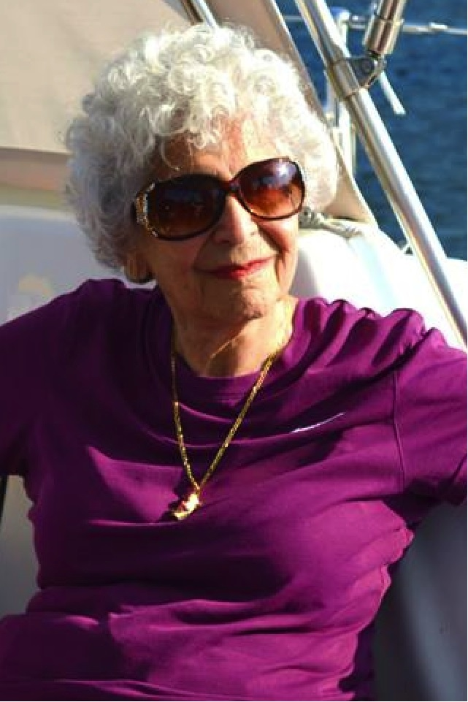
Dr. Bond received her Ph.D. in Developmental Psychology from Columbia University, graduated from the post-doctoral program in psychoanalysis at the Freudian Society, and was a psychoanalyst in private practice for 37 years in New York City. Following an accident-induced coma from which she was not expected to recover, she “retired” to become a full-time writer.
Dr. Bond is a member of the American Society of Journalists and Authors, the Dramatists Guild, and the Authors Guild, as well as a fellow and faculty member of the Institute for Psychoanalytic Training and Research, the International Psychoanalytic Association, and the American Psychological Association. She was one of the first non-medical analysts to be elected to the International Psychoanalytic Association.
Dr. Bond grew up in Philadelphia, where she obtained her undergraduate degree in psychology from Temple University, and following voluntary military service, moved to New York, where she earned a graduate degree in psychology from Columbia University.
A longtime resident of New York City, she lived for nearly a dozen years in south Florida, and now resides in Carlisle, Pennsylvania.

Q&A with Dr. Alma Bond, author of
Hillary Clinton: On the Couch

What is your opinion of Hillary Clinton?
I think she is a political genius who genuinely cares about people, and who will make one of the greatest presidents the United States has ever had.

Did your opinion of her change during or after writing this book?
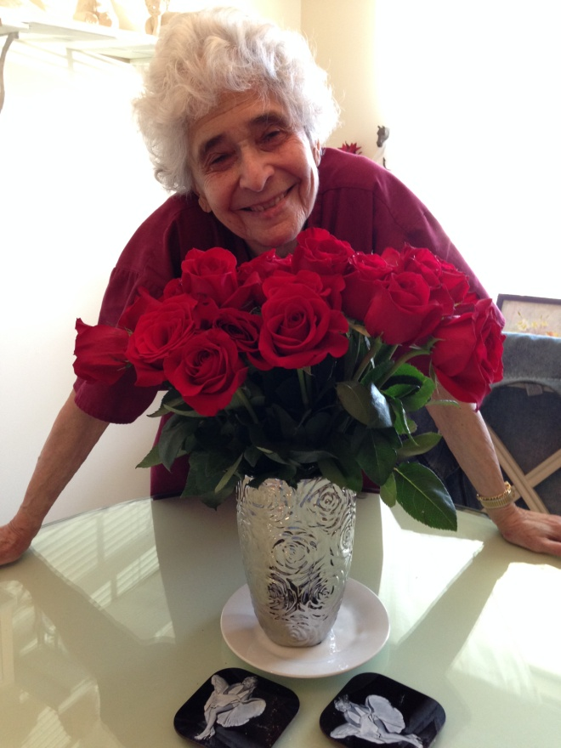
What I felt before beginning to write the book was intensified. I admired her work as the speaker at her college graduation when signs of her future greatness already were apparent; as the wife of the governor of Arkansas; as First Lady; as an elected U.S. Senator; and as Secretary of State. I admire her even more after writing the book.

How did you hope to portray her as a person?
As a wonderful human being with deep flaws, whom anyone would be lucky to call a friend.

How did you hope to portray the other real life people included in Hillary’s story?
As I believe Hilary sees them.

Did any personal opinions about people (Bill, Obama, etc.) influence your writing of this book?
I think Bill Clinton was a great president, and deeply regret that the Monica Lewinsky incident all but ruined his presidency. I am sad that when many people think of Bill Clinton, they fail to remember what great shape the country was in under his leadership and think only of Lewinsky.

Do you hope this can be considered an objective look at Hillary?
Yes, I believe it is a well-rounded portrait of her, which includes her shortcomings as well as her incredible personal characteristics.

How interested are you in politics?
I never have been a political person, but I am more so since I started writing the book. Every book I write changes me in some way. In Hillary's case, it made me more politically aware.

Do you personally think Hillary will be elected president?
I have no doubt she will, unless her health badly deteriorates.

Would you consider writing about another female politician in the future?
Yes, if I find another as interesting as Hillary Clinton, which is highly unlikely.

What made you choose to write about Hillary?
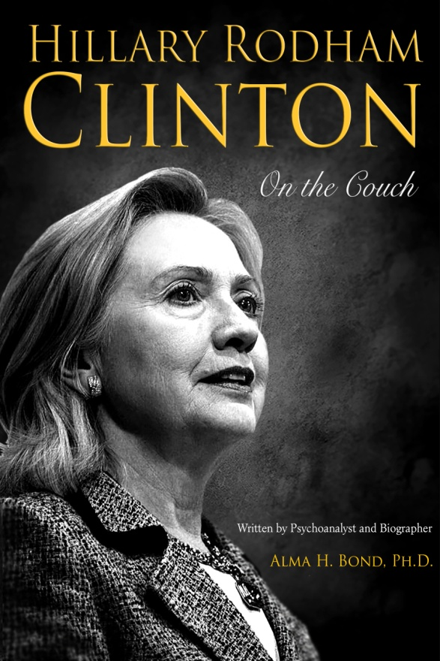
I admire her greatly, and seized the opportunity to gain greater insight into her character as I got deeper into the book. I believe I succeeded in that.

How does her story compare to that of other women you have researched and written about?
She is more normal as a human being, and differs from the others in her great political genius. In that respect, she is, in my opinion, one of a kind.

What do you hope this work accomplishes?
I would like to see it contribute to her winning the election.

Do you hope Hillary will read it?
I’ll have my publisher send it to her, but for her sake, I’d prefer if the section on her adolescent drug use were removed. I suspect reading it would be painful to her, yet it is an important part of her adolescent character. Fighting the addiction helped to develop her iron will and persistence in overcoming obstacles. Beyond that, how many of us could have lived through the brutal attacks hurled at her year after year and come out of it as strong as she has? Indeed, to quote Eleanor Roosevelt, Hillary Clinton, for all practical purposes, has developed "the hide of a rhinoceros," although few can imagine the pain the insults have caused her.

How do you hope she would respond if she did read the book?
I hope she would see my great admiration of her, and value my telling the truth as I see it.

What do you want readers to feel about Hillary after reading this book?
I would like them to share my opinion of her, and disregard the words of Hillary haters.

What made you decide to allow Hillary and Dr. Darcy Dale become friends if that went against the typical rules?
Hillary is not an emotionally ill person. In such cases, I might disregard some of the rigid rules of psychoanalysis, as I might with other healthy patients.

What made you choose the time period (2013-2014) for the Hillary Clinton-Dr. Dale sessions?
Because I had just heard of Bill's latest (at the time) dalliance, and felt it conceivable that such a situation might send Hillary into treatment.

Does psychoanalysis typically last the same length of time Hillary’s did?
No. A successful psychoanalysis generally lasts much longer, perhaps five years on the average. Actually, what the book describes is successful psychotherapy rather than psychoanalysis.

Would you think it valuable for Hillary to actually undergo psychoanalysis?
Yes. Actually, I think it would be valuable for everyone to undergo psychoanalysis. I myself have fewer conflicts in my own life since I had the analysis required to become a psychoanalyst.

What would you say to Hillary if you ever got the chance to speak with her?
I would say that I greatly admire her, and especially her courageous ability to go beyond her own narcissism. Most of us think "me me me." Hillary thinks of the whole world. To use an old cliché, the world is her oyster. In my opinion, the entire planet would be a better place if Hillary Clinton were elected president of the United States.

Questions for Book Clubs

- What previous knowledge did you have of Hillary Clinton before reading this book?
- What was your opinion of her before reading this book?
- Did that opinion change?
- Why did you choose to read this book? An interest in politics? Interest in Hillary in particular?
- Did you find Hillary’s story compelling? Did you want to keep reading?
- Does the book make her seem like a real person as opposed to a “celebrity”?
- How do you think the author wanted to portray her?
- Do you believe Hillary’s story? To what extent was she being honest with Dr. Dale?
- Did you feel the emotions Hillary describes feeling as she undergoes psychotherapy?
- How much do you know about psychotherapy?
- Would you ever undergo psychotherapy yourself? Do you think it can be helpful?
- Do you think psychotherapy was/would be helpful for Hillary?
- What do you think of Dr. Darcy Dale?
- Do you think she makes a fair assessment of Hillary?
- Would you read any more of her book-length analyses of other famous women?
- Did the book change your opinion about anyone else in Hillary’s story? (Bill, Obama, etc.)
- Do you think the author was trying to be objective when writing this book?
- Do you think Hillary should read this book?
- What do you think she would think of it?
- Would you recommend this book to someone else? Why or why not?

Hillary Clinton tops Gallup’s most admired list
By Lucy McCalmont
Politico
12/29/14
7:01 AM EST
http://www.politico.com/story/2014/12/poll-hillary-clinton-most-admired-woman-2014-113838.html#ixzz3NOroSWtr

She may not have a hit TV show nor be British royalty, but Hillary Clinton is the most admired woman of 2014, according to a new poll.
Hillary Clinton tops Gallup’s annual list of most admired women, the poll, released Monday, shows. The former secretary of state earned 12 percent — the only name to reach double digits on the list. Coming in second were Oprah Winfrey and Nobel Peace Prize winner Malala Yousafzai, with 8 and 5 percent, respectively.
Clinton isn’t the only U.S. politician — or former secretary of state — to appear on the list, although it is her 19th time leading the list. Four percent said they most admire Condoleezza Rice; 3 percent said first lady Michelle Obama; and 2 percent said 2008 Republican vice presidential nominee Sarah Palin.
Massachusetts Sen. Elizabeth Warren and former first lady Laura Bush took the last two spots with 1 percent each.
As for the men, President Barack Obama led the list of most admired men of 2014 at 19 percent — and like Clinton, his was the only name to reach double-digit support.
Pope Francis is a distant second with 6 percent, and former President Bill Clinton came in third with 3 percent. Also on the list of most admired men: former President George W. Bush at 2 percent; and Dr. Ben Carson, Fox News host Bill O’Reilly, Israeli Prime Minister Benjamin Netanyahu and Russian President Vladimir Putin, each of whom received 1 percent.
The Gallup poll was conducted Dec. 8-11 and surveyed 805 adults. It has a margin of error of plus or minus 4 percentage points.

Dr. Alma Bond, Hillary’s Fictional Psychoanalyst, Evaluates
the So-called Email Scandal from Hillary’s Perspective (3/20/15)

So, after reading pretty much everything ever written on Hillary, and then having written a book in which my alter ego, also a psychoanalyst, carries on 69 fictionalized sessions with Hillary, I think I have a very good idea what and how Hillary thinks.
If she were to be totally candid, here would be her response to the pseudo scandal over her email practices while Secretary of State from 2009 through 2013:
- I devoted my entire self to this 24/7 job. In service to my country, I made many a sacrifice: I often went without sleep or food as a result.
- My 24/7 approach to the job, which required an ungodly amount of travel because you can accomplish so much more in person that you can otherwise, caused me to compromise my health.
- Having the use of a single cell phone and a single secure email service was not solely a convenience. It was actually a necessity.
- Working this way allowed me to make best use of my limited time on official diplomatic business AND remain grounded and in the rest of the world so I could deal also with at least some aspects of my personal and private life.
- I understand that, in the absence of a Democratic opponent, the media refuses to allow me a free ride.
- And I know full well that Republicans will do anything to defeat me.
- But I did nothing wrong, I betrayed no classified secret, via email or otherwise.
- Some people will never believe that, no matter what. Some people will forever mistrust me, and I’m not sure I can ever do enough to gain their trust.
- My goal, as Secretary of State, was to help make our country and our world a better place.
- I would have the same goal if I were ever to make it to the Oval Office in my own right.
- When political analysts and historians look later at this flap, I’m certain they will reach the conclusion as I have, that, in the big scheme of things, this is simply of little consequence, though I can assure you that, as president, I’ll follow the prevailing laws and rules about retaining and turning over emails.
- I know no one really cares about my feelings, which I’m usually reluctant to show. But right now, given my TOTAL service to the country for four grueling and difficult years, I regard this trumped-up “scandal” as personally insulting and, dare I say it, a bit ridiculous.

