Press Kit for
The Missing Kennedy
By Elizabeth Koehler-Pentacoff
Contact Info:
Publicist
Isabella Michon
Im Media, Inc.
5 Stasia Dr
Novato, CA 94947-1919
415-898-4838
Im.Media@comcast.net

Author
Elizabeth Koehler-Pentacoff
Pleasant Hill, CA
Lizbooks@aol.com
www.lizbooks.com

Publisher
Bruce L. Bortz, Publisher
Bancroft Press
PO Box 65360
Baltimore, MD 21209
410-358-0658
410-627-0608 (cell)
bruceb@bancroftpress.com

Overview

Throughout her childhood, Elizabeth Koehler-Pentacoff frequently visited Rosemary Kennedy, President John F. Kennedy’s sister. Why? Koehler-Pentacoff’s aunt, Sister Paulus Koehler, a Franciscan nun, was Rosemary’s devoted caregiver at St. Coletta in Jefferson, Wisconsin for fifteen years and her driver and travel companion for over thirty years.
The Missing Kennedy chronicles Rosie’s life along with that of the author’s aunt, and delves into the similarities between the two families. It includes many never-before-seen private photos, Kennedy quotes from the author’s interviews, and anecdotes about Rosemary and her famous family.
The book delves into Rosemary’s misdiagnosed condition, why her father sought an experimental brain surgery for her without his wife’s knowledge, how he kept this fact hidden from the rest of his family for twenty years, and what Rosemary was actually like after her lobotomy.
Through the author’s relationship with Rosemary, Sister Paulus, and her other relatives, the author discovered how family, faith and silence intertwine to bond, strengthen, or destroy ourselves and our relationships, no matter our status or circumstance, whether one is in a rich extraordinary family or a poor ordinary one.
The book is special. From an actual friend of Rosemary, there is no single book out there about this mysterious Kennedy. The Kennedy name inspires passionate reactions―positive and negative―here and abroad.
Most people have no idea that Rosemary was the catalyst behind the Special Olympics and related legislation from 1960 to the present. She and her family are part of history.
Eunice Kennedy Shriver’s three sons are enthusiastic about the book, and Mark Shriver has blurbed it. The Kennedys considered the author’s aunt to be a member of their family. The author’s family considered Rosemary a member of theirs.

Basic Media Pitch
Rosemary Kennedy, younger sister of President John F. Kennedy, was lobotomized in 1941 at age 23. In 1959, she was put out of public view at a remote facility in rural Wisconsin, where, for more than twenty years, she remained unvisited by family and non-family alike, until 1962.
Elizabeth Koehler-Pentacoff (Liz) and her parents were likely the first non-Kennedy family members to visit Rosemary following her lobotomy. Liz was niece to Rosemary’s caretaker, Sister Paulus, a Catholic nun at St. Colleta, and she visited Rosemary on a regular basis for the next thirty-four years. Through their friendship, Liz discovered the person many had forgotten or never known.
In 2015, ten years after Rosemary’s death, Liz has come forward with a fascinating book about the hidden daughter of America’s royal Kennedy family. “The Missing Kennedy: Rosemary Kennedy and the Secret Bonds of Four Women” is truly unique. It is an eyewitness account of Rosemary’s post-lobotomy years, the first published by a non-family member, and it’s augmented by nearly 100 never-before-seen pictures of Rosemary after she was lobotomized.
Liz was featured in a popular and widely read cover story of People (http://www.people.com/article/rosemary-kennedy-untold-story-disastrous-lobotomy), She’s also appeared on “Inside Edition” (http://www.wftv.com/videos/news/rosemary-kennedy-had-lobotomy-to-prevent-pregnancy/vDZgk3/ , been interviewed by BBC World Radio (http://www.bbc.co.uk/programmes/p031840y), and been the subject of two immense stories by The Daily Mail Online (http://www.dailymail.co.uk/news/article-3219935/How-Joseph-Kennedy-mentally-disabled-daughter-Rosemary-lobotomized-prevent-sexual-exploits-damaging-sons-political-careers.html AND http://www.dailymail.co.uk/news/article-3246802/How-Rosemary-Kennedy-went-vibrant-young-beauty-smiling-brother-John-F-Kennedy-feeble-spinster-misdiagnosed-forced-undergo-lobotomy-seen-touching-photos-Ted-nephew-JFK-Jr-niece-Maria-Shriver.html.

Liz can shed considerable light on so many questions, the four biggest being:
- Why did no one visit Rosemary for more than two decades?
- What quality of life did Rosemary lead after her lobotomy?
- What should have been the correct diagnosis of Rosemary’s pre-lobotomy condition?
- And in what ways did immense good come from Rosemary’s tragic life?

The book launched October 1. Press kit is below, including the People Magazine cover and story.
As an ebook, The Missing Kennedy has already found its way onto the bestseller list of both The New York Times and the iBookstore.

About the Book
Rosemary (Rosie) Kennedy was born in 1918, the first daughter of a wealthy Bostonian couple who later would become known as the patriarch and matriarch of America’s most famous and celebrated family.
Elizabeth Koehler was born in 1957, the first and only child of a struggling Wisconsin farm family.
What, besides their religion, did these two very different Catholic women have in common?
One person really: Stella Koehler, a charismatic woman of the cloth who became Sister Paulus Koehler after taking her vows with the Sisters of the Third Order of St. Francis of Assisi.
Sister Paulus was Elizabeth's Wisconsin aunt. For thirty-five years―indeed much of her adult life―Sister Paulus was Rosie Kennedy’s caregiver.
And a caregiver, tragically, had become necessary after Rosie, a slow learner prone to emotional outbursts, underwent one of America’s first lobotomies―an operation Joseph Kennedy was assured would normalize Rosie’s life. It did not. Rosie’s condition became decidedly worse.
After the procedure, Joe Kennedy sent Rosie to rural Wisconsin and Saint Coletta, a Catholic-run home for the mentally disabled. For the next two decades, she never saw her siblings, her parents, or any other relative, the doctors having issued stern instructions that even the occasional family visit would be emotionally disruptive to Rosie.
Following Joseph Kennedy’s stroke in 1961, the Kennedy family, led by mother Rose and sister Eunice Kennedy Shriver, resumed face to face contact with Rosie.
It was also about then that a young Elizabeth Koehler began paying visits to Rosie.
In this insightful and poignant memoir, based in part on Sister Paulus’ private notes and augmented by nearly one-hundred never-before-seen photos, Elizabeth Koehler-Pentacoff recalls the many happy and memorable times spent with the “missing Kennedy.”
Based on independent research and interviews with the Shriver family, she tries to come to grips with Joseph Kennedy’s well-intended decision to submit her eldest daughter to a still experimental medical procedure, and his later decision to keep Rosie almost entirely out of public view.
She looks at the many parallels between Rosie’s post-operative life, her own, and those of the two families.
And, most important, she traces how, entirely because of Rosie, the Kennedy and Shriver families embarked on an exceedingly consequential campaign advancing the cause of the developmentally disabled―a campaign that continues to this day.
Ten years after Rosie’s death comes a highly personal yet fitting testimonial to a sad but truly meaningful and important life.
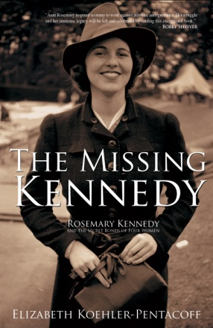

The Missing Kennedy: Rosemary Kennedy and the Secret Bonds of Four Women

by Elizabeth Koehler-Pentacoff
BOOK SUMMARY
Rosemary (Rosie) Kennedy was born in 1918, the first daughter of a wealthy Bostonian couple who later would become known as the patriarch and matriarch of America’s most famous and celebrated family. Elizabeth (Liz) Koehler was born in 1957, the first and only child of a struggling Wisconsin farm family.
What, besides their religion, did these two very different Catholic women have in common? One person really: Stella Koehler, a charismatic woman of the cloth who became Sister Paulus Koehler after taking her vows with the Sisters of the Third Order of St. Francis of Assisi.Sister Paulus was Liz’s Wisconsin aunt. For thirty-five years―indeed much of her adult life―Sister Paulus was Rosie Kennedy’s caregiver.
And a caregiver, tragically, had become necessary after Rosie, a slow learner prone to emotional outbursts, underwent one of America’s first lobotomies―an operation Joseph Kennedy was assured would normalize Rosie’s life. It did not. Rosie’s condition became decidedly worse.
After the procedure, Joe and Rose Kennedy sent Rosie to rural Wisconsin and Saint Coletta, a Catholic-run home for the mentally disabled. For the next two decades, she never saw her siblings, her parents, or any other relative, the doctors having issued stern instructions that even the occasional family visit would be emotionally disruptive to Rosie.
Following Joseph Kennedy’s stroke in 1961, the Kennedy family, led by mother Rose and sister Eunice Kennedy Shriver, resumed face to face contact with Rosie. It was also about then that a young Liz Koehler began paying visits to Rosie.
In this insightful, poignant, and important memoir, based in part on Sister Paulus’ private notes and augmented by dozens of never-before-seen photos, Liz Koehler-Pentacoff recalls the many happy and memorable times spent with the “missing Kennedy.”
Based on independent research and interviews with the Shriver family, she tries to come to grips with Joseph Kennedy’s well-intended decision to submit her eldest daughter to a still experimental medical procedure, and his later decision to keep Rosie almost entirely out of public view.
She looks at the many parallels between Rosie’s post-operative life, her own, and those of the two families. And, most important, she traces how, entirely because of Rosie, the Kennedy and Shriver families embarked on an exceedingly consequential campaign advancing the cause of the developmentally disabled―a campaign that continues to this day. Ten years after Rosie’s death comes the first full-length book about Rosie Kennedy, a fitting testimonial to a sad but truly meaningful and important life.
COMPARABLE TITLE
- Rose Kennedy’s Family Album (Grand Central, 2013).
SALES HANDLES
- First and ONLY first-person account of the life of Rosemary Kennedy, JFK’s sister who was lobotomized as a young adult.
- Book has full and unequivocal support of the Kennedy and Shriver families, as well as all their organizations for the developmentally challenged (Special Olympics, Best Buddies, etc.), and the book’s front cover contains a blurb from Bobby Shriver. Author to do events with those organizations.
- Contains nearly 100 photographs, most of Rosemary at various stages of her life, many with her famous relatives from the Kennedy and Shriver families, and most never before seen.
- Book is being published on the 10th anniversary of Rosemary Kennedy’s death.
MARKETING/ PUBLICITY
- Publicity being handled by experienced, San-Francisco-based publicist Isabella Michon.
- Author doing book-related spec-articles for the following magazines: Parade (23 million readers); American History (95k readers); Parents (2.2. million readers); Columbia (1.7 million readers); Catholic Digest (275K readers), and Writer’s Digest (110K readers).

ISBNs

978-1-61088-174-6 (cloth) /

Price
$25.00 (cloth)

Pub. Date
October 1, 2015

Category

Biography/Memoir

Format
6 X 9

Pages
214

Author Connections
Elizabeth Koehler-Pentacoff was born and grew up in rural
Wisconsin, but left the Midwest for
college in California and has returned only for
family visits. She has written seven books for
children and two for adults, including The ABCs
of Writing for Children, a Writer’s Digest Book
Club Selection. She’s also written hundreds of
articles for magazines and newspapers such as
Columbia, The San Francisco Chronicle, and
Parents Magazine. She’s married and lives with
her husband in northern California.
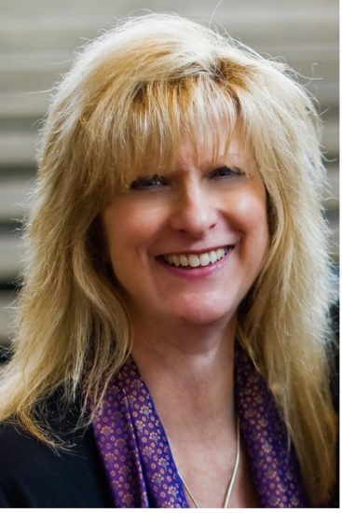
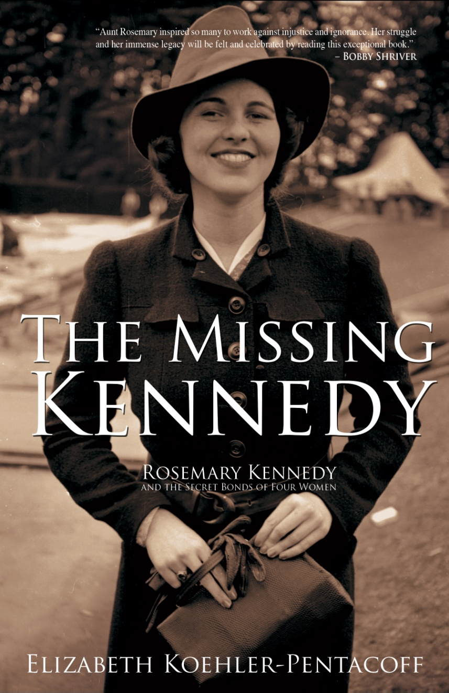
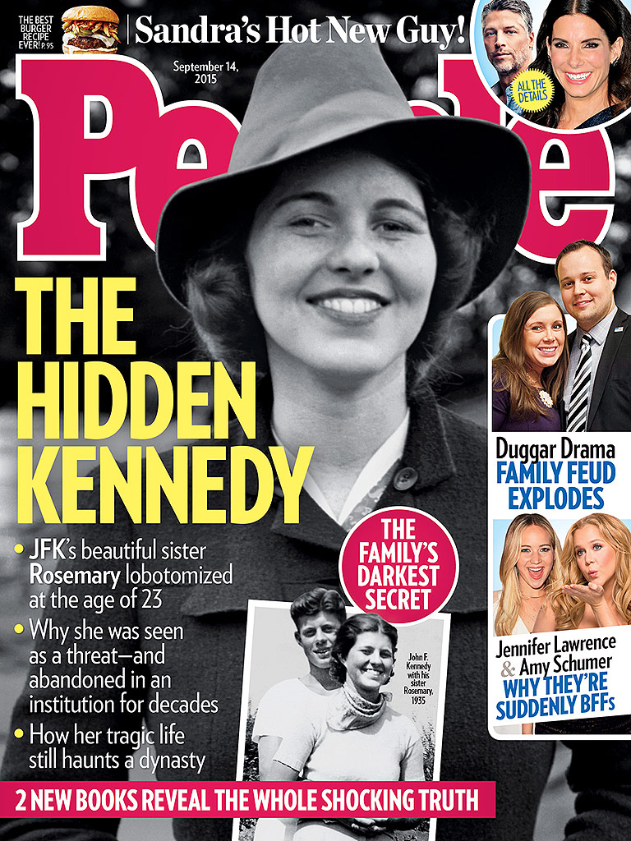
Praise for The Missing Kennedy
“Such a touching book!”
―People Magazine

“Aunt Rosemary inspired so many to work against injustice and ignorance. Her struggle and her immense legacy will be felt and celebrated by reading this exceptional book."
―Bobby Shriver

“Fascinating story!”
―BBC World News Service (Claire Marshall, “Newsday”)

“The Missing Kennedy is truly a fascinating story.”
―Paris Match

“Reveals an untold chapter in the Kennedy saga . . . Also shows how knowledge of Rosie's disability led to the founding of the Special Olympics by Eunice Kennedy . . . Interesting glimpses into one member of the Kennedy clan who was almost lost to her family.”
―Kirkus Reviews
“Koehler-Pentacoff (Jackson and Bud’s Bumpy Ride) offers a personal perspective of the life of Rosemary Kennedy (1918–2005), the intellectually disabled sister of President John F. Kennedy. Provided is a succinct overview of Rosemary’s difficult childhood and the effects of an experimental medical procedure she received as a young adult. However, the narrative centers on the treatment she received at a Catholic nursing facility from Sister Paulus Koehler, the author’s aunt, who cared for Rosemary during much of her adult life. Using her aunt’s private notes, Koehler-Pentacoff relays the dignified and specialized therapy Rosemary was afforded. Also recounted is how, in the early 1960s, after years of virtually no family contact, the Kennedys reconnected with Rosemary. The author chronicles the numerous trips Sister Paulus made with Rosemary to visit her extended family, ascribing how the clan’s devotion to Rosemary in her later years was a catalyst in their activism for the disabled—including the creation of the Special Olympics. While Kate Clifford Larson’s Rosemary (reviewed below) is more in-depth on its subject’s early years, this poignant look at the life of a lesser-known yet remarkable Kennedy, with its dozens of never-before-published photos, is sure to resonate with enthusiasts of this influential family.”
―Library Journal

"The Missing Kennedy is a truly inspiring story. It captures my Aunt Rosie's spirit so well. I especially love how it intertwines the stories about Rosie and the author’s Aunt Stella. And it provides some great glimpses into the author’s experiences with both of them."
―Anthony Shriver

“Poignantly discloses our nation’s shortcomings, both historically and contemporarily, when it comes to understanding the mentally ill and intellectually challenged. Also reveals the dearth of research concerning the women of the Kennedy family, which pales in comparison to the body of work focused on its men . . . This is especially true of Rosemary Kennedy, the eldest Kennedy sister, who was lobotomized and kept from her family and the public eye for over 20 years . . . It was the author’s aunt, Sister Paulus, who was Rosemary Kennedy’s caretaker at Saint Coletta, where Rosemary was kept for many years after her lobotomy only exacerbated her intellectual and emotional challenges . . . Koehler-Pentacoff’s book offers an intimate glance at the sheltered life that Rosemary lived while her glamorous family grew in prestige and power . . . Heads in the welcome direction of telling the largely untold story of Rosemary Kennedy, and the story of the intellectually challenged and their allies in the fight to place them as equal members of society.”
―Irish America

“This is an important and encouraging book. The author tells the story of Rosemary Kennedy (1918-2005) from a personal perspective. Elizabeth Koehler-Pentacoff’s aunt, a nun, cared for Rosemary at St. Coletta’s in Wisconsin, a Roman Catholic home for the mentally ill. The young Elizabeth visited Rosemary when she visited her aunt, Sister Paulus. In this remarkable account, the grace of God ripples through the pages . . . The author, a Roman Catholic, was clearly influenced by Rosie and Sister Paulus, and I could see the grace of God working through them all. Elizabeth’s dedicated aunt, full of love for the helpless, the abandoned, and the unwanted, touched the hearts of all in her circle through her example. I could see that the author was given a deeper sense of appreciation for the handicapped and what it means to love sacrificially as her aunt loved. The dignity of every living person shines through these pages . . . When the Kennedys finally reunited with Rosie, they were inspired to help the mentally ill, funding research programs, passing legislation, and founding Summer Camp Shriver, which became the Special Olympics. All of these efforts were the result of Rosie and her tragedy. Rosie’s handicaps became blessings, making those around her better. She taught them how to love. She taught our culture how to care . . . The Missing Kennedy is full of photos, many from the author’s private collection. The ones I particularly loved were the group photos. At first there is just Rosie and Sister Paulus, then others join, including the author, then more and more Kennedys gather around Rosie. She becomes, in the end, the center of the family. We are all better for her having lived, reminding us that the Rosies of our world have a place in the heart of our culture. We are better, too, for Ms. Koehler-Pentacoff’s heartwarming memoir of Rosemary Kennedy’s life.”
―Christine Sutherland, Managing Editor, American Church Union, the publishing house of the Anglican Province of Christ the King

“Elizabeth Koehler-Pentacoff's aunt, Sister Paulus, became one of Rosemary's caregivers at St. Coletta. Koehler-Pentacoff's memoir recounts their relationship, and the author's visits with both women. Rosemary's privacy at St. Coletta was closely guarded; this book offers details and friendly anecdotes about the late Kennedy's daily life in Wisconsin. She brings to her memoir a sense of compassion gained through experiences with family members with mental illnesses.”
―Milwaukee Journal Sentinel

“Anyone in the world who’s interested in the famous Kennedy family will find this fascinating memoir to be essential reading. Rosemary Kennedy was the least known member of the family but, it turns out, one of the most significant in the big scheme of things. If you don’t read The Missing Kennedy, you won’t know a critical and enlightening part of the Kennedy story.”
―Dr. Abe Bortz, American historian

Publication Notes
- Featured in People Magazine cover story 09/14/15 issue
- #9 on The New York Times’ Ebook Non-Fiction Bestseller List for week ending 9/12/15.
- Featured in Who Magazine cover story 09/28/15 (People Magazine of Australia)
- Author interviewed for “Inside Edition” nationally syndicated segment that aired 09/04/15
- Author interviewed live by BBC World Radio 09/07/15
- Briefly included in Wall Street Journal review 10/3/15
Title Information
- The Missing Kennedy: Rosemary Kennedy and the Secret Bonds of Four Women
- October 1, 2015 release
- Memoir / Biography
- 270 pages, including 125-plus photos (many never before seen of Rosemary after her lobotomy)
- Hardcover/ 6x9
- ISBN 978-1-61088-174-6 (cloth) /
- Bancroft Press/ $27.50
- Also available as ebook and audiobook

About Elizabeth Koehler-Pentacoff

Elizabeth Koehler-Pentacoff is the author of nine books, including a Writer’s Digest Selection for The ABCs of Writing for Children. The Missing Kennedy is her first adult memoir.
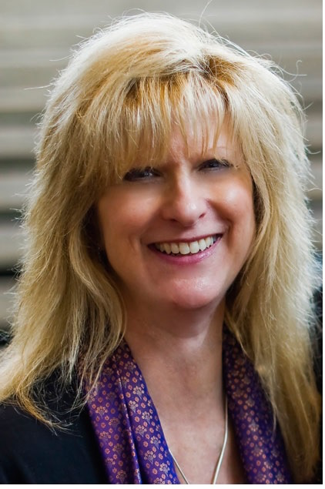
A former Byline Magazine “Writing for Children” columnist, Liz wrote frequent humor pieces for the San Francisco Examiner as well as hundreds of articles and essays in newspapers and magazines such as Parents Magazine, Writer’s Digest, and Parenting.
With degrees in Liberal Studies and Theater Arts/Children’s Theater and two teaching credentials, she’s directed plays and taught elementary, middle school students, and teachers. A speaker for international and state conferences, she presents assemblies and workshops for schools and libraries.
Born in rural Wisconsin, Liz moved to California for all her college and post-graduate education (Fresno State in Fresno, CA), and has lived most of her adult life in the San Francisco area. She’s married, and has one grown child.
For writing advice, ideas, and anecdotes, cisit her blog http://lizbooks.com/blog, contact her at lizbooks@aol.com, or visit her at her website, www.lizbooks.com.

Q&A with Author Elizabeth Koehler-Pentacoff

When you visited Rosie as a child, did you realize the family’s importance to the American public?

Yes. Her brother was president when I entered school and my parents talked about him with reverence.

What about your own life inspired you to write Rosemary’s story? What took you so long to decide to do it (nine years after Rosemary’s death)?

When my parents passed away (2002 and 2009), I was flooded with memories of my childhood. The book idea came to me in a dream. A young man appeared and told me my next book would be The Missing Kennedy. Later, while doing some research, I recognized the young man. He was David Kennedy, Robert’s son, who died young from a drug overdose.

As a previously published author and the niece of Rosemary’s caretaker, you are especially qualified to tell this story. How do you think other accounts of the Kennedy family treat Rosie? Are they accurate accounts in relation to your own experience?

The Kennedy accounts regarding Rosie are recalled with love, as is mine. However, they do not mention Rosie had been diagnosed with mental illness.

In writing this book, you were required to do a lot of research. Did this research change your view of the Kennedy family? What was your opinion of the Kennedys before writing this book?

My research allowed me to empathize with how the family dealt with their own set of disadvantages. Living in the public eye is not easy. The Kennedy children were growing up during the time when Lindbergh’s baby was abducted. Joe and Rose feared that something could happen to their children. It was also a time when people with disabilities and mental illness were hidden and kept secret.

How do you expect the millions of Kennedy fans will receive this book? Do you think they will be interested? Were you writing this for them?

To tell you the truth, I was writing the book for me. I didn’t envision the audience, but I hope the book will be made available to both young and old, as there is much the general public doesn’t know about America’s famous family and Rosemary and how they changed our world for the better.

If indeed this is the first and only book on her, why? Has there been family resistance?

Most of the Kennedys didn’t grow up with Rosie in their lives. After Rose Kennedy had Eunice take charge of Rosie in the 1970s, the Shrivers began encountering their Aunt Rosie whenever she visited them. Although the other Kennedys didn’t know her intimately, they took on the cause of the developmentally challenged through organizations and government.

To what extent have the Kennedy and Shriver families been helpful in writing this book?

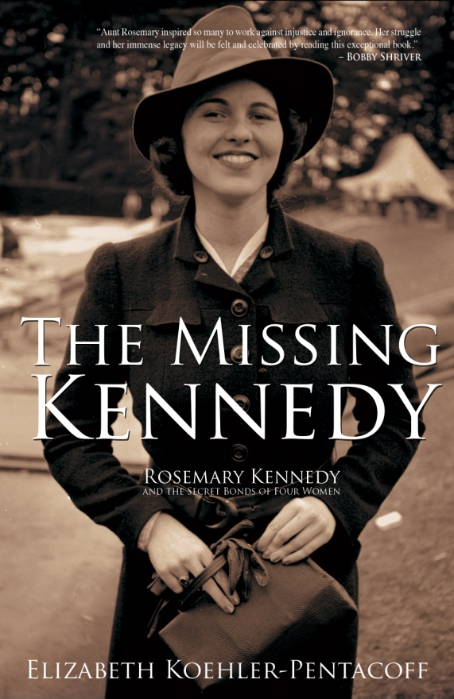
The Shrivers have been extremely generous talking with me about their experiences with their Aunt Rosie.

What do you think is your motivation?
Same as mine. I hope my story will lead to greater compassion for everyone.

How do you think the Kennedys and Shrivers will receive this book?
I hope they will be pleased I wrote it.

To what extent has the Kennedy family wealth been spent on research for the developmentally disabled? If you had $10 million to sponsor research in this area, what would you want to see researched?

The Kennedy family has been quite generous through the Joseph P. Kennedy Jr. Foundation, which has given millions for both research into intellectual disabilities and for assistance to families. If I had $10 million, I’d give it to their foundation because they are the experts who will know how best to allocate funds.

In your book, you write a good deal about feeling like an outcast from your extended family. The dichotomy of inclusion and exclusion plays a big role in Rosie’s life. How do you think it affected the way you wrote?

Because I knew good people in my life suffered from mental illness, I felt unique. And since I felt exclusion in my own family, I realized how drastic it must have been for Rosie and also for my relatives who suffered from mental illness. How can one not be compassionate? When people are involved in personal stories, understanding grows. Put an intimate face to an illness or a hurdle, and acceptance and empathy grows.

Were you willing to disclose more about both the Koehlers and the Kennedys?
Sharing our stories of how people felt, why they acted the way they did, and what the consequences were can invoke acceptance and empathy. This can be done by sharing the truth.

What is the most shocking thing you found during your research?

The doctor who lobotomized Rosemary wasn’t a surgeon, but he was a terrific public relations guru. Popular culture accepted his false claims readily. He was considered the best option at the time. Also, I was both saddened and shocked to find out how people with disabilities and mental illnesses were treated―often locked away in attics because of the backlash. If discovered, people could lose their homes, their jobs, even their friends. All because of fear of the unknown.

Why did you choose to include stories from your family, like Zora and Nick, as well as the Kennedys?

At first, it didn’t occur to me to include them. But as I wrote about my youth, I realized how Aunt Zora and Uncle Nick affected me and my family. It was huge. It informed us how we were as individuals and families. We had these powerful secrets and emotional fears that we thought were unique to us, with no one at that time talking about mental illness. The bottom line is that both the Kennedys and my families, although very different in wealth and social status, dealt with their tragedies through their Catholicism.

If Rosemary’s story was happening today, how would it be different surgically, educationally, and socially?

She was dyslexic, so educators would know how to teach her. Everyone would understand that reading styles aren’t a big issue. She’d receive training appropriate to her abilities, and she could have continued teaching preschool, which she loved, had a meaningful relationship and even been married with a family of her own. The need for a drastic operation would have been replaced by medicine, and therapy.

Is there more that should be done for the developmentally disabled? Do you have an opinion on the controversy of special education and the mainstreaming of mentally disabled?

There’s always more to be done. But I believe we’ve come a long way since Rosie’s youth and in the 1960s, when my relationship with her and the residents of Saint Coletta began. But we have a long way to go. For instance, the prevalence of certain disabilities such as autism and attention deficit disorder is increasing. Why? What can we do about it? Families are still overwhelmed with caring and educating their disabled children. If a family is poor, these problems are even more difficult. How can we make sure all have equal opportunities for available services? And there is always a need for a greater understanding and acceptance for people with disabilities. We still need to create opportunities for love and acceptance.

Obviously, politics influenced many of the Rosie-related decisions made by the Kennedys and the people surrounding them. As you look over her life, do you believe that all that was possible was actually done for her?

I feel sad Rosie didn’t receive more of a rigorous intervention earlier that could have prevented the surgery that was her disaster. I think St. Coletta was the perfect place for Rosie, for there she shed her tantrums and became happy.

Catholicism is very important to you, the Koehlers, and the Kennedys. Do you think being grounded in these beliefs changed how Rosemary’s care was handled?

Absolutely. The nuns at St. Coletta were warm and loving. I could feel the love when entering the dorms and Rosie’s cottage. I’ve never been anywhere else where I’ve been on the receiving end of such kindness and love. And the basis of Catholicism is love and social justice.

How does grief play a central role in this story?

Of course there will be grief if we can see how things could have been different. Playing the “if only” game is heartbreaking. If only Rosemary didn’t have the operation. If only Rose would have learned the truth about what had happened to her daughter. But the upside of grief is action. And certainly, the Kennedys changed history in a positive way due to their actions.

You declare you mother and yourself to be feminists. How did the feminist movement help people like Rosie?

I believe the basis of feminism is equality. This permeates through every segment of lives, including racial, religious, socio-economic, able-bodied and disabled. It is basic social justice. It gave a larger voice for all people to speak out against inequalities in our society. I think Eunice embodies much of what is a feminist. She wasn’t afraid to speak up for the injustices she saw.

Rosie lived for more than 60 years after her lobotomy. For all the damage the lobotomy had on Rosie’s life, her condition inspired the Kennedys to institute programs that spurred nationwide change in the treatment of mentally disabled people. Would you say it was worth it, or would this change have happened eventually anyway?

The only person who can answer that is Rosie. But we know her tragedy benefited millions throughout the world. Without her, acceptance and help would have come much more slowly and with greater resistance.

What was the most significant result of Rosie’s condition?

For Rosie, it was the loss of her ability to communicate, move, and use her brain to the fullest extent possible. For the world, Eunice encouraged the Joseph P. Kennedy Jr. Foundation to focus on research into prevention of intellectual disabilities and advocating for people who have them. This family emphasis led President Kennedy to create The President’s Panel on Mental Retardation. Because of this beginning, people who were once locked away and hidden are now productive members of society, working and living rich, full lives.

What can people do to help mentally disabled people in their communities?

Donate what you can with money and/or time to organizations such as Special Olympics and Best Buddies. My father raised money for the disabled through The Knights of Columbus. Create your own Mission of Kindness. Treat everyone how you wish to be treated. Kindness and acceptance are the biggest gifts we have.

What is the most significant thing you learned from Rosemary?

Her life was valuable. She WAS productive. She gave much love and happiness. She taught me the gift of taking time to appreciate each other. She taught me to slow down and enjoy silence, nature, and being with another person.

Above all, this is a story of family. How has your relationship with your family influenced this book?

My family affected how I grew up. I saw my parents being thoughtful, treating everyone at St. Coletta in a friendly and loving manner. I grew up knowing I, like them, was to make the world a better place.

With Rosie out of the public eye, the Kennedys were not held responsible for her condition. How do you think she slipped out of notice when she was part of such a high profile family?

She was in a large, active family! It was easy for them to say Rosemary was off teaching and enjoying a more private life. She had eight siblings, all blessed with charisma. They all vied for the stage at various times in their lives. The focus was easily placed upon them and their numerous activities.

What do you want people to take away from this book?

Empathy―I hope empathy will inspire kindness. And a knowledge of what the Kennedys did positively for the lives of anyone with a disability.

Questions for Book Club Discussions
- What motivated Stella to become a nun?
- What was Rosemary’s relationship with her father like before her lobotomy?
- Which magazines and papers reported on Rosie and Kathleen’s appearance before the queen? What does this say about Rosie’s status pre-lobotomy? How do you think she fell out of the eye of the press?
- Why was Rosie removed from the convent?
- Who brought lobotomies to the U.S.? How did he make them such a widespread practice? What social conditions were in place to make this possible?
- What are the statistics for sexual abuse of disabled persons? Have rates of sexual violence of disabled women improved since Rosemary’s time at Craig House?
- Who recommended St. Coletta to the Kennedys? What is his significance in Catholicism and the church?
- Do you think keeping Rosie at St. Coletta’s was ultimately beneficial?
- How do Aunt Zora and Uncle Nick relate to Rosemary? How did these stories affect your understanding of mental health?
- What were the effects of the Kennedys’ status and political ambitions on Rosemary and her treatment?
- How did Rosie react to seeing her mother for the first time in twenty years? Was it what you expected? How is it reflective of Rosie’s character/personality?
- What were some of Rosie’s favorite activities, objects, and songs? How do these reflect her personality?
- Catholicism remains central to Rosie’s three families and this story. Where do we see the benefits of such practice? Do the author’s opinions influence your own? In which ways did the Catholicism represented in these families frustrate you?
- Think about major political events surrounding JFK’s assassination. Do you think there was “more than just Oswald”? In what respects?
- How long were Rosie and Sister Paulus apart for? What do you think of Sister Paulus’ unquestioning obedience?
- What details of the homes described in the story resonated with you? Do you think they reflected the families inhabiting them?
- Where was Rosie when she was lost? How would the same event have happened today?
- Who were the two women to wear mink coats? In what was is mink significant to this story? In which instances would ‘fitting in’ be worth it?
- If you had a child like Rosie, what would you do?
- If this happened to another political family, do you think the results would have been the same?
- How do gender roles play out in this book? How are they hurtful? Are they reflective of gender norms and expectations today?
- What are some of the long term institutions set up by Rosie’s family?
- If Rosie hadn’t been lobotomized, how do you think treatment of and for disabled people would be today? Was her lobotomy worth it for all of the long term effects? Was this progression bound to happen eventually?
- Do you know any families with disabled relatives? What kind of strain does this put on the family? What are the benefits?
- Had you heard of Rosemary Kennedy before reading this book? Do you think her life is still being kept a secret of sorts?
- What sort of stigma is attached to different mental health problems and disabilities today?

