**Press Kit**

**Rohini Ralby’s *Living the Practice, the Way of Love***

“For the sincere seeker, or anyone who wants a clear understanding of what spiritual practice entails, *Living the Practice* is more than a book. It shares the map, but, more crucially, it places our feet firmly in the territory.”

**―Yousra Elbagir, Award-Winning Journalist and Writer for BBC Radio 4, Channel 4, VICE, The Financial Times, The Guardian, and Sky News**

*Author*

Rohini Ralby

Owings Mills, MD

[rohini@practiceforus.com](mailto:fburton40@gmail.com)

https://practiceforus.com

410-654-0617 (home) / +1 410-935-9935 (mobile/WhatsApp)

*Publisher*

Bruce L. Bortz, Editor

Bancroft Press (one of the top ten independent book publishers in America since 1991)

4527 Glenwood Avenue

La Crescenta, CA 91214

410-627-0608 (mobile)

[bruceb@bancroftpress.com](mailto:bruceb@bancroftpress.com)

*Publicist*

Brandon Stickney, Bancroft Press Director of Communications

[bstickney@bancroftpress.com](mailto:bstickney@bancroftpress.com)

727-518-5631

Olcott, NY

*Title Info*

*Living the Practice, Volume One: The Way of Love*

Rohini Ralby

Paperback: 978-1610885768

Ebook available

Length: 356 pages

*Distributor*

Baker & Taylor Publisher Services (the premier worldwide distributor of books, digital content, and entertainment products from approximately 25,000 suppliers to over 20,000 customers in 120 countries): 30 Amberwood Parkway Ashland, OH 44805.

*Publisher Info*

* Been a top-ten indie since its start in 1992
* Publishes 4-6 books a year
* Distributed nationally by Baker & Taylor Publisher Services
* Frontlist and backlist titles represented in Hollywood by APA (Agency for the Performing Arts)
* Publishes almost all types of books, from memoirs to mysteries, young adult novels to history and biography
* Bancroft books have received numerous starred reviews—four, in fact, for two 2018 summer books—and have won numerous awards
* *The Missing Kennedy,* a NYT ebook bestseller, was on the cover of *People Magazine* when published in 2015
* Recent mystery (*Her Kind of Case*) received star reviews from all but one of trade review publications
* Published the books of four Pulitzer Prize winners (Alice Steinbach, Stephen Hunter, Elizabeth McGowan, and Mark S. Johnson)

**Reasons Why People Should Buy *Living the Practice: The Way of Love***

1. The author of *Living the Practice*, who also wrote the much-acclaimed memoir and spiritual guide *Walking Home with Baba* (2012), has an extraordinary background: close personal disciple taught one-on-one by the world-famous Swami Muktananda, artist, martial artist, dancer, NFL cheerleader.

2. Instead of offering platitudes or generalities about spirituality, this book hones in on the essence of spiritual practice—how to do it, and how it informs our daily living.

3. This book busts genres, using not only essays but also poetry and paintings to convey the fullest understanding and true, lived experience of spiritual practice.

4. This book is not linear in the sense that you have to read it from cover to cover. You can open it at random or choose a thematic chapter that suits your needs right now.

5. This book can be read and understood by general readers who are just curious about spiritual practice, but it also offers insights and instruction to advanced aspirants.

6. The book doesn’t just dispense ideas. It transmits actual experience.

**Press Release**

FOR IMMEDIATE RELEASE

**A new book dismantles contemporary illusions about spirituality, and explains the day-to-day reality of spiritual practice as lived by those who follow it**

**“Simple, but difficult”: Rohini Ralby releases her new book, a detailed guide to the hard but liberating work of real spiritual practice**

*Living the Practice, Volume One : The Way of Love*

Rohini Ralby

For more information, contact:

Bruce Bortz, Editor

Bancroft Press (one of the top ten independent book publishers in America since 1991)

4527 Glenwood Avenue

La Crescenta, CA 91214

410-627-0608 (mobile)

[bruceb@bancroftpress.com](mailto:bruceb@bancroftpress.com)

*“The goal is not to have supernormal experiences and an expanded idea of who I think I am. If that were the goal, then I could just take hallucinogens. The goal is not to think of myself as a good person. It is not to like myself as I construct myself to be. The goal is not to feel powerful….The goal is to experience that God is within you as you, wherever you go. To experience at every moment that you are not the doer, that God is the doer, that God is All—not as a concept, but as Reality.”*

[Owings Mills, Maryland, USA, June 15, 2022] – On June 14th, 2022, Bancroft Press released the ebook version of Rohini Ralby’s *Living the Practice, Volume One: The Way of Love*. The print version will be released on October 17th.

For over three decades, Rohini Ralby has shared the spiritual practice she learned through years of one-on-one instruction from her Guru, Swami Muktananda Paramahamsa. As her practice has deepened, she has found different ways to give outward expression to inward experience and understanding.

In her second book – published a decade after her debut with *Walking Home with Baba: The Heart of Spiritual Practice* – Ms. Ralby combines prose reflections, poems, and paintings produced over many years to provide a detailed, authentic, uncompromising guide to spiritual practice. Organized thematically, this first volume of a projected two drives home the lived reality of spiritual practice as she was taught it for many years, one-on-one, by her Guru, Swami Muktananda Paramahamsa. Ms. Ralby sets forth foundational concepts before including chapters on tools for practice, understanding the real nature of humility and love, confronting hate in ourselves and others, and discerning right action in the world. She also shares stories, including episodes from her own experience, to illustrate spiritual practice in action.

Throughout, Ms. Ralby is direct and unapologetic in debunking forms of pseudo-spirituality that pervade the marketplace, too many of which are designed to give us soothing or exalted ideas rather than awaken us to the real, often painful work of gaining freedom from our own ignorance and drawing closer to our true nature, which is Love.

Showing not only the depth and discernment she has gained through the grace of her Guru, but also an artistry informed by her many years of training and education in dance as well as her mastery of Tai Chi Chuan, these pieces communicate the lived actuality of spiritual practice, and serve as lamps along the path.

**A Review by Yousra Elbagir**

There are books that we read and books that read us. The first volume of Rohini Ralby’s *Living the Practice* sits firmly in the second category. Whether digested in sequence or cracked open spontaneously, this collection of essays, poems, and paintings is charged and alive. Ralby never trades in vague prescriptions to be mindful or present; rather, she speaks directly to the undercurrent of each moment and guides a practice that is both deeply personal and inherently universal―the contemplation and experience of God.

*The Way of Love* delivers a direct infusion of actionable instructions. You want God? Surrender. You want to heal? Detach. This no-frills guidance will have your ego turning with discomfort, hyperaware of its exposure under the lamp of Ralby’s fifty years of hard-won spiritual expertise. Her unflinching reflections on the human condition and uncompromising directives chip away at the false sense of self that keeps us from true and lasting happiness. From start to finish, her stance is straightforward and consistent: “We must break the cup and merge into the ocean.”

True to her early background as a trained dancer and Tai Chi Chuan teacher, each of Ralby’s essays feels like different choreography to the same music. Some are staccato, others more expansive and vulnerable. The context shifts effortlessly from the situational to the existential, the contemporary to the ancient, but all are underpinned by the wisdom of her Guru, Swami Muktananda Paramahamsa, to whom the book is dedicated. She describes the Guru not to be a person, body, or personality but an unfaltering manifestation of the divine in one who is liberated from ignorance.

Her deep love and devotion for her Baba saturate the pages―in poems, letters, and stories drawn from her eight years as his close personal disciple, learning spiritual practice directly from him. These recollections clear away the nostalgic fog that so often obscures the golden age of globalised communal spiritual practice in the 1970s, when Westerners flocked to India and encountered Swamis like Muktananda and Maharishi Mahesh. Ralby has no interest in perpetuating such illusions. She delves into her experience of authentic discipleship and isolates the lessons of Love at its heart.

This book is practical to the core. It is to be felt on a deep level, not merely thought, contemplated and not intellectualized. The abstract paintings function as triggers for latent frequencies and unacknowledged emotions. The multi-directional poems use space to convey meanings that go beyond words. The Fourchotomy tool that Ralby devised two decades ago acts as a scalpel for cutting away attachments that keep us confined.

Altogether, the volume serves as a roadmap for a journey that has bewildered philosophers and entranced sages since the beginning of time. Evelyn Underhill, in her classic text *Mysticism*―quoted by Ralby in the early pages of the book―critiques philosophical idealists as laying out a diagram of the heavens rather than a ladder to the stars. For the sincere seeker, or anyone who wants a clear understanding of what spiritual practice entails, *Living the Practice* is more than a book. It shares the map, but, more crucially, it places our feet firmly in the territory.

*Yousra Elbagir is an award-winning journalist and writer. As a foreign news correspondent for Vice News on HBO and Channel 4 News, she propelled underreported stories to the forefront of international media, most notably the 2019 youth-led Sudanese revolution. From radio to print journalism and documentaries, her work can be found on BBC Radio 4, Channel 4, VICE, the Financial Times, the Guardian, and more. She is currently the Africa correspondent for Sky News.*

**Praise for**

***Living the Practice: The Way of Love***

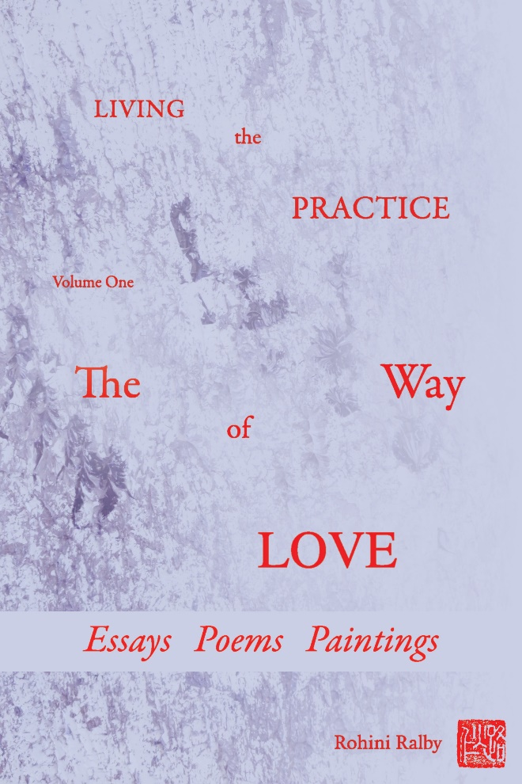“This is a rare book: Many outline the intellectual roadmap of the mystical itinerary, but few show how to travel the road. Rohini Ralby’s decades of experience as a practitioner, spiritual director, and disciple of Swami Muktananda come through on every page. The practice of spirituality is primary, and Rohini equips her reader with a remarkable breadth of tools to do it. With the depth of a master, she articulates the level at which true spiritual practice is to be done: in the stillness beyond thought, arrived at by redirecting the will to rest in the innermost center, the Heart. Teaching stories, reflection, essays, poems, and paintings all serve the common purpose of bringing the reader inward, with clarity of attention, without vagueness. *Living the Practice* makes accessible to readers of a variety of backgrounds and interests the genuine experience of contemplation, in harmony with all the authentic traditions upon which it draws. It is a book I am grateful to have as a guide on the spiritual path.”

**― Joe Romano, graduate student, Columbia University**

“*Living the Practice, Volume 1: the Way of Love* is beautiful. In it, Rohini explains the Practice she learned from her Baba, Swami Muktananda, and how we too can learn, grow, and accept who we truly are. Rohini’s clear explanations of the Practice appear easy to understand; yet upon reflection, they contain deeper and deeper layers of meaning. Her poems and paintings are perfectly paired with each section, and even the negative space within her poems contributes to a meaning beyond the words alone. Leafing through her book and landing on any given page, I find the content speaks to what I’m experiencing in that moment. Each section is titled according to topic, so it’s easy to find a relevant extract and explore the book in short, manageable chunks, not necessarily in sequence. At the conclusion of a section, I have a greater understanding of myself and the Practice Rohini teaches, but more importantly an experience of the Love she is helping me to reach.”

―**Allison Wilson, Teacher**

“Each line of *Living the Practice* makes me struggle to let go of all the misconceptions of who I am. I am a beginner in spiritual practice, and the struggle is what I am getting comfortable with. This text is the perfect companion to help provide context and perspective on this journey. As someone who has walked the journey, the author provided me with the experience of being in the heart through wonderful art, poems, and prose. This is rare, and I’m honored to have read this text. I will keep coming back again and again to it.”

**―Demetrius Thomas, Director of Operations for a Career Program**

“*Living the Practice* is immensely valuable for anyone wanting to understand true spiritual practice, not only because it is such a comprehensive collection of teachings and tools, but because its words are infused with the lived wisdom of their author. As I read, the depth and clarity of the writing doesn’t merely increase my understanding in some conceptual way; it actively aids and encourages me to go deeper internally. Just as Rohini’s Baba shared the way of Love no matter the circumstances, the content of this book directs us through multiple forms― paintings, poetry, and prose―always toward the Heart.”

**―Seth Dorcus, Graduate Student, University of Pennsylvania**

“*Living the Practice, The Way of Love* is a beautiful compilation of poetry, prose, and painting that invites the reader to understand spiritual practice. Informed by her deep understanding of spiritual practice, lessons from and devotion to her Guru, Swami Muktananda, personal experiences, and decades of teaching this practice, the author has created an in-depth yet approachable work. Often reading this volume feels like an encounter―a conversation with the writer herself. This is a masterful achievement and facilitates the reader’s ability to take in the vast body of knowledge and guidance presented by the author. It is a text that one will return to again and again.”

**―Tanya K.**

“I am loving *Living the Practice: The Way of Love*. Rohini Ralby’s essays lay down the simple yet difficult path of spiritual practice with a clarity that speaks to all and that is only possessed by experts. Her poems and paintings, which punctuate the progression of the book, are many invitations to go in and experience the internal practice she teaches. The book is flexible in nature on many levels, one being that I can pick it up at any page and read from there. I have received many lessons from an initial read, but I can tell that they are brewing already and that I will understand them deeper as I come to this book again and again.”

**―Clémence Legrand, Voice-over Artist**

“In a blend of beautiful artwork and masterful writing, Rohini lays out the way of love, the inward practice she learned from her Guru Baba Muktananda. Rohini’s paintings and poetry are rich, conscious, and seamlessly integrated with her accessible practical teaching of some of the world’s most sublime traditions. Working with Rohini’s book has unfolded as a profoundly liberating experience for me. Playful and serious, any page can shatter your surface-sense of self and draw you deeper into the Love of God.”

**―Johannes Wagner, PhD Candidate, Cambridge University**

“An understanding is offered―a true midwife of the soul. Read yourself into Being here.”

**―JW Dorsey**

“There is a force at work in Rohini’s poetry that leaves me in awe. Each line beats like a heart; each pause delivers the living word.”

**―Roald McManus, Karlstad, Sweden**

“The teaching in this book, quite simply, saved my life. Throughout its pages, author Rohini Ralby shares the way to find God, Truth, and Happiness. While her teaching is simple, it is not often easily grasped, thus Rohini goes to painstaking lengths to demystify the practice and point us toward the goal―a feat she performs beautifully through her essays, poems, and paintings.

This book is the perfect companion for anyone seriously seeking God and willing to do the work to clear the obstacles in the way. Each time I read this book, even if just a mere few pages, I come away with a deepened sense of who I am, who I am not, and how to proceed, while feeling a happy hint of where we are headed. The path to God is steep. However, having a guide who has already mastered the way, like Rohini, means all worries dissolve and the path is made clearer. Readers of this book can therefore rest assured that a true master is at the helm here. I can vouch from experience!”

**― Carly D, Teacher**

**Important Excerpts**

**Foundational Concepts … >Page 60**

No—the internal practice uses the will, not the head, not ideas. The esoteric practice is literal. The Heart is actual. God is Real. God is. In order to know that, then rather than just believe it, we have to practice the internal practice that every tradition has at its core: the practice that Muktananda offered to all of us.

**Knowing the Road.… > Page 68**

The goal is not to have supernormal experiences and an expanded idea of who I think I am. If that were the goal, then I could just take hallucinogens. The goal is not to think of myself as a good person. It is not to like myself as I construct myself to be. The goal is not to feel powerful. People want to prove that they are more powerful than anyone else. They want to be beyond anyone else’s control, including God’s. This is just idolatry. The goal is to experience that God is within you as you, wherever you go. To experience at every moment that you are not the doer, that God is the doer, that God is All—not as a concept, but as Reality.

**What Unity Means.… > Page 72**

keeps us different and special. This doesn’t mean we then change the color of our skin or adopt different nationalities so we can all be the same. No: we don’t pretend we’re all the same. We all know we’re all different. But our job is not to be attached and identified with difference of any kind.

**Walking Bliss.… > Page 74**

The practice Baba taught me is sahaj samadhi: looking into the Heart and out at the world simultaneously. It is purely internal. We bore into our center, always moving toward the Heart. This is to be practiced all the time, not just when sitting. This is a practice that removes our attachments, grinds down our wrong understanding, and moves us to truly knowing who we are. As I always say, be with your experience, let whatever comes up come up, and function appropriately on the physical plane. This is how we dig down

**Living Sadhana.… > Page 85**

Emotional pain is a good thing, in that it tells us we are not accepting reality or Reality. Pain is a way to distinguish between when we think acceptance and when we actually accept. If we have fully accepted something, we will no longer be pained by it. When we actually accept, the pain dissolves.

**Liberation.… > Page 88**

Liberation is utterly different from what most people imagine it to be. Baba always made clear that liberation is not for the individual. He always stressed that the individual cannot be liberated, and that the only way to liberation is to give up our attachment to and wrong identification with any separate identity. I specifically went to Baba because that was what he taught. And what he taught was not ideas.

**Chapter Two: Tools for Practice**

**- What Is a Fourchotomy.… > Page 110**

The world appears to us as we choose to see it. Most of us see the world in binary terms, framing our experience in pairs of opposites. These pairs of opposites define and limit our perception by shrinking the world into a kind of template; that template in turn limits our choices and actions. Recognizing and dismantling this template is the key to seeing things as they truly are, which frees us to live fully.

**Vacations.… > Page 123**

Nonattachment is a skill we each need to develop and then constantly practice in order to live life to its fullest. This may seem strange, that nonattachment brings richness, but nonattachment is not apathy and not caring. Nonattachment means we are disentangled from what is not real so that we do not identify inappropriately. We can see clearly and remain calm when we are nonattached. We can see clearly enough to truly know when it is time to back off from a situation and give it a rest.

**Chapter Three: Guru and Disciple: Baba**

**- Guru Purnima 2012.… > Page 146**

When I went to Baba the first time, I realized, through experience, that he had what I was looking for. Through that experience, I knew he embodied what I wanted to know. After that, I began the process of becoming one-pointed on my Guru. I loved and love Baba with all my heart and soul. People think that a person following a Guru loses their freedom. From surrendering to Baba, I actually got my freedom for the first time in my life. Looking in from the outside, it may appear that I had “no say.” But Baba wanted what was truly best for me; he taught me how to discern that for myself. Baba taught me how to truly listen to me. He freed me from the tyranny of my shrunken self.

**Surrendering to Baba.… > Page 157**

Within each of us is the longing to be whole again. We all move unconsciously towards whatever will bring us to ourselves. We must, though, consciously seek a resolution to the question: Where am I going?

**Surrendering to Baba.… > Page 158**

The reason we seek great spiritual beings is that they have answered life’s questions and have come to the final experience of pure Love. When we are in their presence, we catch their bliss. It is contagious. We catch their Love and flow with them into the sweetness of the divine. In Baba’s presence, the waves of Love would sweep over us and we would swim with Baba in the divine blue shakti.

**The Guru Models.… > Page 161**

Our world is presently out of balance. We cannot simply decide to be peaceful, because that imbalance informs everything, including our approach to peace. If we each approach the imbalance in our lives with honesty, inwardly turned and recognizing that we are all contributors to this imbalance, then we can take the first steps towards disentangling and finding real balance and acceptance.

**Chapter Five: Guru and Disciple: The Guru**

**- Walking out of the Darkness..… > Page 220**

We have to accept that in order to BE in the light, we have to be willing to see the darkness and walk out of it. The belief is that we all want the light, and we do—until we realize what we have to give up in order to get it. The Guru will just keep shining the light, showing us the way out of the darkness. We get angry and resistant, and fight. We are afraid to leave. This is like a person who is blind from living in the dark, trapped in a building without light.

**I Am Not a Teacher.… > Page 240**

I am not a teacher. What a relief. If people think of me as a teacher, they relate with me as stubborn and rebellious students. They think in terms of doctrine and doctrinal disputes. I do not. I am not a teacher. I share silence,

**I Am Not a Teacher.… > Page 241**

Thank God I’m not a teacher. As a teacher, my commitment would be to getting through to my students, no matter how recalcitrant they might be. All that I do is share silence, and the practice that brings silence—which brings us to Love.

**The Guru Is Not Your Enemy.… > Page 243**

The spiritual path is dangerous for anyone unwilling to have a guide. Our goal is to dissolve our separateness in Love; the shrunken self’s sense of direction will never get us there.

**Chapter Six: Humility, Acceptance, and Surrender**

**- Spiritual Practice Ruins Your Life.… > Page 268**

Approaching spiritual practice, most people get excited and jump into the process that is sure to bring them to enlightenment. If they have stumbled into actual practice, however, it will not take long before they realize their life is ruined. If their life is not ruined, then they have not begun to practice.

**Spiritual Practice Ruins Your Life.… > Page 269**

Our lives have to be ruined in order to go Home, because if we are really practicing, we are realigned internally, and that will change our outward manifestation. Our lives and all our decisions are based on our “love machine.” When we give up the machine, our motivations will change. If we just take on board new concepts and external rituals, we will not change our lives. We will just have intellectual pablum. And that is sad.

**Accept, Let Go, and Redirect.… > Page 272**

Accept that your life, like everyone’s, is based on wrong understanding. Practice is not the annihilation of the shrunken self; it is the annihilation of our wrong understanding. Listen to all the rationalizations and know them for what they are. “I can’t accept I did this.” “I am not a bad person.” “I am a good person.” Accept what you have. Then stop listening, let go, and redirect into the Heart.

**Give up Good.… > Page 275**

The Enlightenment brought us to think of ourselves as something more important than we are. But we are not the center of the universe. We are not special. We exist. It is only in returning to God that we are who we are, that we are Alive. When we return to God, we will see that the self we thought was so important did not even exist.

**We Are Always Choosing.… > Page 290**

Our greatest sense of agency arises from choosing to surrender to God and letting God act through us. That is ultimate free will. But we have to be willing to let go of our identification with our “amazing” shrunken self. We are letting everything that is temporary

**We Are Always Choosing.… > Page 290**

The belief that, in order to make it in the world, we cannot make it with God, and that in order to make it with God we can’t make it in the world, sets up a false dichotomy. There is no place where God is not. Therefore, God is everywhere, on every level, no matter how deep or superficial. Whether we are aware of it or not, God is there in every moment and provides a lesson that when learned will bring us closer to Home. We have a choice whether to learn the lesson or not. We choose.

**Stand Firm by Surrendering.… > Page 297**

If my motivation is informed by hate, then whether I shut my mouth or open it, I will be cruel. When I speak, I will be cruel. When I don’t speak, I will be cruel. When I question, I will be fighting, but call it wrestling.

**Chapter Seven: Love: Getting to Love**

**- The Risk of Love.… > Page 315**

Love is not reasonable; it is True. Love fulfills everything, so the person who embodies Love is always fulfilling every moment, every event, every situation. We in our ignorance only see the superficial and miss the underlying purpose.

**Who Doesn’t Want Love.… > Page 316**

Everyone says they want Love, but they don’t want to accept that real Love comes from stillness. If we want real Love, we have to do the rigorous work of knowing our vibrations and stilling all of them; then Love, which is underneath it all, can emerge undistorted. This Love is not at the mercy of anything outside of us. “Outside of us” includes our bodies, senses, minds, emotions, intellects, narratives, habit energies—any vehicles or vibrations. This Love arises out of the Heart.

**Chapter Eight: Love: What Love Is**

**- Love Is off the Grid.… > Page 342**

really only power and pleasure. In ordinary relationships, power and pleasure will be present in different proportions. A certain relationship could be comprised of 70 percent power and 30 percent pleasure. Depending on the people involved, this will or will not be sustainable. From what we have observed we will say “they have a great relationship,” only to find out a short time later they have split up. We will need to examine what we believed was at the core of that relationship, what was actually there, and what qualities were being used to express that core.

**Love Is Nondual.… > Page 346**

In 1979, Baba gave me a powerful experience of the void. But it wasn’t empty; it was completely full. It was darkness that was completely light, and brightness that was completely dark. That is what I experienced—the universe as illuminated darkness, or dark illumination. It was everywhere. It was everything. There wasn’t and there isn’t any “Oh well, over here we have something else.” No, it’s all. And that’s why the experience I had was in the waking state. Eyes open. It wasn’t a vision in my meditation.

**What Makes Us Human?.… > Page 347**

What makes us human is a level of consciousness that goes beyond the five senses and a basic striving, a basic will to live. What makes us human is a degree of consciousness that allows us to perceive, to desire, to will, and to be transformed into Love on a universal level. What makes us human is Love—Love in the greater sense rather than the lower levels of attachment, which are merely will and desire.

**Chapter Nine: Love: What Love Isn’t**

**- The Lovers and the Righteous.… > Page 368**

Where is my family? My family is scattered across the earth, hiding. We are a family of Lovers no longer identified with our religions or nationalities or ethnicities. We must now rise up and Love. We must still any hatred and anger that remain within us. Our task is to Love, just Love. If enough of us actually allow Love to shine freely, without the cloak of hate that tends to lurk within us, then we have a chance. We are to give up even survival over Love. So much of the fight these days is because we believe we will not survive if we do not kill the other. Even this idea of survival has to go so that Love of God shines.

**Love Is Not Pain.… > Page 387**

If we summon the courage to face the vibrations we have always had and feel them fully, we then will be able to discern the difference between cruelty and care. We will be headed toward the Heart, and therefore toward Love.

**Q&A with Rohini Ralby, Author of**

***Living the Practice, Volume One: The Way of Love***

**1. *Living the Practice, Volume One: The Way of Love* is your second book, and it’s being published a decade after your first book with Bancroft Press, *Walking Home with Baba: The Heart of Spiritual Practice*. How does your new book differ from your first one?**

*Walking Home with Baba* was, and still is, about what its subtitle says: the heart of spiritual practice, or *sadhana*. It’s a shorter book, and I wrote it to establish for readers the foundations of what spiritual practice is – whatever your faith tradition might be – and how to do it in the most fundamental sense. It was conceived and written as one document. *Living the Practice* – both 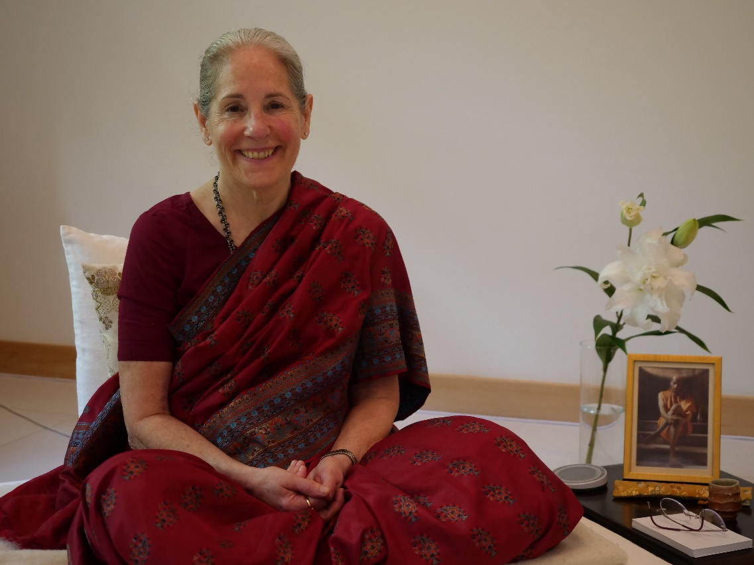this volume and the second, which will be published next year – is a collection of essays and reflections spanning many years, all of which take on specific situations, resources, challenges, and stories that convey the lived experience of practice, day by day, as it unfolds and we work to go deeper. It’s organized thematically, so you can open *Living the Practice* at any chapter that speaks to you in the moment, or even to a random page, and just start reading about all these important facets of practice. *Living the Practice* can absolutely be read on its own, but it’s a richer, deeper experience if you’ve read *Walking Home with Baba*, because then you’ll already be familiar with key aspects.

**2. How did you start pursuing spiritual practice?**

I’ve always pursued spiritual practice; it’s just that my practice, and my understanding of practice, have evolved. As a little girl, my focus wasn’t on religious ritual but on the experience of being with and understanding God. Through dance, through Tai Chi Chuan, and finally through my Guru, Swami Muktananda Paramahamsa, I came to understand what that truly means. I’ve always looked for the bottom line of existence. Baba shared it with me.

**3. You haven’t sought to affiliate yourself with any of the popularly known schools or networks of yoga practitioners and writers on spirituality. Why not?**

I found my Guru, I found the path, and I’ve continually been doing the work Baba taught me. I’ve never felt any desire to distract myself with extra affiliations. My job is to practice, to Love, and to share with others what Baba taught me.

**4. How do you see yourself fitting into the lineage of Muktananda and Nityananda?**

Baba always said that he would remain within everyone who received *shaktipat*, or spiritual initiation, from him. Of course, he meant those people who not only received *shaktipat* but also consciously imbibed the practice. Baba is my Guru. He gave me *shaktipat* and taught me the practice one-on-one, day after day, over many years. He still guides me.

**5. Do readers have to give up their religious convictions or subscribe to Indian beliefs in order to practice what you teach in your books?**

Absolutely not. Spiritual practice is universal; it isn’t specific to one creed. If you go to the heart of any real spiritual tradition, you will find the same practice. The vocabularies and conceptual frameworks differ, but the core practice is the same. The authentic texts on contemplative practice all say the same thing. The practice I learned from Baba actually underlies and informs all religions.

**6. How do your paintings and poems factor into the insights and teachings in *Living the Practice*?**

Everything I do is an expression of my *sadhana*. As to the poems, I found over time that prose pieces no longer felt adequate as a vehicle for me to convey the experience of practice, so I turned to poetry. The poems are more distilled, more concentrated, and they use space on the page as well as letters and words to communicate an experiential understanding. The paintings are much the same. In my younger years, I was a highly trained dancer, all the way to what, at the time, was a terminal degree in dance, and I also studied martial arts and Chinese calligraphy. So the elements of painting – including rhythm, space, movement, stroke, color, texture, etc. – are natural means of expression for me. My paintings, like spiritual practice, work on a vibrational level, conveying experiences directly if the viewer is open to that.

**7. How does the mind-body-spirit connection factor into spiritual practice?**

The fundamental error in the human condition is believing that the mind, especially the intellect, is the self. In truth, mind and body are both objects. The spirit—the Self—is not. They are not equal. The mind and body are temporary vehicles, the agents of the Self, and they are enlivened by the Self. They are real in the sense that they exist, but they are not eternal. Any spiritual practice that focuses on the body, or just on intellectual understanding, is missing the mark. The Self enlivens the body and the mind, and the Self must be the focus of any authentic spiritual practice. For a fully realized, liberated being, everything is revealed to be God, including the physical universe, but for the rest of us, that’s just a nice idea, and a misleading one.

**8. To what extent does your teaching overlap with what might be called therapy?**

There is some overlap, in that you have to know your shrunken self’s system, much of which is based on your childhood experiences. You can’t transcend what you don’t understand. But that’s where the similarities end. Therapy does not operate on the same playing field as spiritual practice, and does not have the same goals. In spiritual practice, problems are seen as life lessons that have to be mastered and transcended on a journey to God. Conventional psychology can identify many of your problems and help you acknowledge them, but it doesn’t show you how to transcend them, how to leave behind the false sense of self in which they are all rooted. Spiritual practice does, because it’s grounded in a very different, deeper sense of the Self. This is not to devalue therapy – there have been many instances in which I have advised students to seek therapy, as they need to gain a better understanding of their mostly unconscious beliefs and cognitive defaults before going further into spiritual practice.

**9. What would you say to a reader who argues that spiritual practice is selfish, that we need to be active in the world trying to change things for the better?**

I would say that person misunderstands spiritual practice. If we venture out into the world trying to change it for the better but are caught in the illusions and narratives of our shrunken self, everything we try to accomplish will be tainted by that untruth, twisted to serve the ends of our systems. The point is to act appropriately in the world from a place of Love, which is universal and free. And we cannot approach Love without the work of *sadhana*, whatever our faith tradition. So the choice between spiritual practice and constructive work in the world is a false one. Whatever you do in the world, practice as constantly as you can while doing it. The great scriptures affirm this. The *Bhagavadgita*, for instance, makes very clear that its hero, Arjuna, should go and fight a battle – but he must fight it from a place of Truth and Love, from consciousness of the Self.

**10. Your guru, Swami Muktananda, died forty years ago. What has it meant for you to continue your practice, and to work as a spiritual director, for so long without your Guru?**

The truth is that I’ve never been without my Guru. First of all, Baba remains a living presence within and around me. Also, as Baba always said, the true Guru is the grace-bestowing power of God, which may act through a human being but is never just that person.

**About the Author**

From an early age, Rohini Ralby was committed to finding the best teachers in every field she pursued. Originally from the Boston area, she completed her undergraduate studies at Washington University in St. Louis and earned a graduate degree at Mills College.

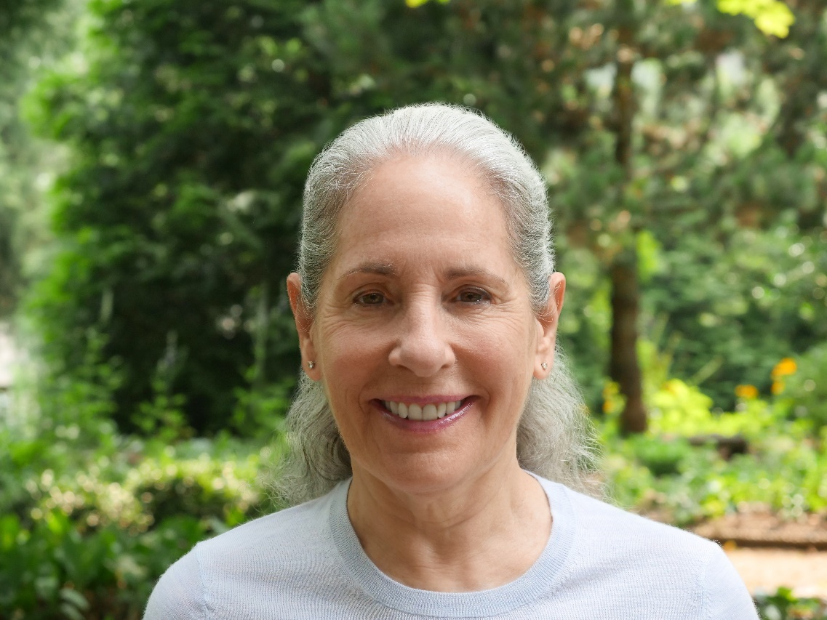While at Mills, she began intensive study of Tai Chi Chuan, and subsequently ran her own school in Cambridge, Massachusetts while also earning a degree in acupuncture and studying Chinese calligraphy and Alexander Technique.

In 1974, she met Swami Muktananda Paramahamsa, and remained a close disciple until his mahasamadhi in 1982. During that time, she studied spiritual practice with him one-on-one. wayofloveinterior.indd 345 9/20/21 10:28 AM

In the four decades since Muktananda, affectionately known as Baba, left his body, she has continued to devotedly live that practice. Since 1990, she has shared it with students all over the world. In 2012, with Bancroft Press, Rohini published *Walking Home with Baba: The Heart of Spiritual Practice*, a guide to the inner practice she learned from Muktananda and continues to share.

*Living the Practice: The Way of Love* is the first of two books that collect Rohini’s shorter writings in both prose and verse as well as some of her paintings, organized thematically so readers can locate, read, revisit, and contemplate her teachings and reflections.