The Lone Star Speaks: Untold Texas Stories about the JFK Assassination

Co-authors
Sara Peterson
Midland, TX
speterson2510@gmail.com
(432) 697-6944
K.W. Zachry
Midland, TX
kwzachry@yahoo.com
(432) 413-7280

Publisher
Bruce L. Bortz
Bancroft Press (one of the top ten independent book publishers in America since 1992)
PO Box 65360
Baltimore, MD 21209
410-358-0658
410-627-0608 (cell)
bruceb@bancroftpress.com
www.bancroftpress.com

Publicist
Brandon M. Stickney
brandonstickney5@gmail.com
727-942-8618

Title Info
The Lone Star Speaks: Untold Texas Stories about the JFK Assassination
Sara Peterson & K.W. Zachry, Co-authors
US History/JFK Assassination
978-1-61088-192-0 (Hardcover)
978-1-61088-194-4 (Kindle)
978-1-61088-195-1 (Ebook) (Audiobook available through Audible, etc.)
Pub Date: October 6, 2020
Length: 512 pages, plus 32-page photo insert and comprehensive, professionally compiled index
$28.95

Distributor
Baker & Taylor Publisher Services (the premier worldwide distributor of books, digital content, and entertainment products from approximately 25,000 suppliers to over 20,000 customers in 120 countries): 30 Amberwood Parkway Ashland, OH 44805.

Publisher Info
- Been a top-ten indie since its start in 1992
- Publishes 4-6 books a year
- Distributed nationally by Baker & Taylor Publisher Services
- Frontlist and backlist titles managed in Hollywood by Sean Berard at Grandview Management.
- Bancroft books have received numerous starred reviews and won numerous awards
- The Missing Kennedy, a NYT ebook bestseller, was on the cover of People Magazine when published in 2015
- Recent mystery (Her Kind of Case) received star reviews from all but one of trade review publications
- Published the books of three Pulitzer Prize winners (Alice Steinbach, Stephen Hunter, Elizabeth McGowan)

Short Description
Almost sixty years after the so-called murder of the century, intriguing information and evidence is still being extracted from Texas on what happened before, during, and after the assassination of John F. Kennedy. This book on the JFK assassination, by two of the most dogged researchers ever, contains new information from Texans that other assassination authors never knew existed. And many of the Texas-based stories told by Peterson and Zachry’s previously uninterviewed subjects conflict with the Warren Commission version of the assassination. As one pre-publication reader put it, "I have read lots of Kennedy books and seen the movie JFK over and over, but I have never heard of three of the men you discussed—J. Goode, Robert Plumlee, and Jim Bolden. How did you ever find out about them?"

Longer Description
The Lone Star Speaks provides new insights into the assassination of John F. Kennedy by using information gleaned from actual witnesses (217), most of them from the state of Texas, the vast majority of whom have never been interviewed (117). These new interviews raise new questions concerning what many have called “the crime of the twentieth century.”
Among the most intriguing of the new Texas-based witnesses is Robert T. Davis, who was the Assistant Attorney General in Texas in 1963. As an attorney sent to help interview Warren Commission witnesses, Davis immediately sensed that the official investigation was a “whitewash.” Davis was one of the first to suggest that the investigation should include Jack Ruby’s contacts with Mafia members.
Other witnesses whom the co-authors located include a Lyndon Johnson staff member directed by the new President to serve as his eyes and ears in Dallas after the assassination. From Dallas Police Department headquarters, Iris Campbell personally reported Oswald’s death immediately to President Johnson on November 24, 1963.
Still another previously unknown witness (who even today insists on anonymity) was part of at least two “abort teams” in Dallas on November 22, 1963. Working with a U. S. Marshall in Dallas that day, he attempted to tell the FBI that more than one assassin fired at the President. More than a half-century later, he is still bitter that his information was ignored by officials.
Other individuals helping the co-authors add information to the Kennedy assassination puzzle include a personal female friend of President Kennedy, and another woman who spent the late hours of November 21, 1963 with Jack Ruby. The authors also uncovered several individuals who can personally vouch for the fact that there was and is a Dixie/Texas Mafia, and that it may have been involved in the Kennedy assassination.
The Lone Star Speaks began with a well-received presentation the co-authors made to the West Texas Historical Symposium in 2014. The presentation soon expanded into a four-year research project during which the co-authors found and interviewed more than 200 individuals, almost all of them Texans, and almost all of whom had not been interviewed before, either by the Warren Commission or other assassination researchers and writers.
Both co-authors became interested in President Kennedy’s assassination at a young age. K.W. Zachry’s grandparents lived in Dallas in 1963, and saved newspapers from that era. Her grandfather was connected to the Dallas oil industry. Sara Peterson became interested in the assassination in 1978 when she participated in the Presidential Classroom for Young Americans program in Washington, D. C. The two have collected books and artifacts concerning the assassination for years. Both are currently employed by Midland College.

New People, New Insights, New Questions
(A Longer Description)

The Lone Star Speaks provides new insights into the assassination of John F. Kennedy by using information gleaned from actual witnesses, most of them from the state of Texas, to raise new questions concerning what many have called “the crime of the twentieth century.”
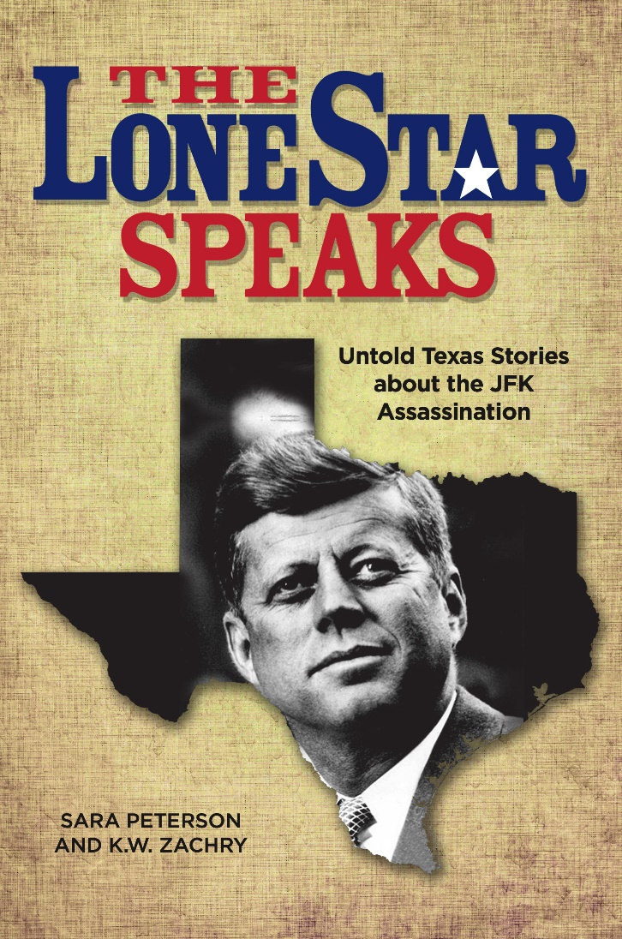
Among the most intriguing of the new Texas-based witnesses is Robert T. Davis, who was the Assistant Attorney General in Texas in 1963. As an attorney sent to help interview Warren Commission witnesses, Davis immediately sensed that the official investigation was a “whitewash.” Davis was one of the first to suggest that the investigation should include Jack Ruby’s contacts with Mafia members.
Other witnesses whom the co-authors located include a Lyndon Johnson staff member directed by the new President to serve as his eyes and ears in Dallas after the assassination. From Dallas Police Department headquarters, Lily Bryan personally reported Oswald’s death immediately to President Johnson on November 24, 1963.
Still another previously unknown witness (who even today insists on anonymity) was part of at least two “abort teams” in Dallas on November 22, 1963. Working with a U. S. Marshall in Dallas that day, he attempted to tell the FBI that more than one assassin fired at the President. More than a half-century later, he is still bitter that his information was ignored by officials.
Other individuals helping the co-authors add information to the Kennedy assassination puzzle include a personal female friend of President Kennedy, and another woman who spent the late hours of November 21, 1963 with Jack Ruby. The authors also uncovered several individuals who can personally vouch for the fact that there was and is a Dixie/Texas Mafia, and that it may have been involved in the Kennedy assassination.
The Lone Star Speaks began with a well-received presentation the co-authors made to the West Texas Historical Symposium in 2014. The presentation soon expanded into a four-year research project during which the co-authors found and interviewed more than 200 individuals, almost all of them Texans, and almost all of whom had not been interviewed before, either by the Warren Commission or other assassination researchers and writers.
Both co-authors became interested in President Kennedy’s assassination at a young age. K.W. Zachry’s grandparents lived in Dallas in 1963, and saved newspapers from that era. Her grandfather was connected to the Dallas oil industry. Sara Peterson became interested in the assassination in 1978 when she participated in the Presidential Classroom for Young Americans program in Washington, D. C. The two have collected books and artifacts concerning the assassination for years. Both are currently employed by Midland College.

Early Praise for Lone Star
“Exceptional! Very impressive!”
— Louis Herthum, Kennedy researcher and documentarian

“One of the best books covering the life, death, and assassination of JFK. I not only highly recommend it. I think it should be required reading for anyone seriously interested in the life and assassination of President John F. Kennedy.”
—Robert Plumlee, former CIA associate

“Really liked it. The material on Tom Alyea alone is invaluable.”
—Bill Simpich, California attorney

“Some fascinating stuff.”
—Lawrence Schnapf, New York attorney

“I congratulate both authors on the extent of their documentation. It is refreshing to know that we still have professionals actively seeking the truth. I completed reading the book a few days ago. I am still reflecting with astonishment at the detailed writeups of so many witnesses. I have not read anything as thorough in a long time.”
—Donald Craig, brother of John Craig, co-author, The Man on the Grassy Knoll

Partial Summary of New Information Appearing in Lone Star Speaks

Though hundreds of books have been published concerning President Kennedy’s assassination, few have been based on personal interviews with witnesses to events that preceded the assassination, the assassination itself, and its aftermath. The Lone Star Speaks: Untold Texas Stories about the JFK Assassination differs from many other books that deal with President Kennedy’s life and death. It is a compilation of extensive research (including FBI memos, law enforcement depositions, police records, etc.) and, most importantly, personal interviews with more than 200 individuals. Most had never spoken publicly before about their experiences, or they shared information they had never told researchers.
Most of the interviews in this book will be unfamiliar to the general reader. This, in itself, makes The Lone Star Speaks different from so many other Kennedy assassination books. The new photos included in this book should be a refreshing change for those who have read numerous books about the Kennedys. Though the book does include basic information concerning the official account of the President’s death, the main focus is on the witnesses’ testimonies and memories.
Anyone who has heard about the death of John F. Kennedy should be interested in new information, especially that which raises more questions concerning how easily a Commander-In-Chief can be silenced along with those who dared to contradict the government’s official investigation.
The following witnesses verified there were at least two men using the name” Lee Harvey Oswald” at different times during the 1950s and 1960s, an extremely important fact that may change the way fair-minded people view the entire assassination. In 1959, a young man from Midland, Texas shared a cabin on a steamer with a man whose name would become infamous in just a few years. Bill J. Lord was travelling to France; his roommate, Lee Harvey Oswald, never admitted that he was headed to Russia, but that is exactly where he ended up. Though Lord never knew that someone else continued to use Oswald’s identity in New Orleans for the next few years, he could certainly swear that one person using the name Oswald crossed the Atlantic with him in that vessel.
Dorothy Cox learned that one Oswald appeared in Houston on September 25, 1963. Cox shared information that only her family members had known about Lee Harvey Oswald. She knew through her brother, John R. Craig, that Oswald, Charles Harrelson, and Charles Rogers had all been together in Houston. Harrelson later served time for killing a Texas judge, Rogers was wanted concerning the murders of his parents, and Oswald, of course, was accused of killing President Kennedy. Rogers and Harrelson have been identified by numerous acquaintances as two of the three tramps in Dealey Plaza the day of the assassination.
The aunt of Cox and Craig, Marietta Gerhart, shared with her family that a man using the name “Lee,” whom she later recognized as Lee Harvey Oswald, was at her house in Houston on September 25, 1963. Another man identifying himself as Lee Harvey Oswald was in Austin asking about his Selective Service status. From Austin, this Oswald travelled to Dallas, arriving in the evening.
Well-known poker player Doyle Brunson knew Charles Harrelson because he often gambled with him. He sat across a poker table from Harrelson many times and knew his face well. Having seen the famous photo of the “three tramps” apprehended near the assassination scene, Brunson believed that the “tall tramp” was Harrelson. Brunson’s verification gives credence to the fact that, at one time, Harrelson admitted helping kill President Kennedy though he later recanted.
The appearances of two Oswalds continued. Clyde Fletcher recalled that about a month before the assassination, a young man brought his early 1950’s Ford station wagon into an Abilene, Texas body shop. The automobile needed a new universal rear joint. A young woman was in the car with him. Even after fifty-four years, Fletcher remembered that when the man paid for the car repairs, he emphasized that his name was “Lee Harvey Oswald.” Fletcher described the man as being extremely tall, which does not match the physical description of the“official” Oswald. Fletcher realized that when he saw Oswald on television after the assassination. However, he cannot explain why the man who obviously was not the “official” Oswald made a point of mentioning that he was Lee Harvey Oswald.
J. Goode, with U. S. Marshall Robert I. Nash, was part of an abort team in Dealey Plaza the day of Kennedy’s assassination. He was then familiar with two men using the name “Lee Harvey Oswald.” He realized on November 22, 1963 that one would be arrested as a patsy for the President’s death and the other would slip away that day without being apprehended. Goode verified the theory that more than one person was using the name “Lee Harvey Oswald” when he answered the question posed by the authors: “Did you know Oswald?” with the reply, “Which Oswald? I knew them both and didn’t like either one of them.” Goode revealed to the authors that the second “Oswald” survived the assassination and its aftermath; Goode saw him years later driving a taxi in Houston.
Robert “Tosh” Plumlee, a member of a separate abort team in Dealey Plaza on November 22, 1963, also verified there were two “Oswalds.” He shared this with the authors in a personal interview.
George McGann was well-known in certain parts of Texas, but most Americans are unfamiliar with his name. His friends openly referred to McGann as being “mob connected” and part of the Dixie Mafia. Several of them recalled that he took several of them to Dallas to meet Jack Ruby. McGann married a girl who admitted to being close to Jack Ruby. Friends and acquaintances who knew McGann shared intriguing stories about a man who grew up in a small town as the only child of middle-class parents and ended up on the FBI’s Wanted List. Not long before he was murdered, McGann shared information with three close friends concerning the Kennedy assassination. One witness deliberately waited until he was the last man alive to tell the authors how George McGann was connected to the Kennedy assassination.

The Warren Commission, as one of its key findings, concluded that Jack Ruby, who killed Oswald, acted entirely on his own, and that he had no significant connections to organized crime. Quite a number of witnesses we spoke to for the book told us that Ruby killed the patsy Oswald on behalf of the mob.
In 2013, Bernie Sindler was one of the few people who could discuss Ruby’s mob without fear of reprisal. According to Sindler, who described himself as “a protégé of mobster Meyer Lansky, who he considered his surrogate father,” Jack Ruby knew Bugsy Siegel, Moe Dalitz, Mickey Cohen, and Johnny Roselli to name just a few well-known mobsters. Sindler was especially close to Roselli, a man he said did not deserve to die the way he did. Roselli had shared information with Sindler about the Kennedy assassination. He named mobster Sam Giancana as a major playe in the plotr, and he knew Lee Harvey Oswald really had been the patsy he claimed to be. Roselli also explained that Jack Ruby was chosen by fellow mob members to eliminate Oswald because Ruby was dying of cancer anyway. Roselli also told Sindler as early as 1964 that Robert Kennedy would also be killed. When asked by the authors if Roselli had been eliminated by the mob, he replied, “No! I think the FBI did that and Johnny didn’t deserve that!” He did not say the same about the Kennedys.
Despite Roselli’s “official” alibi that he was in Las Vegas when Kennedy was killed, there is a preponderance of evidence that he was in Dallas. But most people would not suspect that he was sitting in a basement of a hospital. There has been quite a bit written about the fact that the staff of the Dallas Parkland Hospital was not on alert even though the President and the Governor were riding in a motorcade not far from the hospital. Monzel Bailey explained to the authors that her husband Jessell had worked at Baylor Hospital in l963. He told her that Baylor Hospital was on alert because of the President’s visit. However, when shots were fired at the motorcade and the President and Governor were obviously injured, it was logical to take them to the closest hospital, which happened to be Parkland. The fact that doctors at Baylor Hospital had assumed they would be used if the President was harmed might explain why a witness claimed that gangster Johnny Roselli was waiting in the basement cafeteria at Baylor Hospital when word came over the radio that the President had been wounded.
J. J. Singsong may be the only person alive who can verify where Jack Ruby went on the evening of November 21, 1963 after he closed his two nightclubs. He had been to Campisi’s Egyptian Lounge earlier, but he took Singsong with him to the Cotton Bowling Palace, where he met a man she had never seen before. He introduced himself as “Tony DiMaggio, Joe’s brother.” Singsong had no idea that the baseball player did not have a brother named “Tony.” For the very first time, Ruby insisted Singsong go entertain herself while he visited alone with his mysterious friend. Singsong later returned to Ruby’s apartment and spent the rest of the night there. She never discovered who Ruby’s friend really was.
Dorothy Wean, the widow of Gareth Wean, recalled to the authors how her husband discovered that Dallas Sheriff Bill Decker and Texas Senator John Tower knew that Lee Harvey Oswald had not killed President Kennedy. Decker and Tower shared their private information with Wean, his Los Angeles police partner, and war hero Audie Murphy only weeks after Kennedy’s assassination. The information was in a sealed envelope that may still exist today. However, Wean also shared with his wife that he knew Jack Ruby was mob-connected because he had seen him with mobster Mickey Cohen. This might explain why Ruby made trips to visit Cohen’s girlfriend, Candy Barr, in Edna, Texas after she was released from prison. So many of Ruby’s friends and associates were mob-connected that he must have been connected, too, just as Bernie Sindler indicated.
On the other hand, Jack Ruby also had connections to at least one government agency. Mel Barney provided proof of this to the authors when he shared the fact that Ruby had a secret security clearance which made him more than just a “sleazy nightclub owner.” Barney knew this because he had a manifest for secret flights which showed Jack Ruby’s name as a passenger. Barney also remembered Ruby, whom he met at the Carousel Club, flying on a plane with top-secret auto-pilot equipment.
In 2016, Richard Jones shared a personal story about the moment Lee Harvey Oswald was shot. As a teenager in California, he and his family were gathered around the television set waiting for Kennedy’s accused assassin to be transferred to the Dallas Sheriff Department. Just as Oswald entered the basement of the Dallas Police Department, Jones’ stepfather pointed to the television screen and said, “This is where it’s going to happen.” In a split-second, Jack Ruby stepped out of a crowd of news reporters and gunned down Lee Harvey Oswald. When Jones and the rest of his family demanded to know how his stepfather had known what was going to happen, his stepfather replied, “That is how it’s done.” Jones later admitted his stepfather had once been a member of the O.S.S. (forerunner to the CIA.) Apparently, experiences with this intelligence organization had provided Jones’ stepfather with insights into how “patsies” are silenced if they are not killed during their arrests.
A question that still troubles much of the American public is: Did Lee Harvey Oswald and Jack Ruby know each other? James Womack of Dallas, Texas could have verified that Jack Ruby was somehow connected to Lee Harvey Oswald (or someone who looked just like him) before Kennedy’s assassination had he not been too frightened to talk. Womack was a young intern at the Petroleum Engineers Publishing Company in November of l963. He and a friend also worked an after-hours job at Jack Ruby’s Carousel Club for a few weeks. They installed door jambs in the back part of the club. That is how they happened to see Ruby with several men on different occasions. After Oswald’s arrest, Womack recognized him as one of the men Ruby had visited with. The young man was shocked that he had seen the accused assassin in the Carousel Club, but he was terrified when he saw Oswald murdered by the same man who had hired Womack and had visited with Oswald! Womack finally confided in a co-worker at the library, Bill Cherry, who kept his secret for years. Womack was so frightened that he not only refused to connect Ruby to Oswald, he left Dallas as soon as he could and never returned.

Other interviewees among the more than 200 we dealt with presented new information to the authors on other key issues bearing on the assassination:
Robert T. Davis, who was the Assistant Attorney General of Texas in 1963, described to the authors how chaotic and unprofessional many of the interviews conducted by the attorneys assigned to the Warren Commission really were. As he emphasized to the authors, “I told Waggoner [Carr, Attorney General of Texas] that Lyndon was running the whole thing.”
Iris Campbell revealed to the authors that, as President Lyndon Johnson’s unofficial representative in Dallas after the assassination, she was on the third floor of the Dallas police department at the same time Lee Harvey Oswald was gunned down by Dallas nightclub owner Jack Ruby inside the police department. Campbell telephoned the White House immediately to report Oswald’s shooting directly to Lyndon Johnson. This inside story (and others) concerning Lyndon Johnson, before and after his sudden elevation to the presidency, shed new light on Johnson and his personal feelings about the assassination, as well as how much power he wielded over others.
When convicted Texas conman Billie Sol Estes died in 2013, a mysterious “mourner” approached a woman who still insists the authors keep her identity a secret. Standing behind her as she gazed down at the body of her old friend, he spoke softly. His face was unrecognizable, but his voice—that voice—she remembered well. This man had been known by some as a hit man for Lyndon Johnson - - - and he was supposed to have died years ago. And yet, here he was with a new face and a familiar voice, making sure she knew he had not died after all.
Dennis David, Chief of the Day at Bethesda Naval Hospital on the evening of November 22, 1963 overheard two Secret Service Agents discussing President Kennedy as they guarded his autopsy room. What he heard was shocking, especially because President Kennedy had only been dead for a few hours. However, the words that came from these two men whose jobs were to protect Kennedy showed that at least some of the Secret Service agents had been disgusted by some of the former President’s sexual behavior
President Kennedy’s reckless sexual behavior might explain why Axel Holm told the authors that Kennedy’s one true love had been a woman Holm’s knew. As a teenager, Holm discovered that Inga Arvad’s comments about John F. Kennedy were based on personal experiences. Holm realized that Arvad had saved dozens of personal letters from the future President and that the relationship between him and the beautiful Danish blonde was probably the most significant one of his life.
A retired military steward who served President Kennedy finally verified a rumor that began decades ago concerning the President and a certain Hollywood sex symbol. According to Doyle Whitehead, he was on Air Force 1 with Kennedy when a voluptuous move star joined Kennedy’s entourage. The woman did not hide her famous blonde locks under a wig, but she did list her position as “secretary.”
El Paso police officer Jim Bundren not only arrested Richard Case Nagell, who claimed to have foreknowledge of President Kennedy’s death, but also arrested an intriguing suspect a few months before Kennedy’s murder. The woman, who was identified as “Jessie May,” was dressed in filthy rags; her hair had grown around a plastic headband that might not have been removed in months. She was babbling about President Kennedy and Cuba as she clutched two grimy paper sacks which Bundren almost threw away. Fortunately, he examined them and discovered thousands of dollars in cash among scraps of paper and a notebook covered with names and telephone numbers. The head of the El Paso Secret Service discovered that the notebook contained the private telephone numbers of heads of state, chief executives, and high government officials throughout the world. “Jessie May” was handed over to higher officials but was shortly released, Bundren discovered, and her arrest record disappeared along with her. Only Jim Bundren can verify that a woman concerned about Kennedy and the Cubans, who had access to top-secret information and thousands of dollars, somehow ended up in El Paso, Texas not long before Kennedy was killed.
Unbeknownst to the American public and the Warren Commission, a young former Navy lieutenant, J. Goode, was assigned to assist U.S Marshall Robert I. Nash in Dealey Plaza on November 22, 1963. Nash and his team had been warned that an attempt would be made on the President’s life, either before or after the luncheon at the Dallas Trade Mart. Consequently, the team was posted around Dealey Plaza and were witnesses to shots fired by more than one assassin. To their shock and dismay, their observations were dismissed by Dallas law enforcement, including the FBI. That day, Marshall Robert Nash and his associates realized that the warning about the President’s assassination had been accurate and that, for whatever reason, investigators only wanted evidence of a “lone nut” single assassin.
Jim Bolden was another West Texan who kept his connection to the Kennedy assassination a secret until after his death. Most people knew him only as a man who worked for Texaco and was a certified concealed handgun instructor. What his students and co-workers did not know was that he hid secret government documents in his house, and that he was fascinated by the Kennedy assassination because he had been a member of an abort team ordered to Dallas to prevent Kennedy’s death on November 22, 1963.
Marilyn Johnson was a young wife and mother living and working in Dallas, Texas when President Kennedy was killed. It was decades later that she told a story that verified where Texas School Book Depository employee Billy Lovelady was standing as the presidential motorcade passed the building. This was important because Lovelady resembled the accused assassin Lee Harvey Oswald. He happened to live next door to Johnson, and the morning after the assassination, he excitedly described where he had been and what he had seen on Elm Street that infamous day in November 1963. He had no idea at the time that certain researchers would mistake him for Oswald in a famous photograph. If Lovelady had thought to use Johnson as a witness to prove how soon he had described his position that day, he might have avoided the harassment that followed him most of his life.
Drs. Karl Dockray and James Huddleston both observed Parkland Hospital surgeons frantically trying to save accused assassin Lee Harvey Oswald’s life. Dockray was even allowed to take photos of Oswald on the operating table and of the various surgeons working on him. Huddleston was just a medical student at the time and was soon ejected from the crowded operating room. (However, he was close to Gov. John Connally’s surgeon and knew more about his condition than the average hospital staff member). Dockray refused to look at the historic photos he took; instead, he gave the film, undeveloped, to the Parkland Hospital chief administrator, who placed it in his desk drawer. It sat there for thirty years until researcher J. Gary Shaw helped get it developed. Either no one in l963 thought these photos might be of value, or someone finally realized that no one had obtained Marina Oswald’s permission to photograph her husband’s surgery.
Tommy Wright was a young Ft. Worth police officer who worked with the K-9 unit in November of l963. He helped guard the Lincoln limousine that President Kennedy, Mrs. Kennedy, and Governor Connally rode in on the morning of November 22, 1963. As luck would have it, on Sunday, November 24, he was also ordered to guard something that seemed to be as valuable as the President’s car—the dead body of Lee Harvey Oswald. Wright and a fellow police officer patrolled the Ft. Worth mortuary where mortician Paul Groody and his assistant Allan Baumgardner were attempting to embalm Oswald’s body. Wright observed how often the mortician and his assistant were ordered to leave the embalming room so that government officials in dark suits could be alone with the accused assassin’s body. Wright’s memories verify what Groody had testified to—FBI agents were alone with Oswald’s body, and no explanation for why was ever given.
As a high school student in Jal, New Mexico, Milton Thorpe was told by his band director, Duke Stephenson, that Jack Ruby had once employed him at his Carousel Club. According to Thorpe, after Ruby killed Oswald, Stephenson called someone in Dallas to find out more about his former boss. Thorpe remembers that his band director heard from someone in Dallas that Ruby already had cancer, a disease that Ruby later claimed he contracted from injections given him while in jail for Oswald’s murder.
Paul Gower shared a story with the authors about the FBI clerk assigned to package the so-called “assassination weapon” so it could be flown from Dallas, Texas to FBI headquarters in Washington, D.C. He remembered the FBI clerk describing to him and a group of teachers the condition of the rifle sent to the FBI. Labeled “Agent X” by the authors, this clerk made a deliberate, telling comment about what he saw when he examined the rifle that Oswald had supposedly used.
FBI Special Agent Ural Horton happened to fly into Dallas not long after Kennedy’s assassination. He was immediately put to work interrogating witnesses, according to his son. One of the first things he discovered was that Oswald had left a threatening note at the Dallas FBI headquarters not long before the assassination. Horton learned this from FBI clerk Nan Lee Fenner. Horton did not know that Special Agent Gordon Shanklin had told Special Agent James Hosty to destroy the note after Oswald was killed by Jack Ruby. Horton casually mentioned the note to Shanklin and could tell from his reaction that he was shocked Horton knew about the note. Even after his retirement, Horton was questioned by fellow FBI agents about how he knew about the note Oswald had written.
A man who still insists on anonymity happened to hear Vice-President Lyndon Johnson make a comment to Texas conman Billie Sol Estes less than two weeks before Johnson suddenly assumed the office of the Presidency. Via Air Force 2, Johnson had flown into the private runway owned by Estes outside of Pecos, Texas. The man who accompanied Estes to the huge airplane still remembers a comment that the towering Vice-President made that day. It meant nothing to him at the time, but years later he realized how important it might have been. “The next time you see me,” Johnson said to Estes, “I’ll be on Air Force 1.”
Individuals like those discussed above shared personal information with the authors concerning the assassination and its aftermath. Consequently, their stories are not only intriguing, they also challenge some of the key findings of the Warren Report.
The recollections of these witnesses act collectively as a warning to the American public: They can demand answers from government officials, and if they fail to, then the same type of error-filled investigation as the Warren Commission can also occur if similarly tragic events occur in the future. Indeed, given the current political climate, it is possible that the mistakes made during the official Kennedy assassination investigation of 1964 could well happen again. If it does, Americans must insist from its government that the entire truth, regardless of the potential consequences, be revealed immediately.

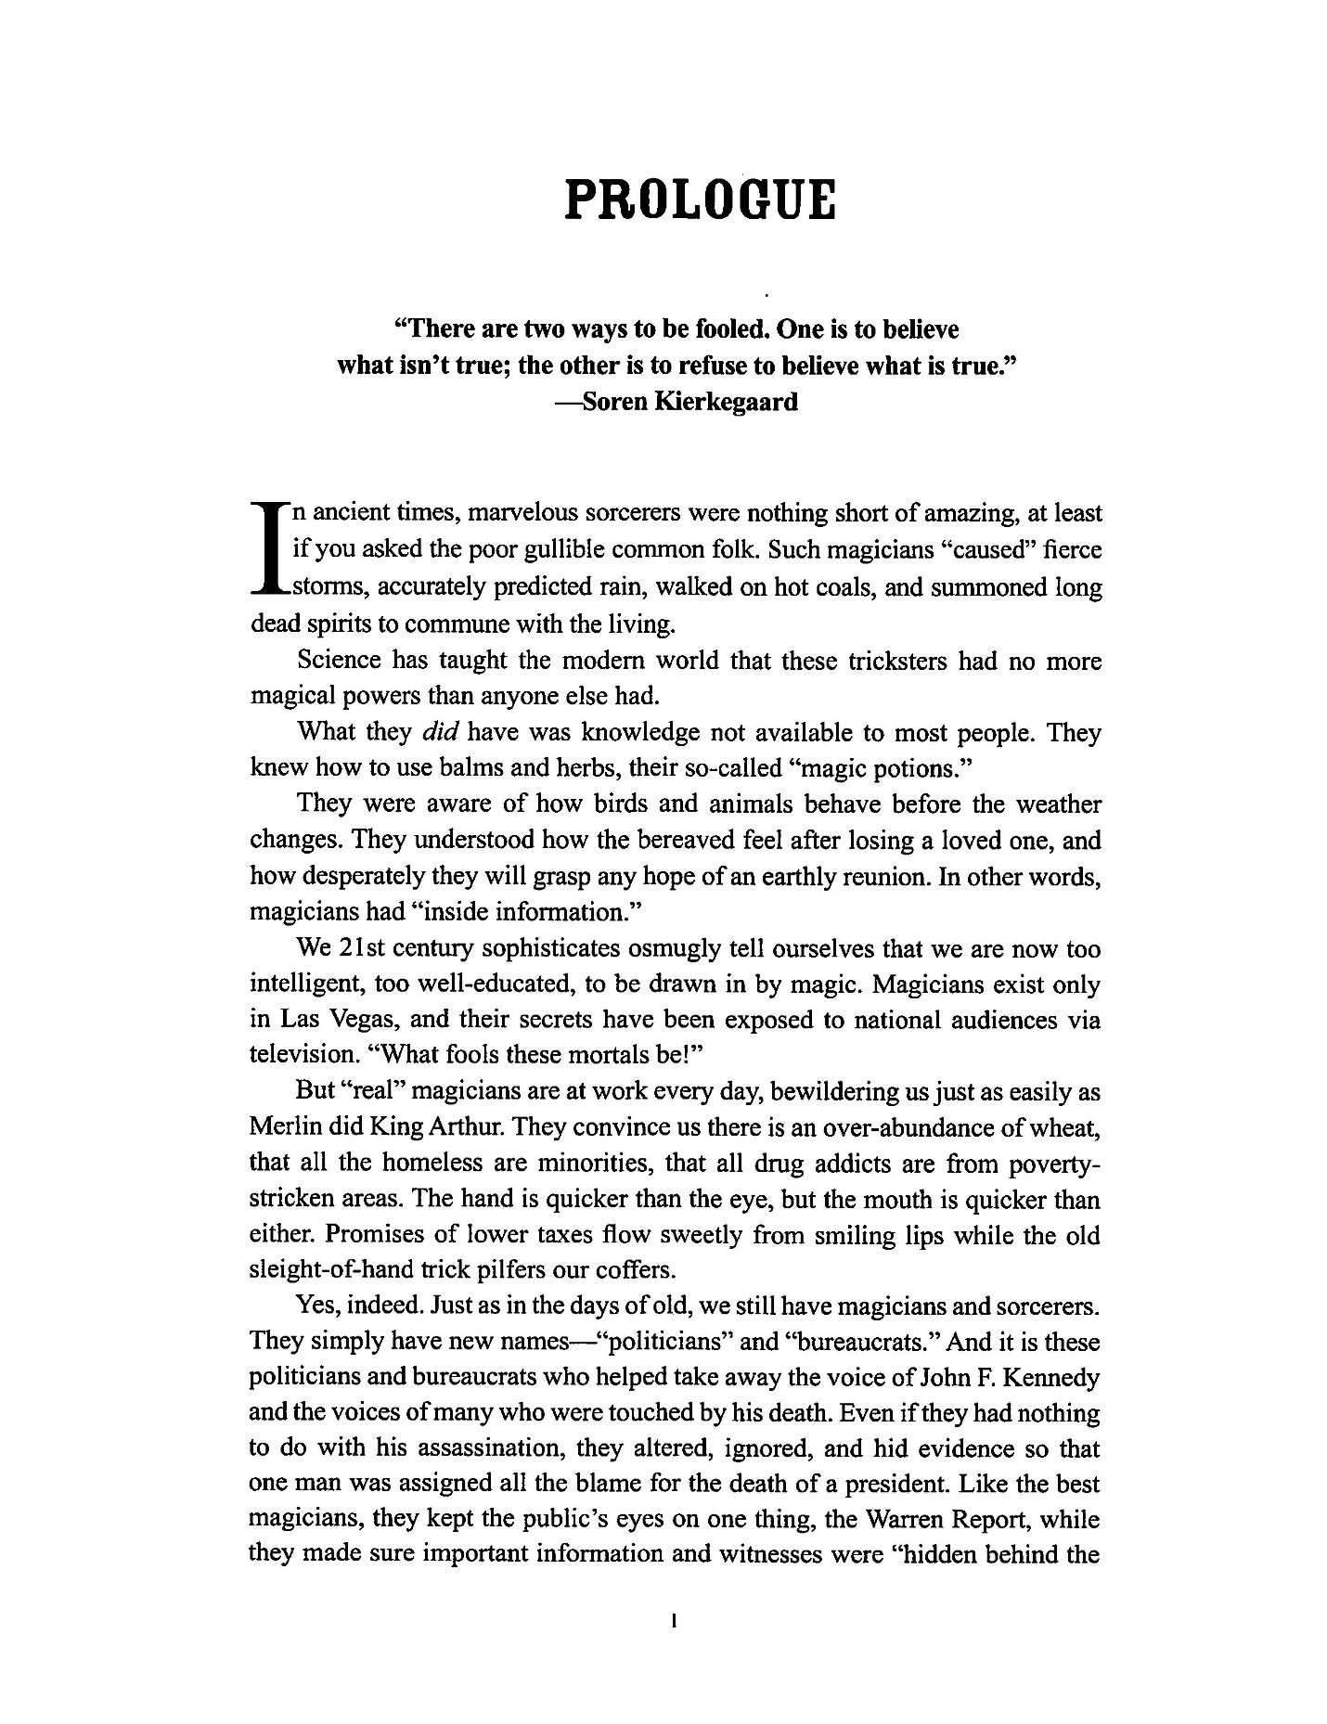

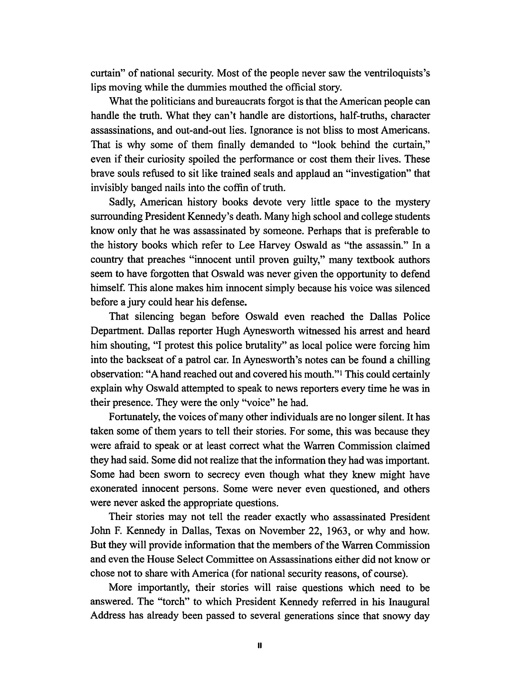

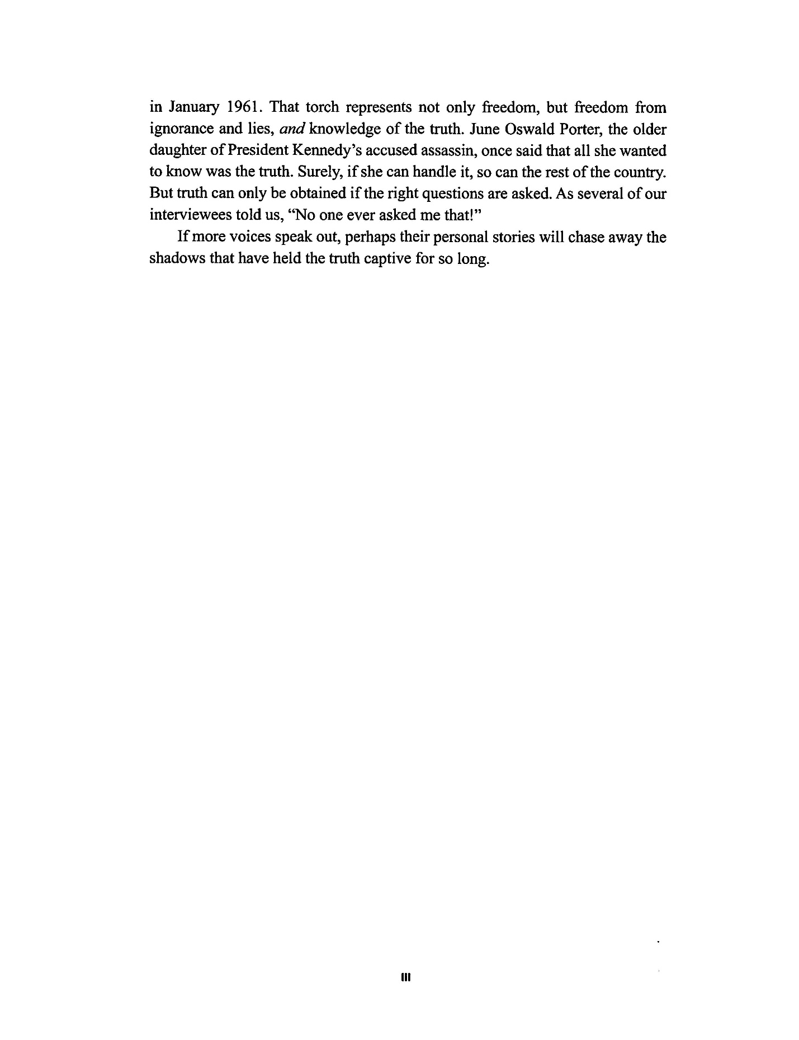
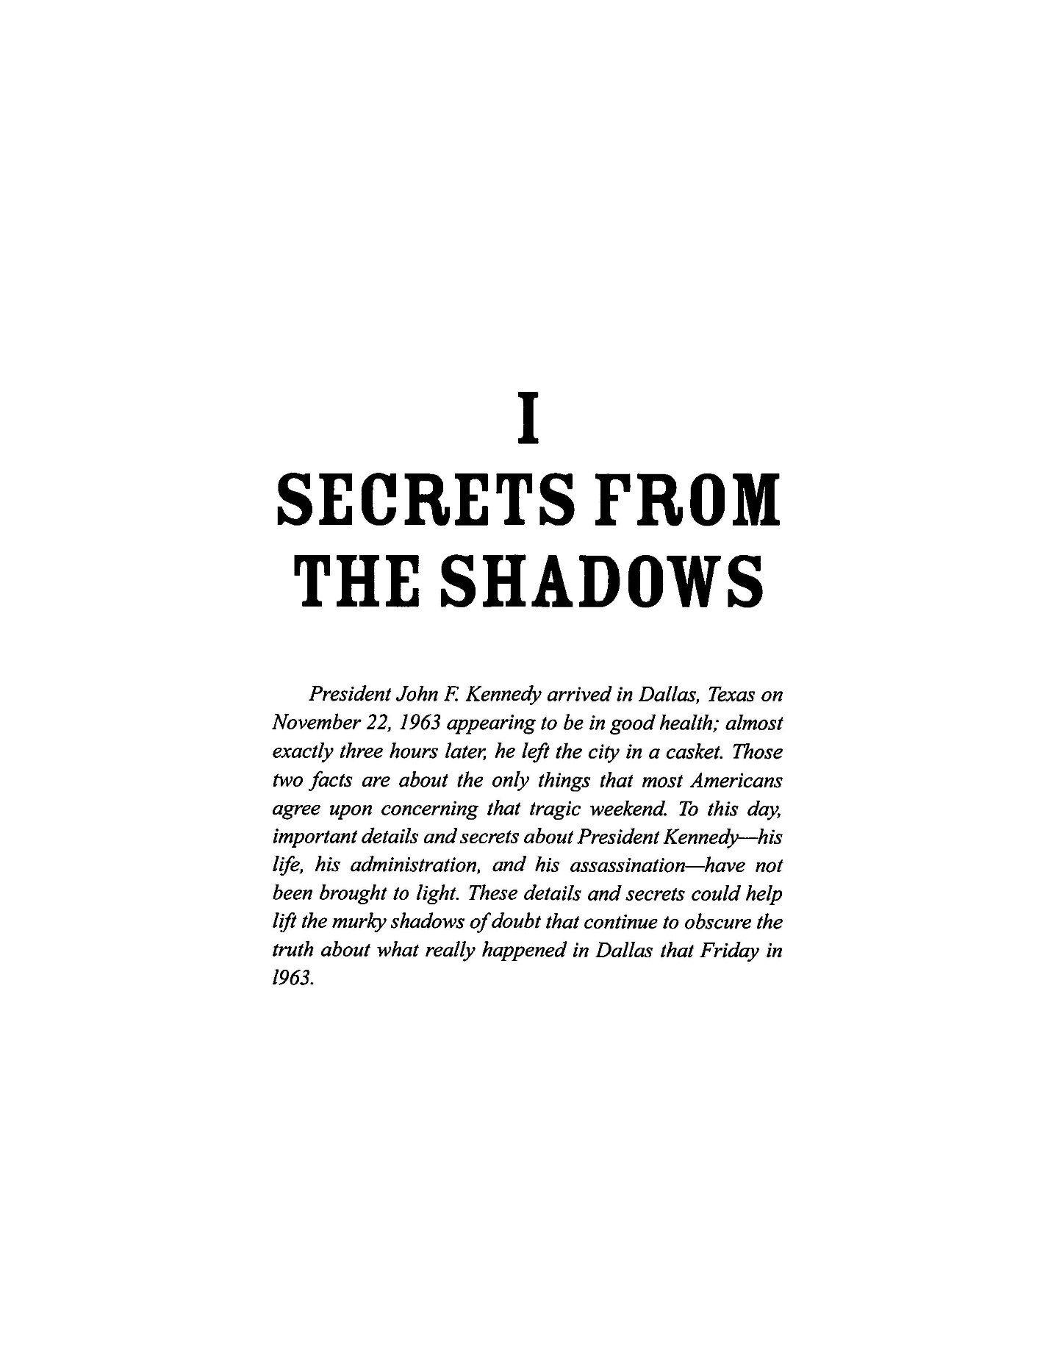
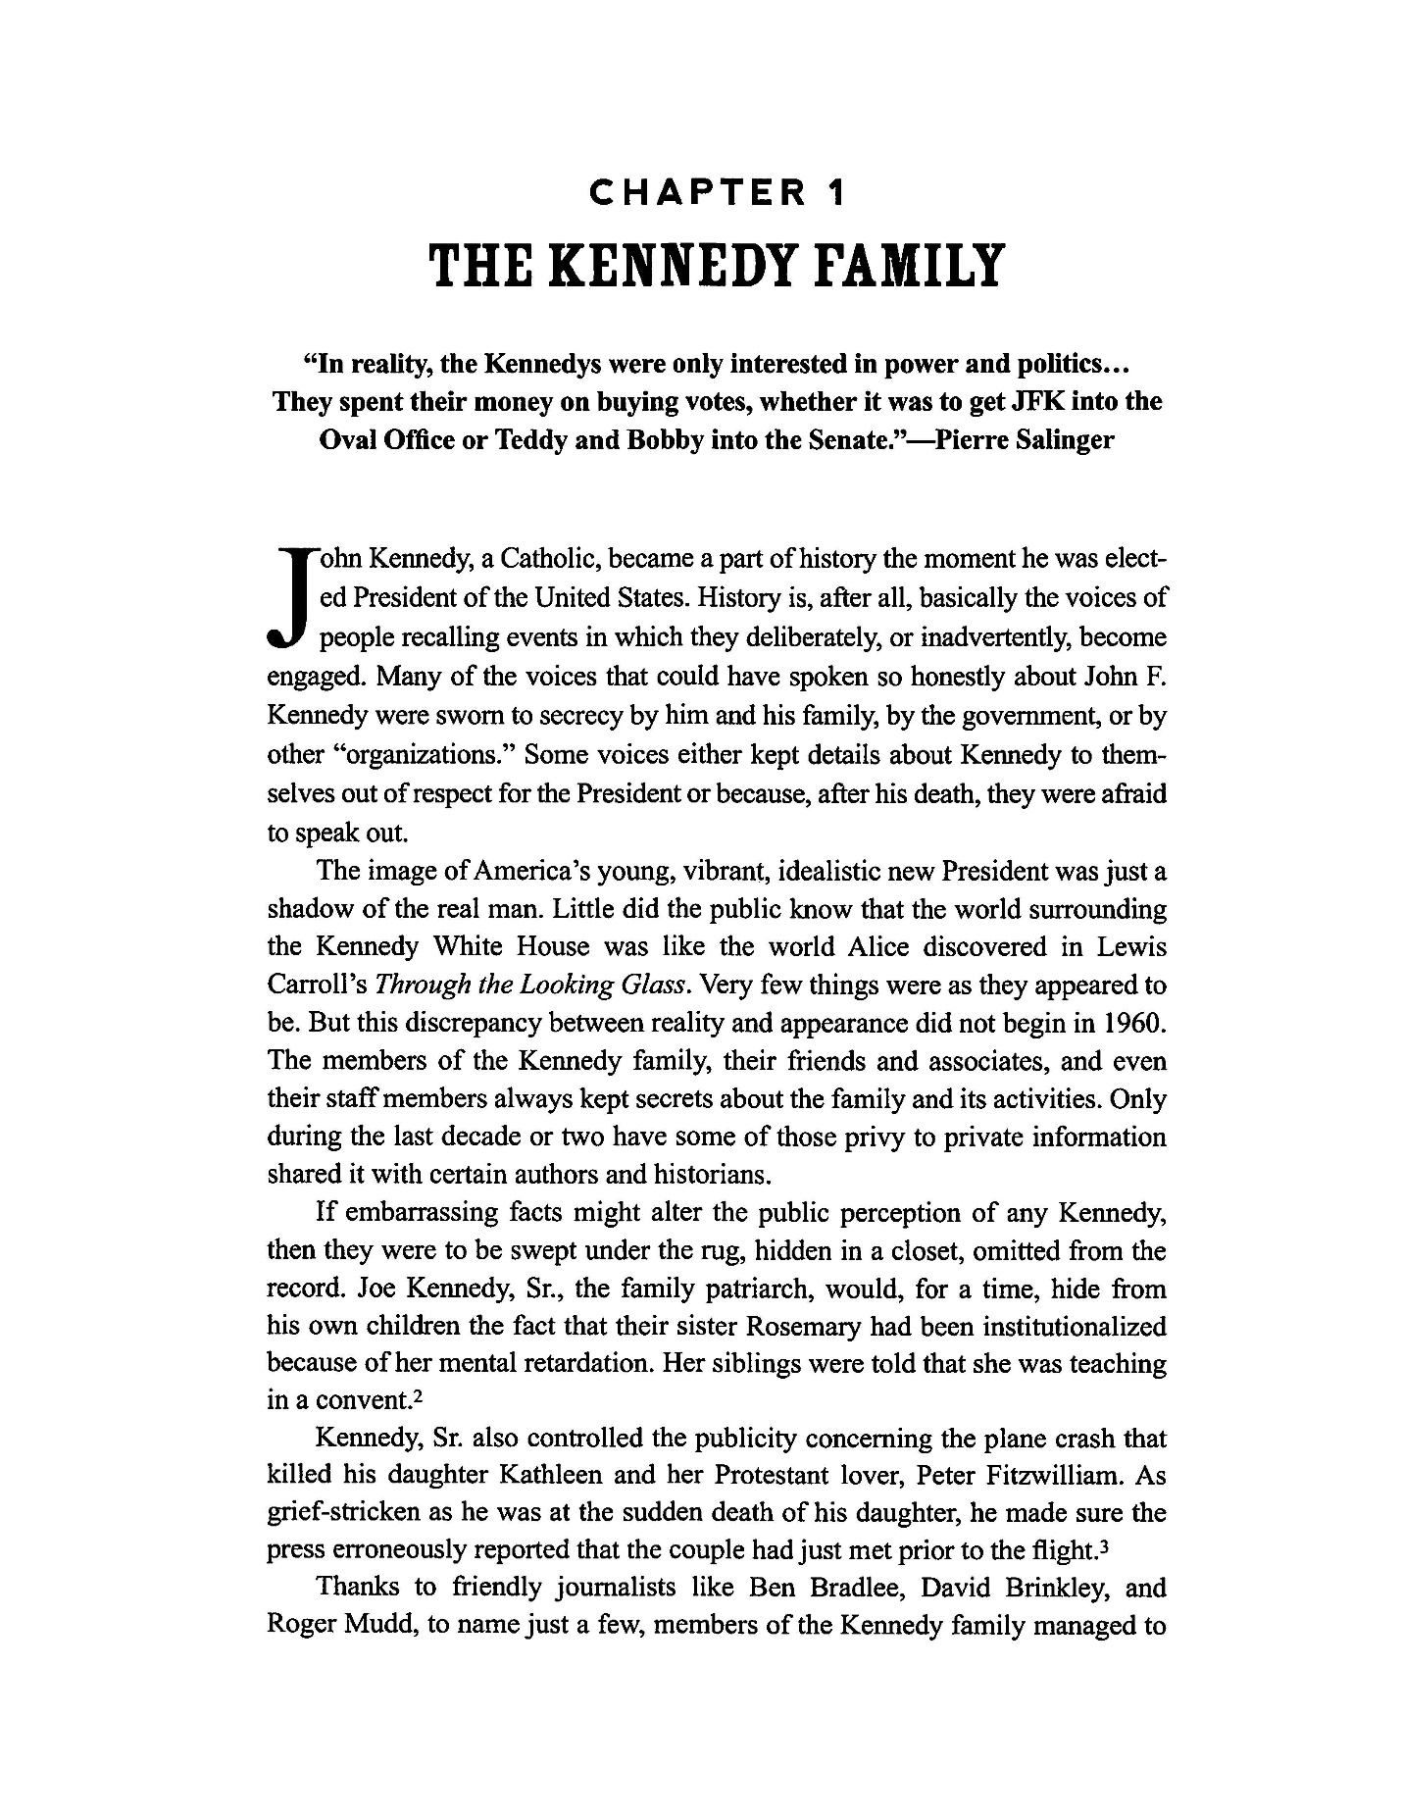
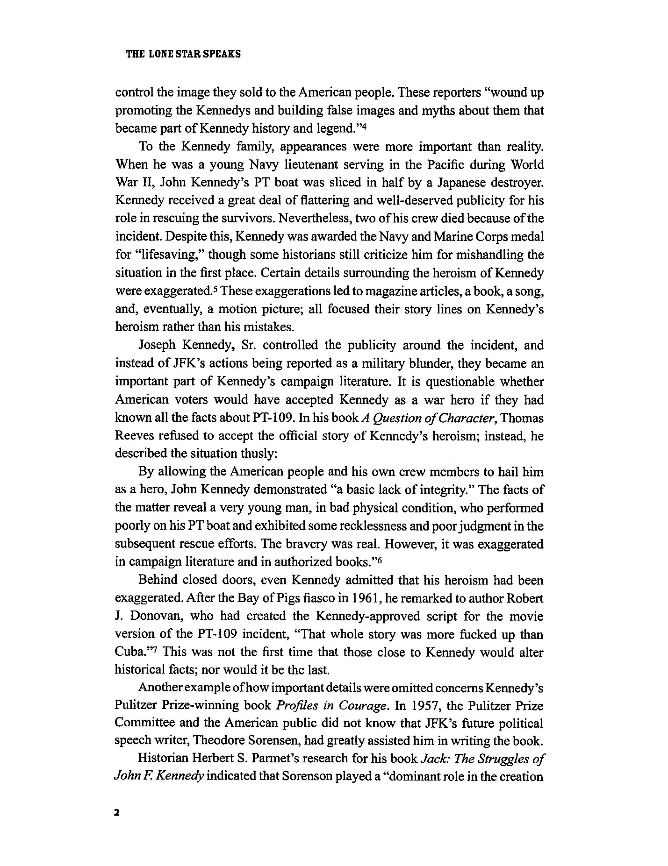
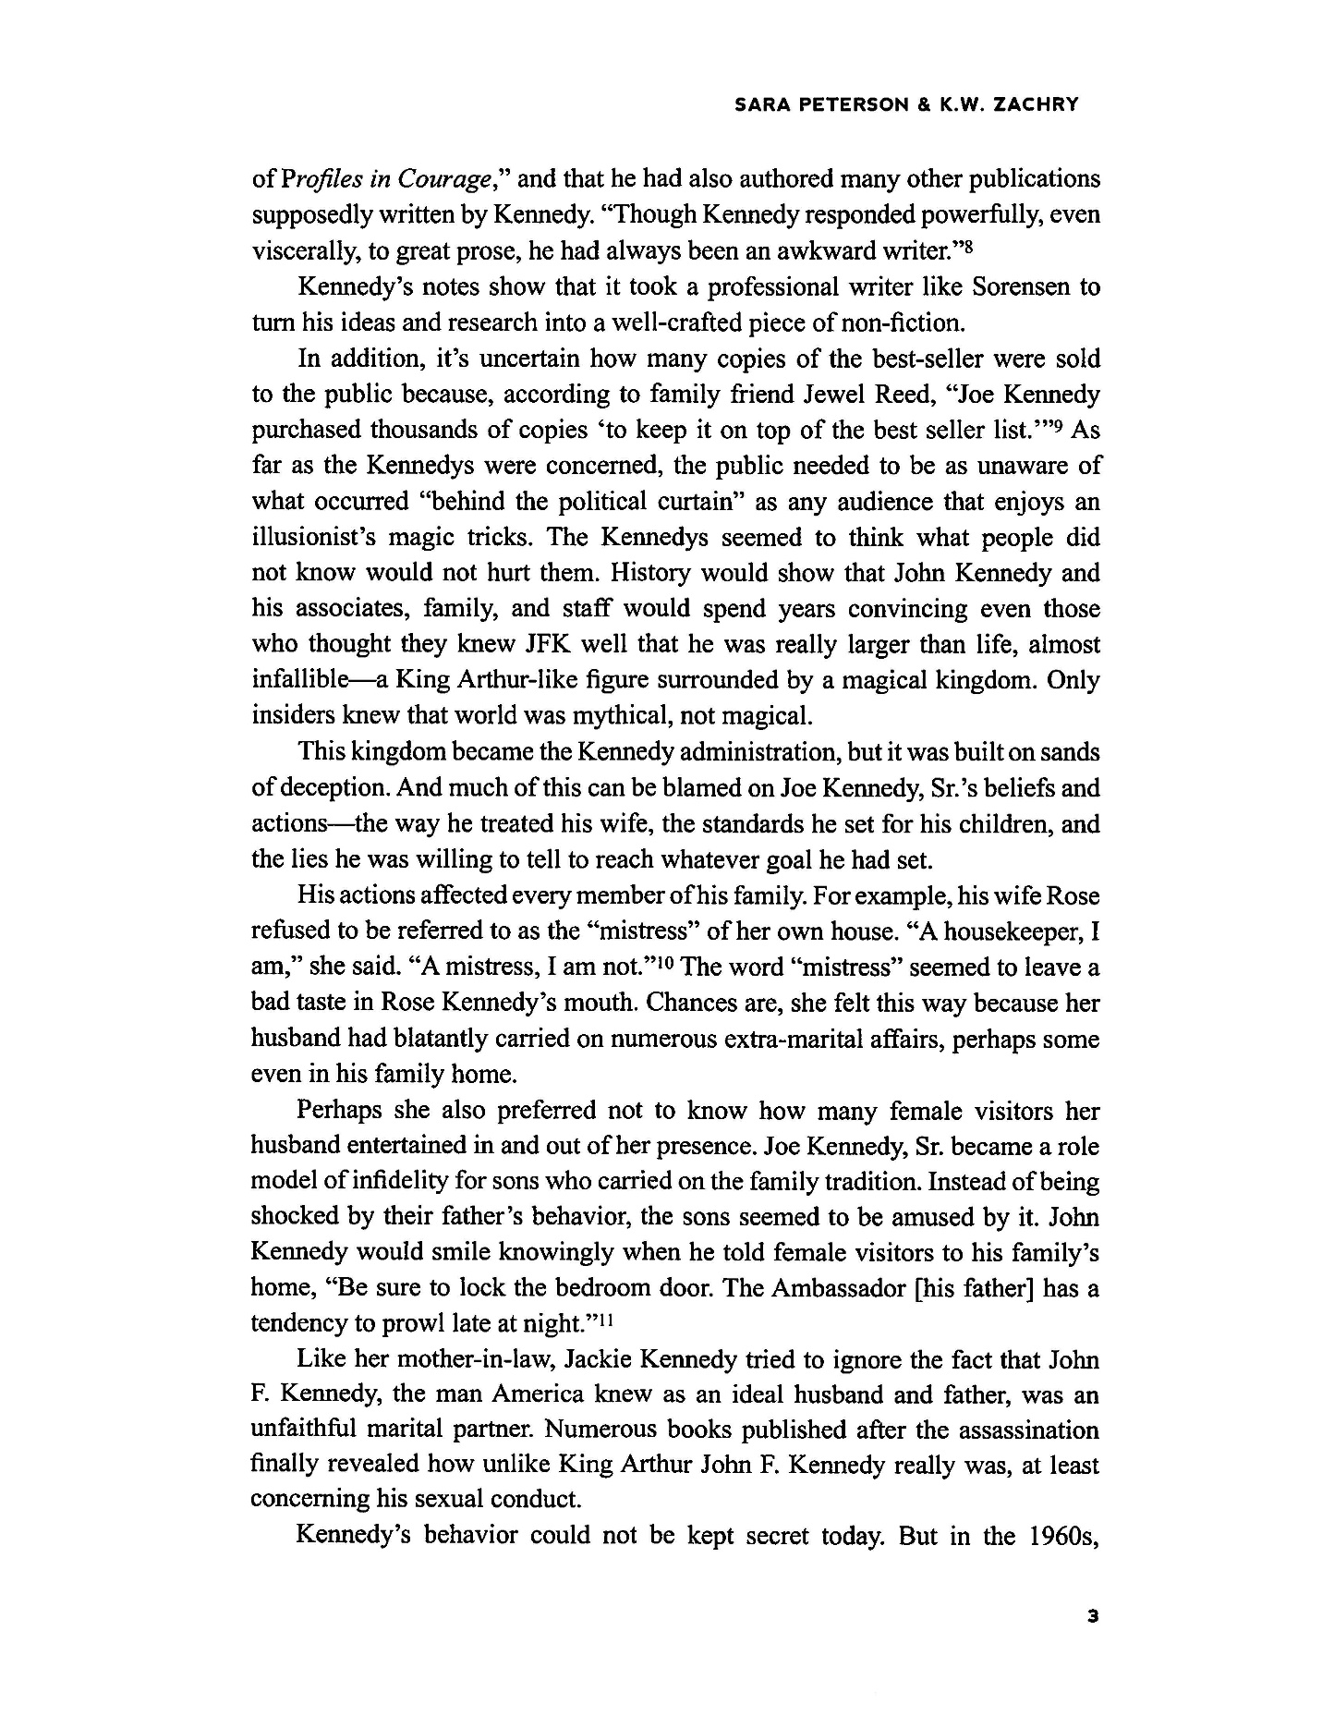
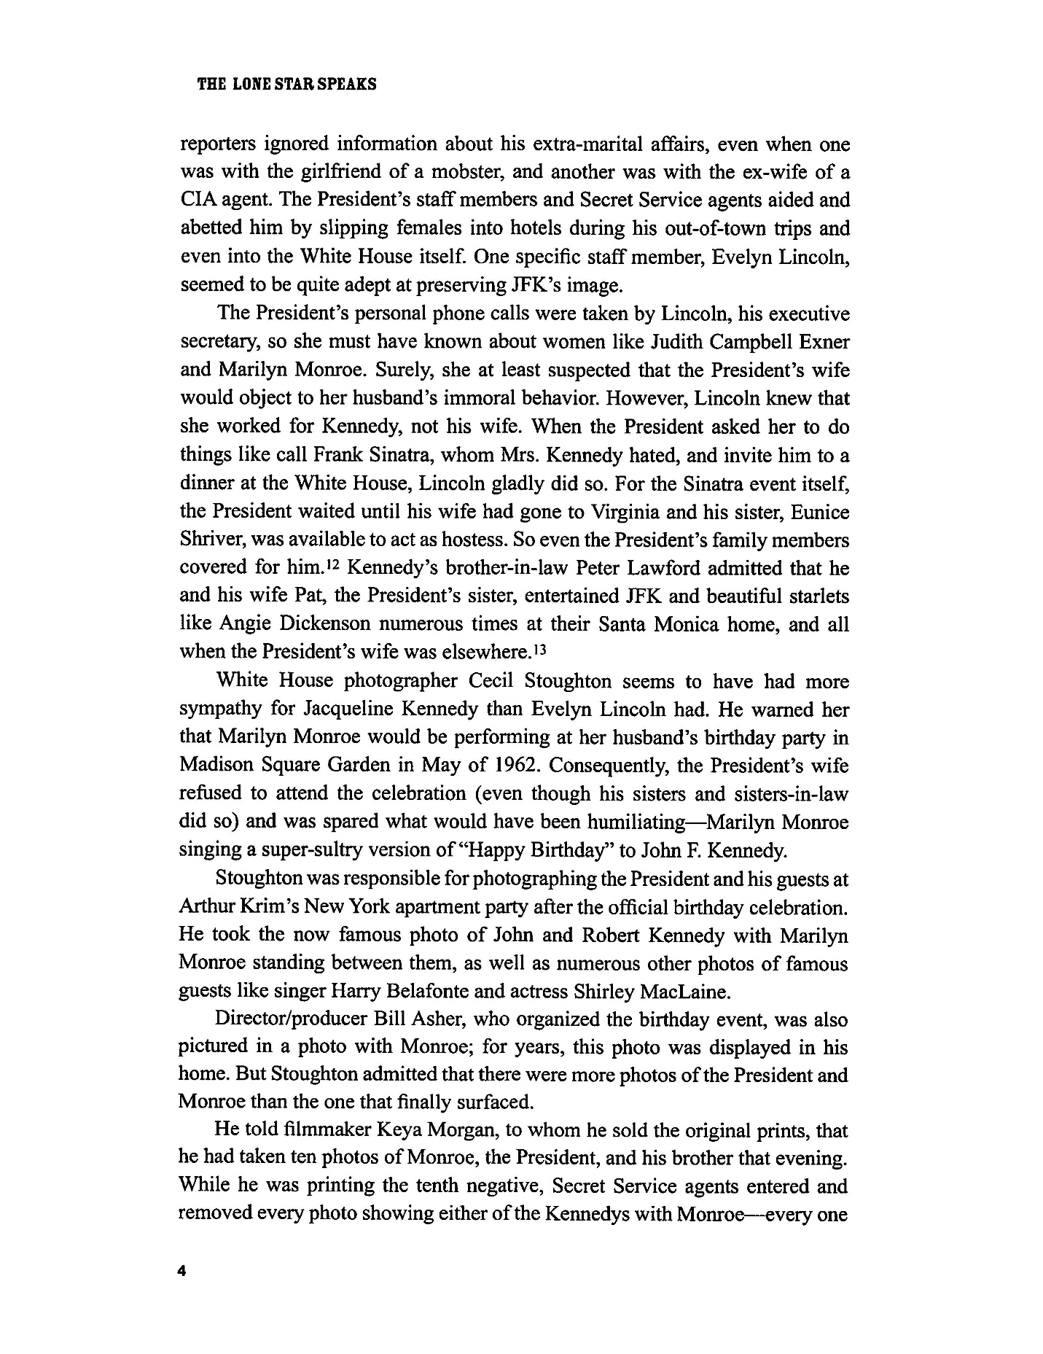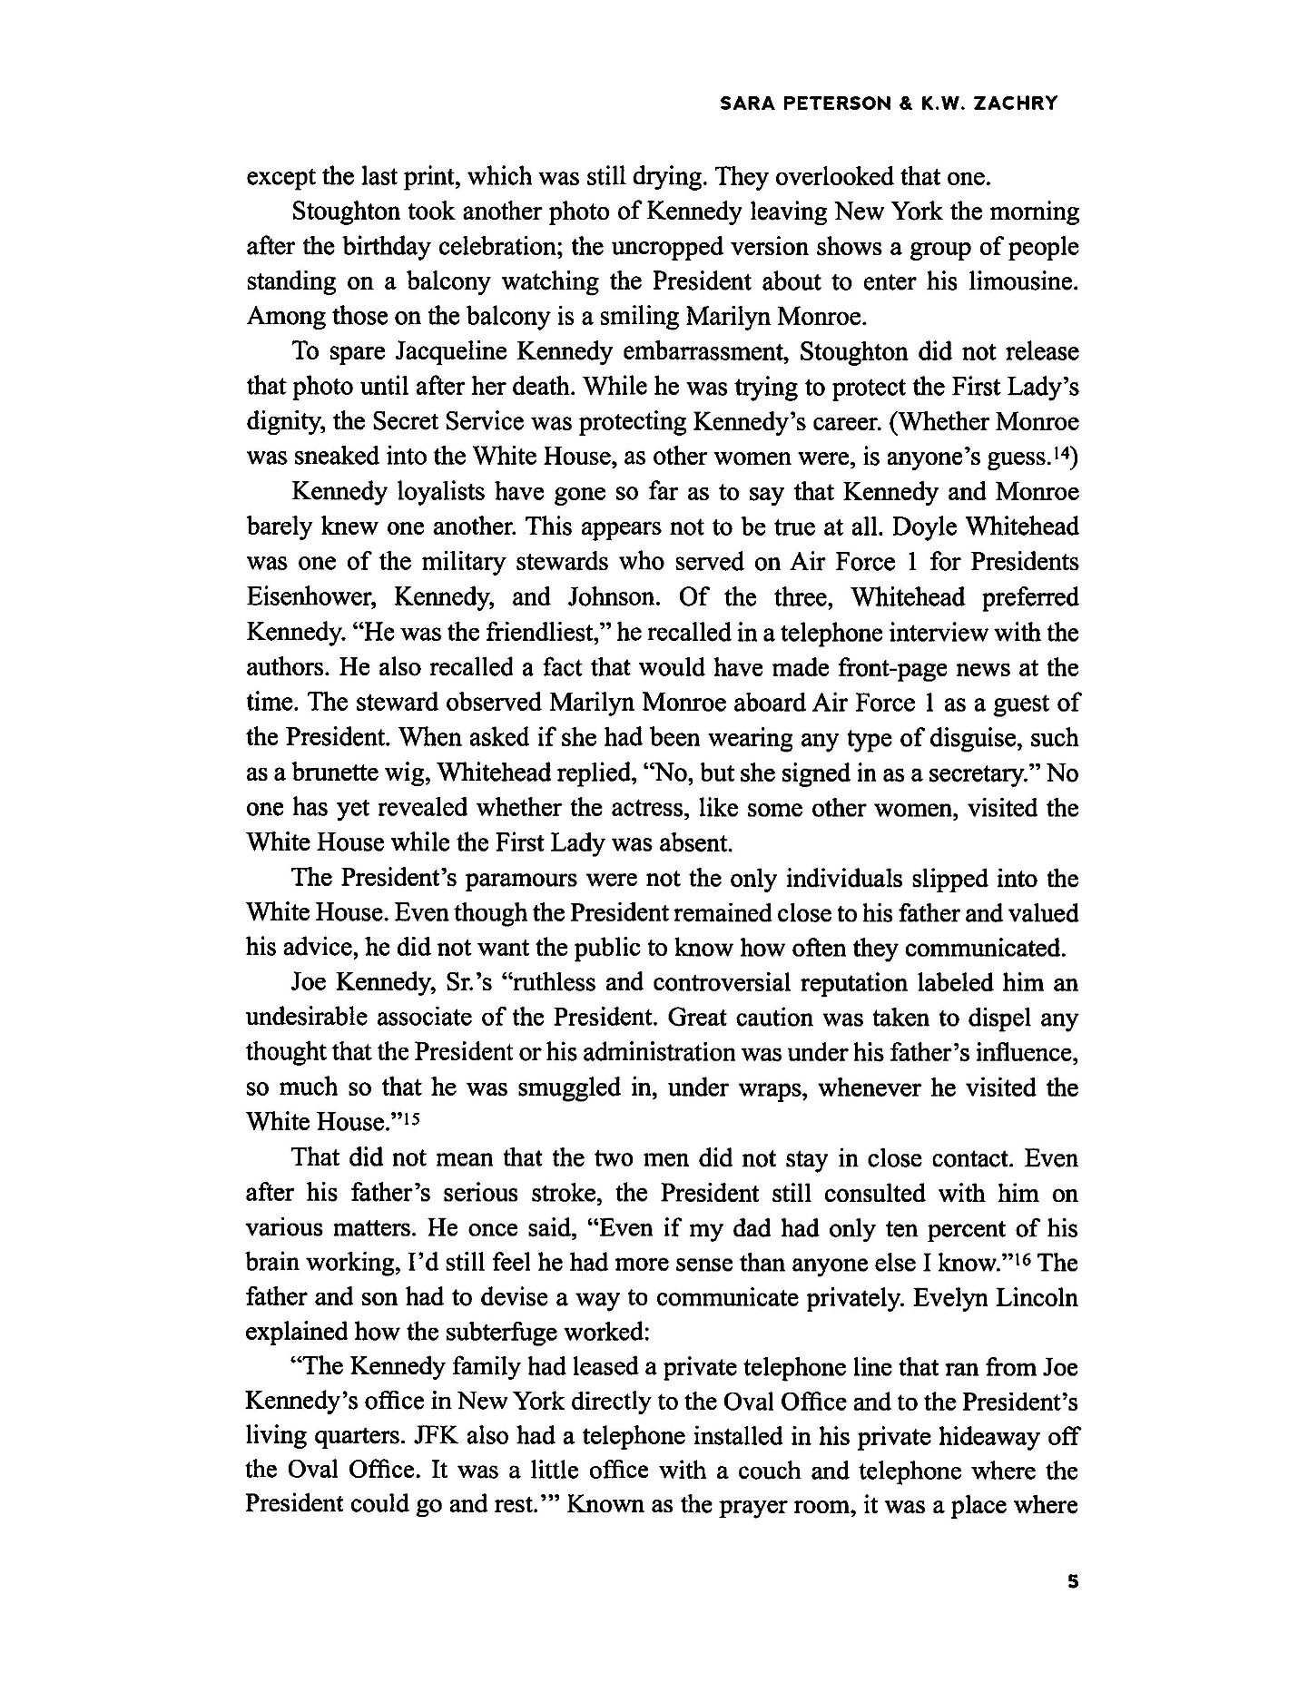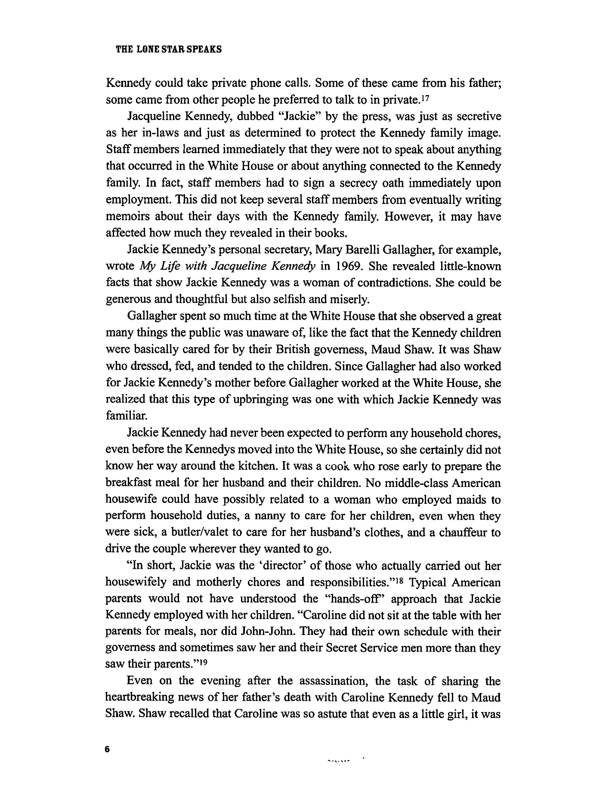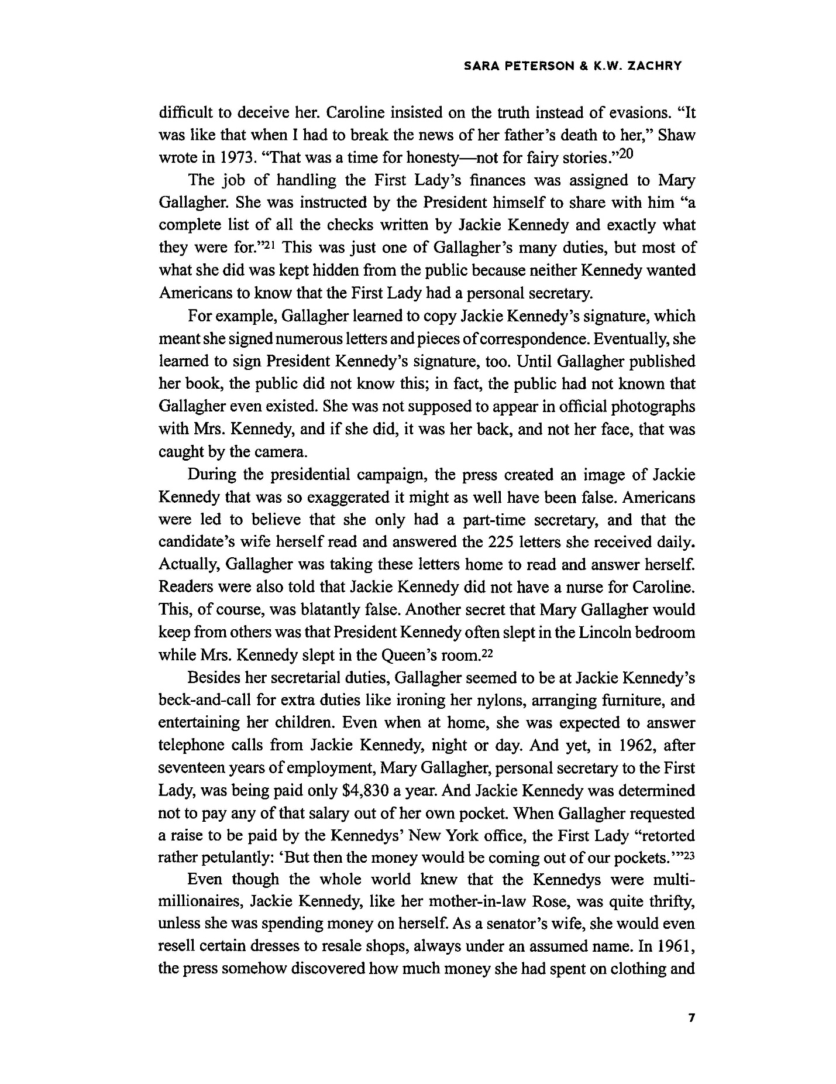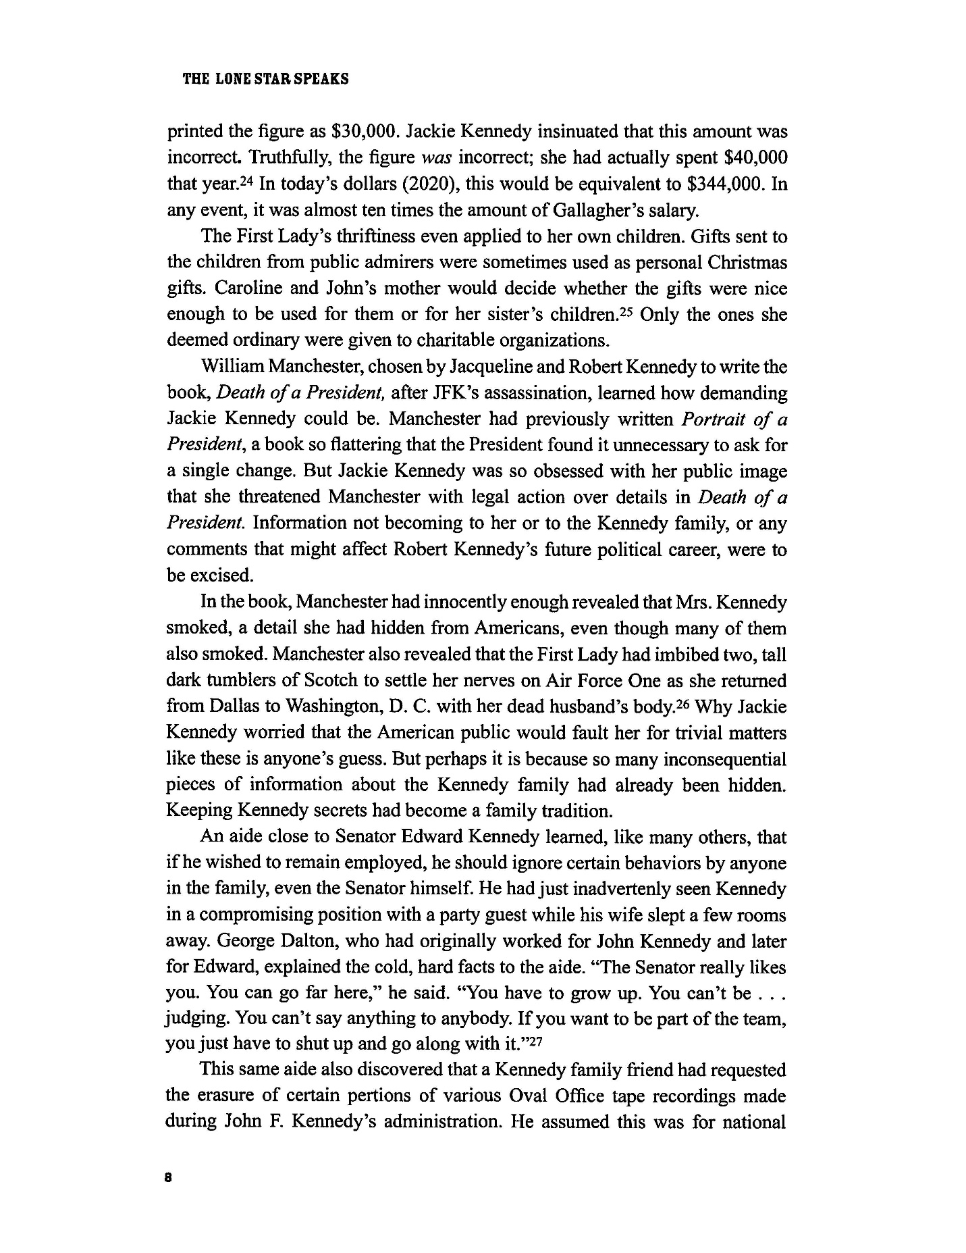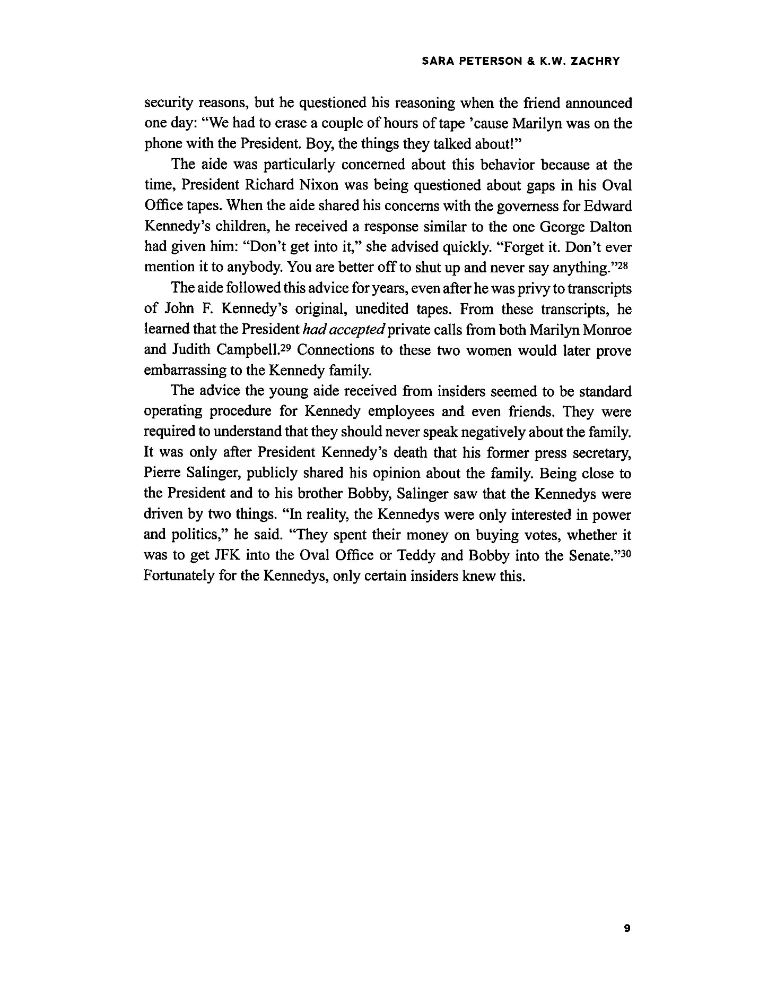
About the Authors
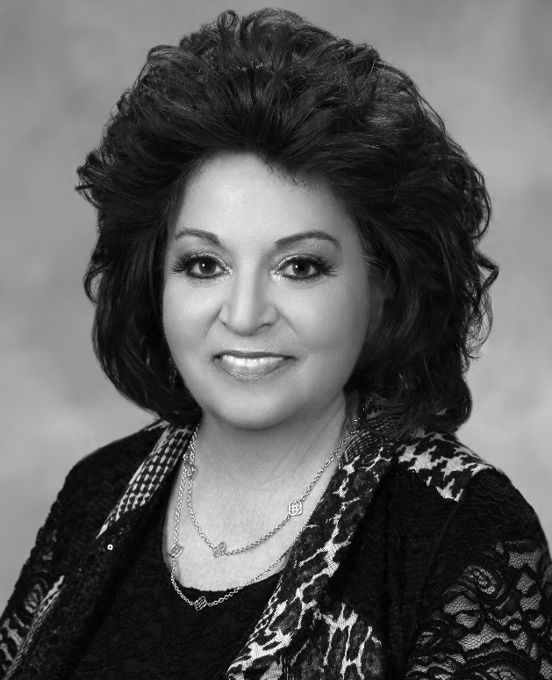
Sara Peterson attended the University of La Verne in California, where she earned a Bachelor’s of Arts Degree in Political Science and in History. After being told by her Political Science Department Chair that she could not do her senior thesis on the Kennedy assassination, she went ahead anyway, focusing on those planning, carrying out, and covering up Kennedy’s murder. Among the most powerful, she decided, was Lyndon Baines Johnson, a former Texan senator and then U.S. Vice-President. Since then, she has continued her research on the assassination and why the Warren Report’s “evidence” is, in her view, inaccurate, incomplete, and in some cases manufactured. She is currently employed at Midland College in Texas as the Coordinator of the Developmental Education Language Lab and Writing Center.
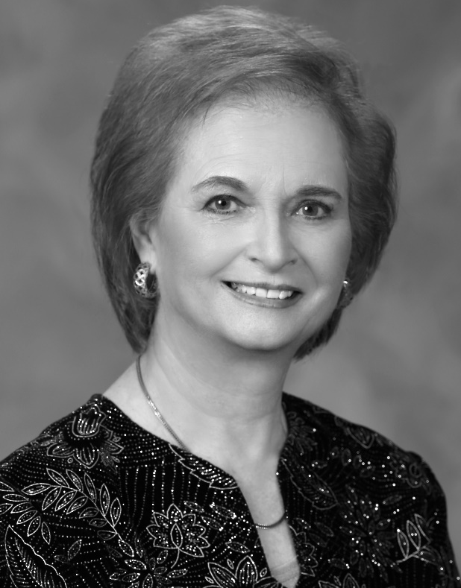
K. W. Zachry earned a Bachelor of Science in English and Political Science from McMurry College and a Master of Arts in English from the University of Texas at El Paso. Her interest in the Kennedy assassination began when her grandparents, who lived in Dallas on 11/22/63, shared with her all of the local newspapers from the assassination. Ever since, she has been reading, researching, and “digging for bits and pieces” from people with first-hand information about the events surrounding the president's murder. By combining information and sources with Sara Peterson, she discovered that many uninterviewed Texans possessed information about the greatest mystery of the twentieth century. She is currently employed at Midland College in Texas as a tutor in the Developmental Education Language Lab and Writing Center.

