Outpedaling the Big C:
My Healing Cycle Across America

"What a journey—a transcontinental chronicle from a writer who is truly, fully alive!"
—Bill McKibben, considered the most effective environmental activist and writer of our time

“The Pulitzer winner interweaves a cross-country cycling travelogue with an account of growing up with her late father. A keen and poignant celebration of being alive.”
—Kirkus Reviews

Author
Elizabeth McGowan
Washington, DC
ehmcgowan@gmail.com
(240) 271-3387 (cell)
(www.renewalnews.org),
Twitter (@ehmcgowanNEWS)
LinkedIn (https://www.linkedin.com/in/elizabethmcgowanreporter

Publisher
Bruce L. Bortz
Bancroft Press (one of the top ten independent book publishers in America since 1991)
PO Box 65360
Baltimore, MD 21209
410-358-0658
410-627-0608 (cell)
bruceb@bancroftpress.com
www.bancroftpress.com

Publicist
Brandon M. Stickney
brandonstickney5@gmail.com
727-942-8618

Title Info
Title/Subtitle: Outpedaling the Big C: My Healing Cycle Across America
Hardcover: 978-1-61088-514-0
Ebook: 978-1-61088-516-4
Length: 268 pages
Photo Insert: 32 pages
Pub Date: September 1, 2020
$28.95

Distributor
Baker & Taylor Publisher Services (the premier worldwide distributor of books, digital content, and entertainment products from approximately 25,000 suppliers to over 20,000 customers in 120 countries): 30 Amberwood Parkway Ashland, OH 44805.

Publisher Info
- Been a top-ten indie since its start in 1992
- Publishes 4-6 books a year
- Distributed nationally by Baker & Taylor Publisher Services
- Frontlist and backlist titles represented in Hollywood by APA (Agency for the Performing Arts)
- Publishes almost all types of books, from memoirs to mysteries, young adult novels to history and biography
- Bancroft books have received numerous starred reviews—four, in fact, for two 2018 summer books—and have won numerous awards
- The Missing Kennedy, a NYT ebook bestseller, was on the cover of People Magazine when published in 2015
- Recent mystery (Her Kind of Case) received star reviews from all but one of trade review publications
- Published the books of two Pulitzer Prize winners (Alice Steinbach, Stephen Hunter, and Elizabeth McGowan)
Overview
“Proceed as the way opens” is how William Least Heat-Moon put it in his book, River Horse. The line becomes a sort of mantra for Pulitzer Prize-winner Elizabeth McGowan, a melanoma survivor. Having been given a five-year clean bill of health, McGowan decides to bicycle all 4,000 or so miles from America’s west to east coast.
For her, there are multiple reasons for the exhausting trip. She wants to help other melanoma victims, and sets out to use her many miles to raise funds for cancer research in southeastern Wisconsin, where she was treated.
She also wants to better understand her late father, who died of melanoma at the age of 44, when Elizabeth was just fifteen.
She rides through small towns and places that she visited as a kid with her dad, mom, and siblings. Her long, nearly 90-day cycling trip across the U.S. continent not only showcases people affected by cancer and more than willing to help promote cancer research, but it personally brings McGowan closer to her father. Recalling him at different places and times during his short life, she begins to realize that she owes directly to him the ease with which she meets people across her long transcontinental route. She comes to see that, like her father, she is funny, and has the dedication and resilience needed to take on and complete major projects.
At the end of her bicycle ride, McGowan’s mother shows her, for the first time, letters about her father received after his untimely death. They open her eyes to the fact that she, too, can move through life with gusto whenever she makes sure that “the way opens.”
Outpedaling the Big C is an anything-but-typical, exhilarating journey story revealing how immersion in the natural world is a balm for the wounded.

One Sentence Description
Cancer survivor (and Pulitzer Prize winner) takes cross-country cycle ride in gratitude for her cancer-free condition, to raise money for melanoma research, and to better understand her father, who died young of melanoma.

Brief Synopsis

After a five year clean bill of health, Elizabeth McGowan adventures out on a solo cycle tour of America, from coast to coast, in hopes of promoting a fundraiser for cancer research in southeastern Wisconsin. McGowan suffered a ten-year bout with melanoma, the same cancer that killed her father, Ron McGowan, when he was just 44 and she was fifteen.
- Starting in Astoria, Oregon, McGowan begins a wonderful journey where she realizes just how many communities have been affected by cancer and are willing to help her. Each time she stops along the way, she learns something about the different cities or about her family.
- Throughout her trans-continental journey, McGowan is reminded of spots she visited as a child with her father. She seems to enjoy reminiscing about times when her father was sweet and funny. The memories she shares of her father at her various childhood homes are much different. The bicycle tour helps her comes to understand why her father was such an angry and frustrating man when she was a kid. The terror of knowing that melanoma is taking over your body becomes a thought process that she shares with him. That understanding gives her the ability to think differently about why he was always so irritable. She comes to gain the realization that he wanted what was best for everyone in his family and that he would be proud of her today.
- The story is incredibly motivating and McGowan does a wonderful job taking her readers through America and her family history.

Audiences for Outpedaling the Big C

- Adventurers
- gives people with an itch for dangerous and exhilarating hobbies more reason to keep moving
- possibly gives people a desire to adventure and promote different research programs, hopefully ones that support cancer solutions
- https://firstdescents.org (Organization for survivors to heal through adventure)
- Those Who Need Motivation
- provides one with a strong urge to act and do something that they have always wanted to do because you never know what could happen to you
- may motivate some who feel confused or lost or just need more drive
- https://patch.com/us/across-america/epic-bike-ride-supports-cancer-research-through-v-foundation
- Female cancer survivors and those close to them
- provides survivors with someone who can empathize with them
- gives them hope and shows them ways to survive and thrive
- those close to them can see ways that they can help promote their loved one
- those close to them can get a better understanding of what is going on in their loved one’s head and how they can comfort them
- First Descents Org. could be used for this too
- Medical Professionals
- shows them what their clients are going through and what might be helpful in supporting their clientele
- may help them grow a stronger community within their office
- https://www.skincancer.org/about-us
- Those Who Need Closure For An Incomplete Relationship With A Parent
- gives ways that one could find out how their parents may have/do feel
- provides information on how you may be thinking thoughts that your parents did/are
- may inspire some to rekindle relationships with their parents
- Travelers
great way to show people who like to visit places a new alternative
- also gives travelers with money a way to donate to communities while taking trips
- https://www.travelandleisure.com/blogs/travel-for-a-cause-packages-that-give-back

7) Fans of “Wild” (book and movie)
- gives them another thing to read that is in the same vein
- hopefully fans would help promote it enough to become a best seller and/or movie

8) People from states she traveled through:
- Oregon
- Idaho
- Montana
- Wyoming
- Colorado
- Kansas
- Missouri
- Illinois
- Kentucky
- West Virginia
- Virginia

9) Environmentalists
- the book is full of information from someone familiar with different aspects of environmental care
- specifically the time she lived in the cabin and helped volunteer with Don

Praise for Outpedaling
"What a journey—a transcontinental chronicle from a writer who is truly, fully alive!"
—Bill McKibben, considered the most effective environmental activist and writer of our time

“The Pulitzer winner interweaves a cross-country cycling travelogue with an account of growing up with her late father. A keen and poignant celebration of being alive.”
—Kirkus Reviews

““McGowan takes readers through an intimate journey—across the country and through her own past—as she shares insights and lessons learned that will resonate with cancer survivors, medical professionals, and anyone who’s ever wanted to just ‘say yes’ to an adventure. Melanoma—or any cancer—changes you and the way you see the world. Outpedaling ‘the Big C’ thoroughly and entertainingly proves that all change isn’t bad.”
— Michael Kaplan, President and CEO, Melanoma Research Alliance

"A powerful, rollicking adventure that takes us across America and deep into one person's life-and-death experience."
—Carl Zimmer, New York Times science Columnist (and one of the foremost science writers in the country)

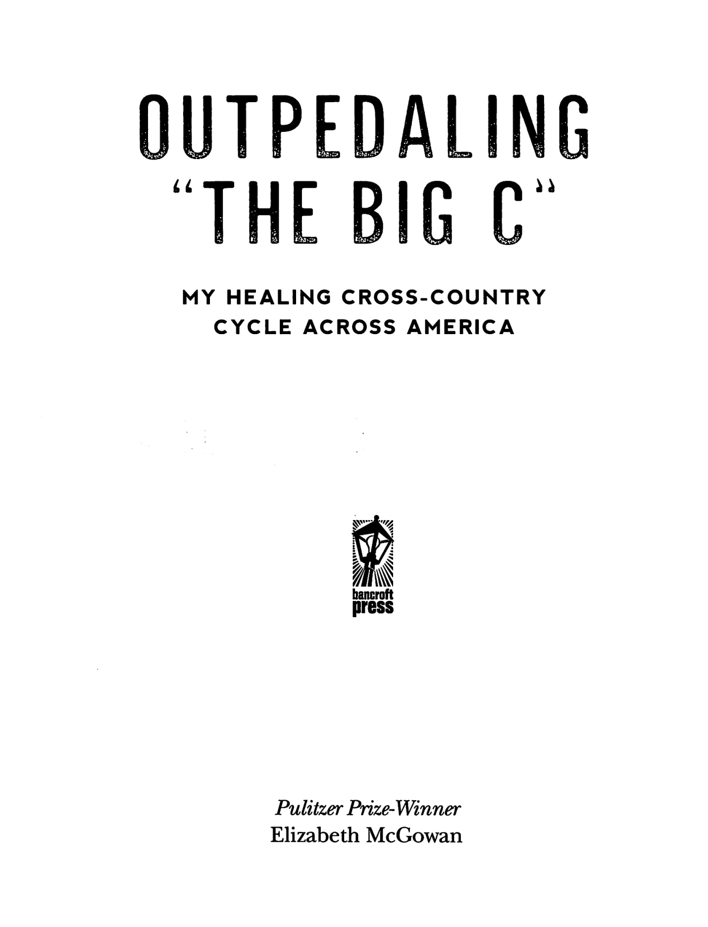
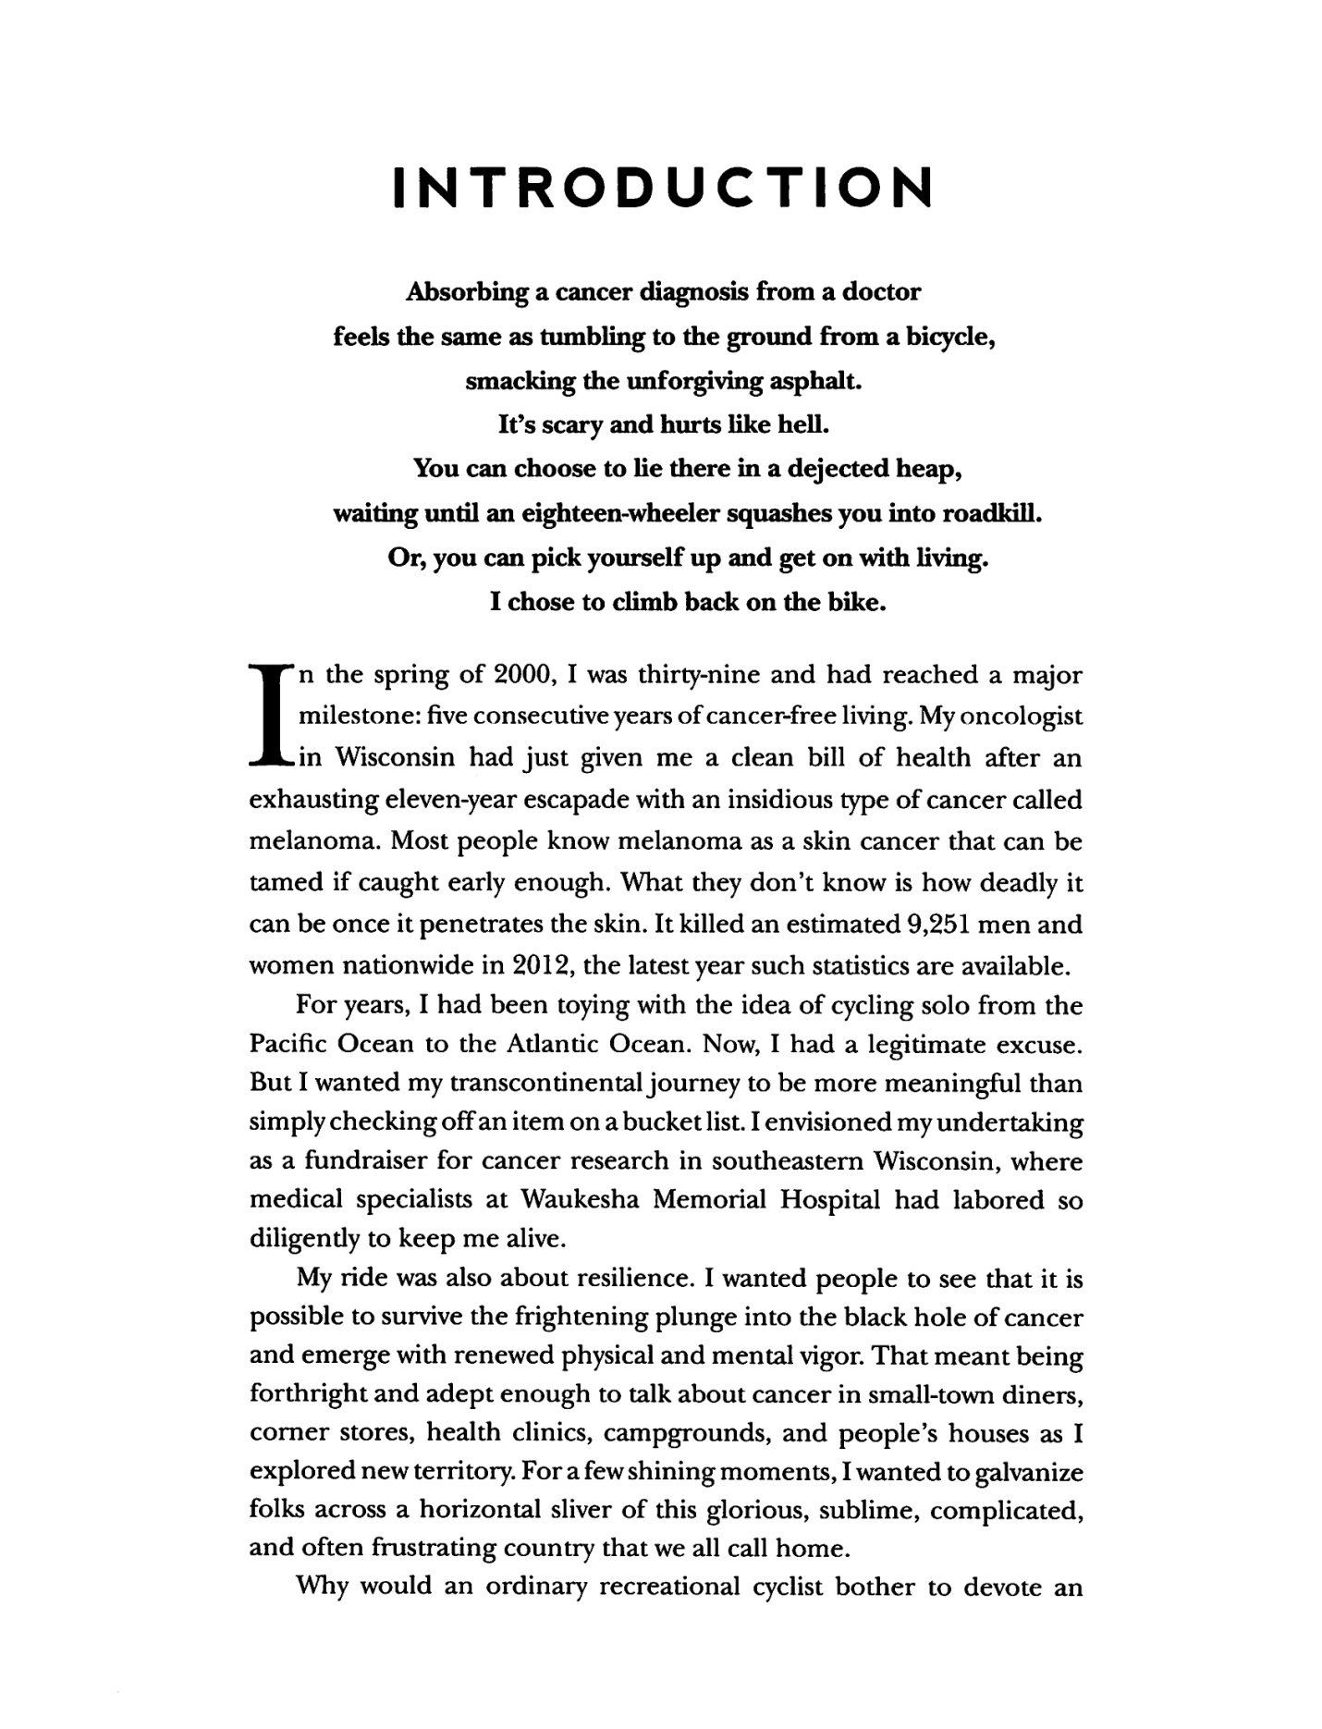

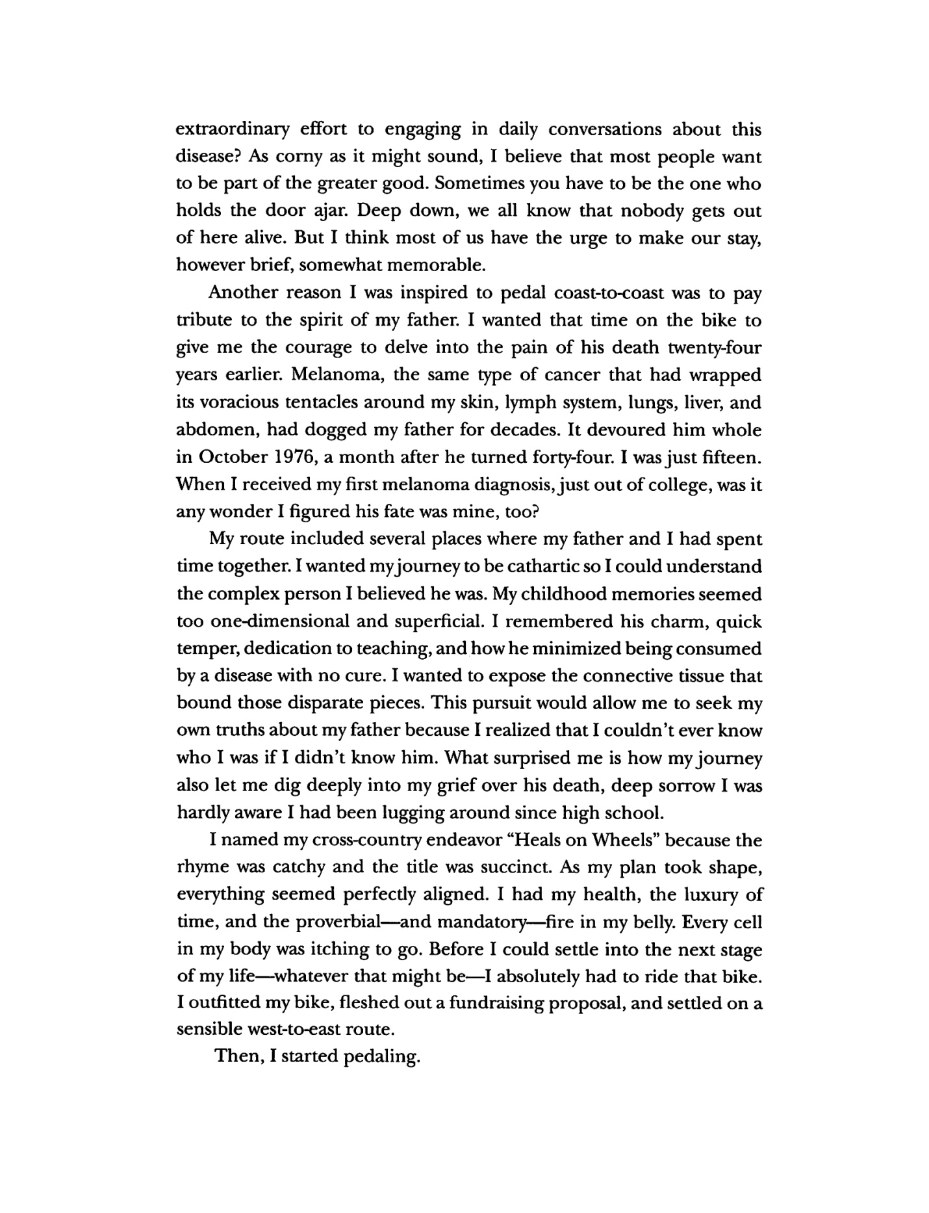
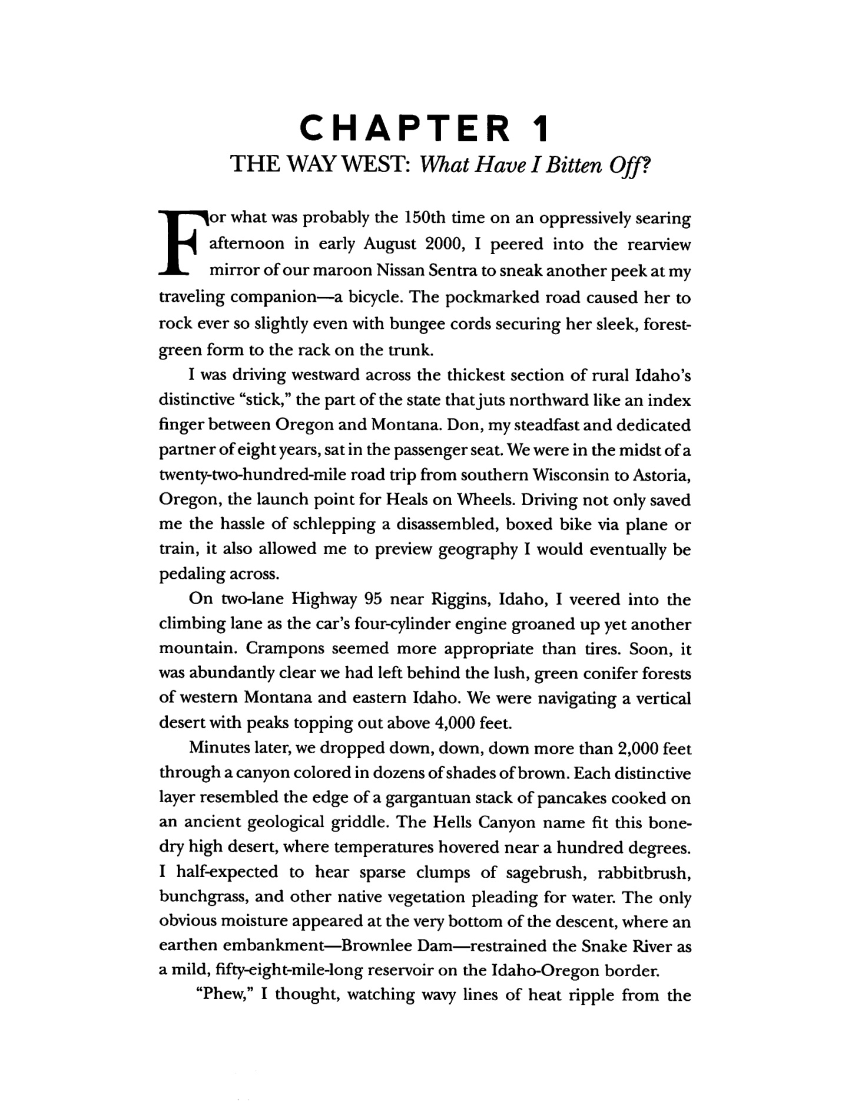
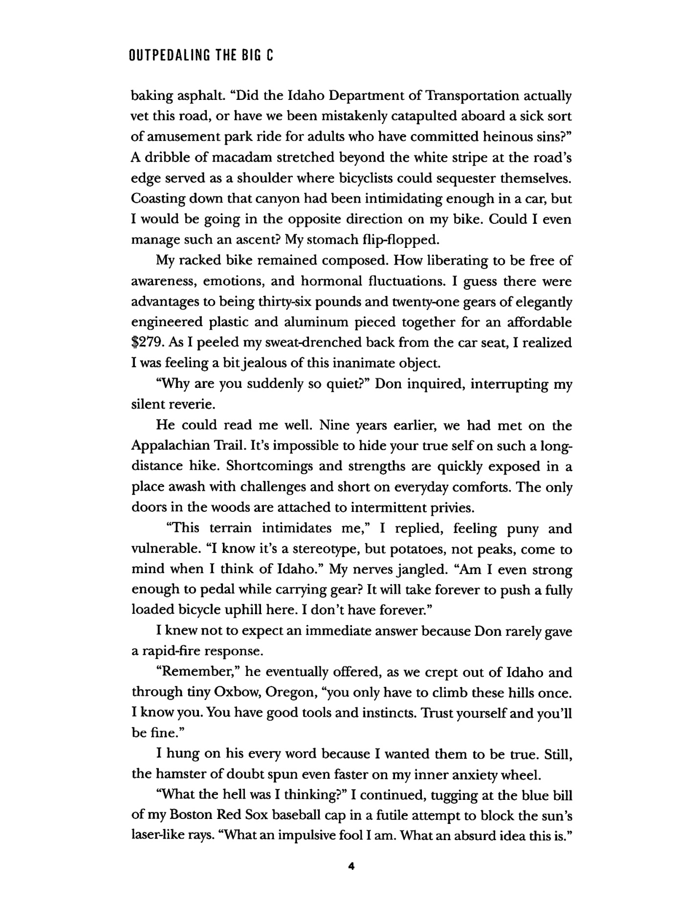
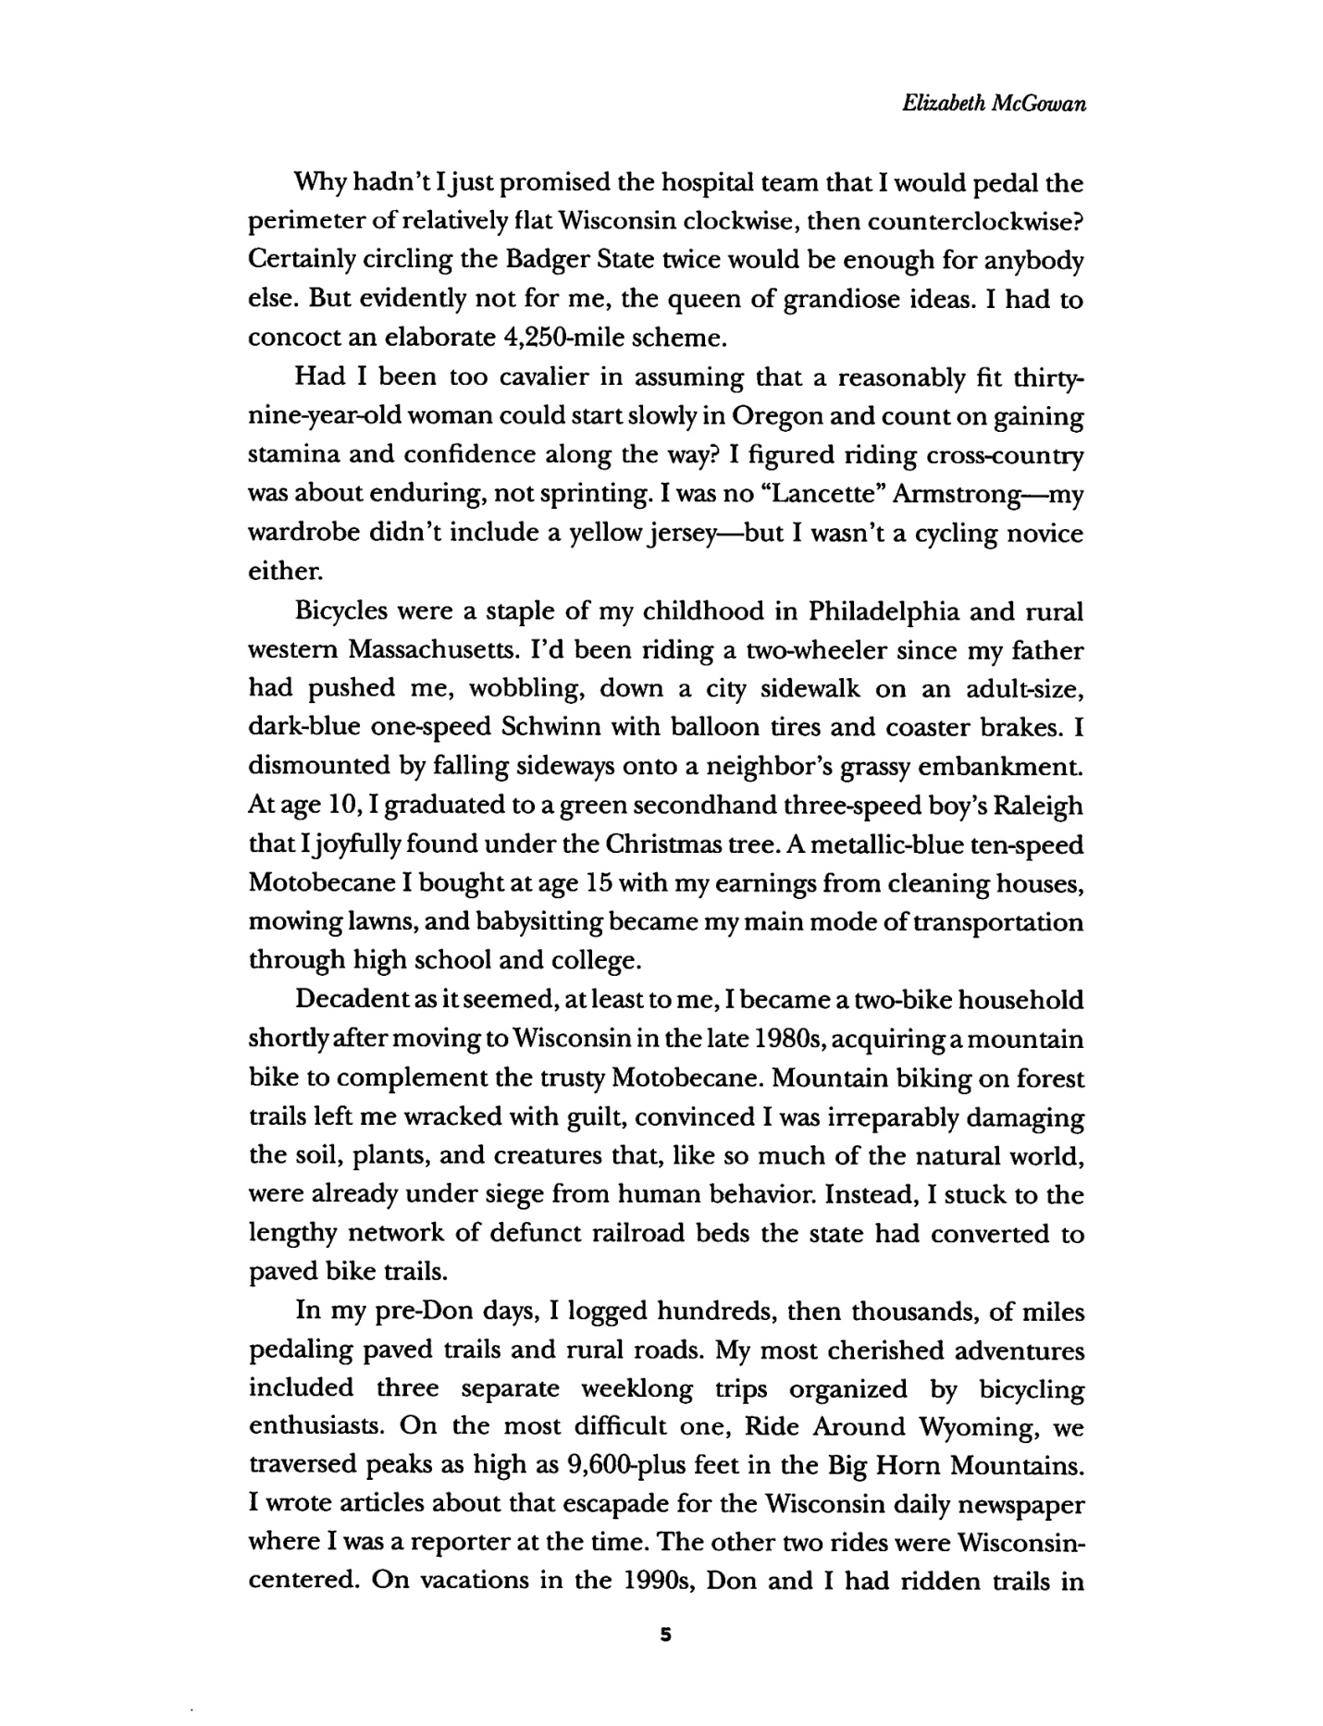
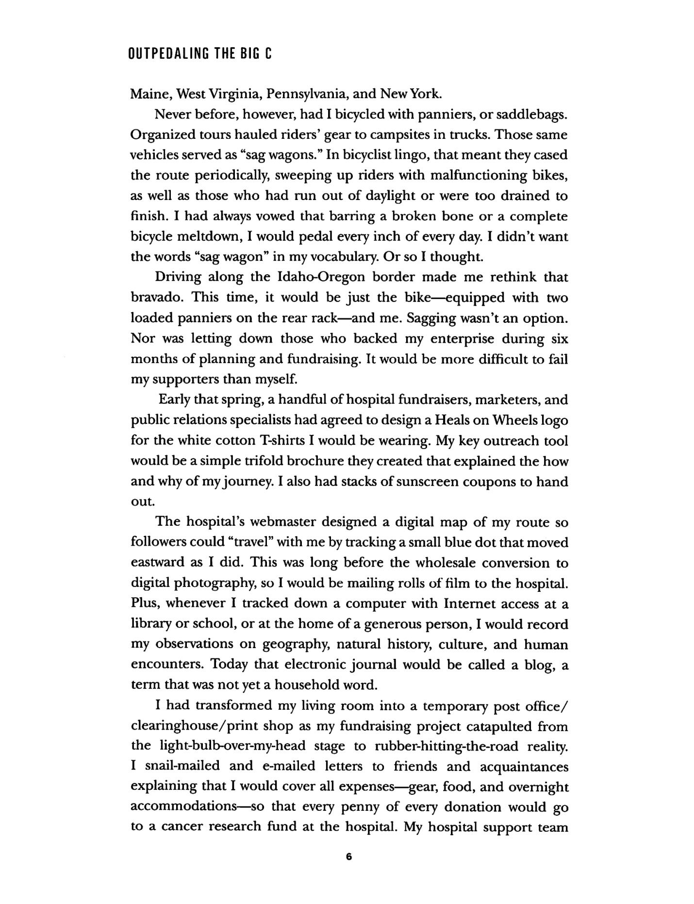
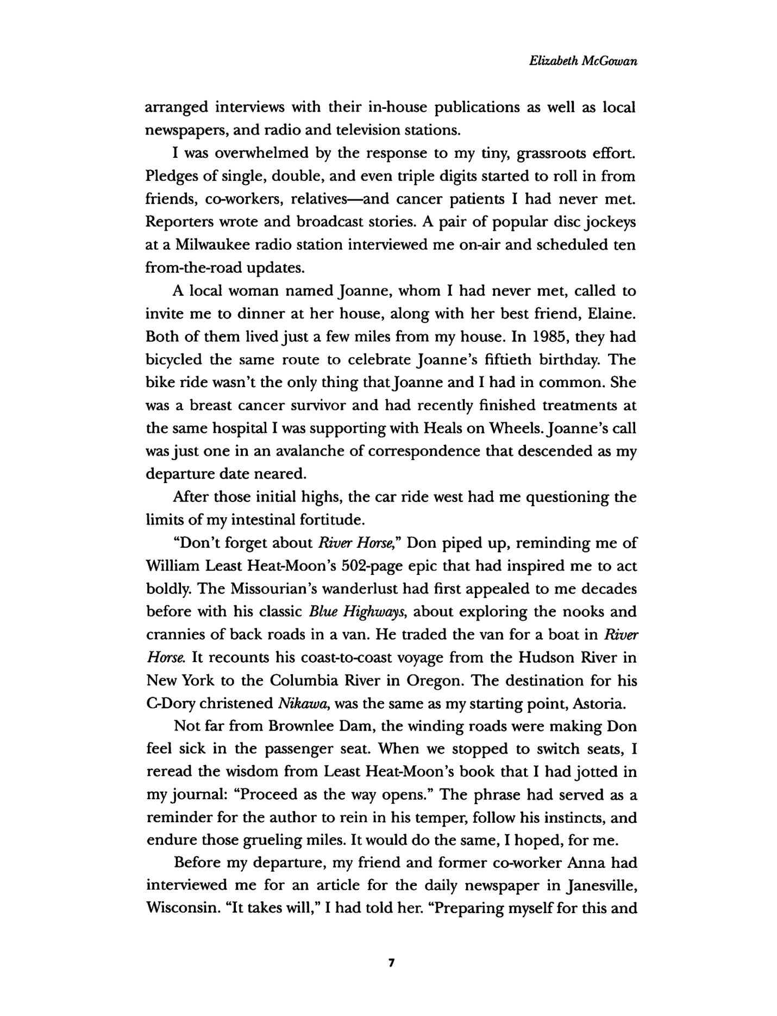

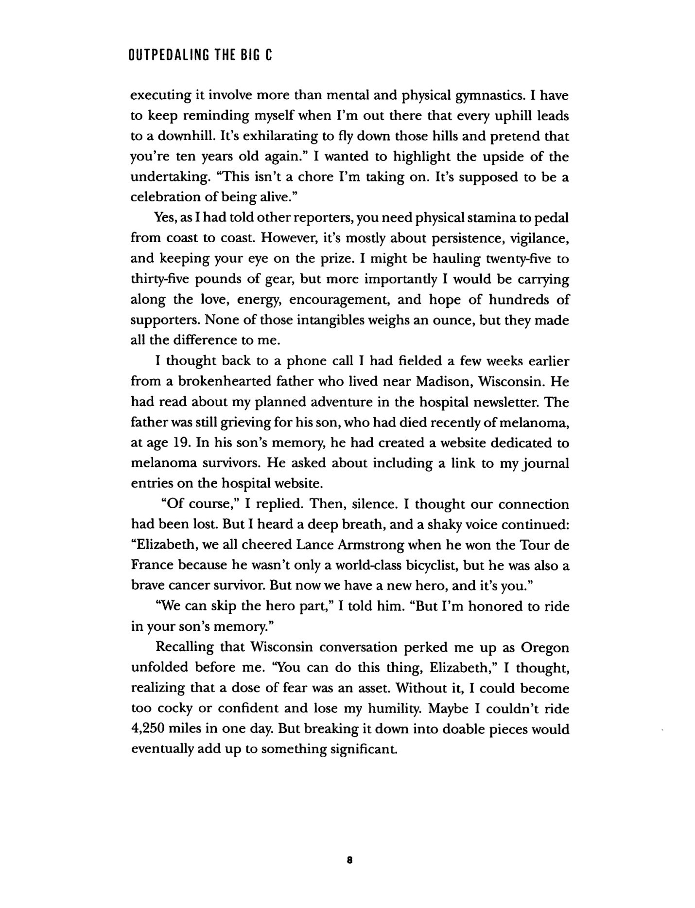
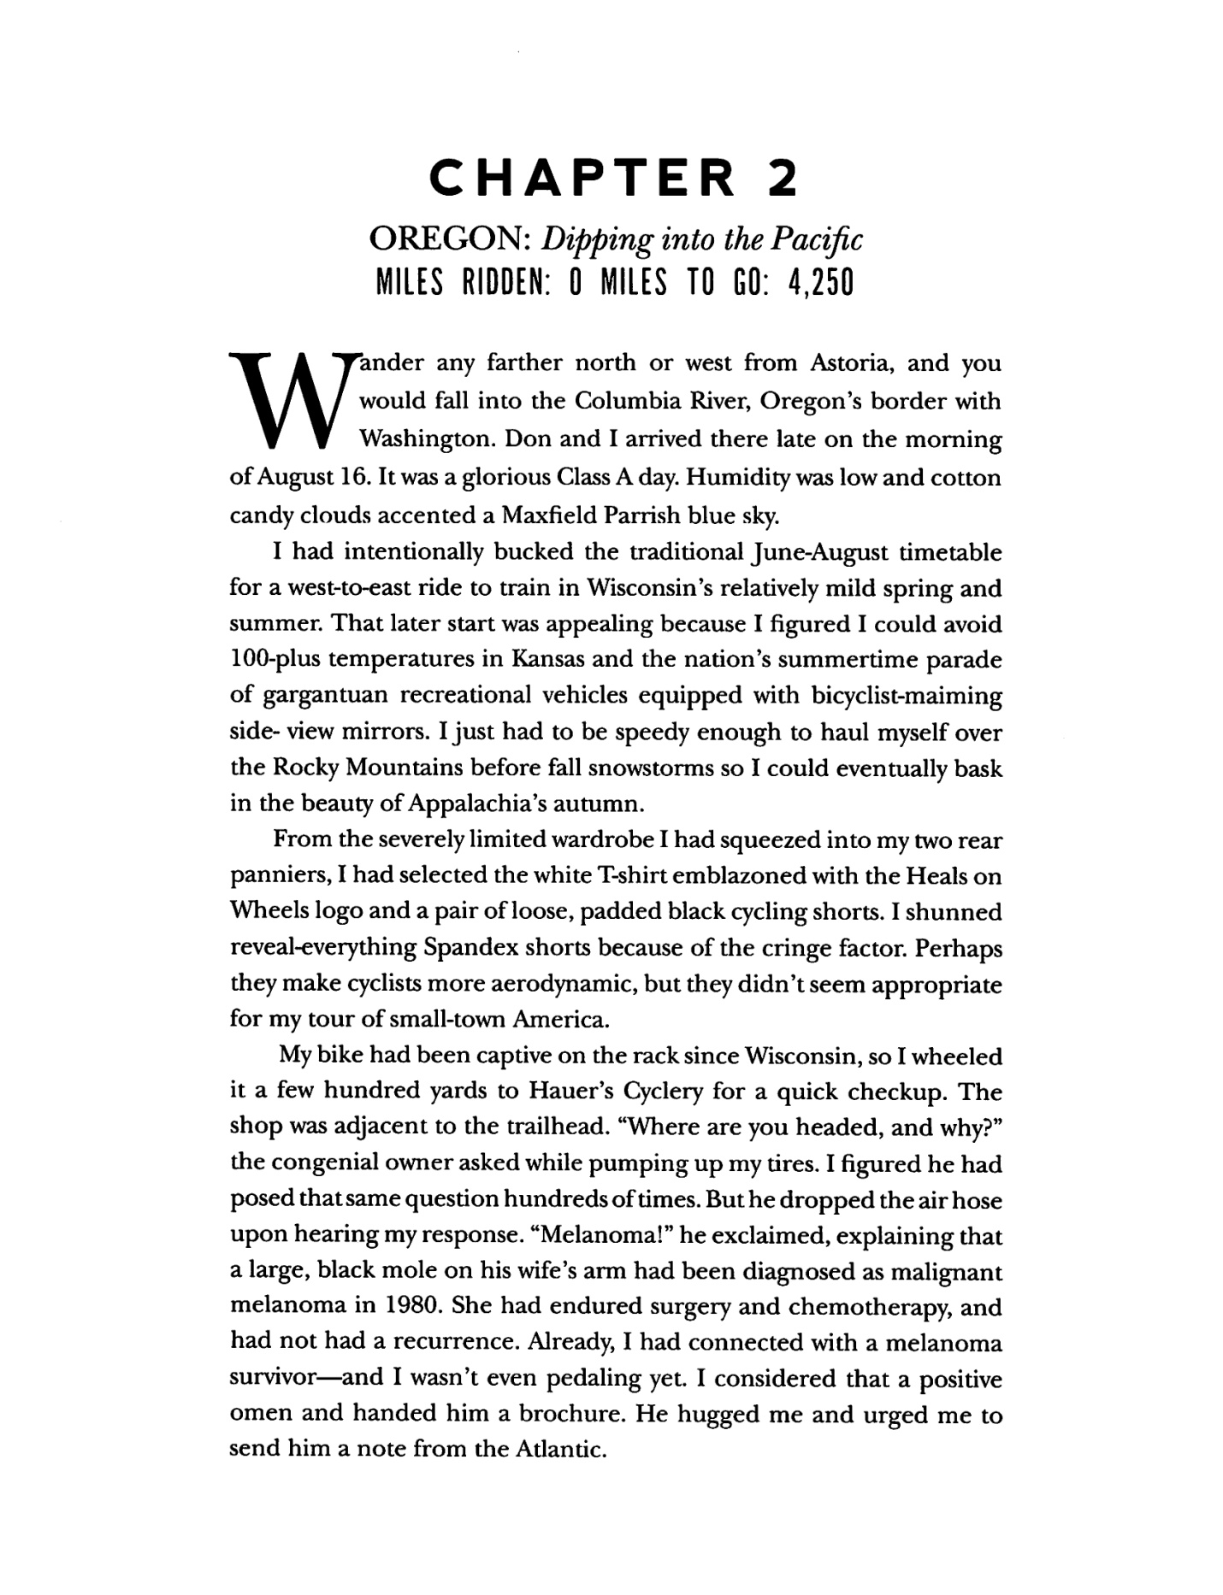
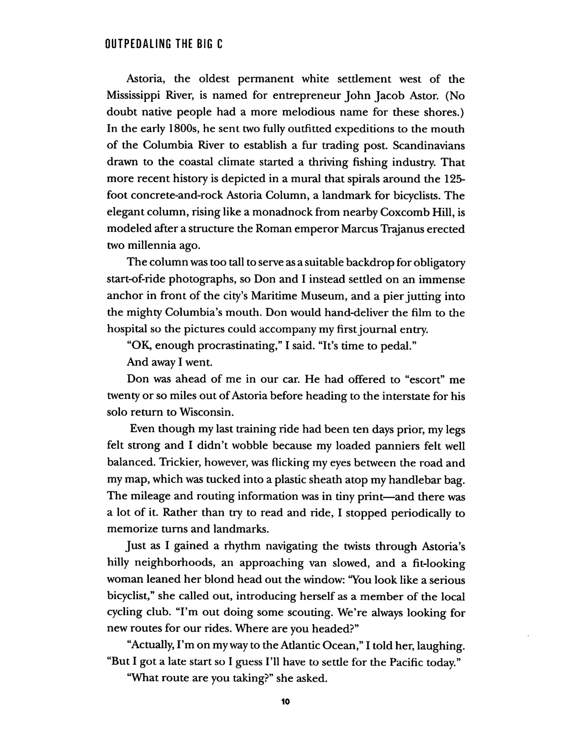
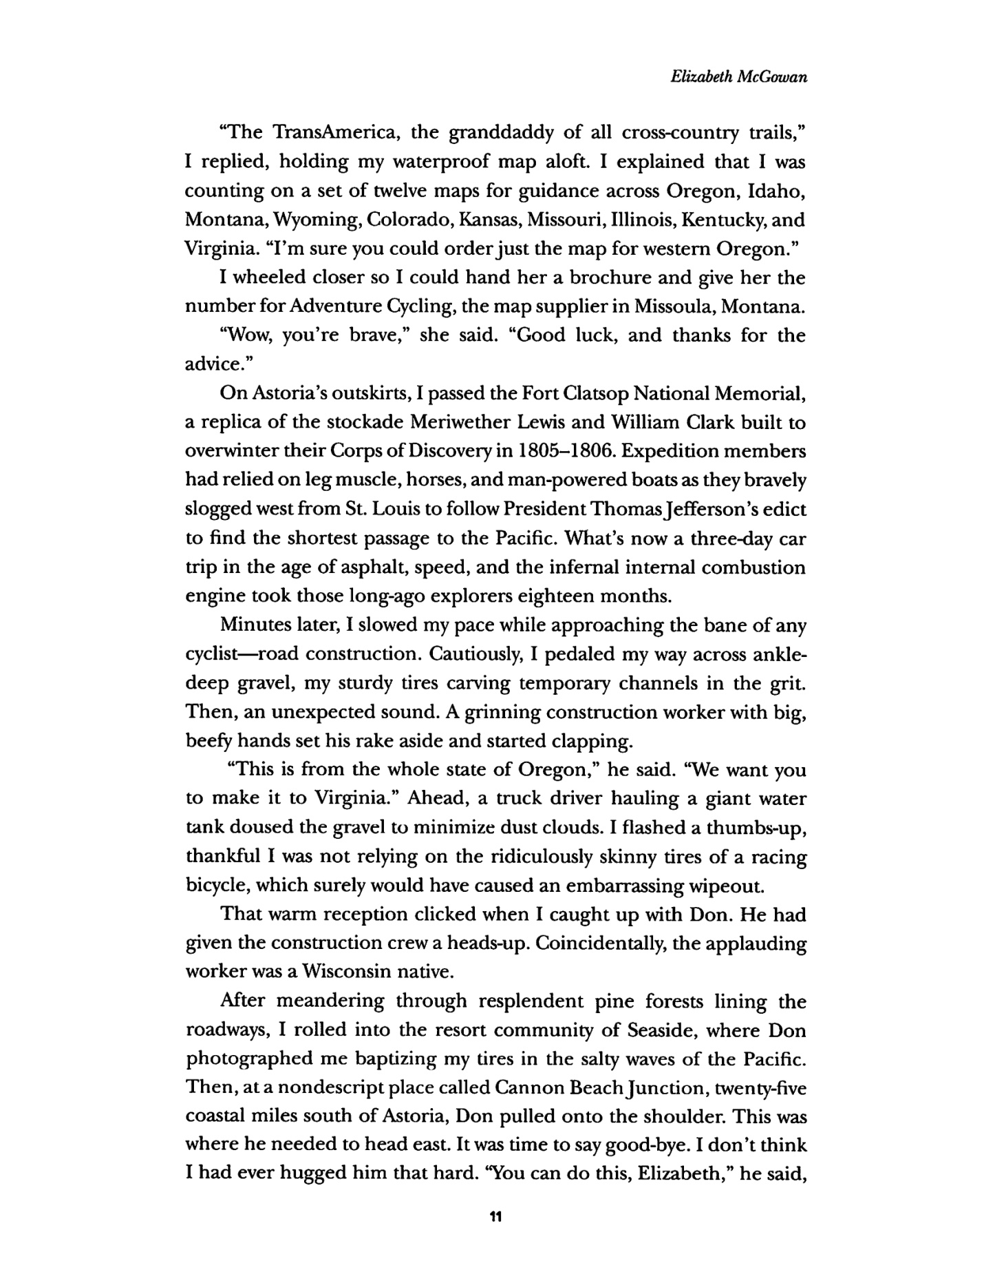

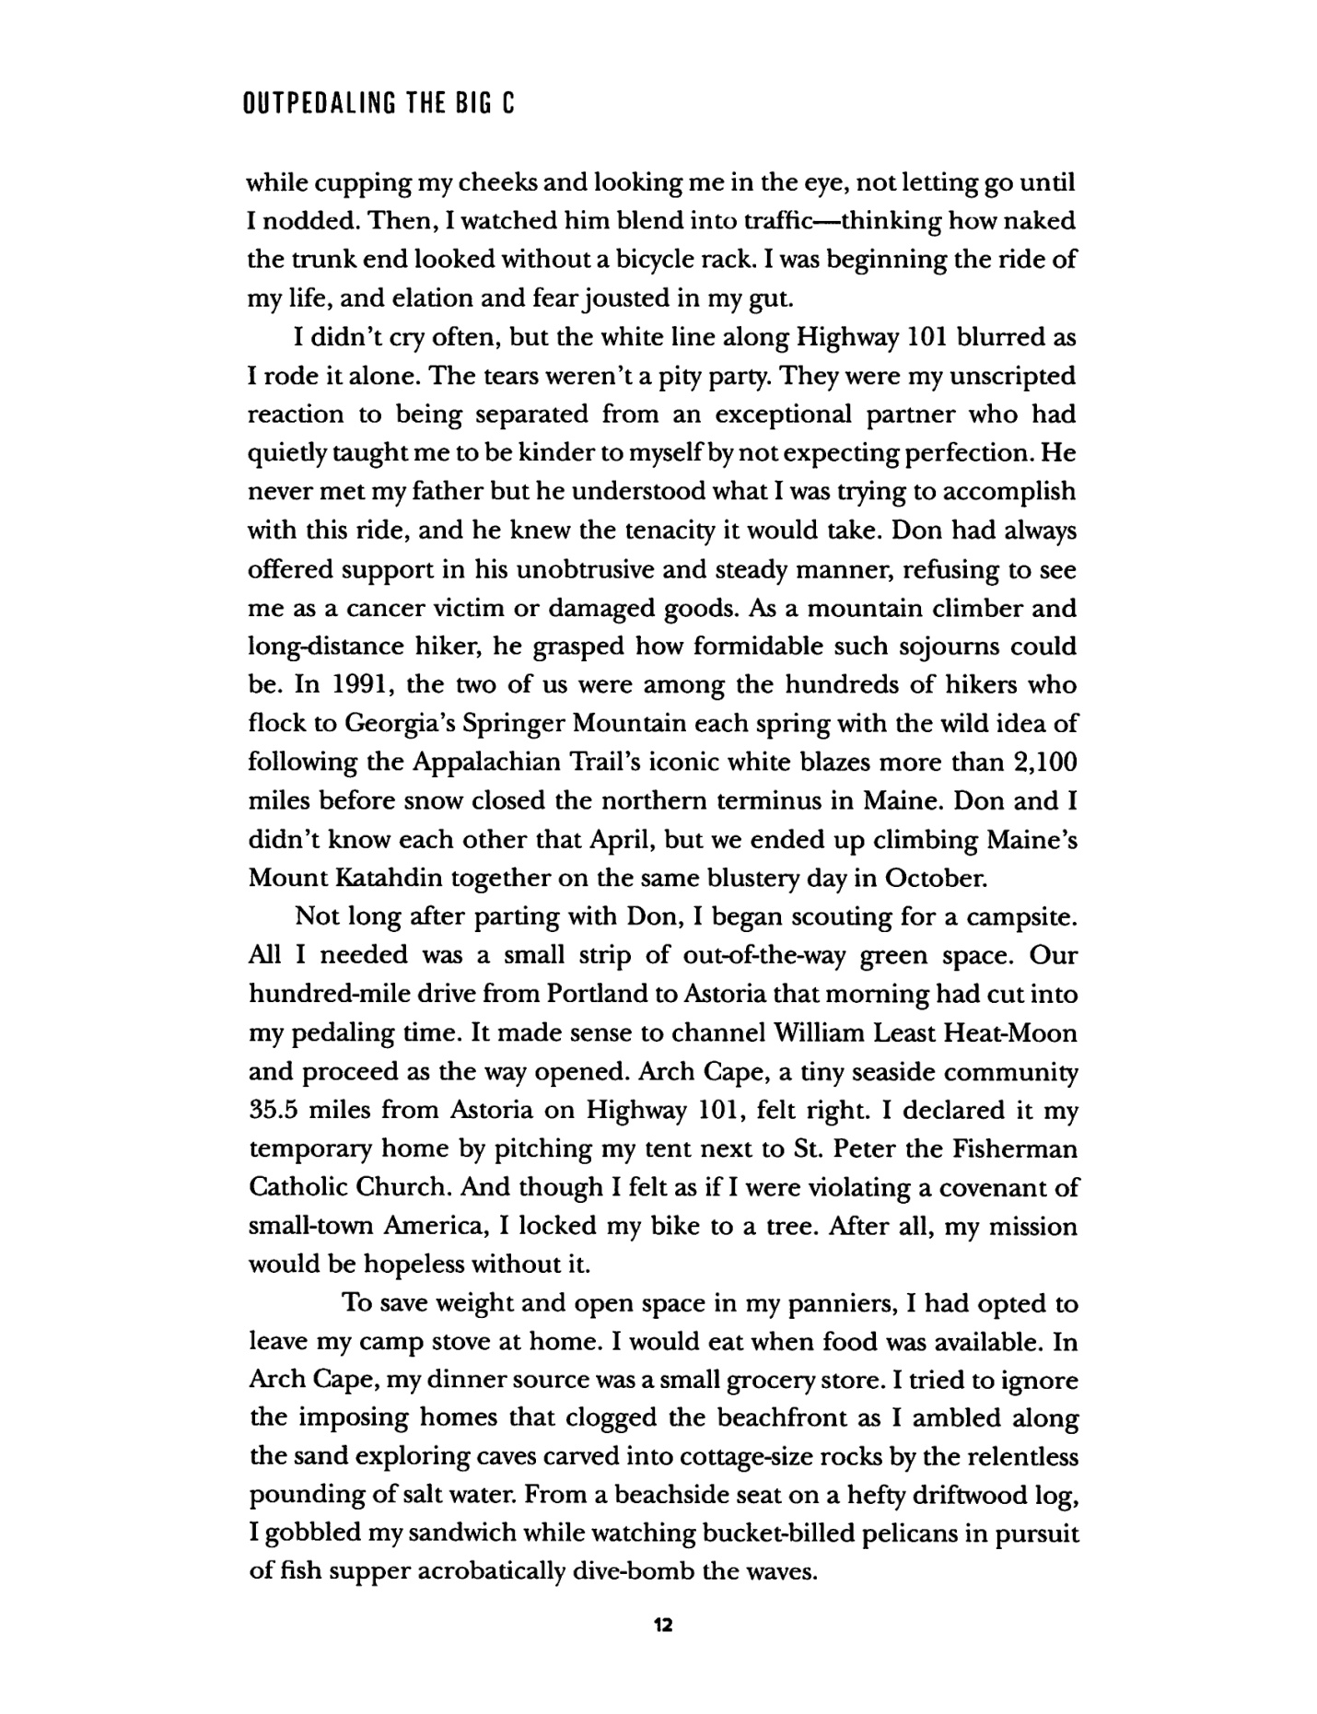
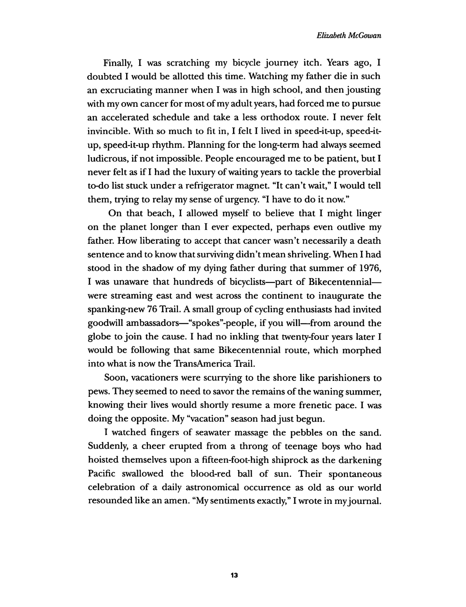

Reading Group Questions

Do you think you would be able to do a solo tour like Elizabeth McGowan?
- Throughout the book, McGowan comes to terms with her father through the bicycle tour. Do you think you would ever go on an adventure in the hopes of healing?
- Did the book help you discover ways to think about your relationship with your parents and who they are as people?
- McGowan has difficulties telling her mother about her diagnosis several times throughout the book. Do you think you, too, would find that a hard thing to talk about? Would you have spoken to your parent(s) sooner?
- Did the book make you consider moments of your own past that you never really thought about?
- Did the book encourage you to help promote cancer research? Did you learn more about the journey of a cancer victim than you already knew?
- If you are a victim/survivor, did the book feel comforting and relatable? Do you feel less alone after reading it, knowing that someone else has been through something similar?
- If you were diagnosed with several melanoma bouts like McGowan, would you have done as much research as she did or made the decisions she did? Or would you have trusted your doctors’ advice?
- McGowan has an easy time meeting and talking to people along the tour. Do you think you would have been able to do the same?
- In the book, McGowan refers to a memory of when her father let her bring his sword to school for “show and tell.” Do you have any similar memories of your parents?
- Have you ever gone on a long trip climbing or bicycling? Did it help you heal in some way like McGowan? Did you learn anything from the adventure?
- McGowan discovers a love for baseball when she is a kid living in Massachusetts. The hobby brings her closer to her father. Are there any hobbies that you share with your parent(s)?
- After reading the book, do you feel encouraged to be more conscious of your skin care? Will you go in for skin checks and wear sunscreen more often?
- After reading the book, would you be interested in seeing it as a film? Do you think that the book would be successful in that medium?
- Elizabeth McGowan hopes that sharing her story helps survivors, victims, and their families feel less alone/have a better understanding of what they went through. If you or someone in your family was diagnosed with cancer, would you recommend they read this book?
- Ron McGowan and his daughter keep pushing through life and stay dedicated to their professions while suffering from bouts of melanoma. Do you think that you would be able to keep pushing through as they did?
- Does reading the book encourage you to go on more adventures throughout your life? Do you think that you would ever consider traveling while promoting a charity?
- Elizabeth’s mother endures two family members going through melanoma. How do you think it differed for her seeing a husband and child suffer? Do you think there was a difference for her based on the separate times that her family members were treated for cancer?
- Elizabeth’s coworkers help her along the way in incredible ways, whether they were there for her to make her tell her mother about her melanoma or giving her shots when she could not stomach doing so. Would you ever help a coworker as they did?
- Elizabeth McGowan seems to always have had a drive to help nature and go on outside adventures that most people would not consider. Do you have a drive for outdoor activities? Do you ever have a drive to go on an adventure as big as the ones McGowan has gone on?

About Outpedaling Author Elizabeth McGowan
Elizabeth McGowan was born in Philadelphia in 1961. She spent most of her childhood there, running around with her four sisters and tip-toeing past her often angry father, Ron McGowan, who was a gifted teacher. At such a young age, she could never have imagined where she would be years later―living with the same cancer that killed her father when she was just fifteen. She was diagnosed with melanoma in the 1980s, several times in very similar spots to her father’s.
McGowan graduated from the University of Missouri-Columbia School of Journalism with a Bachelor of Journalism degree. She started her journalism career at daily newspapers in Wisconsin and Vermont, which she worked while enduring several bouts of melanoma.
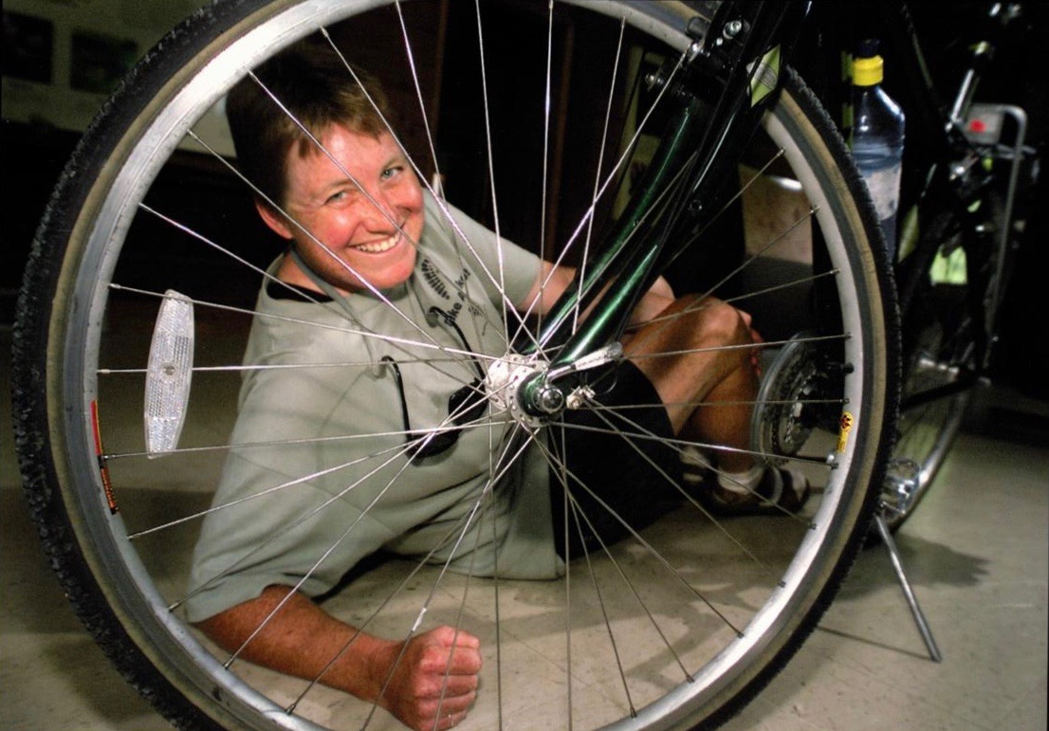
In the 1990s, she won numerous explanatory writing and reporting awards from the Wisconsin Newspaper Association, the Milwaukee Press Club, the American Heart Association, and the Wisconsin Association of School Boards while a general assignment and feature writer, first for The Janesville Gazette and then for the Racine Journal Times.
In 2007, McGowan won second place in the Cleveland Press Club’s Ohio Excellence in Journalism Awards contest in the public service/investigative category for two stories published by Crain Communications about the five-year anniversary of Sept. 11; one story focused on the compromised health of cleanup workers, and the other on the environmental complications associated with razing the Deutsche Bank building near the Twin Towers site in New York.
In 2013, she won the Pulitzer Prize for National Reporting for “The Dilbit Disaster: Inside the Biggest Oil Spill You’ve Never Heard Of.” She was the lead reporter for a three-person team at the digital news startup, InsideClimate News. The e-book version of the series won the Rachel Carson Book Award from the Society of Environmental Journalists that same year. The series, “Dilbit Disaster,” won the James Aronson Award for social justice reporting in 2013 along with an honorable mention for the John B. Oakes Award for Distinguished Environmental Reporting; it was also a finalist for the Scripps Howard Foundation Award.
Today, she is an author and a Pulitzer Prize-winning energy and environment reporter who is dedicated, savvy, endlessly curious, adept at finding sources, and able to present complicated topics in straightforward and compelling language. Her first book, Outpedaling “The Big C,” shows just how incredible a person she is―a woman with an urge to heal and discover through endless adventures. She continues to work as a freelance reporter in Washington D.C.; several of her articles can be found at https://energynews.us/author/emcgowan/ along with her own digital startup (www.renelwalnews.org), where original reporting explores the intersection of nature, labor, and energy in feature stories and investigative news pieces.
She lives in Washington, DC, with her husband Don.

