Bountiful Calling: A Novel

Author
Fred Burton
Baltimore, MD
fburton40@gmail.com
717.798.1162 (cell)
Fburton40@gmail.com SKYPE

Publisher
Bruce L. Bortz
Bancroft Press (one of the top ten independent book publishers in America since 1991)
PO Box 65360
Baltimore, MD 21209
410-358-0658
410-627-0608 (cell)
bruceb@bancroftpress.com

Title Info
Bountiful Calling: A Novel
Fred Burton
Hardcover: 978-1-61088-509-6
Ebook: 978-1-61088-511-9
Length: 256 pages
Pub Date: April 30, 2020
$26.95

Distributor
Baker & Taylor Publisher Services (the premier worldwide distributor of books, digital content, and entertainment products from approximately 25,000 suppliers to over 20,000 customers in 120 countries): 30 Amberwood Parkway Ashland, OH 44805.

Publisher Info
- Been a top-ten indie since its start in 1992
- Publishes 4-6 books a year
- Distributed nationally by Baker & Taylor Publisher Services
- Frontlist and backlist titles represented in Hollywood by APA (Agency for the Performing Arts)
- Publishes almost all types of books, from memoirs to mysteries, young adult novels to history and biography
- Bancroft books have received numerous starred reviews—four, in fact, for two 2018 summer books—and have won numerous awards
- The Missing Kennedy, a NYT ebook bestseller, was on the cover of People Magazine when published in 2015
- Recent mystery (Her Kind of Case) received star reviews from all but one of trade review publications
- Published the books of three Pulitzer Prize winners (Alice Steinbach, Stephen Hunter, Elizabeth McGowan)

Overviews
Long
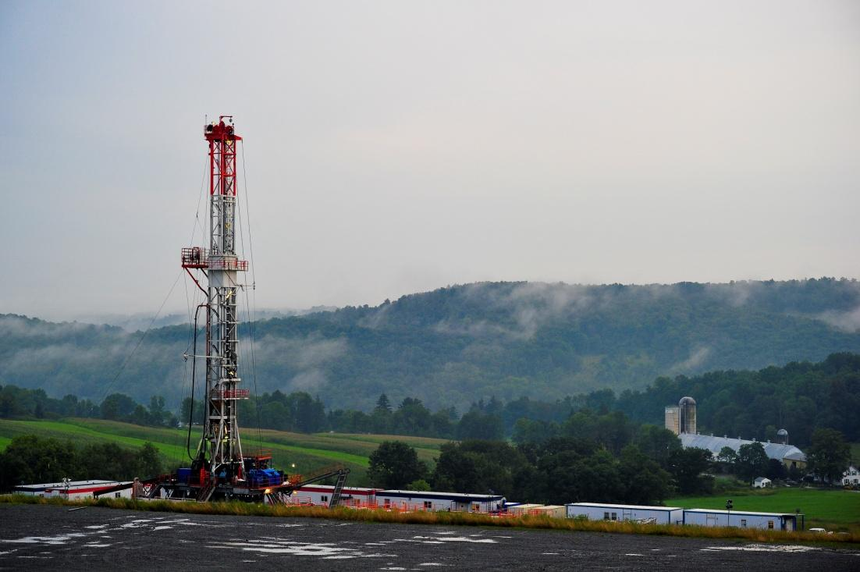
In his environmentalist novel, Fred Burton makes a moving plea to preserve our nation’s most beautiful landscapes and natural resources. Set in the mountains of Pennsylvania’s Loyalsock State Forest, the novel centers on Joe, a senior staff member of the State Senate. His loyalties are tested when he meets Nicole, a woodland retreat owner in the Loyalsock Forest, whose family business is threatened by the hegemonic gas and oil industry newly focused on fracking. Nicole emerges as a burgeoning environmentalist when the drilling company decides to build a rig on her family’s property – whether they want it or not. Joe must choose between his senator’s economic agenda for his bedraggled constituents and his growing feelings for Nicole and her family, who have come to treat him as one of their own. Triggered to write by his participation in an anti-fracking protest rally in Pennsylvania, Burton masterfully describes the vicious effects of fracking that go well beyond destroying the natural beauty. His contemplative narrative shows readers a perspective too often overlooked. Burton gives voice to the people directly impacted by these drillings, in places where corporations seem to do whatever they want. By the end of the novel, readers will feel a deeper connection to the lands we call home and will hear the call to preserve our forests and landscapes before it’s too late.

Medium
Joe has a successful government position working with a state senator in Pennsylvania, Nicole and her family enjoy their life on their rural campgrounds, and the two seem headed towards romance and possible marriage. But Nicole’s very way of life is threatened when the government takes over her father’s property for fracking, stealing away the life her family has known for years. Responding to this tragedy, Nicole finds her personal relationships strained, even the one with Joe. What will she do? As Joe weighs his career goals against his personal morals and individual aspirations, he’s left with this fundamental question: Does he put his job above everything else, or risk a total professional loss for Nicole’s sake?

Short
Joe and Nicole’s lives and relationship are fundamentally challenged after Nicole’s Pennsylvania land is claimed for a fracking site. Follow the two as they decide what to do about fracking and learn who they really are.
Audiences for Bountiful Calling

- Environmentalists
- Women (due to a strong female character)
- Anyone interested in the costs and benefits to local communities and the environment derived from hydraulic fracking
- Anti-fracking organizations
- People affected by fracking and those close to them
- Pennsylvania residents
- Residents in states in which fracking is a major issue:
  - New York: Fracking ban is regularly attacked by its detractors
  - Colorado: Trying to limit or stop fracking
  - West Virginia – see Pro Publica article 12/18
  - Oklahoma: increase in earthquakes due to fracking
- Owners of property, but not the mineral rights, on which they make their living
- Participants of Burning Man or other such festivals
- Readers who enjoy seeing characters make difficult decisions that relate to their sense of justice and personal freedom

Praise for Fred Burton’s Bountiful Calling
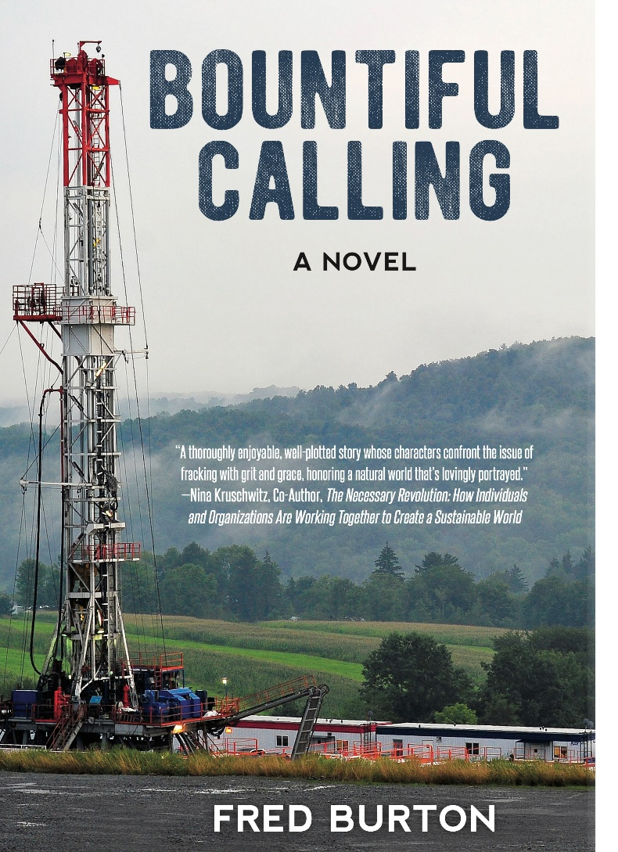
“Set in the present-day Marcellus Shale region of Pennsylvania, Burton’s novel presents thought-provoking moral dilemmas. Joe is a young, trusted, and sometimes implausibly naïve staff member working for a state senator who embraces the financial lifeline fracking can bring to his struggling constituents. Joe meets Nicole and a tentative romance blooms. She works in the mountains with her parents who own the land, but not the mineral rights, on which their resort and organic farm, Bountiful, is built. When Nicole faces terrible loss, she must decide what path to take. And when damaging information comes into Joe’s hands, he must decide whose side he’s on. Burton presents a paean to the idyllic landscape and lifestyles fracking has destroyed. Well-informed on the mechanics of fracking and its devastating health impacts, as well as the deleterious alliance between politicians and corporations, Burton dramatizes how the game is fixed against communities and offers wide-ranging commentary on the values of our society.”
—Booklist

“A thoroughly enjoyable, well-plotted story whose characters confront the issue of fracking with grit and grace, honoring a natural world that’s lovingly portrayed.”
―Nina Kruschwitz, Co-Author, The Necessary Revolution: How Individuals and Organizations Are Working Together to Create a Sustainable World

“I read this excellent and entertaining novel with great joy. I got attracted to the characters, and the story is fun and meaningful.”
― Etienne Portelance, Physics Professor, John Abbott College

“This is a brilliant and insightful book. I found the weaving together of the narrative and the characterizations absolutely wonderful. I particularly loved the way the author was able to create a number of distinct characters and capture their unique perspectives and thought processes. And to be able to integrate them with our contemporary culture was both profound and beautiful.”
― John Taylor, Economist, Calgary, Alberta

“A timely and urgent novel about the unfolding of fracking in the rural Northeast. Fracking's onslaught preys on families and quickly ruins the landscape and pollutes the environment. Burton’s tactile and visual prose brings the reader from the precipice of destruction to a renewed hope for the future. A necessary read for our times.”
—Ellen Fernandez-Sacco PhD, Genealogist and Public Educator

“Perhaps the most important benefit of good fiction is that it allows the reader to experience the drama and emotions of the characters in the story in ways that non-fiction can’t do. Thus, good fiction gives us insights to human experiences that are often missed in our day-to-day lives. Fred Burton’s powerful novel Bountiful Calling about the lives of people caught up in the explosive forces unleashed by the natural gas boom in Pennsylvania is not only an excellent and well-plotted story, but also describes very plausible emotional responses of those caught up in the highly contentious civic warfare over gas fracking that erupted less than two decades ago. Because the characters in this book are believable, understanding their hopes and fears deepens the reader’s empathy for those who continue to be engaged in disputes about the potential impacts of natural gas development on the environment from activities backed by some who benefit economically. Because the intensity of disputes about the acceptability of fossil fuel combustion is likely to deepen in the decades ahead, an understanding of the emotional life of some affected by fossil fuel controversies provided by this novel will enhance the reader’s insights about the human dimensions of important civic challenges still unfolding.”
—Donald A. Brown, Scholar in Residence and Professor, Widener University Commonwealth Law School, And Recent Recipient of UNESCO’s Avicenna Prize for Excellence in Climate Change Ethics

“When I revisit the mountains of north central Pennsylvania, it’s unsettling to see the dust clouds created by eighteen-wheeler trucks. Peace, solitude, and wilderness leave you much quicker than the engulfing dust cloud. Beauty in the area persists, but it’s marred by large holding ponds, well and staging pads, and natural gas pipelines. Fracking, which produces the gas, is driven neither by the need for energy independence nor economic growth, but by greed and power. Companies abandon wells because profits aren’t high enough to pump them. Fred Burton’s compelling novel Bountiful Calling showcases the emotional and economic impacts of fracking on communities and people while capturing strategies used by companies to reach their justified end. His characters are intricate, experience emotional turmoil, and struggle to confront shattered dreams caused by the high-handed business and politics of fracking.”
—Phil Lloyd, Conservation Artist

“The environmental debate over fracking, the politics of it all, and the reports of numerous negative environmental and health impacts are not new topics, but Fred Burton puts a new, more humanistic spin on them with his novel, Bountiful Calling. To say this book is just about fracking is to unjustly boil down the plot to the bare essentials. Burton’s novel (his second) centers first on Joe, a young, idealistic aide to a Pennsylvania senator instrumental in drawing more fracking companies to his struggling part of the commonwealth. Joe questions his own seemingly solid support of fracking (for economic and political reasons) when he meets fiery Nicole, whose family business is threatened by fracking. An instant connection forms between these two young, driven people, but it is soon battered by endless storms and roadblocks. Nicole is pushed into action and forced to ask herself how far she’s willing to go to defend her beliefs. Joe is torn between loyalty to his senator, and loyalty to Nicole. Joe’s very future hangs in the balance as he grapples with who he should be, and who he’s cut out to be. Fred Burton uses his considerable skill as a writer to weave together an easy-to-follow tale of financial struggles, heartache, and the big debate over the impact of fracking. His novel is accessible, informative, entertaining, and above all, gripping.”
—Emily Batdorf, Student, Juniata College

“I liked this book a lot, for a lot of different reasons. The author’s ear for political dialogue struck me early as excellent. His descriptions of the industrial/fracking corporations were extremely realistic and scary, though unsurprising. I also liked the fact that he did not paint the environmentalists as simply ‘the good guys.’ Some of them obviously had their own agendas. The characters of Nicole and Joe were well-drawn. They both had obvious conflicts in their positions, and they dealt with them, I feel, very realistically. The dilemma of the families who felt forced to ‘sell out’ is extremely sad, especially when they end up caught in a controversy they wanted no part of. The author did a great job of conveying all that. Above all else, the author did a great job of conveying the ‘hopelessness’ of an industry with seemingly few boundaries, balanced against the hope that there are still some good and thoughtful people on both sides of the issue.”
— Gerard Luken, Writer/Editor

Q&A with Bountiful Calling Author Fred Burton

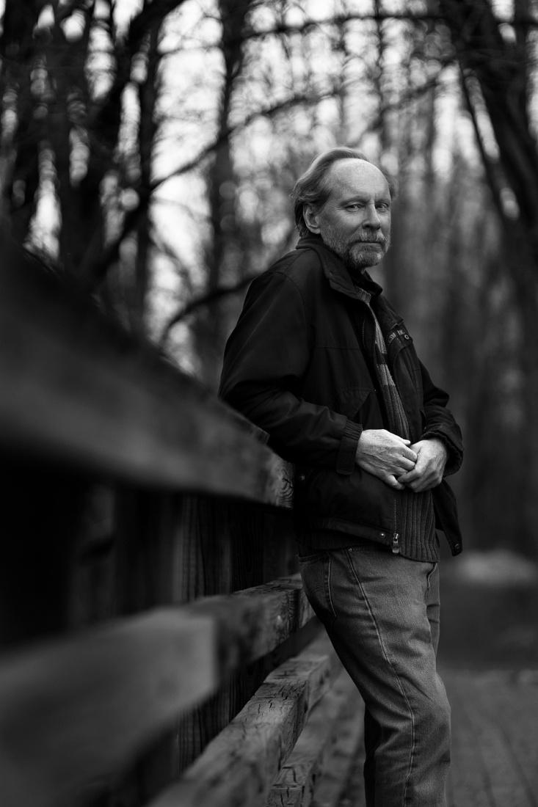
- The book’s main conflict involves fracking. Have you or anyone you know been personally affected by it?
No.

- What brought up the desire to write this book?
I lived in Harrisburg, Pennsylvania for many years. I attended a few anti-fracking demonstrations during which residents from the fracking regions spoke about the hardships they endured. These areas were under siege, the people collateral damage. I wanted to give voice to their struggles and this book is a response to that desire.

- What made you choose to set the events in Pennsylvania?
As stated above, I lived in Harrisburg and was exposed to some of the influences discussed in the book. Further, actual historical events intermix with the fiction. Also, Pennsylvania is one of the epicenters of fracking that is transforming the economy and environment of the US.

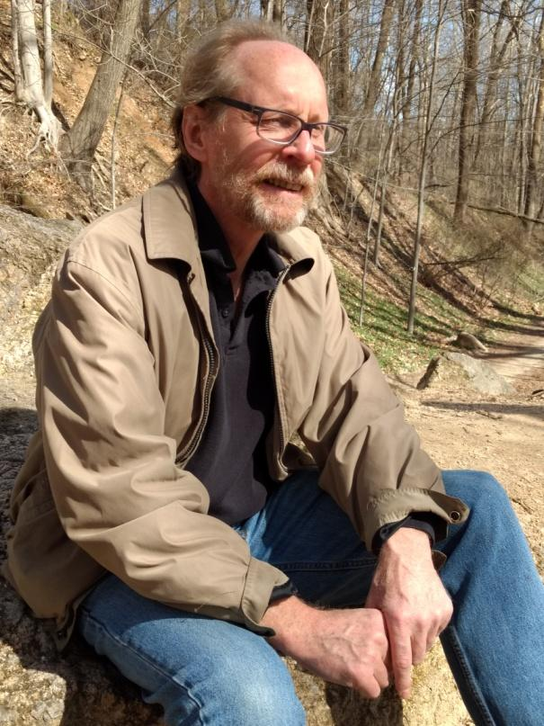
- In your opinion, is there anything of merit that comes from fracking? If so, is it worth the negative side effects? Would it be better if the government worked with property owners more in order to facilitate the making of more agreeable terms, or do you think that fracking should not be done at all?
The only argument in favor of fracking is if it is used as a bridge energy source to renewables. This is clearly not the case in this country, because there is no defined policy directed towards this outcome. Instead, we burn as much oil and gas as we can pump out of the ground. Even if you listen to only the moderate narrative coming from the scientific community, it’s clear that burning fossil fuels, as we do currently, represents an existential threat to all of us. We are compelled to keep the gas and oil in the ground if we hope to continue a semblance of life as we know it. But this means acting in ways that do not maximize our profit-making capability. And this is in direct conflict with enormously powerful forces present in every phase of our lives. This is the essential drama of our day and Bountiful Calling tries to fairly portray this dynamic.

- What would be an ideal government-citizen relationship in regard to fracking?
Today’s governments need to learn from indigenous cultures. Fracking is an excellent example of an overarching societal problem. When we separate ourselves from the world, everything is turned into commodities from which profit can be derived. Governments need to balance short-term needs with the health and sustainability of the planet. Fracking needs to be seen within this framework, which means it needs to stop as soon as possible and governments need to turn their attention to supporting renewable energy technology and development. Most people understand this. Governments need to be responsive to this majority and not the elites, who benefit most from current laws and regulations.
- The book goes into more detail on fracking’s negative effects on people than the effects it has on the environment and animals. Was this a conscious decision? Was there a reason why you chose to distance the story from a more man vs. nature conflict in favor of a man vs. man conflict?
This is an interesting question. A major emphasis in the first part of the book was to give the rich cultural traditions that bound the people to the land, which described the spirit of the place. These relationships were at risk because of the juggernaut that fracking had become. This was the lens through which I described the devastating effects of fracking on the natural world. Perhaps I chose this route because this is a human made problem that can only be fixed by modifying human behavior.

- Of the two major characters, Joe and Nicole, which one do you relate to more? Did that have an effect on how the character was written?
I’m probably more aligned with Nicole’s point of view because I think we need to explore alternative lifestyles. We have become extremely isolated from each other and the world around us. Healing the wounds this has caused won’t be accomplished with incremental change. But I definitely feel there is a need for people like Joe, whose gift is to work within the system, guided by concern and fairness.
I would like to think my alignment to one or the other character had nothing to do with how the characters were developed. In nearly every aspect, I try to distance myself from the book and instead act as a conduit for the development and action that must necessarily occur.
- The book follows the point of view of a few different characters, but it focuses on Joe and Nicole the most. What caused you to have two central characters rather than only one?
I think it is extremely powerful to bring to life multiple characters simultaneously. This gives the reader a dynamic experience, as he or she considers who they stand with, and what resonates for them. It’s also consistent with other ideas I’ve expressed in my comments previously. We really aren’t disconnected from each other. Energy flows between us. Expressing that energy is one of the magical qualities that is particularly well-suited to a novel.
Another advantage to working with multiple characters is it helped me avoid writing a polemic. This book takes on very complex issues, and multiple points of view deserve to be represented. Environmentalists will probably be the central audience, but there are some within those ranks who will feel I should be harsher with those having different opinions. Anyone with an interest in the societal costs and benefits of fracking should find in this book something that stimulates thought and emotion.

- Was there anything you were trying to convey by making Joe work for the government since it was portrayed to a major extent as a co-antagonist of the story? What made you decide to have Joe work with Nicole from within rather than represent the opposing ideals?
This is an excellent question. Joe developed a moral core through the course of the book. In the beginning, he was satisfied with managing his day to day tasks, and performed them without much consideration for their meaning or consequence. Later in the book, I could point to factors that contribute to his behaving in ways not aligned with his best self-interest, but I can’t tell you exactly why he does what he does. In these instances, he experiences his own non-linear, non-rational decision-making process. Accepting this part of himself, then embracing it, allowed him to grow in ways that would not have been possible otherwise.

- Was Gabe’s death always planned from the beginning? Was it always intended to be Nicole’s driving force, or was it something that you discovered needed to happen while writing?
It was not planned from the beginning. When I’m writing a novel, I look for the time when the structure is sufficiently formed that it begins placing its demands upon me. These moments, when it starts giving back more than I’m putting into it, are the most exhilarating. Once I accepted the fact that Gabe should die, it opened up the possibility for themes that would be carried through the rest of the book. An example is the transfer of mythic power from 1960s style activism to the type of behavior young people are exhibiting today.

- What was the inspiration for the activist group 2 Degrees? Do you think that change can be brought about more effectively if there were more groups with that same level of activism? Or would it be more of a hindrance than a help for the cause?
Groups like 2 Degrees are more of a hindrance. If they ever were able to rise to power, their rule would be just as cruel and unjust as the power structure they are in conflict with. But that is irrelevant because they will never have enough guns or bombs to effect the outcome they desire. The only way for real change to occur is if enough people decide they are not going to participate in the lifestyle demanded of them by those in power. Local, resilient economies must emerge, like the one in its nascent form at the end of the book.
There was no specific inspiration for 2 Degrees, although I did find myself thinking about the daughter in Philip Roth’s American Pastoral. Her pursuit of a pure, revolutionary spirit not only destroys her own life but the lives of her family as well.

- Nicole ends up attending a festival that has a spiritual effect on her. Was this inspired by anything that you’ve experienced? What values, if any, does the festival hold that you agree with? How important do you think connecting to the spiritual is for a person?
The festival was inspired by an event attended by someone very close to me. I think the values expressed there, of community and encouraging experiences that extend beyond rational thought, are necessary and useful. But the festival also plays a part in a very important theme of this book. The idea that you cannot force fundamental change is posited in the first few chapters. Instead, we move forward as best we can in partial darkness towards some hard-to-recognize destination. And then, suddenly, outcomes that seemed out of reach are made manifest. And those of us open to what is newly available will be there to embrace them.
I think many of us in this culture are working our way back into living with a heightened, spiritual sense. The first way for many is to enter into a more direct relationship with the world around us and to be open to the wonders that this relationship brings forth.

- Is there anything about the final story that ended up different from what you originally had in mind? Was there anything that was cut or added later in the writing process in order to make the book’s message stronger?
There weren’t a lot of significant changes after the first draft. I was surprised at how things fell into place once I got rolling. Actual historical events, my personal observations, and totally made-up characters and scenes all melded agreeably. This was something for which I am very grateful.

- Now that you’ve finished this book, what’s next for you? Do you have anything else in mind for Nicole and Joe? Any possibilities for their stories to continue, or are you happy with leaving it here for the two of them?
For now, I will let Nicole and Joe go on their way. I’m confident their lives are on good paths.
Currently, I’m working on another novel. It was inspired, in part, by Elon Musk’s work with Neuralink technology. It will pit a fully-formed cyborg who has been programmed for military purposes by a dystopian government against a cyborg who has had Neuralink sessions across the full-range of his thinking and emotional capabilities. But the non-government cyborg is forced to flee before he can fully synthesize all the information available to him. His search for a third way must be performed outside the laboratory.
With my new book, I am challenging the notion that the new cultural paradigm I hinted at in Bountiful Calling does not support the idea of heroes and super-heroes. I’ll let you know what I decide when I finish the book.

- What are you hoping readers will take away after reading the book?
Throughout the book, I debunk many of the cultural icons on the left and the right. This set the stage for Joe and Nicole to take very bold risks at the end of the book. These actions were tied to an increased appreciation of their own humanity and the world in which they lived. If this gives readers a little more courage to pursue activities that give them a deeper appreciation of their lives, that would be enormously satisfying. If the readers have already staked out a path they feel destined to follow, I hope this helps them stay true to that path and gives them a sense that there are others out there with them.

https://projects.propublica.org/graphics/wva
Powerless
What it looks and sounds like when a gas driller overruns your land.
By Ken Ward Jr., The Charleston Gazette-Mail, Al Shaw and Mayeta Clark, ProPublica
December 20, 2018
This article was produced in partnership with the Charleston Gazette-Mail, which is a member of the ProPublica Local Reporting Network.
Lee Martin loved her 104-acre farm in Wetzel County, West Virginia. The family raised chickens there and rode horses. The kids played in mud puddles. They all took walks in the woods.
Flat land is rare in Wetzel County, in the state’s northwestern region, and the place had a good barn, clean water and plenty of privacy.
Then, starting in about 2012, Martin had to begin sharing the farm with Stone Energy.
Stone built a new bridge across the creek and a new road right in front of the Martins’ house. The company told Martin it needed the road to reach the new natural gas wells it drilled on the new well pad for which it flattened an area she used to go to pray, bucolic hills forested with huge oak trees.
Soon, hundreds of trucks rumbled past her house every day, spewing exhaust. Martin had asked the company to build the bridge farther up the creek, away from her house, and the well pad away from the oaks.
But Martin didn’t have a say over any of this. While she owns the house and the surface land it sits on, she doesn’t own the natural gas underneath. And that gave Stone Energy not only the right to access her property, but also the right to tear down trees, build structures and send as much traffic as it deemed appropriate onto it.
“It took the very core out of me to watch this pristine farm get torn up like this,” Martin said. “It just hurt.”
For decades, coal from West Virginia helped power the nation. Now, natural gas has overtaken coal as an electricity source. Gas from West Virginia heats homes and fuels kitchen stoves in faraway cities. The industry’s growth has brought much-needed jobs and tax revenue to West Virginia, an economic bright spot for a state where many communities are still reeling from the downturn of coal, long the state’s most powerful and profitable industry.
Today, hundreds of big rig trucks rumble past their house on the way up to and down from the pad each day.
Along the way, however, the gas rush has changed the look and feel of communities across West Virginia. It has shattered the quiet of rural life for people like Martin. Modern drilling and gas production bring traffic, noise and dust to communities that haven’t had to wrestle with large-scale industrialization. For some residents, gas operations aren’t down the road or up the hollow, but right on their farm, forest or driveway.
And today, the gas industry is far different in scale, scope and impact than could have been imagined possible when West Virginians signed over natural gas rights decades, or more than a century, ago.
“The disturbance is so much more vast,” said David McMahon, a lawyer who has spent his career trying to help residents in their battles with gas companies. “It’s beyond all anticipation.”
The number of permits approved for horizontal gas drilling in West Virginia jumped from about 400 in 2008 to more than 700 in 2014, according to state Department of Environmental Protection data. Natural gas production in West Virginia more than doubled between 2008 and 2012, then rose again, to nearly 1.4 trillion cubic feet in 2016, according to the U.S. Department of Energy.
Long-standing property rights law says mineral owners may do whatever is “reasonably necessary” to extract natural gas from the ground, whether they own the affected land above it or not.
But to meet production demand, the industry has expanded what is “reasonable” and “necessary,” residents and legal experts say. Gas producers use hydraulic fracturing, which pumps huge amounts of water and chemicals underground to loosen up gas reserves, and drill extensive horizontal holes to suck in gas from much wider areas. They bring in fleets of heavy trucks and install tanks and pipelines.
Sept. 14, 2017
7:43 a.m. — 4:00 p.m.
A time lapse of images taken by a motion-detecting camera captured a day's worth of trucks going back and forth past Lee and Chuck Martin’s bedroom window on their way up to the gas well pad on their farm. (Graphic: Al Shaw/ProPublica, Photos courtesy of Lee Martin)
In a statement, the West Virginia Oil and Natural Gas Association said its member companies “are diligent and responsive in working with surface owners, mineral owners, and local communities” to address “concerns that may arise from time to time.” The group said its members “strive to be considerate and responsive.”
But gas companies often have the final say, at least in part because of an arcane legal system that governs mineral ownership. Critics say protection for landowners hasn’t kept pace with advances in gas drilling technology, and that it’s often far too easy for a powerful industry to game the system. The laws and interpretations were established before gas companies used rotary drills, let alone lateral well bores that can stretch for miles.
Long-standing disputes among surface landowners and gas producers might be coming to a head.
Two of West Virginia’s largest gas producers, in separate cases, are trying to cement their practices into the state’s case law. Residents are hoping the cases help them preserve their lifestyle, and maybe get a share of the profits gas is generating.
The state’s two gas lobby groups — the West Virginia Oil and Natural Gas Association and the Independent Oil and Gas Association of West Virginia — argue in a joint legal brief that, if their current practices are curtailed in any way or their reading of the law is overturned, it “will effectively eliminate future oil and gas development in West Virginia.”
Joshua Fershee, a West Virginia University law professor who is following the cases, said they could have broad ramifications, but he cautioned that the industry might be taking its legal theories too far.
“The arguments basically from the companies seem to be, if they have a lease, they can do what they want,” Fershee said. “You have a right to do a lot, but it’s not unlimited. That’s why it’s called ‘reasonable’ and ‘necessary.’”
Like controversies over royalty payments, in which residents argue that drillers use various schemes to trim payments to local gas owners, much of the dispute between the gas industry and surface landowners stems from the split ownership that seems to dominate West Virginia communities where coal was once king and natural gas has taken over.
Someone might own the surface land, while someone else owns the coal, oil or gas underneath. Sometimes, people own the surface, as well as the gas below. Gas is generally produced under leases, in which gas owners or their ancestors grant a production company the right to drill, produce and sell the natural gas. Often, the leases are so old that current surface owners didn’t sign them. And they can be so complicated that, even if they did sign them, they frequently don’t know what’s in them.
When the land and mineral rights were split, leases sometimes gave the mineral owner specific rights to come onto the surface to drill or mine those minerals.
But more often than not, the right to come onto the surface — to bring in a drill, set up a well and take out the gas — was something the law calls an “implied right.” Mineral ownership must include the right to get at the minerals, the state Supreme Court ruled back in 1909, because without this right, the coal or gas would be worthless.
In that ruling, in a famous case over whether a company could build a tram road to carry fire clay to an adjacent plant, the court also said mineral owners had the right to use as much of the surface as “fairly necessary” to extract the minerals, but that they had to show “due regard for the rights of the surface owner.”
Along the way to modern times, the phrase “fairly necessary” morphed into “reasonably necessary,” but the idea of how to balance the rights of mineral owners and surface owners never really got resolved — at least not in the context of giant, modern natural gas drilling like what’s happening in the Marcellus Shale region.
Larry Barr is a retired coal miner who had hoped to live out his life in the peace and quiet of his farm near the community of Mobley, in Wetzel County.
A few years ago, Barr came home to find that a natural gas company had moved in next door. The company had started to build a well pad on the adjacent land and even put some of its equipment on his property by mistake. Then came the drilling and fracking, and the bright work lights pointed toward his house.
“It was really noisy,” Barr recalled. “It vibrates the whole house. We hung blankets and stretched them out over the windows to keep out the light and some of the noise.”
Five years ago, a West Virginia University study found that “problematic” noise levels occurred frequently near natural gas operations and recommended steps be taken to address the problem, such as building a fence or planting trees to block sound — or perhaps relocating roads or other infrastructure away from homes.
That was one of a series of legislatively mandated studies that urged additional protection for residents in gas producing areas of the state. Lawmakers have never acted on the recommendations, and when Gov. Jim Justice took office in January 2017, one of the DEP’s first actions was to revoke a rule aimed at giving residents some relief from excessive noise and light.
Barr says things are a little better for him, because the drilling and fracking — the most noisy and intrusive activities in gas production — have been completed, and the wells near him are producing gas. But the sprawling well pad is still right next to his farm, and the traffic continues. Barr avoids taking out the 1957 Pontiac that his son helped him restore, because he doesn’t like dodging the gas company trucks.
“I miss the peace and quiet more than anything,” Barr said.
In 2016, in response to a lawsuit filed by Wentz and Crowder, a court ruled that EQT had trespassed by building a well pad on their land primarily to get gas from beneath adjoining properties. EQT is appealing to the state Supreme Court.
“We knew we wanted to live somewhere quiet where we wouldn’t need an awful lot of money to sustain ourselves,” Crowder later testified when she and Wentz sued EQT Corp., West Virginia’s second-largest gas producer. “We didn’t know what we wanted until we saw Brush Run. We realized that is what we wanted.”
But Crowder and Wentz only bought the surface land of the farm. (They divorced in 2005 and split the surface property, where they live in separate homes.) The minerals, in this case natural gas, were owned by the heirs of a man named Joseph L. Carr and were under a gas production lease originally signed in 1901.
Crowder and Wentz were not strangers to natural gas drilling. There were several old vertical wells on the farm. But those didn’t amount to much more than small tanks and pipes sticking out of the ground.
Then, in 2012, EQT, the new owner of the lease to Carr’s gas, notified Crowder and Wentz that it was going to drill nine modern, horizontal wells on the farm. EQT’s plan was to put in a road, the wells and a well pad on the farm, but use long horizontal drilling to suck up the gas from surrounding properties where it held leases.
Crowder and Wentz warned the company not to do so. They wrote a letter saying EQT would be trespassing. EQT ignored the couple, and it began clearing land and drilling wells in February 2013.
The work took 16 months to complete.
Later, after Crowder and Wentz sued EQT, Circuit Judge Timothy Sweeney detailed the work for the 20-acre well pad: Drilling just one of the wells involved nearly 11 million gallons of water, all of which was trucked to the site. EQT used trucks to haul in 1.8 million pounds of sand to frack the wells. By comparison, vertical wells drilled in 1962, 1990, 1991 and 1995 used a total of only 305,000 pounds of sand.
“The construction of the road was this grinding, continuous noise, and the blasting seemed to shake everything, even from a distance away,” Crowder recalled.
“They worked 24/7,” she said. “They were continually loading and rolling and crashing pipes, which sounded just really loud, and it was the intensity and quantity that I could hear very plainly from my house.
Economically and technologically, gas production today is all about what industry officials call “laterals.” These are the horizontal holes, or well bores, that companies drill out in all directions from the vertical hole, so they can pull in gas from many properties all at once. These laterals stretch for great distances. EQT planned an average lateral of 2.2 miles this year in Appalachia. Antero Resources said its laterals have increased 30 percent since 2014 and now average more than 2.8 miles.
In February 2016, Sweeney found that EQT didn’t have the right to do any of this — that, by coming onto the Crowder-Wentz property to drill for gas from adjacent land, the gas giant had trespassed.
After a trial in September 2017, a local jury awarded Crowder and Wentz nearly $200,000 in damages.
EQT is appealing to the West Virginia Supreme Court.
In some ways, the case could present a narrow legal issue that the court could easily dispense with. Both sides generally agree that companies with gas leases have the right to do what is “reasonably necessary” to drill for and produce that gas.
Crowder and Wentz, though, say that only applies to gas that’s under the property, not to reserves under adjoining tracts. EQT disagrees. The company says its right to produce gas from the adjoining tracts gives it the right to use the Crowder-Wentz surface to do so.
EQT declined to discuss the case beyond its court filings. But a friend-of-the-court brief filed by lawyers for the Independent Oil and Gas Association of West Virginia urges the court to take a far broader approach to protect gas companies from cases like the one filed by Crowder and Wentz.
The ruling by Sweeney, the industry lawyers say, “creates a material and substantial impediment to oil and gas development in West Virginia.” They say the ruling was “obviously wrong” and “devastating to the oil and gas industry.”
EQT lawyers made similar warnings at trial, telling jurors during closing arguments about the positive economic impact of gas. “If you want to stop all of that today, you can, but not using common sense,” EQT lawyer Brian Swiger said.
Legally, the industry believes the law in West Virginia and throughout the country makes mineral ownership “dominant” and surface land ownership “servient,” meaning secondary.
Industry officials say that horizontal drilling, using one large pad for multiple wells pulling gas from a collection of tracts, has a smaller overall footprint on communities and the environment. The alternative, they say, would be a far larger number of vertical wells that would be drilled at many more locations, creating more widespread impact.
Advocates for surface owners and residents agree, to a point. Fewer pads, even larger, centralized ones, can certainly reduce the number of landowners who have to live with wells on their property.
But that also means concentrating the effects on the surface owners unlucky enough to have their property picked for one of those pads.
Those unlucky landowners should have to agree to have large centralized pads on their land, and they should be fairly compensated, with a share of the gas profits like gas owners get through royalties, according to the West Virginia Surface Owners’ Rights Organization, which lobbies for landowners.
“Our case really isn’t such an extreme case,” said David Grubb, a former state senator and longtime activist who, with McMahon, represented Crowder and Wentz at trial. “There is so much money to be made that there’s no reason the surface owners shouldn’t be fairly compensated.”
While EQT is appealing a courtroom loss, the other major gas case that could decide how surface owners are treated is an appeal of a victory for Antero Resources, the state’s largest producer.
A group of Harrison County residents is challenging a lower court ruling that threw out their nuisance lawsuit against Antero’s operations in the Cherry Camp area, to the east of Doddridge County.
The residents say Antero should compensate them for unbearable traffic, “constant dust” that hangs in the air and settles on homes and vehicles, disruptive heavy-equipment noise and bright lights that shine into their homes day and night.
In a written statement, Antero Vice President Al Schopp said the company works hard to “listen and collaborate” with surface owners and residents in the communities where it operates.
“As a result of that, we’ve limited truck schedules, installed sound abatement, modified lighting, and rebuilt roads so they are better and safer once our work is done,” Schopp said. He said that Antero’s policy is to try to reach agreement with surface owners on the use of their land, and that longer laterals “allow us to produce more energy from a single well, which means less surface disturbance.”
The case focuses on two-dozen wells and a compressor station built on six pads in the immediate area. Hundreds of similar cases are pending, and the Supreme Court’s decision could set a precedent for all of them.
“It’s like Grand Central Station in front of my house,” said one of the residents, Deborah Andrews. Another resident, Mary Milkowski, said the dust is so bad her family stopped using their porch.
A panel of judges who handle large-scale litigation in West Virginia ruled against the residents. They appealed.
Industry lawyers say a ruling for the residents would pose an even larger threat to natural gas operations than the Crowder-Wentz verdict.
“Any other result will devastate oil and gas owners, lessees, producers, secondary suppliers, contractors, users, royalty interest owners, and the state of West Virginia and its local communities,” a joint brief filed by the West Virginia Oil and Natural Gas Association and the Independent Oil and Gas Association said.
The West Virginia Coal Association, the West Virginia Manufacturers Association, the Chamber of Commerce and a variety of other business groups filed their own brief, maintaining that the noise, dust, vibrations, lights, odor and traffic “are part and parcel to the normal drilling operations” that come with natural gas development.
“Simply put, activities that are required for mineral development cannot support a claim for nuisance because, by their very nature, they are reasonable and necessary to the exploration and extraction of minerals,” those parties said in their brief.
Pat McGinley, a WVU environmental law professor who has represented citizens in cases against the coal and gas industries for decades, said West Virginians have heard these kinds of arguments — that damage to communities is the inevitable cost of natural resource industry jobs — many times over the years. The same points were made by coal producers.
“These arguments are jobs extortion,” McGinley said. “They are trying to maximize profits and say the law doesn’t set any limits. That’s really the history of exploitation of natural resources in West Virginia.”
Oral arguments in the Antero case are set for Jan. 15. The EQT case hasn’t been scheduled yet. Both cases come at a time of turmoil and change at the court, in the wake of a spending scandal that prompted the impeachment of four justices and the resignation of a fifth, and amid
Back in Wetzel County, Lee Martin and her second husband, Chuck, say some things got a little better when EQT took over the drilling from Stone Energy, following a sale of the company in 2017.
EQT at least tried to do a better job controlling the traffic, she said. And the company paid for the material for a large fence to help block some of the noise and dust from the road.
“When landowner concerns arise, EQT works diligently to address them,” EQT spokeswoman Linda Robertson said in an email. “EQT has addressed concerns raised by the Martins and continues to work with them to address their additional concerns.”
Robertson noted that Stone Energy had reached an agreement with the Martins on the use of their land and paid them a confidential amount, both sides said. Lee Martin said it wasn’t like there was much choice, given that the company had a lease for the gas.
“They showed us the design, and we had absolutely no say on where the bridge was going to be, where the road was going to go or where the pad site was going to go,” Martin said.
Life at the farm is just not the same. Too many trucks, still too much noise. No privacy. Martin worries about air pollution and water contamination from the gas industry. She doesn’t feel at home anymore.
The Martins put the farm up for sale. A young man who works in the gas industry is a potential buyer.
“We have to get out of here,” Lee Martin said. “I fell in love with it, but there have been too many changes.”
Tractor-trailers leave a natural gas well site in Doddridge County. (Chuck Burkhard/Drone Imageworks for ProPublica and Mayeta Clark/ProPublica)
ProPublica Research Fellow Alex Mierjeski contributed to this report.
What do you think is reasonably necessary for the gas industry to ask of residents in West Virginia? Share your thoughts with us: changingwv@wvgazettemail.com.
This marks the final piece from this ProPublica/Charleston Gazette-Mail collaboration. But our reporting in West Virginia isn’t done — not by a long shot. ProPublica will continue to follow the Crowder-Wentz case in 2019, and the Gazette-Mail will keep covering natural gas and other environmental issues. And the ProPublica/Gazette-Mail partnership continues next year as Ken Ward Jr. embarks on a new West Virginia investigation. We are still listening, and your stories still matter.
Ken Ward Jr. covers the environment, workplace safety and energy, with a focus on coal and natural gas, for the Charleston Gazette-Mail. Email him at kward@wvgazettemail.com and follow him on Twitter at @kenwardjr.

About the Author

Fred Burton grew up in Queens, New York. He wrote fiction in his early 20s and returned to it again after his children reached their teen years. His first novel, The Old Songs, takes place in Queens during the 1950s and early 1960s. Although he grew up after the years covered in this book, he did experience the turbulent effects of this era and heard the stories brought forth from it. One reviewer said the book read like a “gritty Anne Tyler novel.”
His latest novel, Bountiful Calling, is set in central Pennsylvania and was drawn from a variety of influences. While living in Harrisburg, Pa. he was involved in the anti-fracking movement. This was an excellent vantage point from which to see the powerful business and government forces coalescing around the economic potential of fracking but also its effects on individual people and communities.
Burton avoids easy answers, whether in the emotional interactions in The Old Songs or the ideas swirling about in Bountiful Calling. He carefully constructs situations and characters and at a certain point lets them go on their way. He would rather place the reader within a richly textured, complex situation and let him or her decide what is important, what rings with the sound of truth.
Burton spent his career working in the computer information world, both for government and in the private sector. He’s now semi-retired and living in Baltimore, MD.

