“Wiegand's fascinating account will have great appeal for art lovers and museumgoers.”
—Booklist

“A treat for fans of off-the-beaten-track places as well as odd corners of art history.”
—Kirkus Reviews
Dancer, Dreamers, and the Queen of Romania:
How an Unlikely Quartet Created America’s Most Improbable Art Museum

Author
Steve Wiegand
Sun City West, AZ
stevewiegand11@gmail.com
(661) 978-9387 (cell)

Publisher
Bruce L. Bortz
Bancroft Press (one of the top ten independent book publishers in America since 1991)
PO Box 65360
Baltimore, MD 21209
410-358-0658
410-627-0608 (cell)
bruceb@bancroftpress.com
www.bancroftpress.com

Title Info
Dancer, Dreamers, and the Queen of Romania: How an Unlikely Quartet Created America’s Most Improbable Art Museum
Steve Wiegand
Hardcover: 978-1-61088-494-5
Ebook: 978-1-61088-496-9
Length: 268 pages (plus 32-page photo insert)
Pub Date: April 2, 2020 (coincides with the 80th anniversary of the Museum’s opening)
Non-Fiction/History/Biography/Art

Distributor
Baker & Taylor Publisher Services (the premier worldwide distributor of books, digital content, and entertainment products from approximately 25,000 suppliers to over 20,000 customers in 120 countries): 30 Amberwood Parkway Ashland, OH 44805.

Publisher Info
- Been a top-ten indie since its start in 1992
- Publishes 4-6 books a year
- Distributed nationally by Baker & Taylor Publisher Services
- Frontlist and backlist titles represented in Hollywood by APA (Agency for the Performing Arts)
- Publishes almost all types of books, from memoirs to mysteries, young adult novels to history and biography
- Bancroft books have received numerous starred reviews—four, in fact, for two 2018 summer books—and have won numerous awards
- The Missing Kennedy, a NYT ebook bestseller, was on the cover of People Magazine when published in 2015
- Recent mystery (Her Kind of Case) received star reviews from all but one of trade review publications
- Published the books of two Pulitzer Prize winners (Alice Steinbach, Stephen Hunter)

Overview
Long
Twentieth century millionaire philanthropist Sam Hill was well-known for his savvy business sense and grand ideas. However, he bit off more than he could chew when he decided to build a lavish home for his daughter, Mary Hill. His plans went south when Mary’s condition worsened and she was interned at a mental asylum. Half-finished and half-furnished, with hundreds of thousands of dollars invested in it, the fate of the Maryhill mansion was unclear. That was until his friend, Loie Fuller, came to Sam with an unusual proposition.
By the 1920s, Loie was widely celebrated for her mesmerizing “serpentine dance” and innovative lighting techniques throughout Europe. Loie’s new dream was to build a museum—one where artists from all over the globe could contribute and display their wondrous and exotic works, a place that would foster a global community of artists and art lovers. The only problem was she didn’t have the money to fund such a project, nor did she have a place to put the museum. Sam was strapped for cash at the time, but could offer up his unfinished mansion. Meantime, their mutual friend, wealthy San Francisco socialite Alma Spreckels, had a passion for art and an expendable income to help sculpt Maryhill into the makings of a proper museum.
Even with the three of them working together, Maryhill was being built in a lonely corner of the U.S. so far off the beaten path that locals would seldom make the trek to the museum. Sam, Loie, and Alma needed a big promotion to draw visitors to Maryhill. They needed a celebrity sponsor, and Loie knew just who to contact – her old friend, Queen Marie of Romania.
In The Dancer, The Dreamers, and The Queen of Romania, the lives of these four exceptional individuals intertwine. In the midst of financial straits and life-threatening family disputes, they struggle to find happiness and a true sense of fulfillment while slowly bringing into existence the most improbable art museum in American history.
Shorter
The Dancer, the Dreamers, and the Queen of Romania tells the story of the Maryhill Museum in Klickitat, Washington and the wildly different individuals―Samuel Hill, Louie Fuller, Alma Spreckels, and Queen Marie of Romania―whose lives and dreams came together to create it against difficult and, at times, unusual challenges. This fascinating story is both informative and captivating, giving an in depth portrayal of the “main characters” as well as the diverse supporting cast as their lives intertwine with each other’s. An unlikely team, diverse dreams, improbable odds, and determination all come together in this tale of the founding of Maryhill, a museum as diverse as the people who created it.
Short
An aging dancer, two idealistic millionaires, and the Queen of Romania come together under extraordinary circumstances to build a museum unlike any other.

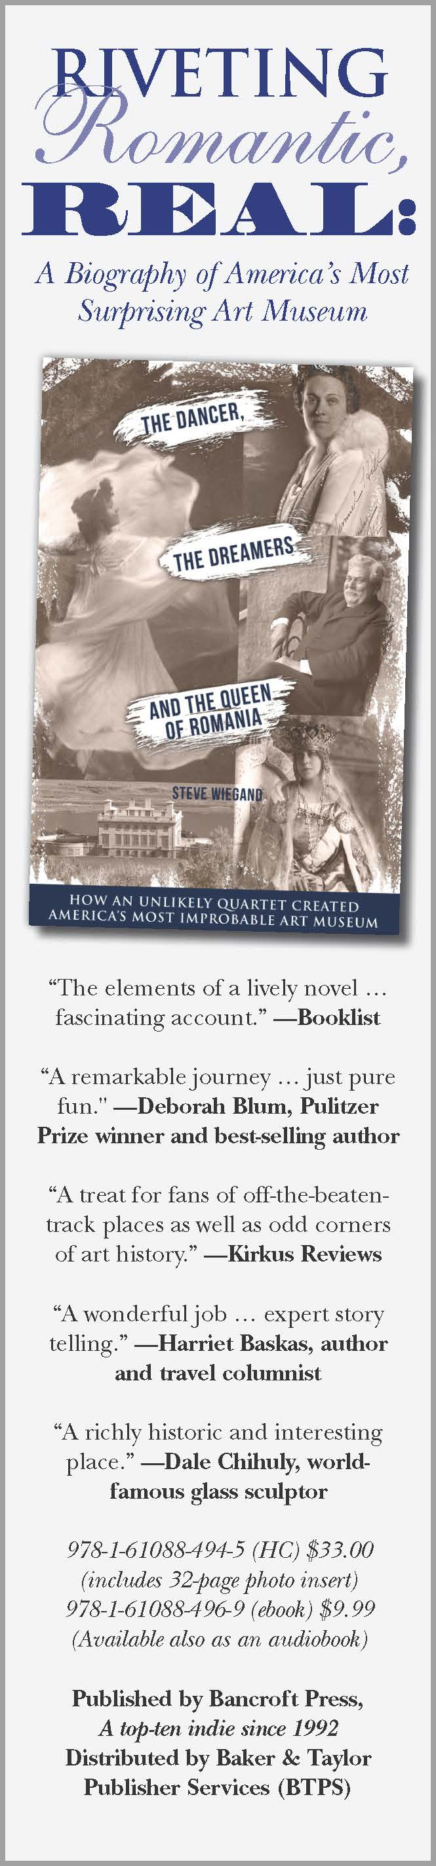
Target Audiences

1. History buffs
2. Art History fans
3. Baby Boomers (Specifically male Baby Boomers)
a.. Baby Boomers are more likely to read nonfiction books
4. Women Readers and feminists
a. There are multiple sections of the book that tells the story of the women who played a role in the establishment of the Maryhill Museum.
5. Residents of the state of Washington
a. More specifically, Klickitat County
6. Residents of the state of Oregon
7. Residents of San Francisco and the Bay area
a. Alma Spreckels, one of “The Big Four,” had an outsized impact on the city, and is memorialized in a famous statue in the middle of downtown San Francisco
8.. Art museum attendees
a.. Looking at art museum visitation statistics, the most consistent age rages of attendants of art museums throughout the years were 35-44 and 65-74.
9. Historians
a. US history
b. Art history
c. Romanian history
d. Woman’s history
e. Washington state history
f. Museum history

Praise for The Dancer, The Dreamers, and the Queen of Romania
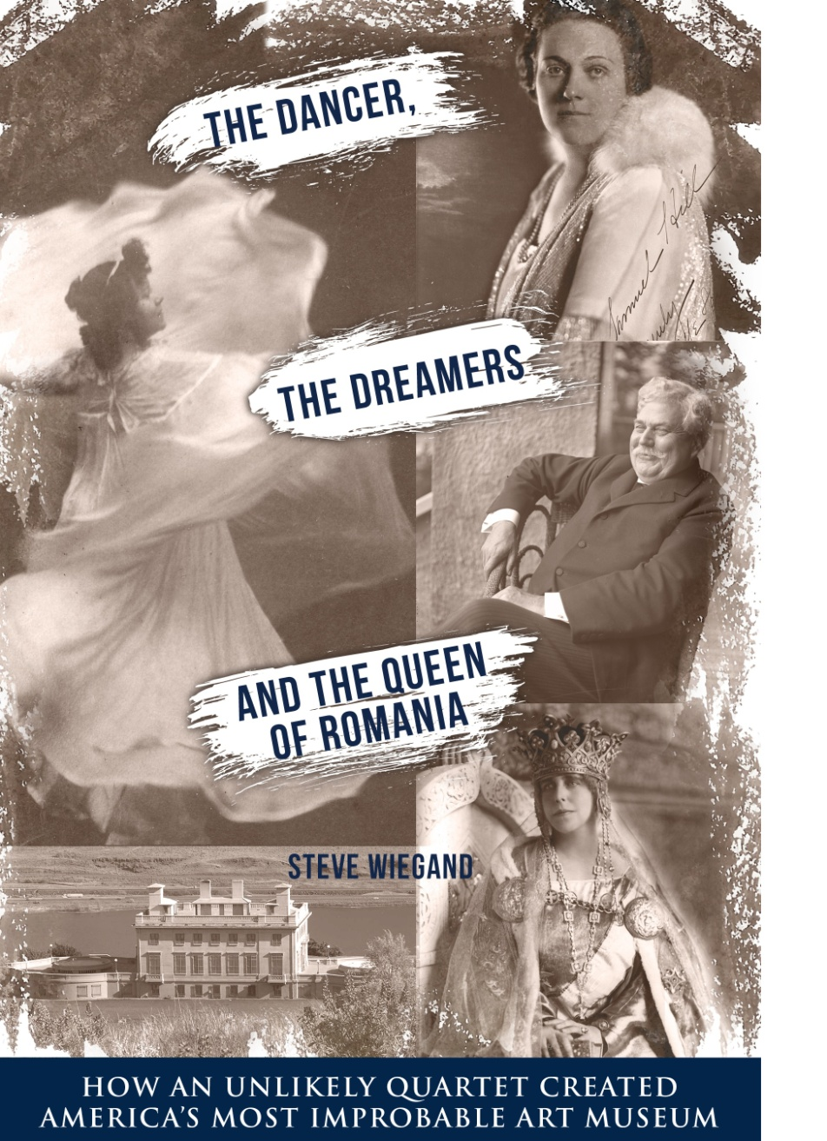
“A cast of real-life characters, an eclectic collection, and a remote location could be the element of a lively novel, but Wiegand tells the true if unlikely story of the Maryhill Art Museum in central Washington. The dancer was modern dance pioneer Loie Fuller; the dreamers were socialite Alma Spreckels and entrepreneur Samuel Hill; and the queen of Romania was Marie, granddaughter of both Queen Victoria and Czar Alexander II. In 1914, Hill planned to build a mansion on a bluff overlooking the Columbia River Gorge. Fuller convinced him to turn it into a museum. Queen Marie dedicated the unfinished building in 1926. Hill died in 1931, and in 1937 Alma Spreckels took over and saw the building through to completion. The museum finally opened in 1940, displaying works by Rodin, Native American beadwork and baskets, Eastern Orthodox icons, 300 chess sets, and Art Nouveau-style glass, much of it donated by Hill, Fuller Spreckels, and Queen Marie. The museum grounds include a full-sized concrete replica of Stonehenge. Wiegand's fascinating account will have great appeal for art lovers and museumgoers.”
—Booklist

“Pleasantly spun tale of a museum with an unlikely history—and collection . . . A treat for fans of off-the-beaten-track places as well as odd corners of art history.”
—Kirkus Reviews

"The Dancers, the Dreamers, and the Queen of Romania is both the backstory of an unusual art museum and a remarkable journey through some of the quirkiest personalities and politics of the early 20th century. And, in Steve Wiegand's engaging tell, it's often just pure fun."
—Deborah Blum, Pulitzer Prize winner and best-selling author of The Poison Squad: One Chemist's Single-Minded Crusade for Food Safety at the Turn of the Twentieth Century

“In The Dancer, the Dreamers, and the Queen of Romania, Steve Wiegand skillfully answers the question everyone asks after visiting the eclectic and eccentric Maryhill Museum of Art in rural southwest Washington state: ‘How the heck did this odd attraction end up here?’ The tale of the museum’s creation and continued existence is replete with true-life characters and odd plot twists that would be at home in a season or two of a TV drama series. Wiegand does a wonderful job of weaving together the fractured and often wacky life stories of the dancer, the dreamers, and royalty in the book’s title. But his research and expert storytelling also gift us fascinating bonus historical, cultural and economic context to understand how unusual the Maryhill Museum of Art really is.”
—Harriet Baskas, author of Hidden Treasures: What Museums Can’t or Won’t Show You (Globe Pequot), and a regular contributor to CNBC, USA Today, Travel and Leisure, and other outlets

“Steve Wiegand brilliantly unravels the complicated relationships and astonishing teamwork of four unique individuals––a groundbreaking dancer, hopeful socialite, wealthy businessman, and real-life Queen of Romania––as they joined forces to create something that would outlive them all: one of America’s most surprising and eclectic art museums.”
—Zeva Oelbaum, award-winning filmmaker and co-founder of Between the Rivers Productions, currently in production on a feature documentary about the dancer Loïe Fuller

“I presented an exhibition of my Baskets at Maryhill Museum in 1995 and discovered that I shared with Sam Hill an interest in fine art, collecting, and the craft of Indigenous Peoples. I recall visiting Maryhill’s surprising collections of objects from around the world and feeling honored to exhibit my work in such a richly historic and interesting place with so many stories to tell.”
—Dale Chihuly, world-famous glass sculptor

Q&A With Dancer, Dreamers Author Steve Wiegand

- What made you choose to write a book about the history of Maryhill?
I think the real impetus was from a conversation my wife and I had with one of the staff members the first time we visited the museum. She was trying to answer a multitude of questions we had, and the more she talked, the more these nuggets of fascinating factoids and phrases came spilling out. By the time we got to the parking lot, I was thinking “how can there not be a book about this place?” I went home, did some preliminary research, and just got hooked..

- How much and what kinds of research did you do in order to get the full scope of the museum’s story?
All the usual kinds: Secondary source materials, such as books about the Columbia River Gorge, World War I, Romania, Rodin and U.S. history. There were also autobiographies by two of the principal characters in the book, Queen Marie and Loie Fuller. There were a couple of relatively obscure books on Marie’s 1926 trip to America. And there were biographies on each of the “Big Four,” although these ranged in reliability (and readability) from excellent to eminently forgettable.

Online sites opened more avenues Example: an online genealogical work by an ancestor of Sam Hill led me to the Minnesota Historical Society, which happened to have a member researching Quakers in 19th century Minneapolis-St. Paul, who happened to know where some cool letters could be had about Sam and his family, and happily agreed to send me copies.
A huge breakthrough came when I contacted the Klickitat County Historical Society, which is in Goldendale Washington, about 12 miles from Maryhill. Those folks put me in touch with Dr. Judith St. Pierre. Judith is a historian who had worked as a volunteer at the museum for many years, and had collected reams of material. She not only advised me on what to look for and where to look, but graciously shared her papers and notes.

I visited libraries up and down the Columbia River Gorge, from Portland and Vancouver to White Salmon and The Dalles. I pored through hundreds of newspapers, both digitally archived and bound in musty volumes. Finally, I spent weeks in the museum’s basement archives, reading letters, perusing minutes of board meetings from 75 years ago, wading through annual reports and generally making a pest of myself to the knowledgeable and patient museum staff, particularly the collections manager, Anna Goodwin.

- What are the difficulties in writing about people from the past?
  - In “The Dancer, The Dreamers, and the Queen of Romania,” who was the most enjoyable to write about?
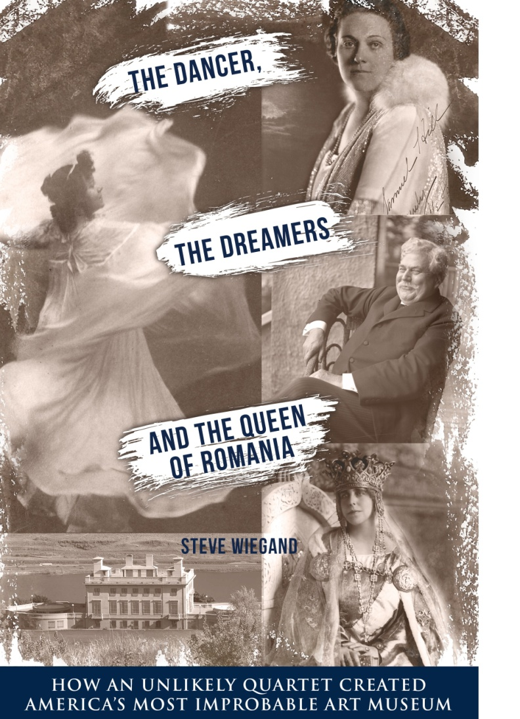
Without a doubt, the hardest part is trying to fill the inevitable gaps that pop up in people’s lives: a missing letter that would answer a key question, a month or year without a paper trail, contradictory accounts of an event, with no tie-breaker on which to rely. In those cases, you end up looking everywhere you can and then either make your best educated guess, or just say you don’t know what happened. There is small comfort in the fact that probably no one else does either. Probably.
As to my favorite character, it would be Sam Hill. He was a true product of America’s Gilded Age, with conflicting goals and dreams.

- What to you makes Maryhill so unique?
It’s a classic example of the parts being much larger than the whole: Its setting; the wildly disparate backgrounds of its main characters; its collections; and its nick-of-time rescues from financial oblivion.
But it’s also interesting to me because it isn’t unique. Maryhill’s birth, growth, and survival as a museum are emblematic of museums all over America that are there because people had dreams of preserving some aspect of our culture, and worked extremely hard to realize those dreams. Their stories aren’t likely to be populated with as many fascinating people or events as Maryhill’s, but their existence is just as important.

- What kind of story does The Dancer, The Dreamers, & The Queen of Romania tell?
It’s essentially a romance, but not in the sense of a Pride and Prejudice, or a contemporary bodice-ripper. It’s about four people who for very different reasons wanted to make the world a better place, and by doing so make themselves happier. They were later joined by a succession of people who were both dreamers and doers. The product of all this dreaming and doing became a wonderfully quirky art museum in a splendid natural setting that almost a century after its birth is still fulfilling their dreams.

- What made you want to write about the history of the Maryhill Museum?
The story was too good to be left untold. The more I learned about the museum and the people behind it, the more I wanted to know. The more I knew, the more I wanted to write it.

- Is the history of the museum important to you personally? How so?
Yes. I have no personal connection to its founders, location or operation. But the Maryhill story is inspiring, because it took both idealism and pragmatism to create and sustain it, and still does.

- What made you decide on the title for the book?
The stories of the museum’s “Big Four” founders form a good-sized chunk of the book’s core, so I wanted a title that reflected all four of them. But I have a natural impulse to collect things in threes when writing – maybe it’s the rhythm. Since two of them were naturals for individual descriptions – the Dancer and the Queen – I figured “Dreamers” was the best way to describe the other two.

- How did you go about researching the book, and what was the experience like?
I began by reading whatever secondary source material I could find -- books and contemporary articles on the museum and the founders. Next came networking sources, then doing some interviews and online research, particularly going through hundreds of digitized newspapers and magazines. Then came the on-the-ground stuff: visiting regional sites and libraries. By far the most time and effort came at the museum itself, digging through file cabinets and boxes of everything from personal letters to invoices and inventories. I’d say the experience ran the gamut from exhilarating to exhausting to exasperating and back to exhilarating.

- What did you find the most interesting or surprising when doing your research?
The most interesting was how articulate, and often eloquent, almost everyone was in their personal correspondence. I learned more about the characters in the book than I thought possible just from reading their letters and notes, even on the most mundane subjects. As for “surprising,” it was like Cracker Jacks – a surprise in every box. Example: a carton containing letters of application to serve as the museum’s director that included pitches from prison inmates, a woman whose resumé sounded suspiciously like a brothel madam, and a guy who swore he would be great if they just explained to him what a museum director did.

- Do you believe that the book will be an interesting and engaging experience for those who have no prior knowledge of the history of the Maryhill Museum?
    - How will the book read for, or engage, non-historically savvy audiences?
At the risk of rolling around in self-congratulation, yes. The story of Maryhill would be interesting and engaging even if the museum didn’t exist, so no prior knowledge of it is necessary. The fact that it is a very real place and the characters in the book are real people should add to the interest for history buffs, but it shouldn’t discourage or diminish the interest of people who aren’t that interested in history. And I think there’s enough context provided to keep readers with only a passing interest in history clued in as to what the setting was like at any particular point in the narrative.

- How did you decide on the format of the book, and how does it tell the story of Maryhill Museum in an effective and engaging way?
I wanted to get readers invested as soon as possible in the main characters and in the uniqueness of the museum. So the book opens with the museum’s dedication, which was one of the very few events where all of the “Big Four” were together. Each of the next few chapters is devoted largely to individuals. They start with an anecdote meant to quickly capture the essence of the person. And each contain links to one or more of the other main characters, while nudging the narration along. Chapters in the last half of the book begin with anecdotes as well, but the focus shifts to the museum itself as the main character, with various people as supporting actors. The goal, which I hope I attained, is to blend the creation, the nurturing, and the maturation of a building with stuff in it, into a story about people making a dream come true.

- What do you hope readers will get out of reading this book?
    - What lessons can we learn from the book?
First and foremost, I hope people finish the book and say to themselves – or, even better, others -- “that was a good book. I didn’t know anything about these people or heard of this museum, but if I’m ever in the area, I’d like to go see this place.” Second, I hope it encourages people to look for Maryhills in their own communities. You can do a lot worse than give up an afternoon of Netflix for an hour or two at the local art museum. Sorry if that sounds preachy.

- How did you decide on the names for the chapters? Was the decision based on theme or important event, or how you summarize the chapter, etc.?
It came from the first chapter, which is titled “This curious and interesting building.” That was a quote from Queen Marie describing Maryhill in her dedication speech, and I thought it captured the essence of the museum. The idea of using a phrase that was quoted in a chapter and encapsulated the chapter’s contents just stuck with me. Eleven of the 14 chapters use a quote for the title.

- Does The Dancer, The Dreamers, & The Queen of Romania provide any information about the history of Maryhill that will be new to readers familiar with the museum’s history?
Absolutely. Even longtime museum staff members with whom I’ve shared bits and pieces of my research were surprised and intrigued at things I found.

- How does The Dancer, The Dreamers, & The Queen of Romania stand out among other books on the topic?
There are no other books on this particular topic. Most books on museums tend to be more catalogues than stories. This is a book about people and a museum, and the museum is more a character than just a building that contains objects. I hope it’s more biography than history.

- Can you describe the central individuals of the book: the dancer, the dreamers, and the queen? Are readers going to be able to relate to them when reading the book?
At the height of her fame, the dancer Loie Fuller was the Madonna or Beyoncé of her day. She was both performer and celebrity, and a creative genius in her field. But she seemingly couldn’t avoid controversy and/or teetering on the edge of financial disaster. One of the title’s dreamers, Alma Spreckels, had million-dollar aspirations and a ten-cent background. She parlayed her abundant sexual allure into marriage with a fabulously wealthy and much older man, and spent the rest of her life trying to balance her yearning to be deemed respectable with her desire to enjoy herself and the hell with everyone else. Sam Hill was a rich dreamer who wanted to be great. He married the boss’ daughter, chafed at living under his famous father-in-law’s immense shadow, and spent his life trying to achieve greatness by simultaneously completing substantive projects, and building symbols he hoped would outlive him. Queen Marie was her era’s Princess Diana: a beautiful woman trapped in a dutiful and unhappy marriage, and the subject of scandals both real and imagined. She was a real queen who wanted to be a fairy-tale queen. I think all four will resonate with 21st century readers.

- How does the book highlight the influence of the female figures who played a part in Maryhill’s history?
The fact is that female figures played most of the largest roles in Maryhill’s history. Three of the title’s four characters are women; three of the five directors in the museum’s history have been women. A woman was the driver behind launching the museum; a woman gave Maryhill its face internationally, a woman kept it going after it first opened, and a woman rescued it financially in its recent history. Part of the story here is how they did it in eras even more daunting for women to succeed in than today.

- Does the book go equally into the stories of the individuals who played a role in the founding of Maryhill? Or does the book focus on one person in particular?
The book leans heavily, but in fairly equal measure, on the stories of the museum’s “Big Four” founders. But it also devotes ample space to the key people who came after them.

- Do you believe that the book addresses an important event in American history? In what way has the state of Washington, Klickitat County, or America as a whole been changed due to the museum?
It would be a stretch to say the creation, birth, and life so far of the Maryhill Museum of Art was a key event in U.S. history, or even the history of Washington state. Moreover, Klickitat County is so rural and its growth so static that even though Maryhill is the top tourist attraction, it hasn’t engendered explosive economic impetus. That said, the struggle of the museum to stay relevant and provide the area it serves with access to fine art, cultural events, and a sense of community is vitally important, as are similar efforts by museums all over the country. So in that sense, yes, it’s important beyond its region.

- How are the history and stories presented in the book relevant to today’s time?
Maryhill’s story is emblematic of the desire to share our collective human experiences through the preservation of our past and our creative efforts through art. We’re so heavily bombarded with information and images today that we often automatically put up our deflector shields rather than try to sort the substantive from the superficial. If in reading this book people take a moment to reflect on the worth of places like Maryhill as oases of dreams-made-real, it’s relevant.

- What makes the Maryhill Museum “America’s most improbable art museum”?
Its almost-laughably remote location; its dependence over the years for economic survival on everything from cattle and car commercials to wind turbines and French fashion dolls; its eclectic collections; its spectacular setting; and its implausible origins. If I pitched a movie script to you based on the idea that an eccentric tycoon, a chubby choreographer, a rich San Francisco would-be socialite, and the queen of an Eastern European country were going to create an art museum in the wilds of Washington state – and it would actually get off the ground and survive – you’d … well, given the dearth of original ideas in Hollywood, you’d probably buy it. But maybe not as “based on a true story.”

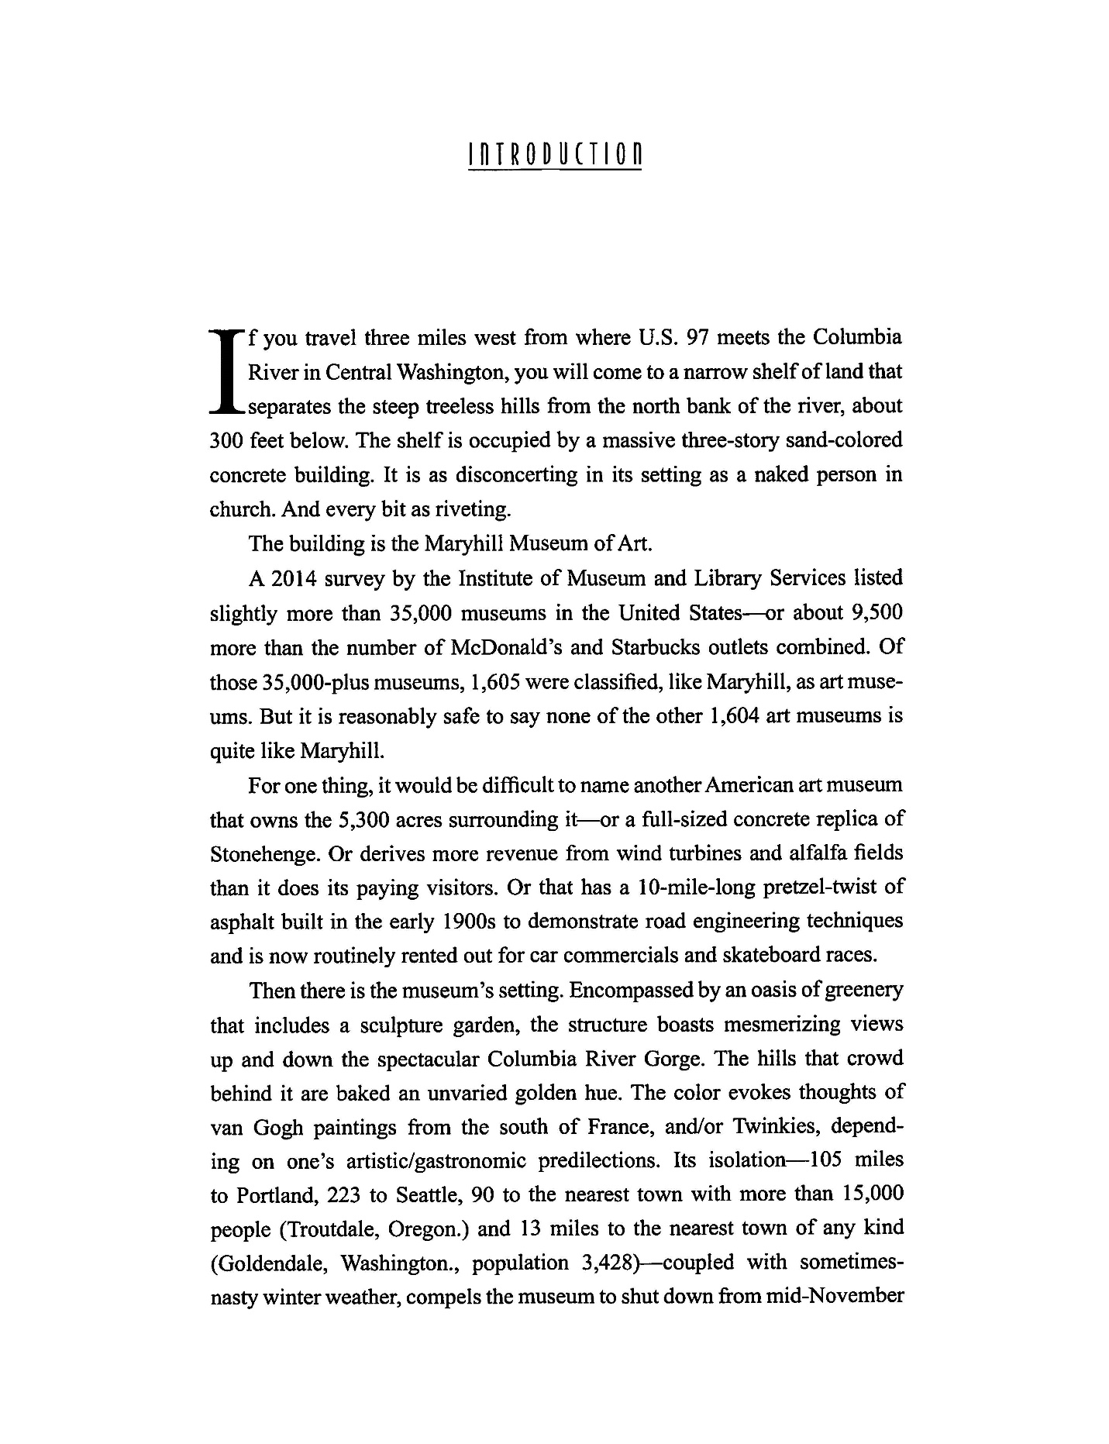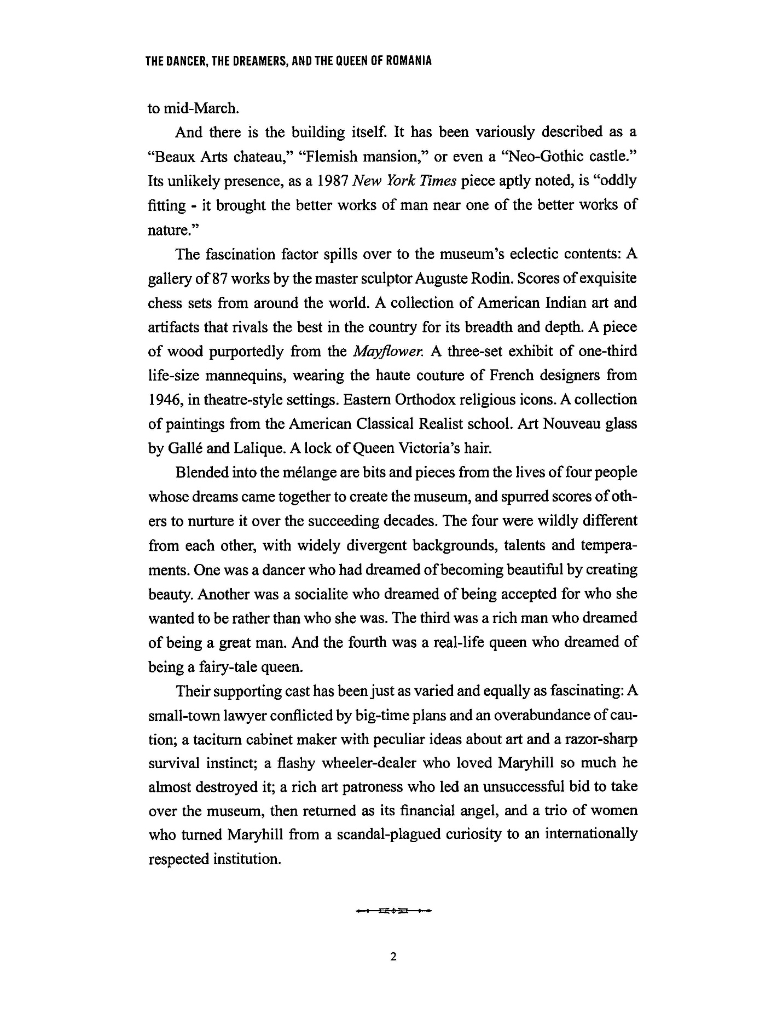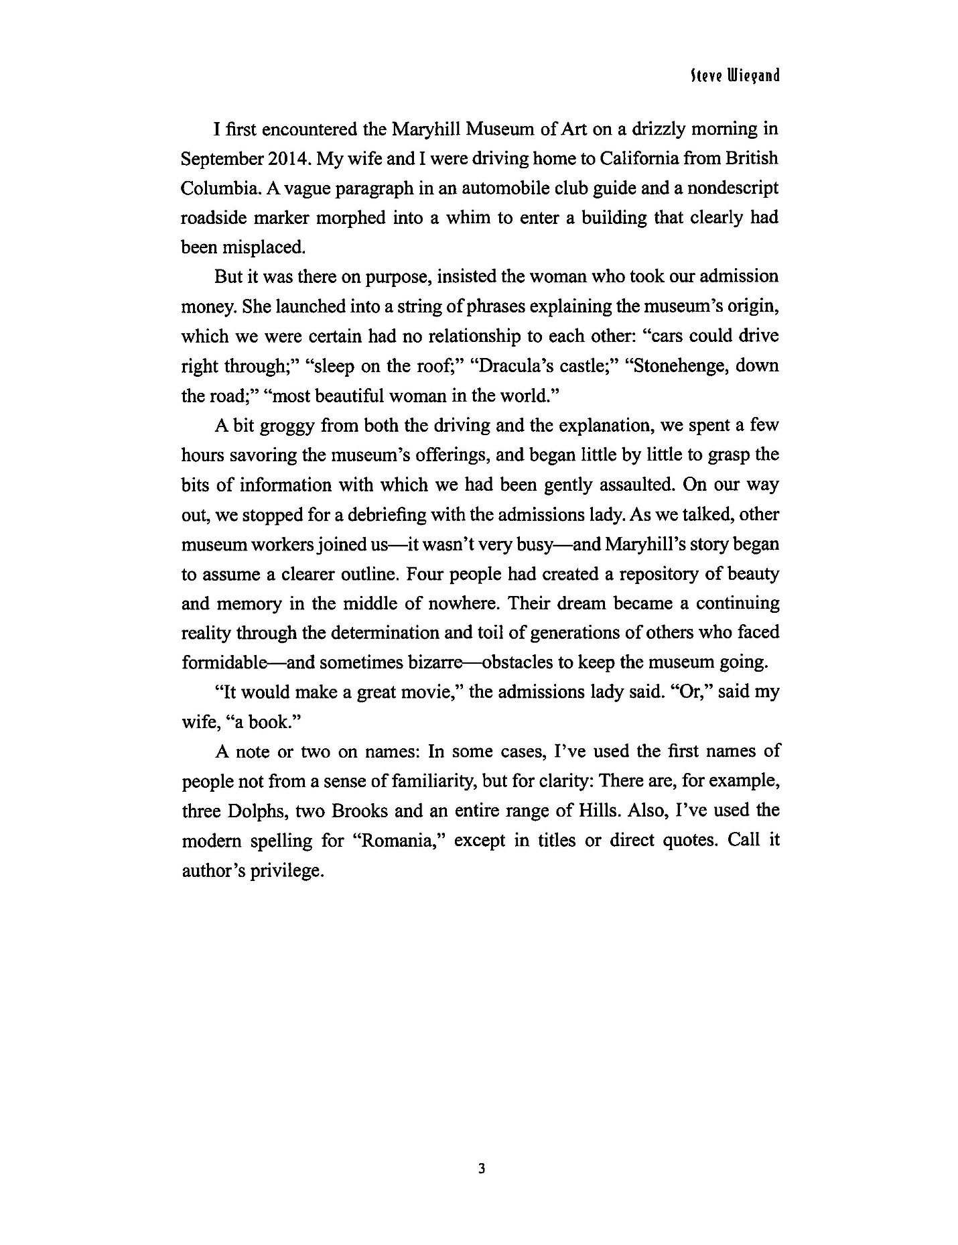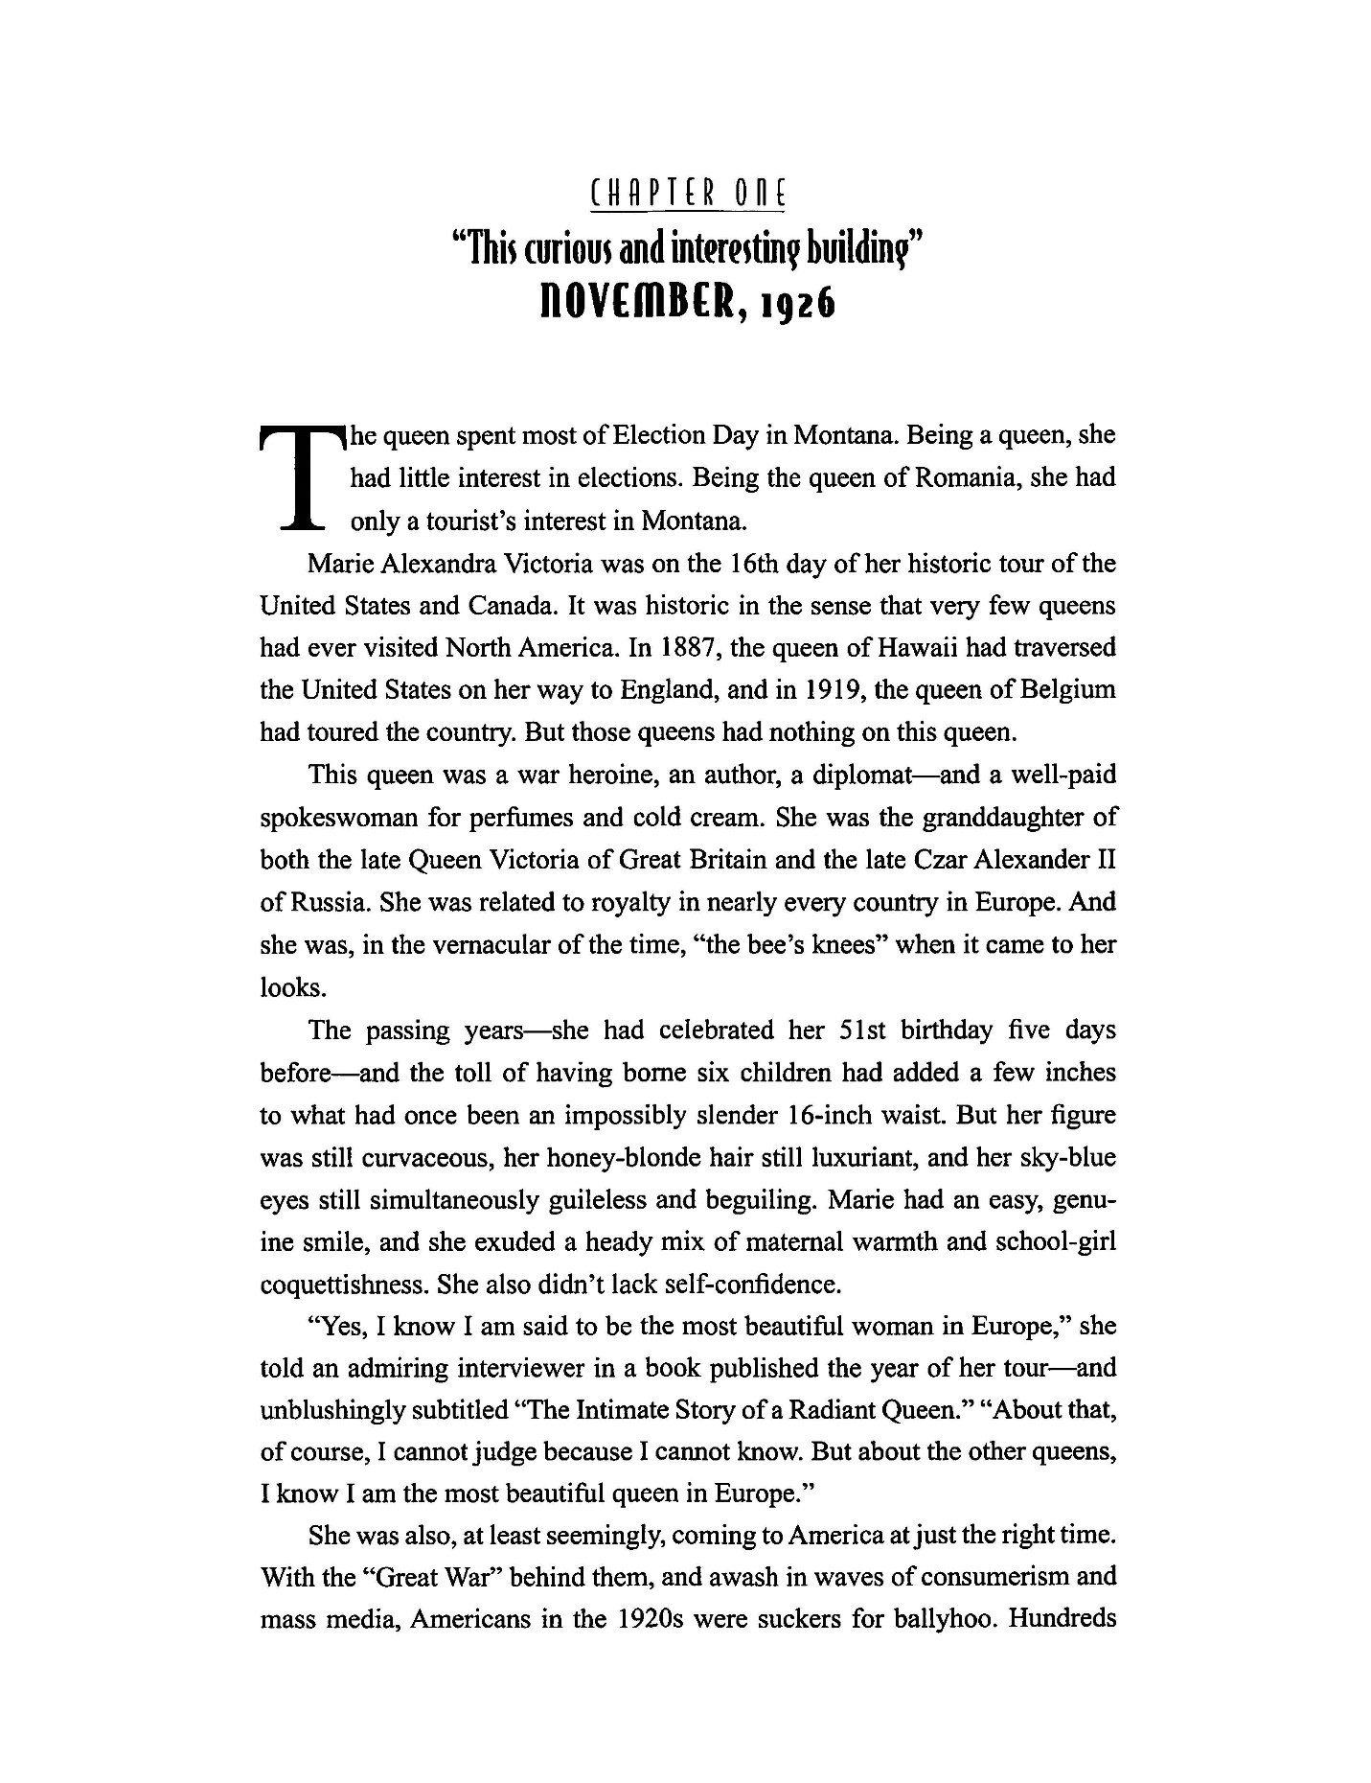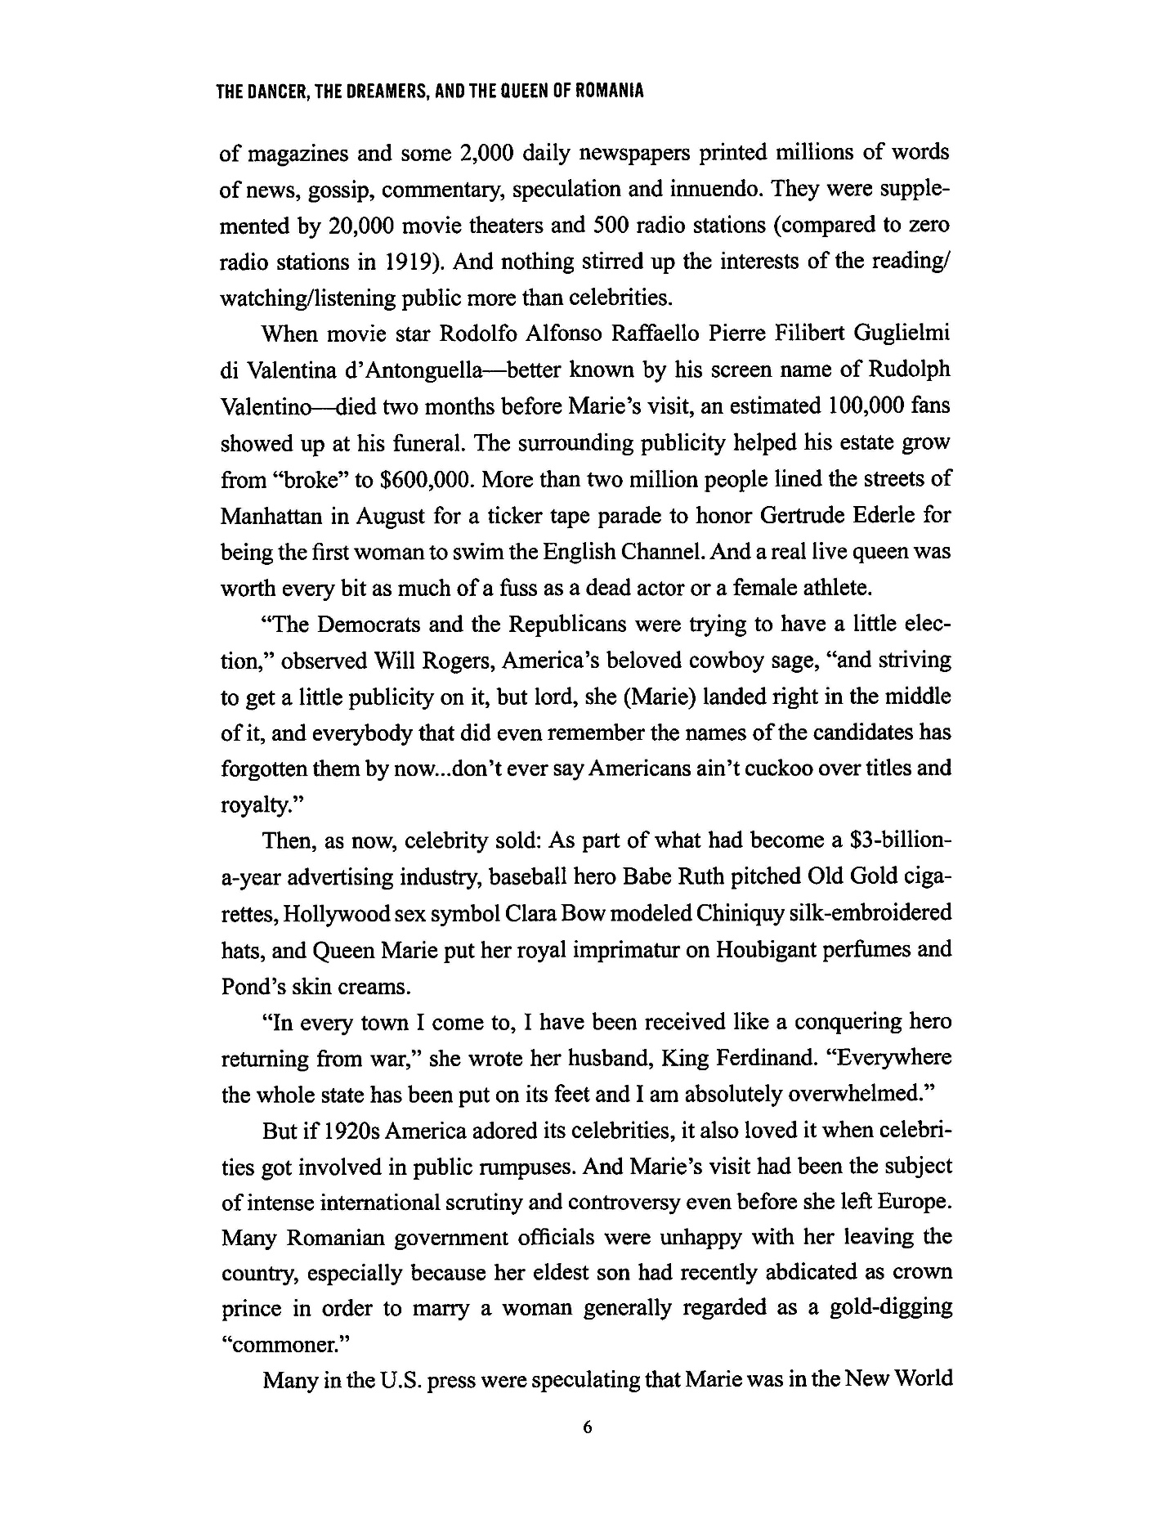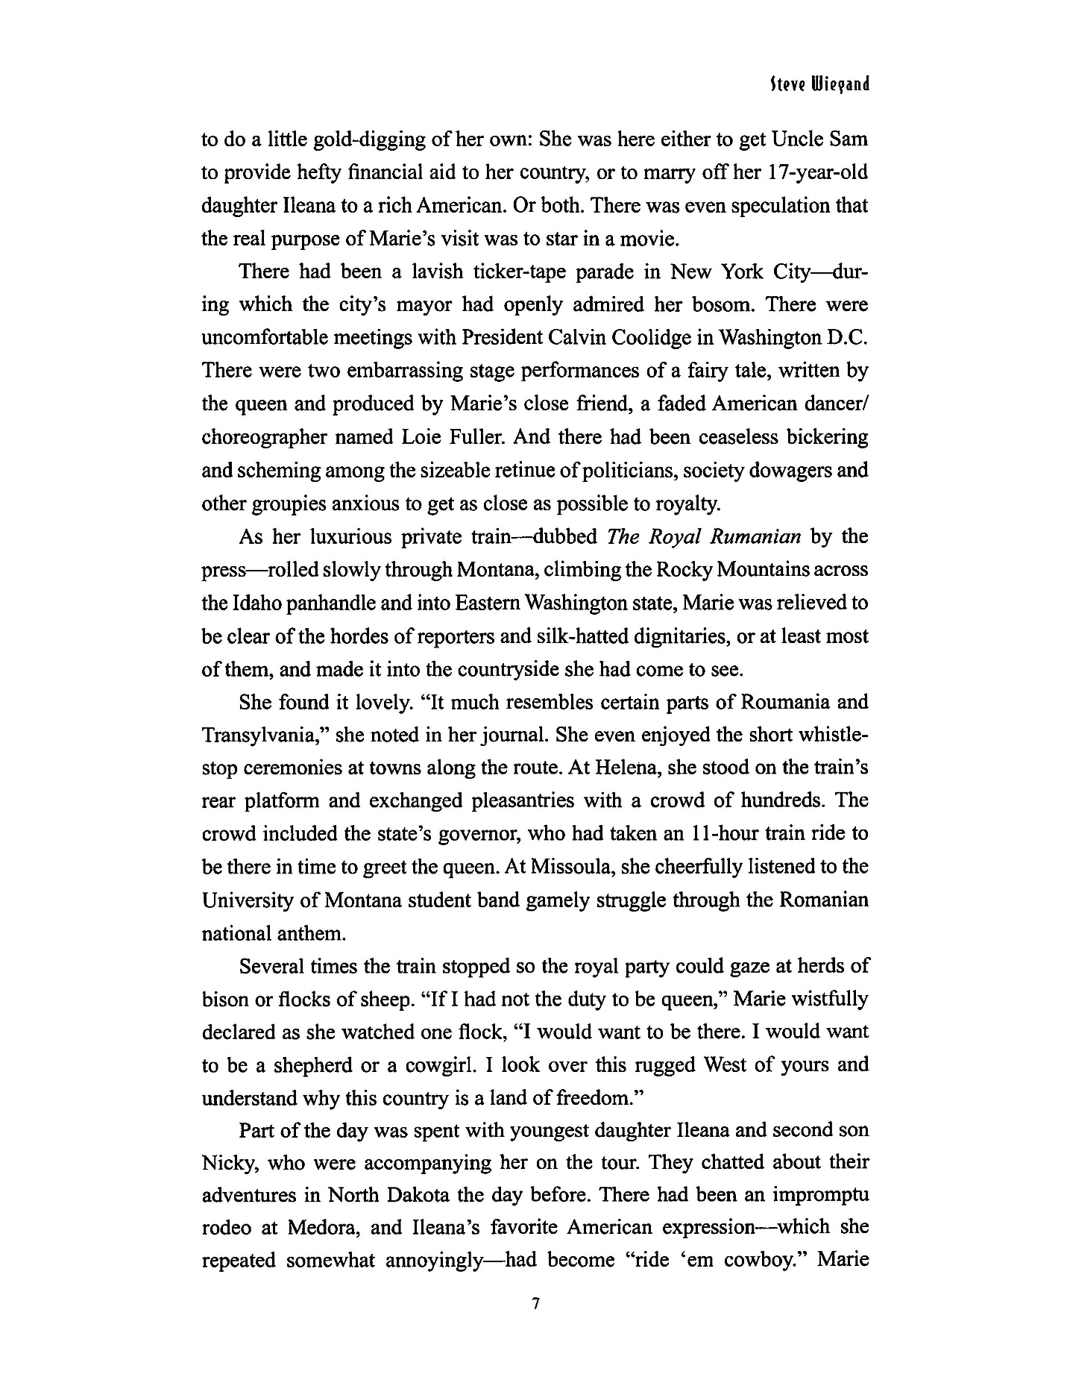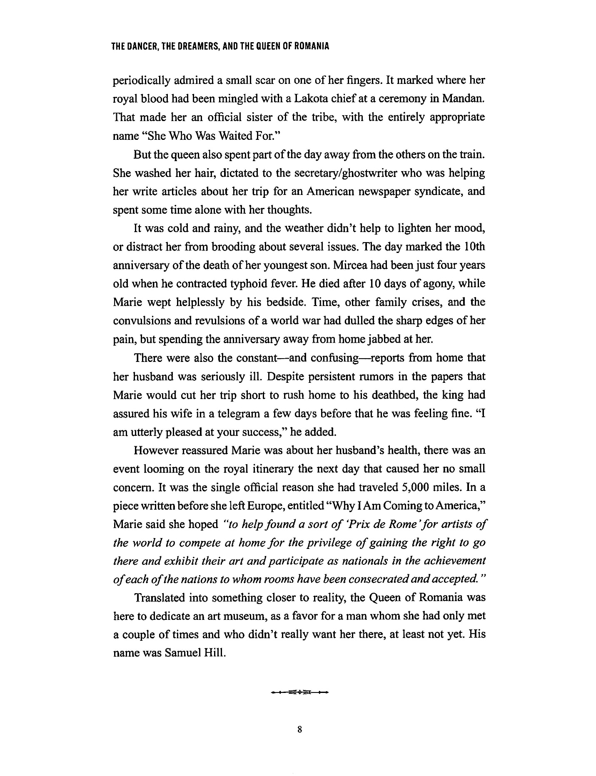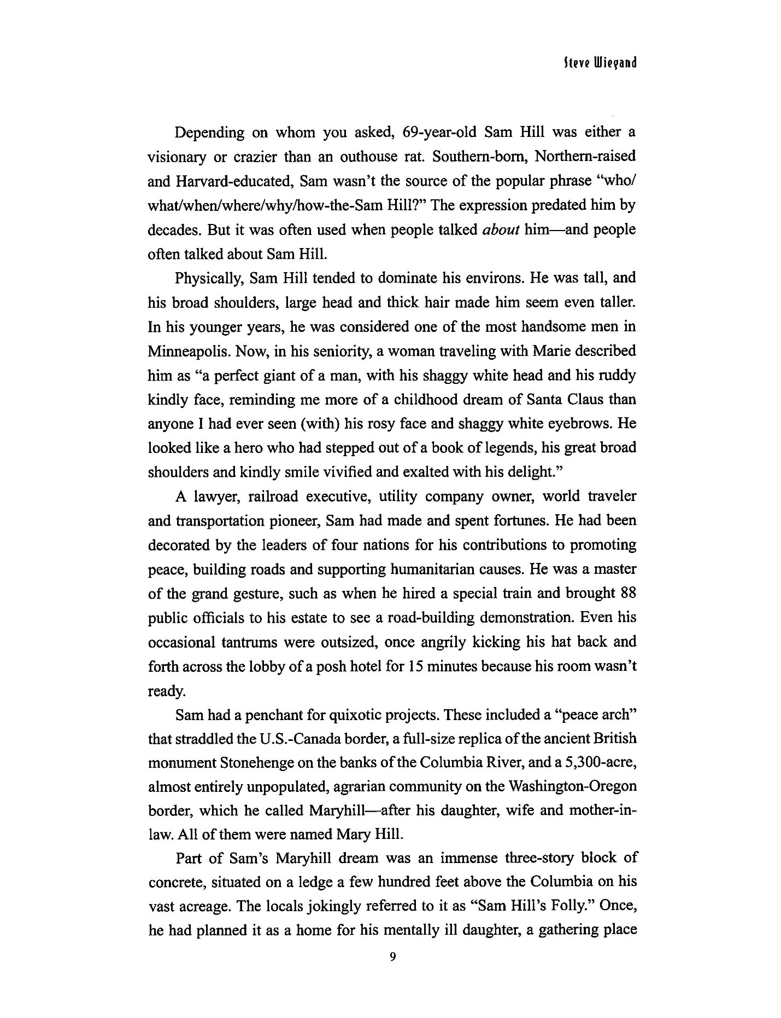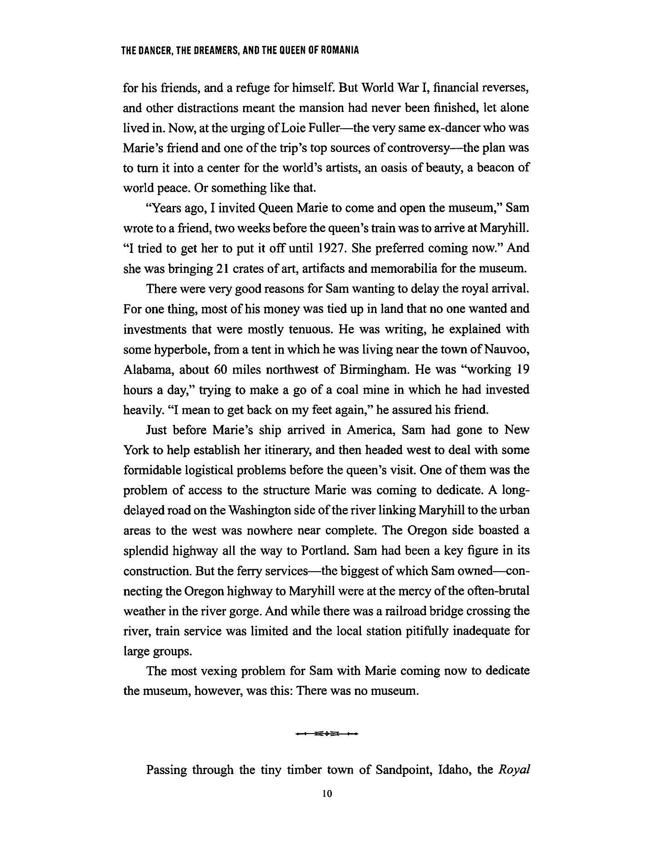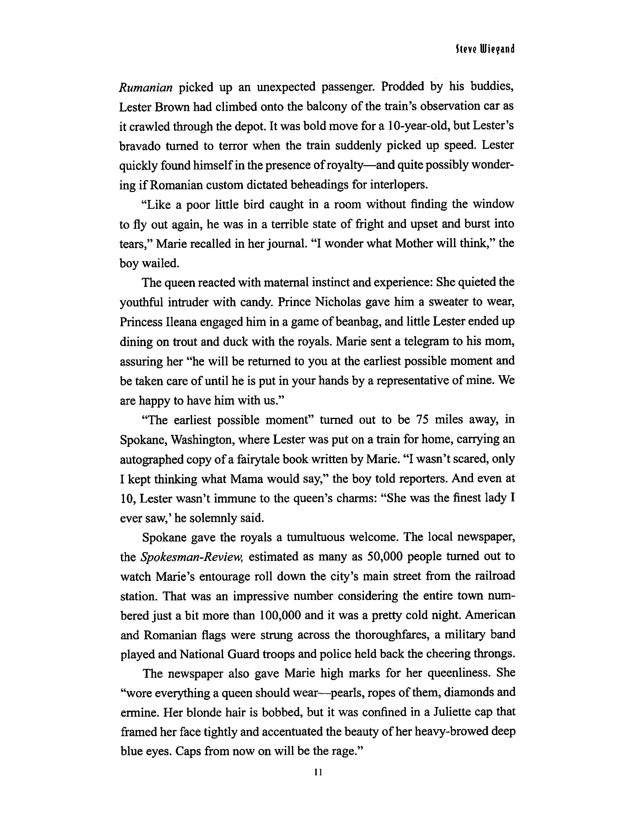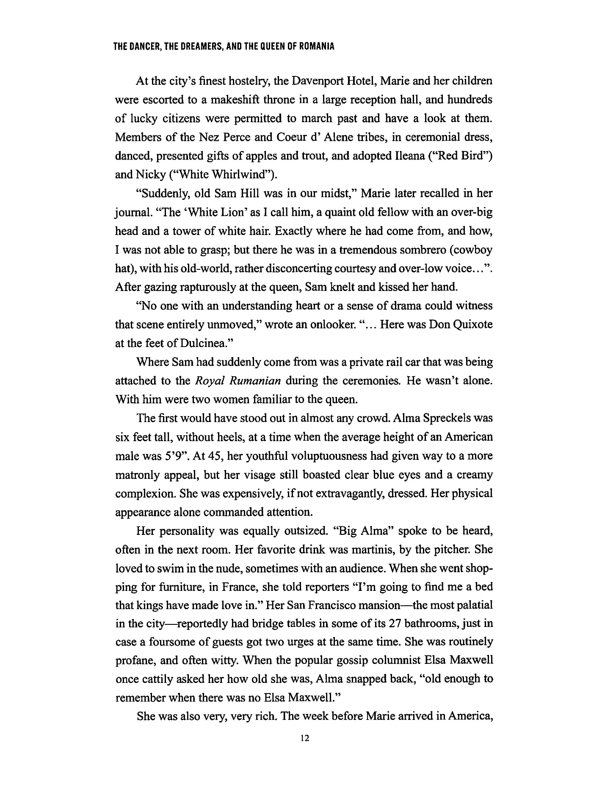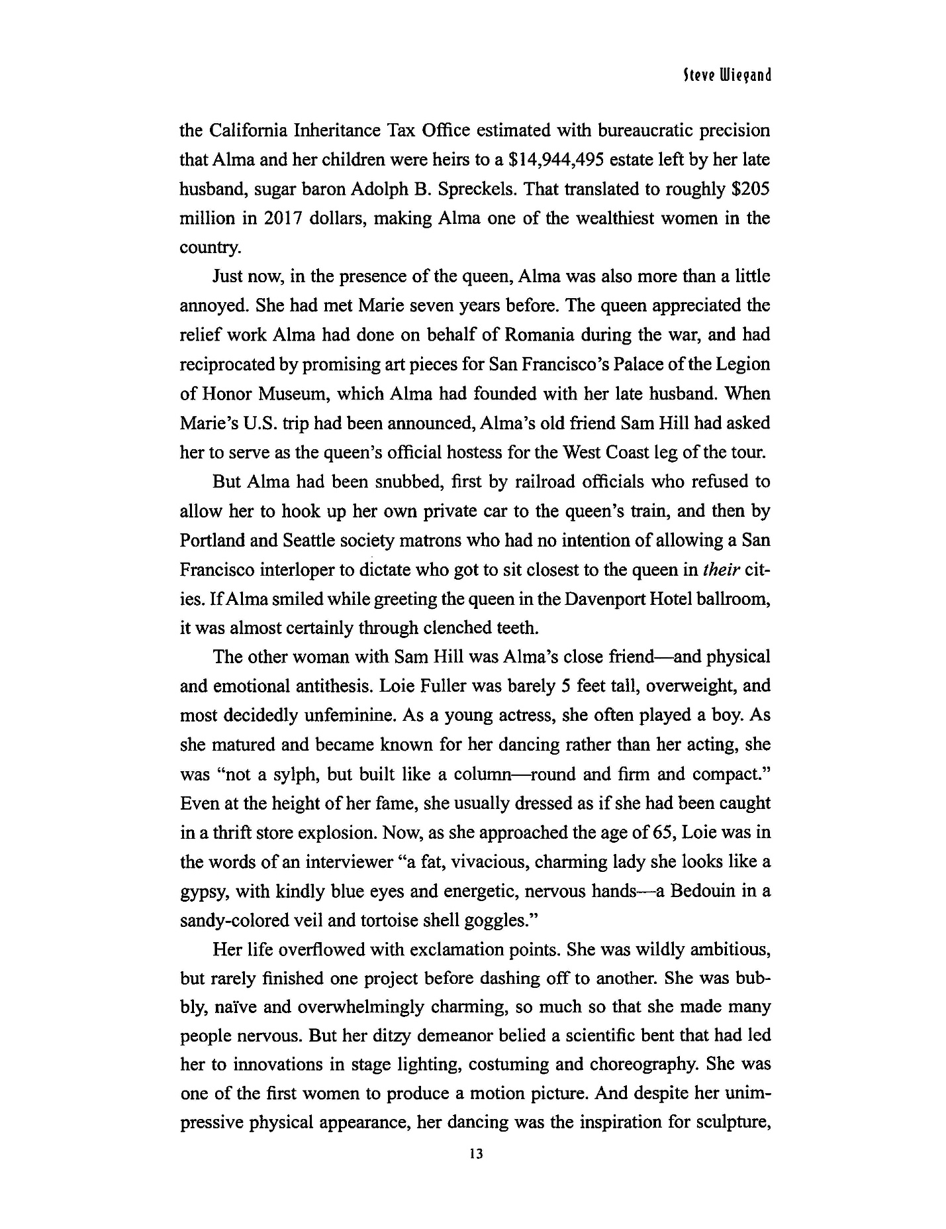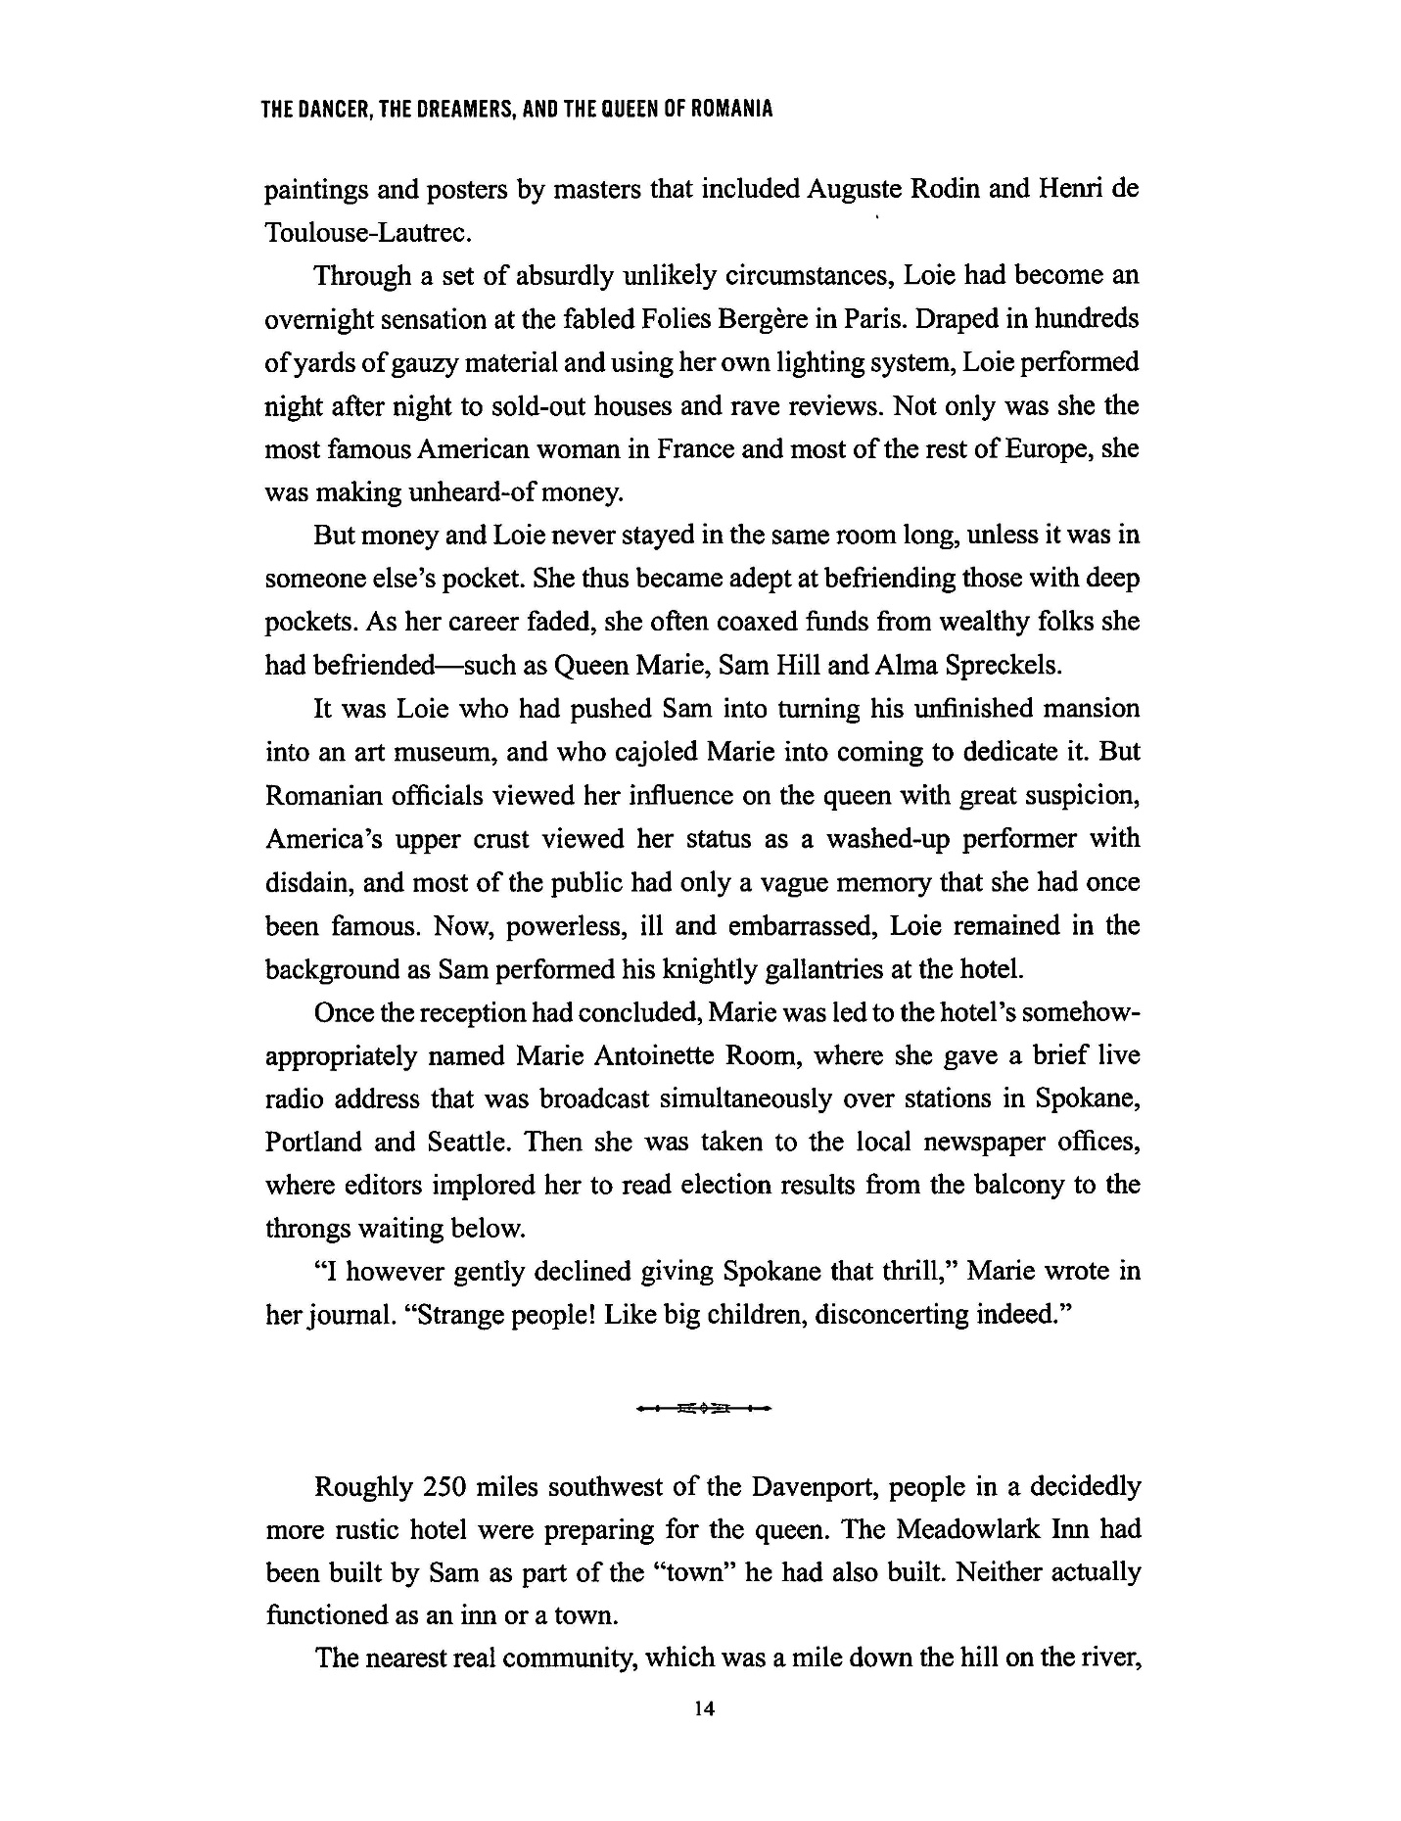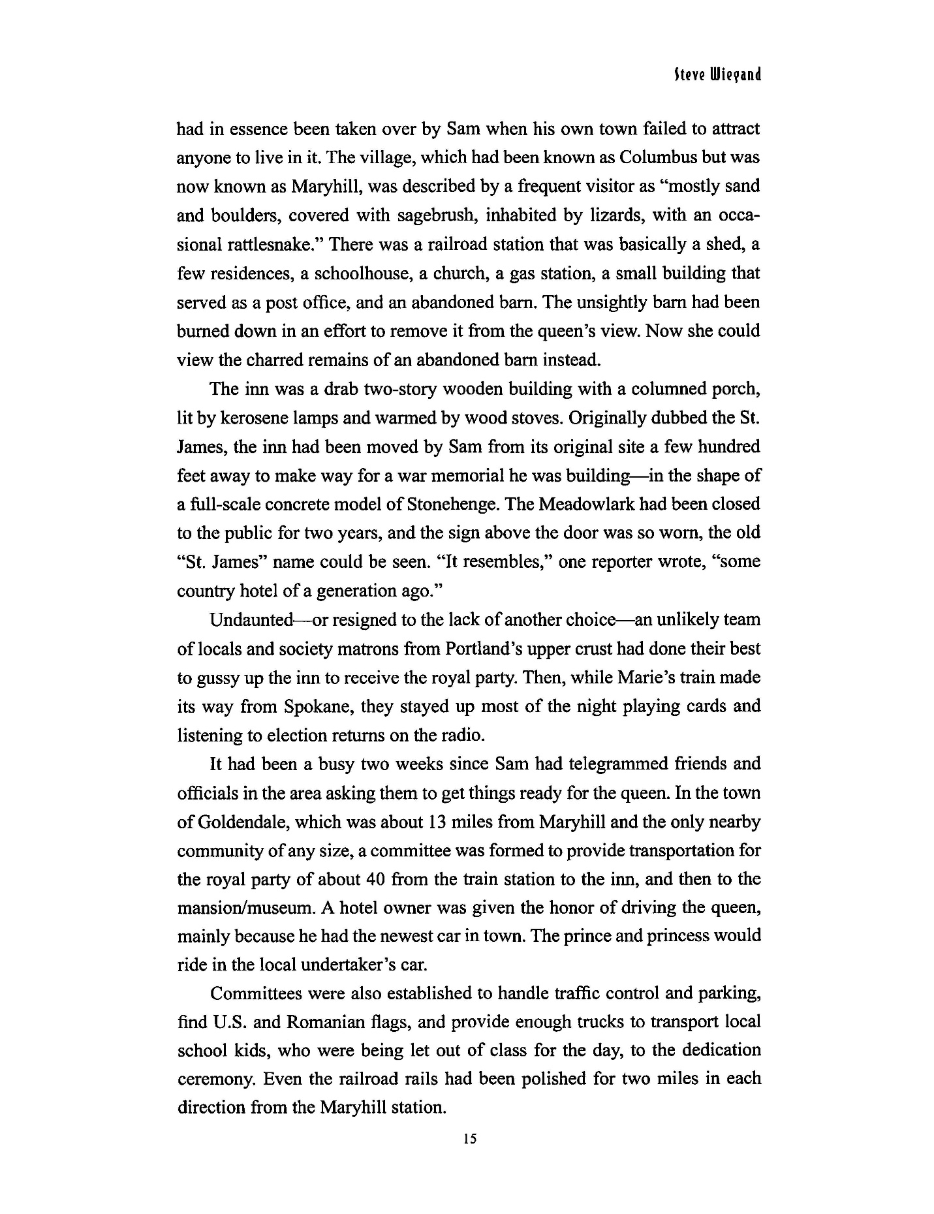
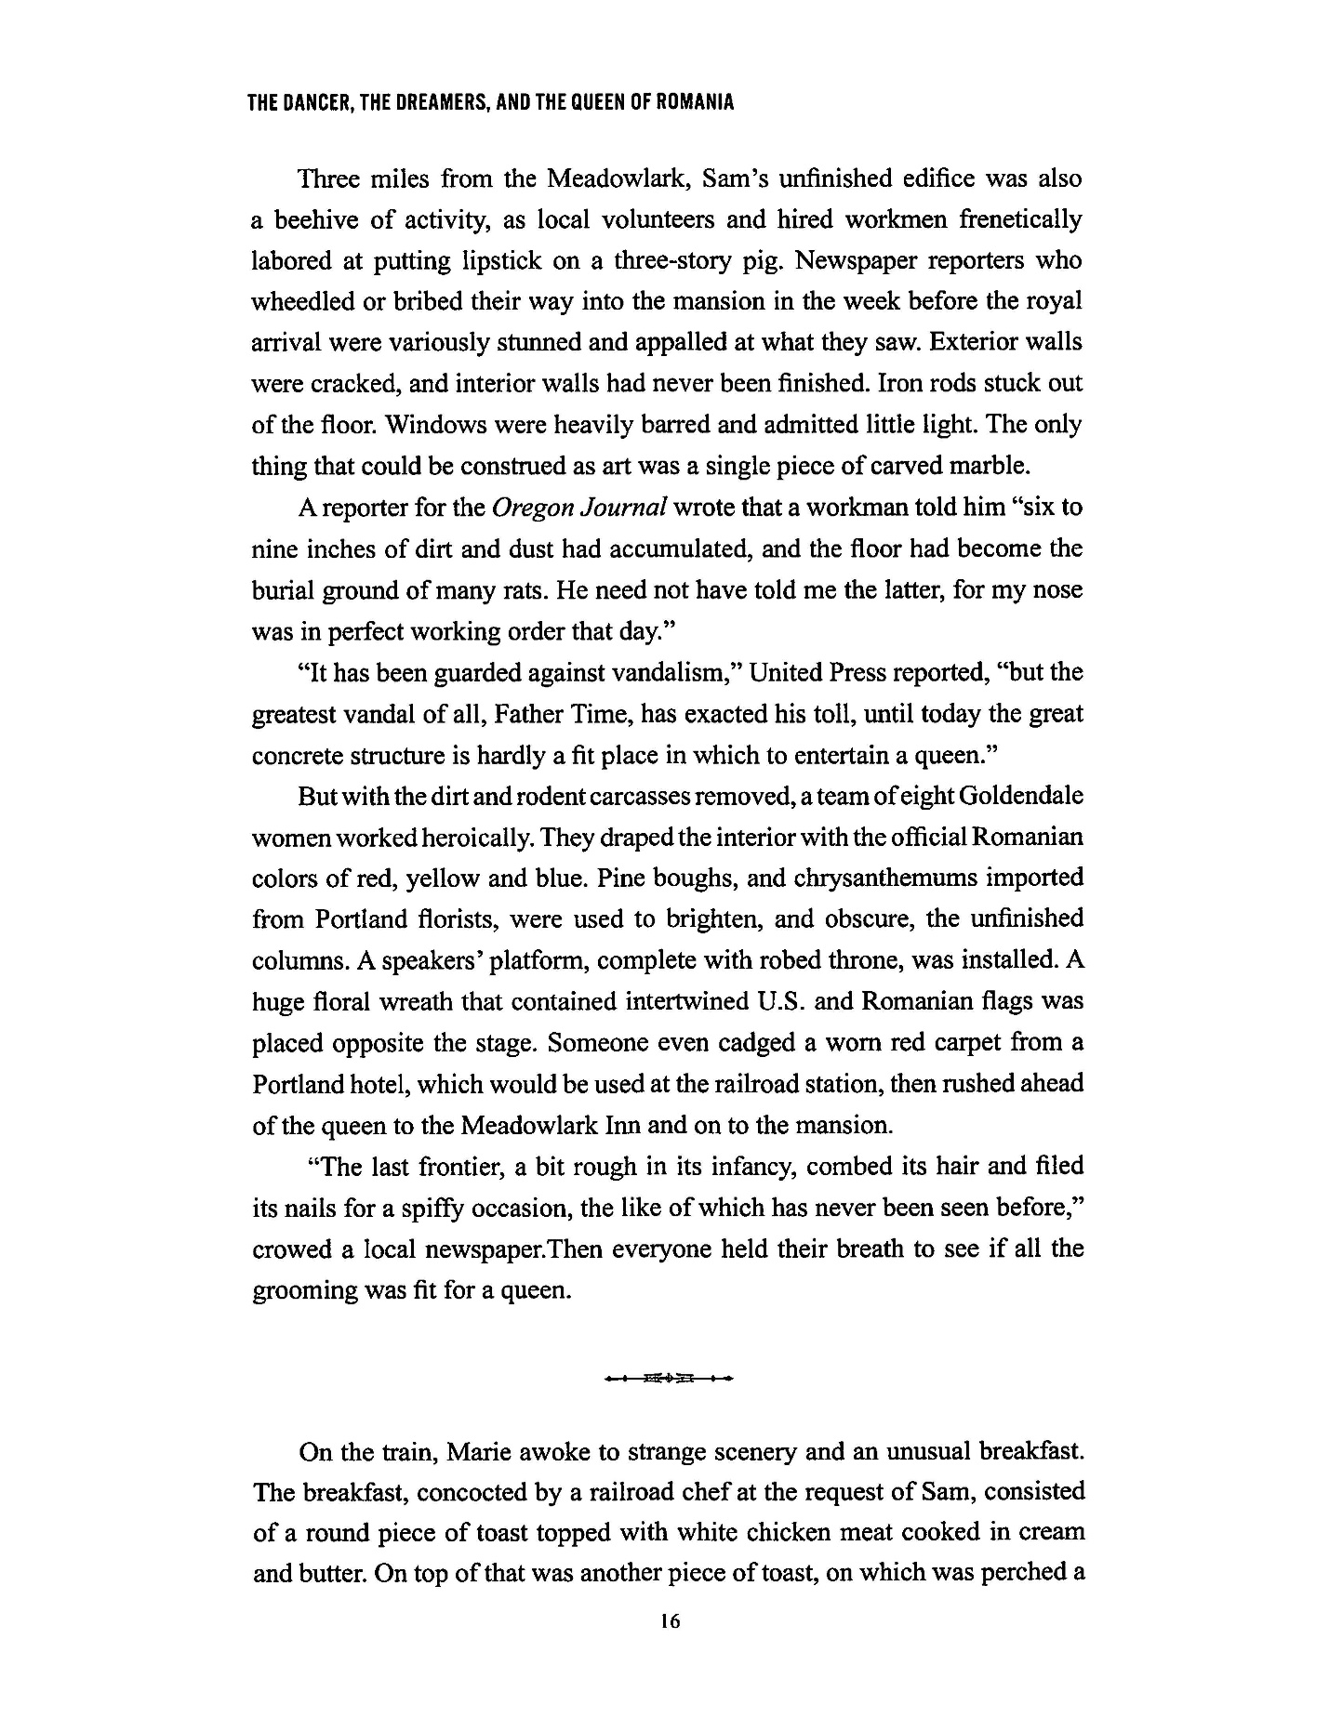

Book Club Questions
- What did you like most about the Dancer, Dreamers, and Queen of Romania?
- What parts of the book were less appealing to you?
- What scenes in the book engaged you the most?
- What did you think of the book’s narrative? Did it spend too much time on any one person? Not enough?
- Was the book the right length? Did you want more, or was it too long? Where did you feel it drag on, if at all?
- Which of the Maryhill founders did you relate to the most?
- Do you think any of those characters would make for good role models?
- Which of the characters would you like to meet the most?
- If you were making a movie about The Dancer, Dreamers, and the Queen of Romania, who would you cast and why?
- Why do you think the author, Steven Wiegand, wanted to write a book about this museum?
- Have you read other books by the author? How do they compare to this one?
- Would you read another book by Wiegand? Why or why not?
- How original and unique was this book?
- Would you go visit the Maryhill Museum after reading this book? What would you be interested in seeing or learning about there the most?
- How do you feel about the author’s research? Does it feel accurate and thorough? Does it feel like you’re reading a history textbook or a captivating story?
- How does the author make learning about Maryhill’s history interesting and enjoyable?
- Has this book changed your thoughts about art or museum culture?
- Would you read other books like Dancer, Dreamers, and The Queen of Romania?
- Would you recommend this to your friends or family?
- Would you be a dancer, a dreamer, a queen?

About the Author

Steve Wiegand is an award-winning journalist and history writer. His 35-year journalism career was spent at the San Diego Evening Tribune, where he was chief political writer; San Francisco Chronicle, where he was state capitol bureau chief; and Sacramento Bee, where he was a special projects writer and politics columnist.

Wiegand is the author, co-author, or contributing author of eight books, including U.S. History for Dummies, which is currently in its fourth edition and has been published in both Chinese and German; the Mental Floss History of the World; Papers of Permanence; Lessons from the Great Depression for Dummies; and The American Revolution for Dummies.

He is a graduate of Santa Clara University, with a bachelor’s degree in American history and literature, and has a master’s degree in mass communications from San Jose State University.

He lives in Arizona.

