Mademoiselle de Malepeire by Fanny Reybaud (1854)

Translator
Barbara Basbanes Richter
Larchmont, NY
barbara.basbanes@gmail.com
(914) 260-4331

Publisher
Bruce L. Bortz
Bancroft Press (one of the top ten independent book publishers in America since 1992)
PO Box 65360
Baltimore, MD 21209
410-358-0658
410-627-0608 (cell)
bruceb@bancroftpress.com
www.bancroftpress.com

Publicist
Brandon M. Stickney
brandonstickney5@gmail.com
727-942-8618

Title Info
Mademoiselle de Malepeire
Fanny Reybaud, Author; Barbara Basbanes Richter, Translator
Mystery/ Translation/ France
HC: 978-1-61088-520-1
Ebook: 978-1-61088-522-5
Audio: 978-1-61088-523-2 (Audiobook available through Audible, etc.)
Pub Date: October 6, 2020
Length: 158 pages
$19.95

Distributor
Baker & Taylor Publisher Services (the premier worldwide distributor of books, digital content, and entertainment products from approximately 25,000 suppliers to over 20,000 customers in 120 countries): 30 Amberwood Parkway Ashland, OH 44805.

Publisher Info
- Been a top-ten indie since its start in 1992
- Publishes 4-6 books a year
- Distributed nationally by Baker & Taylor Publisher Services
- Frontlist and backlist titles managed in Hollywood by Sean Berard at Grandview Management.
- Publishes almost all types of books, from memoirs to mysteries, young adult novels to history and biography
- Bancroft books have received numerous starred reviews and won numerous awards
- The Missing Kennedy, a NYT ebook bestseller, was on the cover of People Magazine when published in 2015
- Recent mystery (Her Kind of Case) received star reviews from all but one of trade review publications
- Published the books of three Pulitzer Prize winners (Alice Steinbach, Stephen Hunter, Elizabeth McGowan)
One Line Description

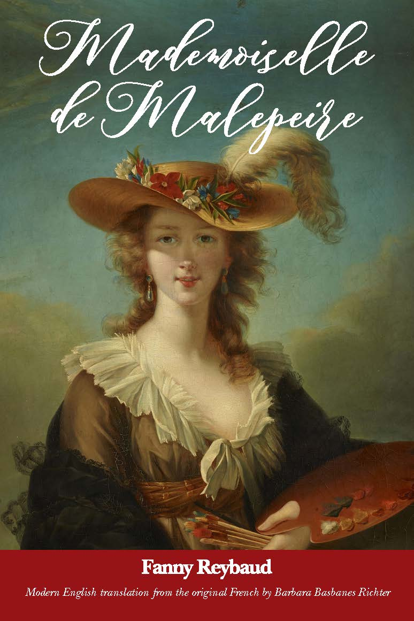
A modern translation of Fanny Reybaud's 19th-century romance and murder mystery, where a captivating portrait of a beautiful aristocrat inspires a young scholar to discover the subject's true identity, only to uncover a French Revolution-era tale of murder and deception.

Longer, More Detailed Description

After completing his education, Frederic, a young man living in nineteenth century France, decides to spend a few weeks with his uncle, Dom Gérusac, who’s a scholar of sorts. An unknown but beautiful woman is depicted in a portrait which hangs in his uncle’s home, and Frederic becomes so infatuated with the beautiful image in the portrait that he resolves to determine to know her identity by questioning the people of the nearby town. Frederic finds himself defeated, with nothing to show from his inquiries, until a long-time friend of his uncle, Monsieur de Champaubert, arrives for a visit, recognizes the woman, and subsequently begins to tell how they met.

The Marquis delves into the short time he had been a suitor of the woman, named Mademoiselle de Malepeire. He tells of her disdain towards their prospective marriage, of her inclination to read and study, and of her final rejection by fleeing into the night the day of the wedding announcement. Frederic, after hearing her story, resents all he had felt about Mademoiselle de Malepeire.

The story ends as another friend of Dom Gérusac, the old priest Abbot Lambert, arrives and tells of how a French speaking woman had come to live in the Provençal village which he served, but that he did not know the current whereabouts of this woman. Thirty years after the completion of the portrait and the Marquis’ failure to attain its subject as his wife. Frederic’s curiosity about the woman continues to flourish despite his drastically changed perspective on Mademoiselle de Malepeire, which drives him to successfully uncover the surprising result of her choices.

Mademoiselle de Malepeire evokes opinions on the female gender from the male perspective in a time when traditional aspects of womanhood dictated the upbringing and future expectations of children and adults. This bias still exists today in the multitude of forms expressed in the novel, which is why it is still relevant almost two hundred years later.

Riveting New Translation to Revive Interest
in French Female Author of 1854 Bestseller

Bancroft Press, now in its thirtieth year of continuous operation, is proud to announce the publication of its first translation with Mademoiselle de Malepeire by Fanny Reybaud. Translated from the French with an eye to a modern audience by Barbara Basbanes Richter, this captivating novel from 1854 returns to the English-speaking world for the first time in more than a century.
Set a few decades after the tumult of the French Revolution, we meet Frederic, a young student who spends every summer vacation in southern France with his uncle, dom Gérusac. Frederic develops an infatuation for an unknown but beautiful woman featured in a portrait hanging in his uncle’s home, and is determined to discover the subject's identity. His attempts are largely futile until a long-time friend of his uncle, the Marquis de Champaubert, arrives for an unexpected visit. Upon seeing the portrait, the Marquis reveals that its subject was his onetime fiancée, Mademoiselle de Malepeire, the gorgeous, sole surviving daughter of a rich French nobleman.
But clearly they did not live happily ever after; Mademoiselle de Malepeire had other plans and was willing to defy her tradition-bound parents and renounce everything she had ever known in the pursuit of liberty and happiness. As the story unravels in dom Gérusac’s dining room, another unexpected guest arrives and reveals the startling finale in Mademoiselle de Malepeire’s tale.
A fast-paced and delightful mystery, Reybaud’s novel, in Richter’s hands, is a clever and inspiring gem that will tug at the heartstrings of 21st century readers. Though written more than 166 years ago, this novel feels surprisingly relevant today as it deals with mother-daughter relationships, social classes, the expectations of romantic love, and the never-ending battle of the sexes.
Bancroft Press believes that this new, highly readable translation will revive interest in Fanny Reybaud’s enchanting body of work. A bestselling French novelist for nearly thirty years, she is now little known in her native country, America, and elsewhere, despite being considered by many during her lifetime to be the literary equal of fellow female French novelist George Sand.

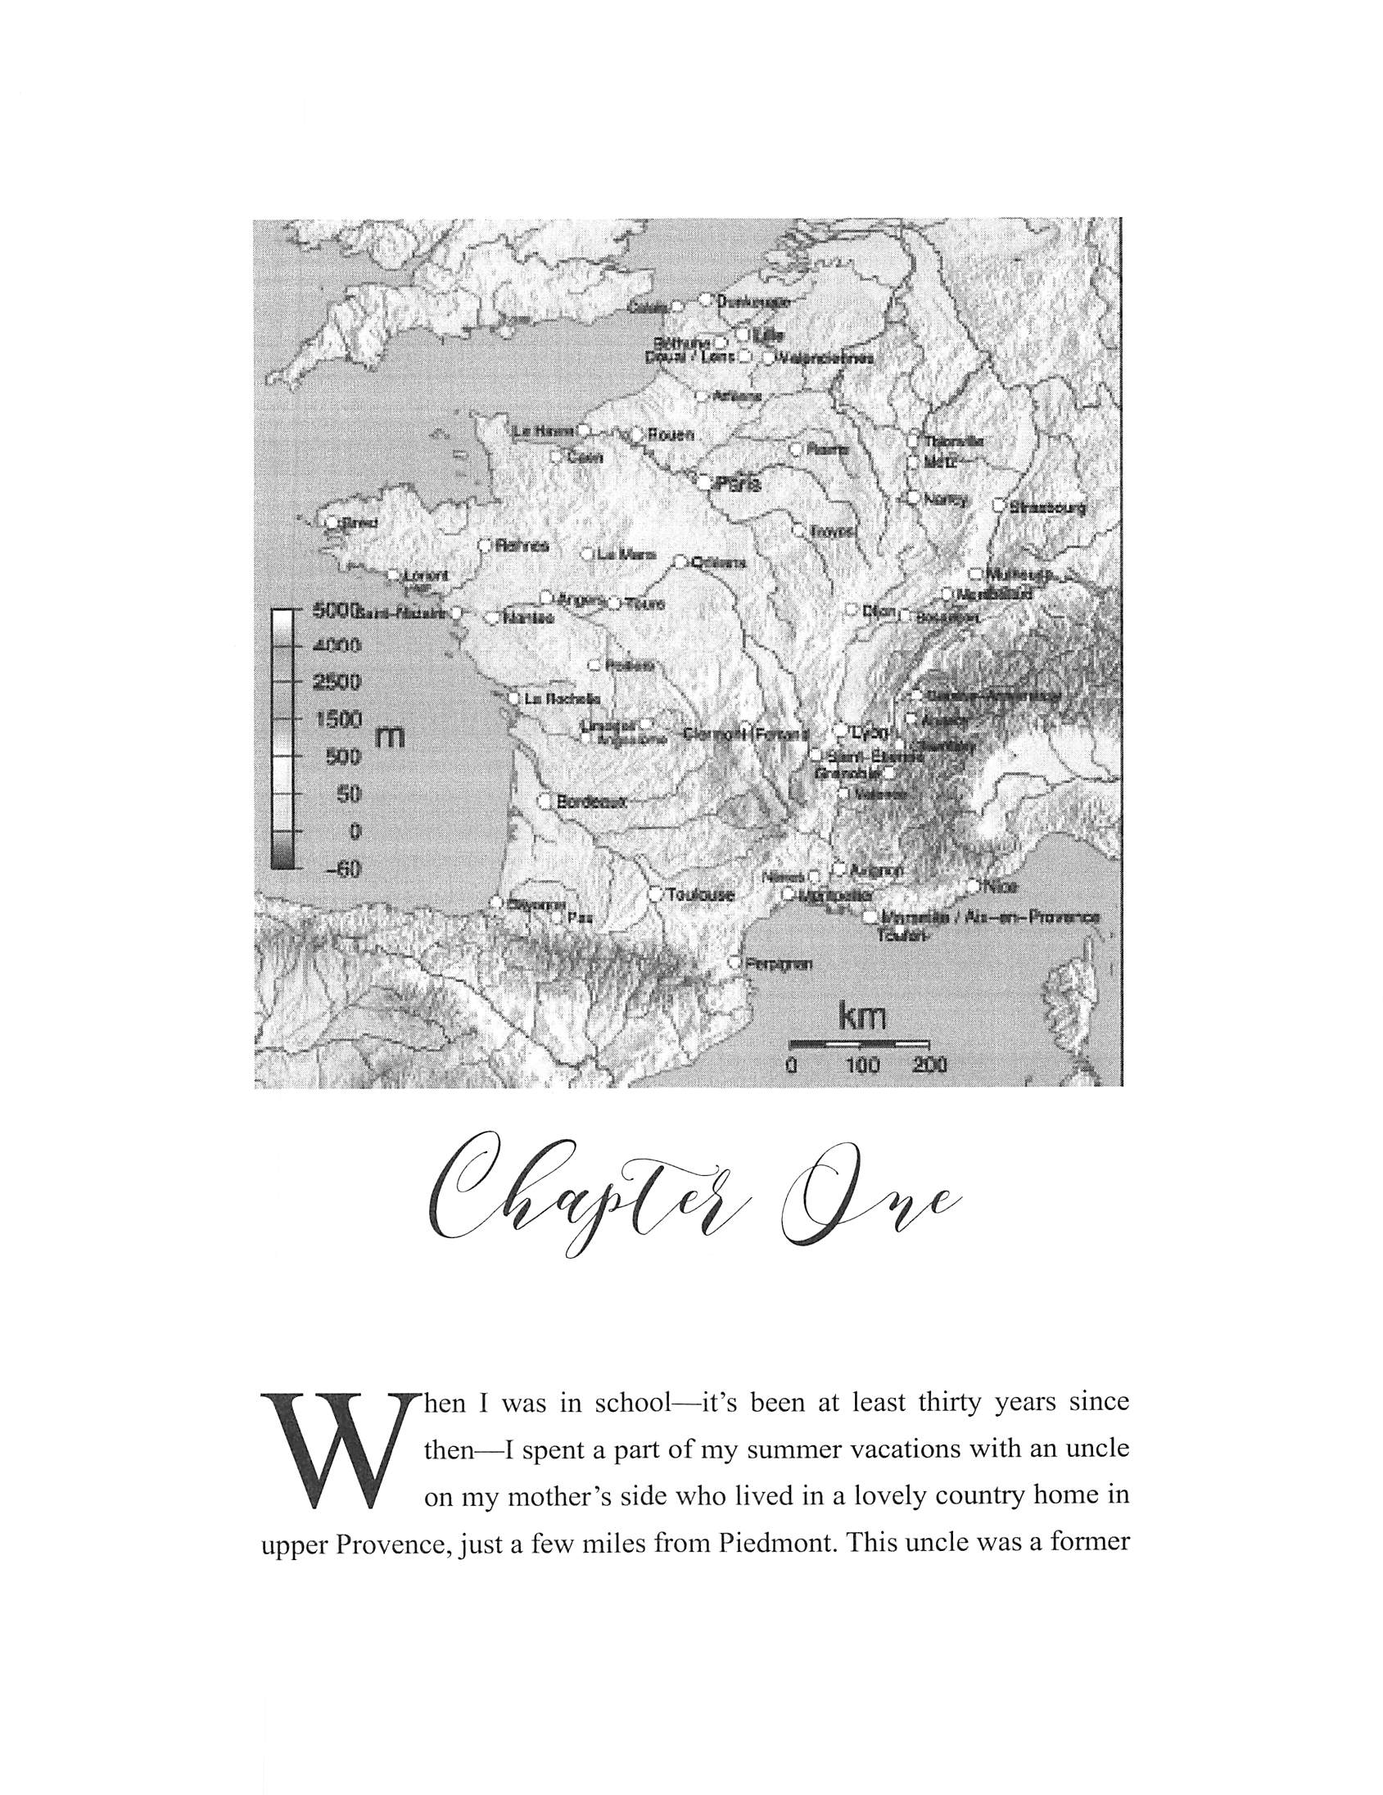

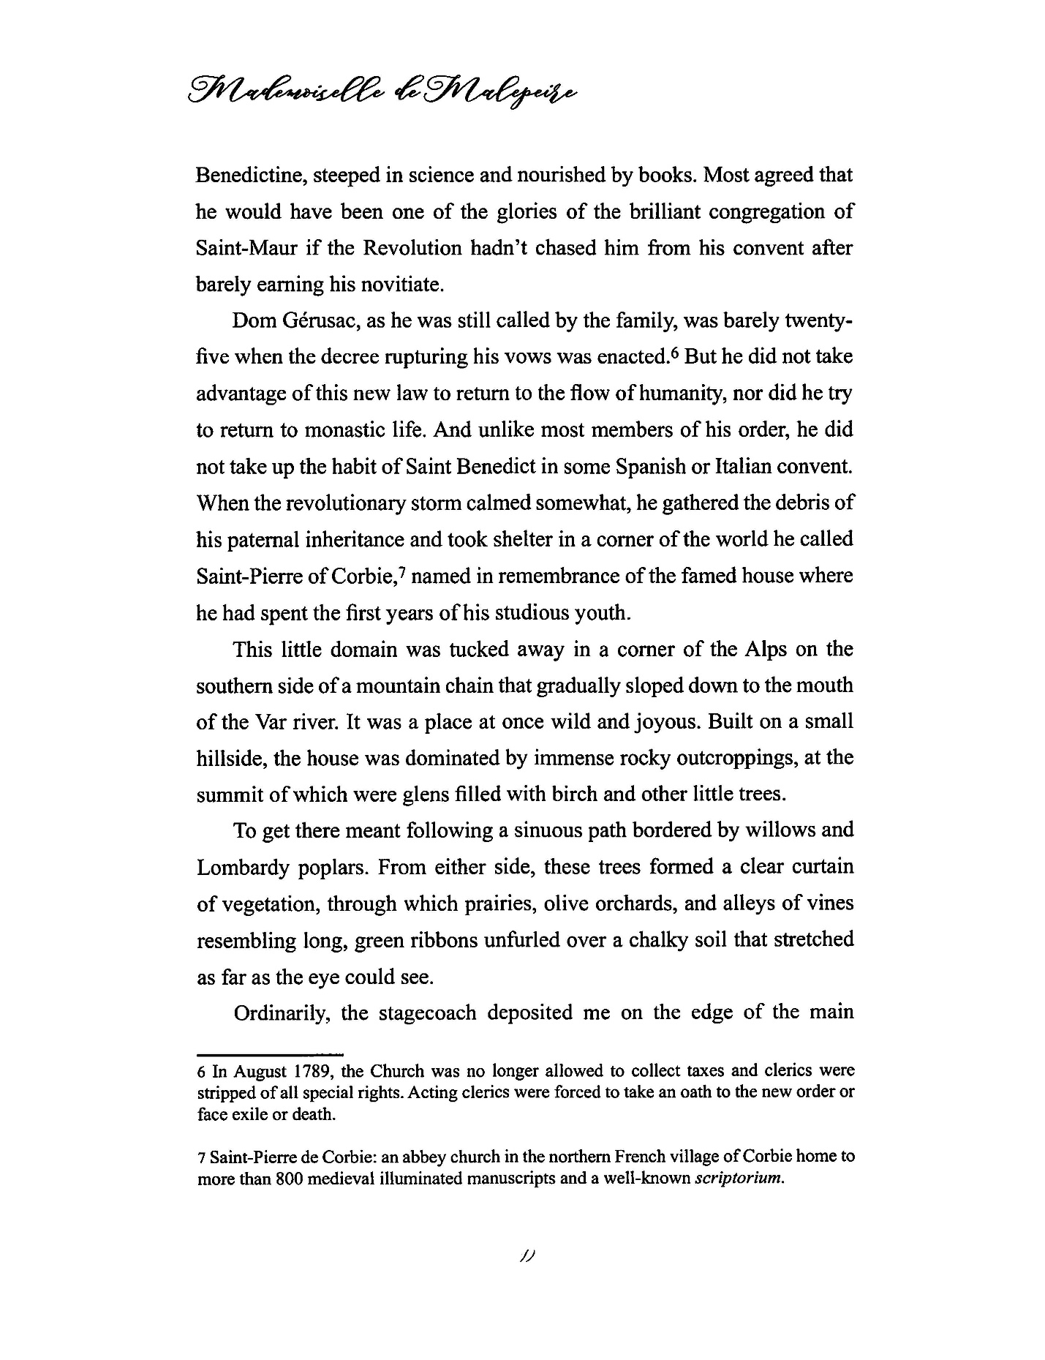
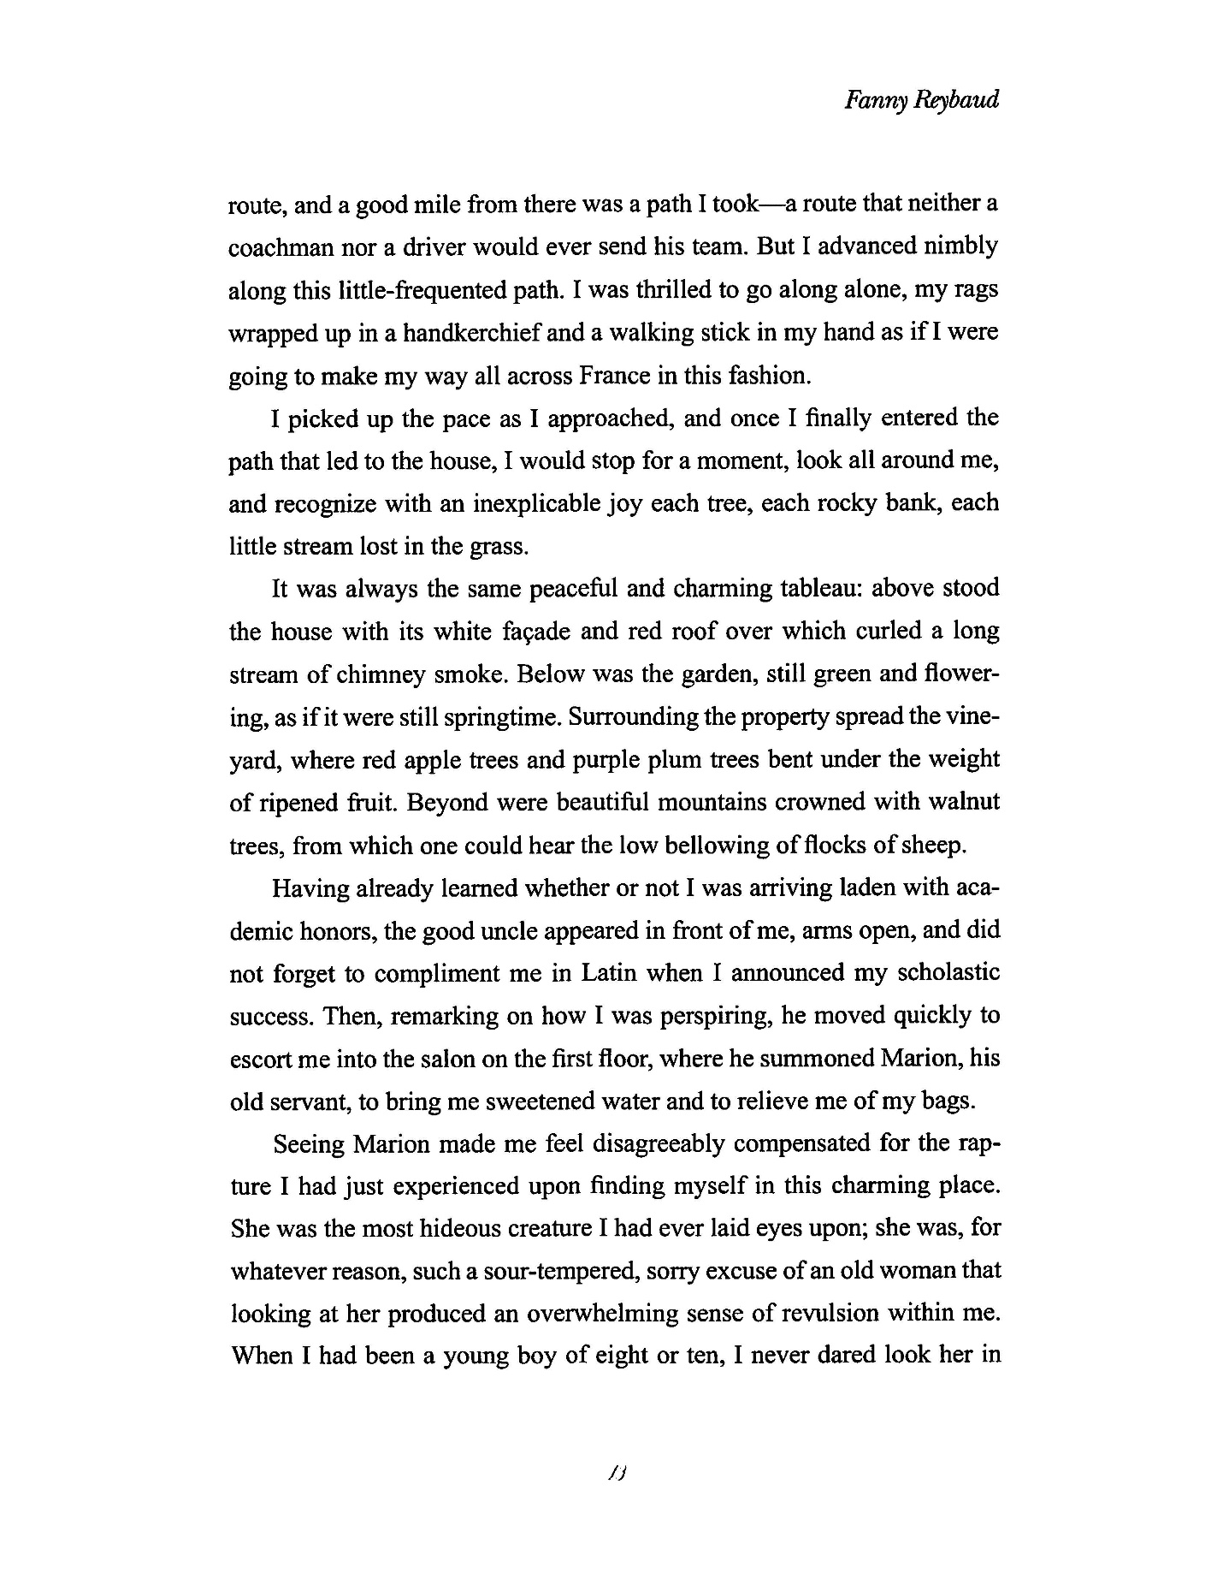

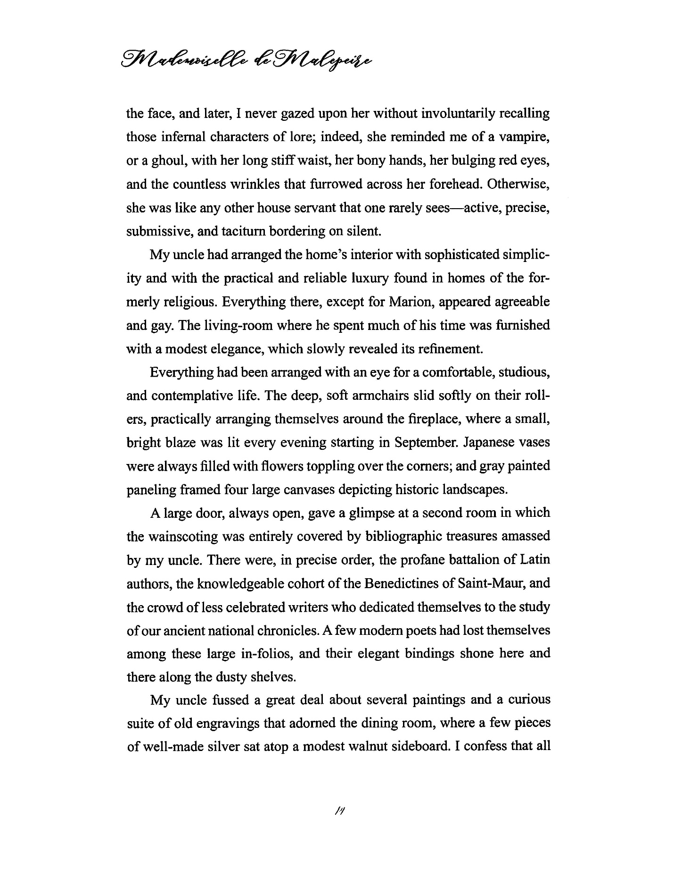
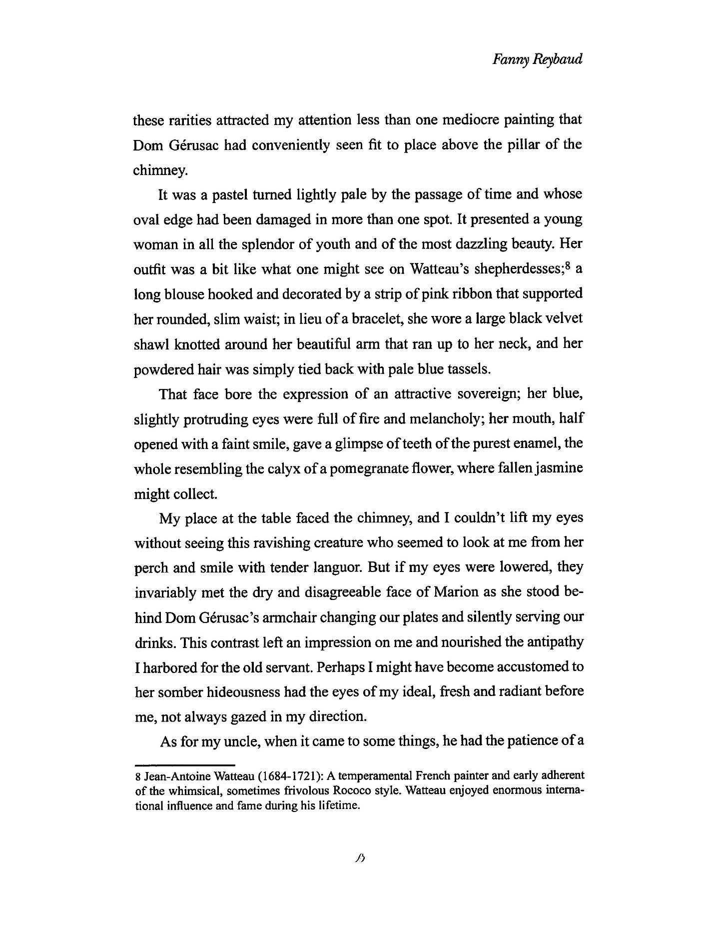
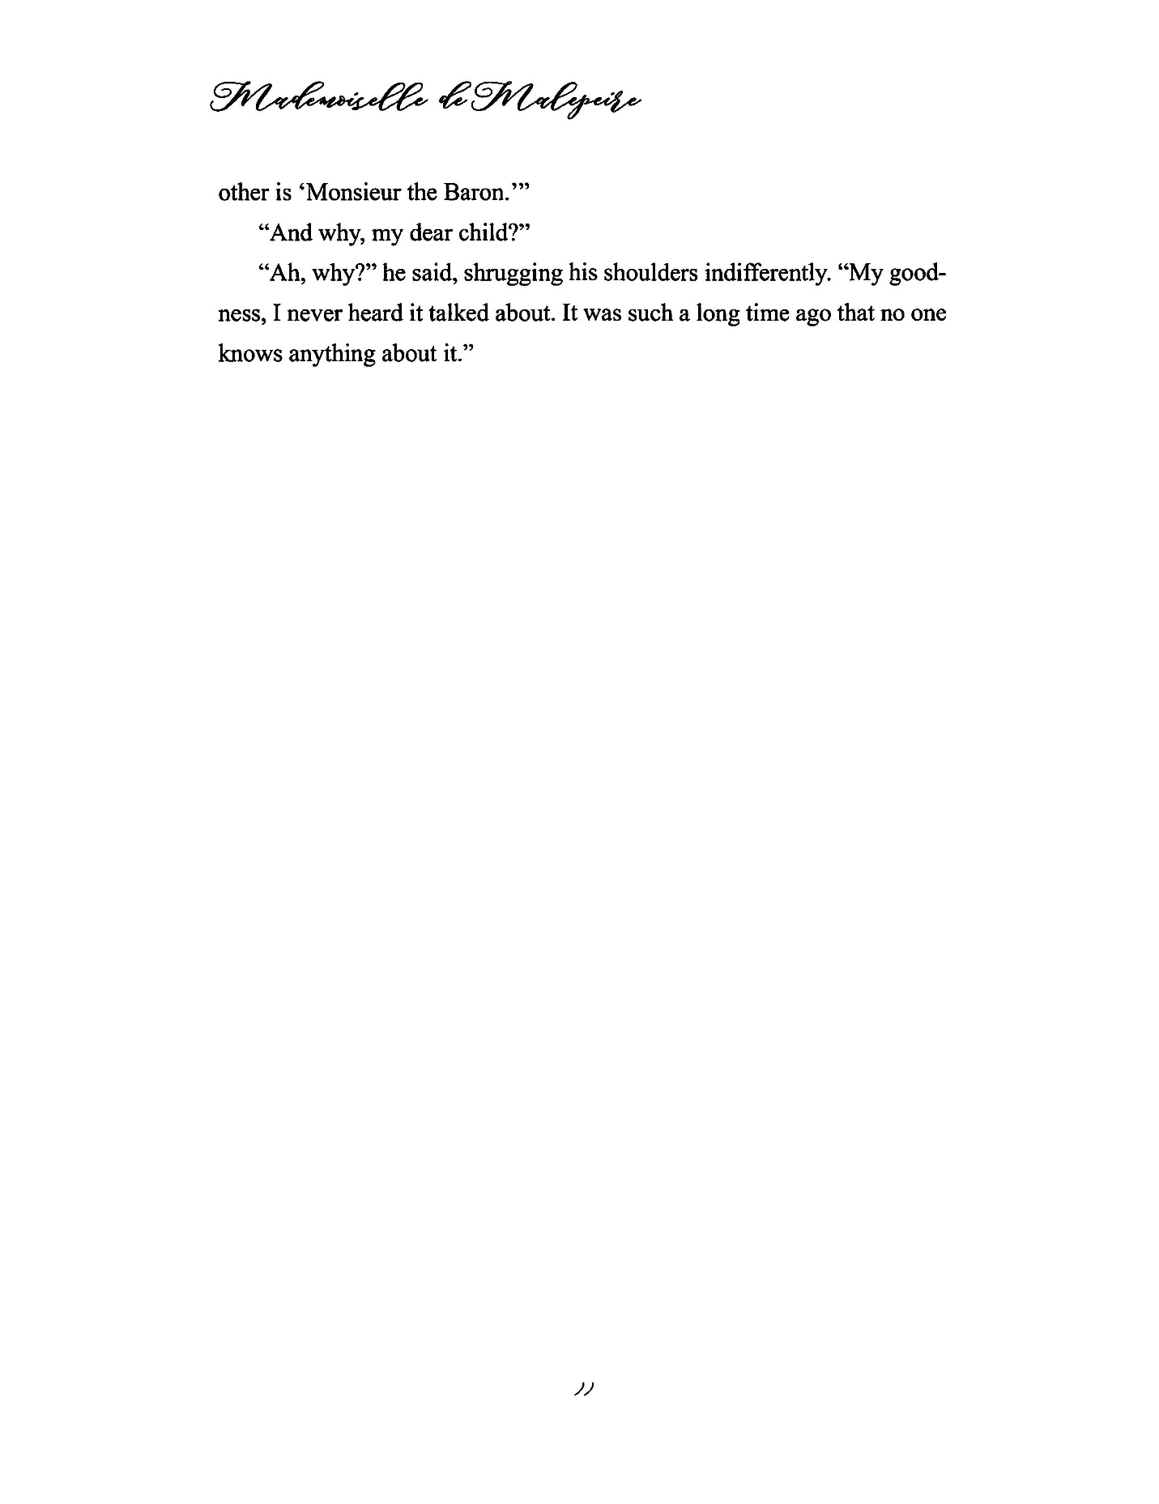

Q&A with Translator Barbara Basbanes Richter
- What is the central theme of the novel?
Fanny Reybaud’s novel examines the themes of honor, duty, freedom, and a woman’s place in society. Perception is perhaps is one of the greatest themes, while prudish moralism and its consequences is another.
- Is this novel more or less of a romantic drama?
Mademoiselle de Malepeire is a Romantic novel, but unlike George Sand, a fellow French Romantic writer of the 19th century, Reybaud hardly offers an idealized look at love. Rather, Reybaud turns the idea of Romanticism on its heels and reveals a story that shuns the notion that love can triumph all. When romantic literature is done well, as I believe is the case here, it provides a nuanced examination of prevailing social and cultural issues. When Reybaud wrote this novel (1854 and 1855), France was barely fifty years past the bloody uprisings of the Revolution, and questions of equality were still very much a part of the national debate.
- Why is it important for anyone to read this novel?
Many of the issues Reybaud examines in Mademoiselle de Malepeire remain surprisingly current, such as women’s rights and social inequality. Granted, today we face far less of a cultural and social upheaval than the French witnessed during and in the aftermath of the French Revolution, but women continue to wrestle with identity—who we are, who others want us to be, and who we are meant to be—and how much of our identities are shaped, for better or for worse, by men.
- Were there any special problems in the way the writing translated?
No. However, my goal was to strike a balance between maintaining Reybaud’s voice and style and keeping contemporary readers in mind. For example, some slang and metaphors would probably confuse most readers if translated literally; I tried to offer English equivalents without making the text sound as though it had been recently written.
- Do you feel as if you did the story justice?
I do. I think Reybaud’s wit is on full display here. Of course, I’m most interested to see what readers think.
- Do you think being able to converse with the author would have improved this translated version of the novel?
I don’t think speaking with Reybaud would have changed the way the translation came out. Her words need no further interpretation or explanation. That said, I have so many questions about her personal life that remain unanswered.
- Do you think she would have changed anything if she were alive today, and knew that her story was being translated again?
I doubt she would have changed much—perhaps Reybaud might have set the story in Iraq or Afghanistan, or perhaps even in India, where women’s equality remains a battleground topic and patriarchy dominates. Interestingly, Mademoiselle de Malepeire was one of the earliest books to be translated into Arabic in 1858 in Syria, a moment in that country’s history when women’s rights were a major point of discussion. Reybaud is one in a surprisingly long line of women writers—starting, it can be argued, with French medieval author Christine de Pizan—who have attempted to define or redefine the role of women. Reybaud, and many authors before and after her, have struggled with what a woman’s role in the world ought to be and whether she is in a position to achieve her goals.
- How do you feel about the fact that a story that is 166 years old is still relevant? What does this say about the way our world works, and what do you think Fanny would have had to say about that?
I’m not sure what Fanny would have to say about the continued relevance of her book—she had once expressed disdain for “women authors” such as herself, yet that hardly stopped her from producing a significant body of work. I think this book is a reminder that there continue to be differences of opinion on how men and women interact with each other. Unconscious gender bias exists at all levels of society—and it cuts both ways, but more often than not, it seems that a male bias against women has greater negative consequences than in the reverse.
- Which male character in Mademoiselle de Malpeire is your favorite?
Favorite is a tough term. I suppose I appreciate the young nephew, Frederic, because he evolves. Dom Gérusac, his uncle, remains aloof, and Maximin de Champaubert never learns the full truth of his beloved from many years past. The baron and Pinatel serve as studies in opposition—neither is willing or capable of change.
- Which one do you dislike the most. Why?
Actually, I don’t dislike any of the characters. I find Mademoiselle de Malepeire to be a font of contradictions, but my ultimate view of her is based entirely on male testimony. Let’s not forget, she murders her husband—was there no other solution to her predicament? Some readers may argue that she could have simply picked up and left, but where would she go? Who would take in a useless, unskilled ex-aristocrat?
- What about Mademoiselle de Malpeire make her most interesting to you?
Mademoiselle de Malepeire isn’t suited to either the aristocracy or the peasantry, but it appears that she never makes much of an effort to try, either. Granted, she may feel that any effort to conform is a waste of energy, so why bother in the first place, but Reybaud seems to suggest that you can’t simply pack up and move and suddenly your life will be better—you need some skin in the game, so to speak. I would argue that this book is a subtle jab at the prevailing Romantic literary movement, itself a reactionary format wherein the focus was on individualism and a renunciation of the modern world.
- How do you feel about women who put other women down for not conforming, considering this is something that happens in the novel?
Women are other women’s worst critics—always have been, always will be—but not all women. In my experience, women who put down other women often lack confidence in themselves.
- Do you think Mademoiselle de Malepeire’s attitude toward men is justified? She seems very hotheaded and unreasonable towards any man but the one she chooses, even if they have good intentions.
“Justified” seems too strong a word, and it’s interesting that you use the terms “hotheaded” and “unreasonable” to describe her behavior. From a man’s perspective, she’s all of that. And, she’s more than “hotheaded” towards her husband—she kills him. But, put yourself in her shoes for a moment. Here is an aristocratic girl, barely twenty, clearly headstrong, forced into an arranged marriage. She’s had zero education or any kind of formal training for a future among the elites, and now she’s expected to move to Paris and leave the only home she’s ever known. Some might say that’s too bad for the poor little rich girl and she ought to get over it, but other readers may see her as a victim of circumstance—if she had the option to be alone, to live an independent life, might she have done so?

- How did you discover Fanny Reybaud’s book? What drew you to this work specifically over her other published works?
I first discovered this book back in graduate school during a course on Reybaud’s contemporary, George Sand. We read Mademoiselle de Malpeire as a counterpoint to Sand, and, I enjoyed it immensely, but once the course was over, the book went into my library, where it sat for over a decade. I returned to that same dogeared, highlighted paperback while looking for something to read in French for pleasure, and again, Reybaud dazzled. This time, partly due to my reluctance to simply reshelve the volume, I challenged myself to translate it, with the goal of making it enjoyable for a modern reader with no understanding of the French language. The footnotes peppered throughout the book were included with that imagined reader in mind.
- After your research on Fanny Reybaud, do you feel that you connect with her, or is it more of an admiration for her work that inspired you?
I admire Reybaud’s tenacity--much of her early work fell on deaf ears--and her personal life in adulthood was tumultuous--and yet, she persisted.
- What is the most difficult part of the process when translating a 19th century story like this one?
Retaining Reybaud’s singular style and ensuring readability in the 21st century.
- Did you find it difficult to maintain Fanny Reybaud’s “voice” as you translated the story from French to English?
No, and it is a joy to see her words in English and to share them with people who might not otherwise have the opportunity to read her work.
- Do you intend on translating some of Reybaud’s other published works? Or are you planning on rediscovering other French female writers who have been uncelebrated?
Reybaud has many more works to be translated, and I have a few in mind I’d like to tackle next.
- Why do you think it’s important to make French literature accessible to the English-speaking world?
One of the finest literary legacies in the world is rightfully claimed by France and the Francophone world. France awards approximately 2,000 literary prizes annually, and there’s even a weekly prime-time television show dedicated to interviewing authors and discussing books—it’s hard to imagine such a program succeeding here in the United States—only the weekend BookTV program on CSPAN2 compares, and that’s almost entirely for books of non-fiction. That said, these treasures of the French-speaking world are often ignored or overlooked by English readers for a variety of reasons—a misinformed sense of snobbery or elitism primary among them. Translations, done well and with care, offer English speakers the opportunity to revel in the wordplay and nuance at which many French authors, both past and present, excel.
- What role has literature played in your life? Do you think literature is taking a back seat in the modern era?
I grew up in a home of bibliomaniacs. My father is Nicholas A. Basbanes, author of A Gentle Madness (Holt) and, most recently book number 10, Cross of Snow: A Life of Henry Wadsworth Longfellow (Knopf). (Side note: both father and daughter have books coming out in 2020, which I think is pretty special.) Prior to writing books, my father was book editor at the Worcester Telegram & Gazette, which meant we received boxes of review books. Besides being on a first-name basis with the deliverymen, this continuing, nearly endless literary bounty ensured a steady supply of reading material, in which I indulged regularly. French literature, however, sparked my imagination, and I eventually earned undergraduate and graduate degrees in French Language and Literature. After teaching French and Latin for nearly a decade, the siren call of the biblioworld beckoned, and so I became a book reviewer and regular contributor to magazines like Fine Books & Collections, but often with a focus on the Francophone world. Now, when I’m not translating forgotten literary jewels, I run a ghostwriting business, where I help people create their own stories, so I’d say that I am fully immersed in the world of literature.

- Do people still read books for pleasure?
I believe people crave great stories. Many of us passively watch stories on screens rather than engage in the act of reading, but we are, I think, all looking for the same thing, which is a great story. Netflix alone went on a book buying spree in 2019. Why? Because books provide great inspiration for visual content. The format changes, the intent is the same. Though I will forever argue that reading a book provides a richer reward than watching a screen adaptation, there is, thankfully, room enough in the world for both.

The Translator’s Own Questions for Book Club Discussions

(Because of Plot Spoilers, Look at Them ONLY After Reading the Book)

As a member of a modern-day audience, do you sympathize with the position that Mademoiselle de Malepeire is in, or should she away turn from love in the name of family duty and the traditions of the nobility?

Do you think Marquis de Champaubert is worthy of sympathy in his telling of the story?

What relationship do you feel is the most genuine in Mademoiselle de Malepeire? What role do these relationships play in order to move the plot forward? What relationships influence your own life?

This 19th century book has been “rediscovered” and translated into English. How do you think it will be received differently by an 19th century audience versus a modern audience?

Would you want to visit (or live in) the 19th century as described in this book?

Is there a time when you, like Mademoiselle de Malepeire, were influenced by your heart (not necessarily in a romantic way) when making a decision? What were the consequences of this?

Honor plays an important role in this book. Mademoiselle de Malepeire’s honor is protected until she elopes, the Marquis de Champaubert is honored by her family and Dom Gérusac, and François Pinatel honors his mother more than his wife. Is there someone you honor in your own life? Is there a trait or virtue that you find more important than honor?

Do you think it was fair that Mademoiselle de Malepeire was given a second chance at life through her role as Marion? Was this manual labor a way to atone for the death of her husband, or should she have remained imprisoned? Is there anything in life that you feel the need to atone for?

After hearing the story of Mademoiselle de Malepeire, the nephew was still enthralled with the painting and was intent on stealing it from his uncle. Do you understand his unwavering fascination with it and his motivation to possess it?

This book takes place prior to the bloody French Revolution. In what ways can you see the building tension between the peasants and the nobility in the book? Do you think this tension is present in American communities today?

Towards the end of the book, the Marquis de Champaubert desires to learn of Mademoiselle de Malepeire’s current identity: “My intention is that from now on, her needs will be met and she will enjoy her final days in peace.” Do you find it surprising that the Marquis would be so generous with someone who had slighted him and broken his heart? Would you make the same offer in his position? Have you had to forgive someone in similar circumstances before?
About the Translator
Books have always been part of the life of Barbara Basbanes Richter, who’s both a bibliophile and a Francophile, and there was no way she could have grown up without an appreciation for the power of the printed word. After receiving both a BA and an MA in French Literature (Smith College and Tufts University, respectively), she taught French and Latin for the better part of a decade. As the department chair of a world languages program in Fairfax County, Virginia, she led the development of a school-wide world language curriculum and resurrected a dying French and Latin program.
She also has translated works from French to English before, and her translations have appeared in the following books by non-fiction author Nicholas A. Basbanes: On Paper (Knopf 2013), Every Book Its Reader (HarperCollins November 2005), and Patience and Fortitude (HarperCollins October 2001). In 2015, she translated nineteenth century French correspondence for Wedgestone Press, an endeavor funded by the National Endowment for the Humanities dedicated to transcribing and publishing the documents of Robert and Elizabeth Barrett Browning and their circle.
Now, in addition to translations, she interviews authors, illustrators, and other movers and shakers in the book world for Fine Books and Collections Magazine and for Literary Features Syndicate. She has written about spy libraries, book arts programs for children, Alice in Wonderland's 150th birthday, Shakespeare on Letterpress, even bibliotherapy and how ISIS funds its terror programs by selling antiquarian books. She also wrote an essay about danger in children’s literature for the Spring 2015 issue of The Sewanee Review, and a long article, “Benjamin Franklin and the Pamphlet Wars,” for the digital version of Humanities Magazine, the magazine for the National Endowment for the Arts. Other publications include reviews and profiles for High Country News, Ravishly.com, FACES Magazine, and FSR Magazine.

