Press Kit

Kaitlyn’s Wheel: A Sci-Fi Romance by Chris Halvorson

Author
Chris Halvorson
Culver City, CA 90230
halvorsonc@gmail.com
(310) 526-3023 (cell)
@halvorson.christopher (Instagram)
https://www.facebook.com/profile.php?id=100013792485969 (Facebook)

Publisher
Bruce L. Bortz
Bancroft Press
La Crescenta, CA 91214
410-627-0608 (cell)
bruceb@bancroftpress.com
bruce.bortz@gmail.com
www.bancroftpress.com

Title Info
Kaitlyn’s Wheel: A Novel
Bancroft Press
May 2, 2023
$22.95
YA-Crossover Fiction
978-1-61088-552-2 (HC)
978-1-61088-554-6 (Ebook)
978-1-61088-556-0 (Audiobook)

Distributor
Baker & Taylor Publisher Services (the premier worldwide distributor of books, digital content and entertainment products from approximately 25,000 suppliers to over 20,000 customers in 120 countries) 30 Amberwood Parkway Ashland, OH 44805

Publisher Info
- Been a top-ten indie since its start in 1992
- Profiled by Publishers Weekly
- Publishes 4-6 books a year
- Distributed nationally by Baker & Taylor Publisher Services
- Frontlist and backlist titles frequently optioned or bought by Hollywood producers
- Publishes almost all types of books, from memoirs to mysteries, young adult novels to history and biography
- Bancroft books have received numerous starred reviews—four, in fact, for two 2018 summer books—and have won numerous awards
- The Missing Kennedy, a NYT ebook bestseller, was on the cover of People Magazine when published in 2015
- Published the books of four Pulitzer Prize winners (Alice Steinbach, Stephen Hunter, Elizabeth McGowan, and Mark S. Johnson)
- Operated internship program with colleges and universities around the country each semester (and summer) since 1992

Overview
KAITLYN’S WHEEL by debut novelist Chris Halvorson is the ultimate teen romance…but with a supernatural and environmental twist.
In rural Iowa, eighteen-year-old Kaitlyn Stokes witnesses a UFO over her house the night her father dies of cancer, giving her reason to believe he was taken by aliens. She secretly hopes he may someday return as an “ancient astronaut,” a theory based on modern science.
In the Pacific Northwest, Zachary Taylor sarcastically tells his high school principal that he was abducted by aliens, his excuse for skipping classes the day before. When the school secretary overhears him, she tells her teenage daughter and the story goes viral on social media, leading to a frenzy of TV news reporters outside his house.
Seeking answers, Kaitlyn connects with Zachary and their love story begins. With graduation just months away, they could soon overcome the distance between them - or so they plan until Kaitlyn discovers their relationship was built on a prankish lie. Brokenhearted and lost, Kaitlyn is greeted by a surprise visitor who gives her fatherly advice and the suggestion that a higher intelligence may have brought her and Zachary together for reasons no one could have ever expected.
Kaitlyn's Wheel is reminiscent of Mike Chen’s Light Years from Home, Lindsay Ellis's Axiom's End and Truth of the Divine, and the teenage drama in various John Green novels.
This exciting, vivid, and heartfelt debut novel destined to capture the hearts of readers.
Halvorson is an exciting new voice in YA, sci-fi, and crossover fiction!

Reasons to Read Kaitlyn’s Wheel
1) The book addresses serious issues facing future generations, such as climate change and robotics taking over jobs. Unlike many teen dystopian novels, however, it encourages young people to solve their problems by coming together.

2) In today's era of teens spending a great deal of time on their phones, we see the universal human need to make a real connection via social media.

3) The romantic connection is made after Kaitlyn witnesses a flying saucer over her house the night her father dies, and Zachary claims to have been abducted by aliens as his excuse for skipping school. It's a unique set-up to the story, and makes us question if aliens really exist (both in the story and in real life).

4) Kaitlyn's quest to connect with her deceased father explores some fascinating theories based on both modern science and ancient religions. Many creation theories cite flying saucers and alien beings, including Ezekiel in the Old Testament.

5) The tone of the book is emotionally compelling. As Kaitlyn grieves the loss of her father, she falls in love with a boy in another state. Through the sadness and disappointments, there are many comic moments. Their day-to-day activities feel very true to life.

6) The small-town country setting of Iowa offers many great characters, including Kaitlyn's mom, her best friend, and her church pastor, who offers wisdom without being preachy. Meanwhile, Zachary resides in a town modeled after Roslyn, Washington, a former coal mining town located in the mountains. The conflicting settings reflect the cultural differences between the Midwest and the Pacific Northwest but, as the story demonstrates, love can conquer those differences.

7) The novel’s supernatural elements bring a lot of action and mystery to the story. For instance, Kaitlyn builds a satellite to connect with her father on the other side, and Zachary drives into a tornado during his quest to finally meet her in person. When he sees a bright light at the end of the black funnel cloud, he believes it's heaven awaiting him. It later turns out to be an alien spaceship coming to his rescue.

8) It's the perfect "feel good" surprise ending---as we learn that Kaitlyn's father, his final mission, has been playing matchmaker from outer space. The planet needs love more than anything, which is the controlling theme of this teen romance, and why Kaitlyn and Zachary were brought together.
It's a one-of-a-kind romance with crossover appeal to all ages and genders.

9) It's very cinematic and visually told. The author's background is in screenwriting and film. That said, the novel does not read like a movie, but retains its literary value.

Q&A #1 with Author Chris Halvorson
- What was the research process like for this book? What kind of information did you research? How much did you already know?
I had very general knowledge of its scientific and biblical content, including Ezekiel’s Wheel which the TV show Ancient Aliens featured an episode about. For better knowledge and details, I found numerous articles online, such as the theory by former NASA scientist Dr. Rich Terrile that we’re living in a computer matrix as part of an alien experiment, and how the observatory at Ohio State University may have made contact with aliens through a radio signal. Since I’m not a techie or skilled with a toolbox, the biggest challenge was learning how to build a satellite dish. The best source was Dennis C. Brewer’s Build Your Own Free-to-Air (FTA) Satellite TV System, which became Kaitlyn’s manual as well as mine.

- What were some difficulties you faced in writing Kaitlyn’s Wheel?
Besides the challenge of keeping a daily writing regimen, I struggled with finding the right balance for Kaitlyn’s character that would make her flawed yet sympathetic and believable. I also feared making her too naïve in believing Zachary’s story without ever pushing him too hard for answers; however, I know from personal experience that we often choose to believe what we want to, especially during times of despair. Later on, Kaitlyn regrets her naivety and the humiliation that comes with it.

- How does the most recent draft of your story compare to your initial idea of it?
As I began writing, I knew the key plot points to hold the structure together, but many of the individual scenes came to life during the process. The biggest twist I hadn’t planned for is where the aliens had been influencing Zachary all along. Initially I feared it might seem too contrived or convenient, but ultimately decided it worked. Starting out, I also wasn’t sure about Kaitlyn building the satellite. I thought the subplot might take over the central story, so I had to be sure to interweave it with the other story elements.

- In what ways was the story influenced by your own life?
Like Kaitlyn’s father, my brother died of cancer, and soon after visited me in a dream as a “Light Being” described in the book. It was a very powerful experience, his final farewell which let me know he was in a better place. Also, the scene where Kaitlyn’s father makes a supernatural visit through the Christmas tree star is based on a family experience. My mother and sister were saying how they missed my grandfather during the holidays, when unexpectedly his former reading lamp came beaming on. I believe he was saying, “Hello, I’m always with you,” just like Kaitlyn’s father in the book. Since my college days, I’ve questioned life and death more than most after a tree fell on top of a car I was in. The woman driving wasn’t nearly as lucky as I was. After several weeks in a coma, she miraculously survived with impaired vision and cognitive issues which still impact her today. Oprah featured her in an episode which I chose not to appear in.

- What is the biggest takeaway you want people to have after reading your book?
That there could be some hope for the future, but the next generations are going to have to find a way to work together, both spiritually and through scientific advancements. Otherwise, they could be facing The Hunger Games as a reality. I loved that book series but wanted to write something in contrast to the dystopian teen novels that reflect the current psyche of young people. Instead of accepting a doomed fate, let’s take action.

- Why do you think that Kaitlyn and Zachary work well as a couple?
Consider it the corny romance element of the novel, but they are truly soulmates. They share the same intellect, passion, and curiosity about the world, yet they come from different backgrounds (conservative Midwest and liberal Northwest) which makes them equally curious about one another. Searching for answers, they will never find them alone, but on a journey together. They need each other’s friendship more than anything, to keep each other balanced.

- To what extent do you believe in the alien and supernatural tales/ sentiments mentioned throughout the story?
As portrayed in the book, the Phoenix Lights was a real incident which is impossible to ignore, along with so many other UFO encounters. Even the US Navy is finally allowing its pilots to discuss their alien sightings with media. The question is no longer whether aliens are among us, but how and when are we going to interact with them? We could sure use their help, and if Ezekiel in the Old Testament was truly referencing an alien spacecraft, then maybe his prophesy will eventually come true for all of us.

- Why do you think it is important for Kaitlyn and Zachary to meet in person at the end of the story rather than the beginning?
Kaitlyn just lost her father, so I felt it would be rushed to have her in a physical relationship with someone so quickly afterwards. In that case, it would probably be nothing more than a temporary escape from her grief. Since she and Zachary are both introverts, it felt right having them connect first as friends through text messaging. By talking to someone far away, it also builds longing and suspense to finally meet in person, along with the insecurities and fears that come with it. In the end, it’s a bigger payoff for both the characters and audience, that big moment we’ve been waiting for.

- How much do your values align with Zachary’s on the matter of climate change? How pressing of an issue do you find it in comparison to him?
I’m far from being as diligent as Zachary; however, I’ve vowed that my next car will be a hybrid and I do recycle; however, I still eat meat, through rarely beef. Truthfully, I think my generation will survive okay, but I fear for my nephew and his future children (should he choose to have them). Therefore, it would be easy for me to stay obliviously in denial, but a friend of mine (Barrett Stuart, who also produces movies) is writing op-ed articles on climate change and what we can do to slow it down. He’s expert in the field and has made an impact on me (along with Catholic guilt which is constantly a motivator).

- Which scene was your favorite to write and why?
The final sequence where Kaitlyn’s father appears on various devices in the house. It’s what kept me going on days I was low energy. I had to get to that moment, followed by his arrival in the spacecraft. Given its visual and emotional impact, I kept thinking of the Steven Spielberg’s movies I grew up with (while hoping he might direct the movie adaptation).

- How did you come up with the idea for Kaitlyn’s Wheel?
That one is hard to answer. For a few months, I’d been grappling with an outline for another YA novel and couldn’t make the pieces fit. While doing dishes one evening, I was struck with the idea for Kaitlyn’s story and wrote the first scene the next day. It was the story I’d been needing to tell, which finally surfaced out of nowhere (though water is very meditative, even in the kitchen sink with soap suds).

- What do you imagine happens to Kaitlyn and Zachary after the story ends?
I think they will be happy and without regret, but no relationship is without its bumps. They grow closer, they drift apart due to their hectic schedules, they question getting married too young, but ultimately grow closer than ever. What keeps them together is their shared curiosity about the world and their passion to make it a better place for their children (which is a major decision for them to have). Plus they will always share the UFO experience which is a daily reminder of their destiny together. Not too many couples can say the same, so they are blessed.

- How did your family and friends react to your story?
Early on, I read the first few scenes to my girlfriend, who confirmed the story needed to continue. Since then, I’ve kept the novel under wraps, except for the brief synopsis. My family, especially sister, is eager to read it; however, I’d rather wait for the final edits before sharing it with anyone. It’s far more exciting to see a book off the press.

- How do you relate to the characters?
I related my former teen self to Zachary, a guy who doesn’t really connect with the high school crowd and pop culture. Kaitlyn is more mysterious. Over the years, I’ve become more like her in that I’m less eager to share myself with others. She keeps a safe distance from people, except for her mother and best friend Jenna (and Zachary of course).

- What has the publication process been like (so far)?
So far, so great. Bruce Bortz at Bancroft Press showed tremendous enthusiasm for the project. His editing made the book sing, hum, and dance (preferably the tango since it’s a story of passion and love).

- What genres do you read? What kinds of books do you read? Did any of them inspire Kaitlyn’s Wheel?
I read all genres, scouting the NY Times Top 100 picks each year and National Book Award nominees. My favorite YA authors include John Green, Katherine Applegate and Karen McManus, each giving a uniquely different flavor to their target audience. In other works, The Idiot by Elif Batuman features a college freshman close to Kaitlyn’s age, who communicates through emails with a student she’s in love with, despite them both being on the same campus. Hari Kunzru’s Men Without Gods was another major influence. Though conceptually different, it features a spiritual element of alien intervention after a boy goes missing in the desert.
- What made you write the protagonists as teenagers? What differences would there have been if they were any older?
Teenagers experiencing first love is far different than older characters with more jaded life experience. As high school seniors, they are legally adults but still living at home and therefore treated as children to some degree. On the cusp of real adulthood, they have college and their entire lives ahead of them. It’s a unique time in people’s lives and can be very frightening and exciting at the same time. After all, the future is unknown, no matter how much we think we can plan our careers and relationships.

- Did you any experience writer’s block while writing Kaitlyn’s Wheel or did it flow? If the former, how did you overcome it?
On a daily writing schedule, I wrote the first half of the novel without an outline, but then hit a wall on how exactly to execute the second half because I had too many ideas brewing with no clear direction. Therefore, I forced myself to write a “beat sheet” outline which put me on track the rest of the way. Worse than writer’s block is a 1000-page novel with dozens of subplots and characters which never pay off. That’s where writing becomes a discipline as much as a craft.

- What do you do when you’re not writing?
This reminds me of writing a bio on former dating sites, and realizing how boring I truly am. I love reading novels, binging on TV series and movies with my girlfriend, watching sports (without the girlfriend), and forcing myself to exercise every day. I love pizza and ice cream and all things bad for me. I’d like to have a cat but my place is too small and there’s dangerous traffic in front of my building. I need to travel more and plan on doing so before I’m too old to see the world. And before I get the cat, because then I will have to find someone to care for it.

- If you could meet any of the characters in your story, which ones would you choose and why? And what might you say to them?
I would most definitely meet Kaitlyn’s father if he could make one more visit in that spacecraft. Better yet if he can welcome me on board. I have no idea what we’d talk about, but I think we’d get along quite well.

Praise for Chris Halvorson’s Kaitlyn’s Wheel
"A brilliant trip through the cosmic expanse of the human heart."
—Shan Serafin, NY Times Bestselling Author

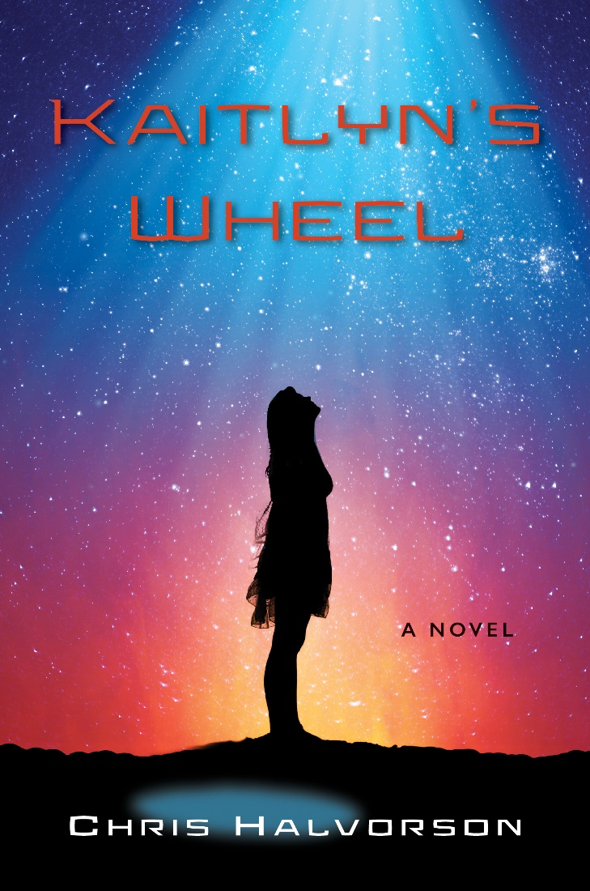
“In this high school romance, Halvorson’s prose style is simple and often effective.”
—Kirkus Reviews

“In his debut YA-crossover novel, Kaitlyn’s Wheel, Chris Halverson tells the story of two high school seniors who share life-changing experiences with UFOs, either real or imagined. Relying on texting and FaceTime, Kaitlyn (in Iowa) and Zach (in Washington state) fall in love as they sort through loss, college applications, troubled parents, and shifting friendships. Halvorson is quick to draw in his readers by opening with Kaitlyn’s first nighttime sighting of the alien ship, in the sky just outside her bedroom window. The story’s complications develop quickly, revealed in consecutive scenes focusing on one character at a time. Halvorson writes with energy and compassion; he brings in references ranging from religion to UFO theories to high school hierarchies. Young adults and older adults alike will appreciate the reality of the novel’s complications and enjoy rooting for Kaitlyn and Zach, and perhaps begin to keep a lookout for flashing, round, slightly familiar, extraterrestrial ships in the night.”
—Leslie Goetsch, Author of the Critically Acclaimed YA Novel Back Creek

“Kaitlyn Stokes, a teenager saddened by the sudden death of her father, clings to the belief that aliens have taken his soul, and that it might even be possible for him to return to Earth. No one believes her, especially her mom. Then Kaitlyn discovers Zachary Taylor, who lives many states away and has told everyone he was abducted by aliens. Kaitlyn, feeling she’s on to something, seeks out Zachary, only to discover…well, was his alien experience real or not? The journey that they both embark on creates a tender, warm, and funny story of love and friendship―of connecting with others who believe in you, no matter what, no questions asked. Both Kaitlyn and Zachary battle against non-believers, which leads to an emotional climax that brings tears to the reader’s eyes. Young teens are often misunderstood, and even worse, not believed. This story is about believing in our children, and allowing them to have thoughts and dreams that we as parents have long forgotten. It’s a beautiful story, told simply and elegantly.”
―Scott Rosenfelt, One of Hollywood’s Most Successful Independent Producers (Home Alone, Smoke Signals, Mystic Pizza, Teen Wolf, and Extremities)

“Kaitlyn’s Wheel, a moving and accessible YA novel, is a warmhearted reminder that we all want answers to the questions of the universe, especially where our loved ones end up. With its entertaining story and characters, it also makes the important case that deep down, what we all really need are people on this planet to connect with and love.”
—Sara Griffiths, Author of the Critically Acclaimed YA Novels Thrown a Curve and Singled Out

“A well-observed, heartfelt, and terrific novel. Author Chris Halvorson makes you believe in both teenage love and UFOs.”
—Daniel G. Sullivan, Co-Writer of the Hit Romance While You Were Sleeping

“A thoughtful and funny story of trust, growth, and hope.”
—Jennifer Medrano, Towson University
“Chris Halvorson’s thoughtful tale about two college-bound seniors is a sweet romance that addresses all the complexities of the human experience—the intensity of senior year, the loss of a parent, and relationships. It’s also an intelligent read that addresses real-world problems such as carbon pollution and climate change, and offers a supernatural element that allows teenagers to grapple with the mysteries of life.”
—Karen Hart, author of the Much-acclaimed YA Novel Butterflies in May

“I really liked this novel. It was easy to read and fun, and I became pretty invested in Kaitlyn and Zachary’s relationship. Author Chris Halvorson does an amazing job of writing a story that seamlessly weaves together teen romance, the characters’ interest in science, science fiction, and also faith.”
—Life According to Jamie Blog Review

Book Finds Interview of Chris Halvorson
May 5, 2022
Bookfinds

- Tell us the story behind the story. How did KAITLYN’S WHEEL come to be?
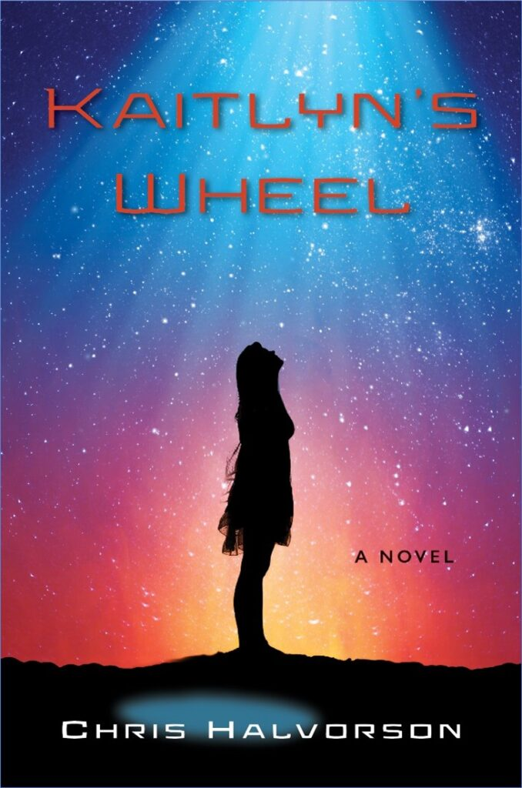
I’ve always been fascinated by UFOs and extraterrestrial life. It began in my childhood after I saw Steven Spielberg’s Close Encounters of the Third Kind. Fast forward to June of 2020: One night, while doing dishes in the sink, I was struck with the idea: Girl sees UFO right after her father dies. Boy claims to have been abducted by a UFO as his excuse for skipping school. His story goes viral and connects them. At the time, UFOs were not even on my mind, as I’d been grappling for several weeks to outline another novel. It does, however, show the meditative power of water (even soapy dishwasher) to tap into our subconscious minds, as it’s hard to say where ideas originate from.
Several years before, I’d first heard the story of Ezekiel’s Wheel, and how he was really describing a flying saucer in the Old Testament. It was also featured on the History Channel in an episode of Ancient Aliens. Around that time, I witnessed a UFO hovering over the Pacific Palisades at night; there were two glowing orange triangular shapes which suddenly took off at laser-fast speeds toward Malibu. Soon after, I learned that several people in the Palm Springs area had reported seeing “military crafts” being tested over the desert (about 100 miles away). I have to say, I was disappointed because I was hoping they were visitors from outer space. In the novel, I have a trucker reporting two glowing orange triangular shapes flying over the highway. His are definitely aliens.
2. What was the most challenging aspect of writing KAITLYN’S WHEEL?
It’s a ton of work writing a novel, and I had some days when I didn’t feel like writing, because I let the fear of rejection sour my mood. But I kept going, even on days when I was low energy or having my doubts. To stay motivated, I constantly reminded myself that the goal was to finish the best novel I could write, and not to worry about the reception it would get from agents and publishers. I also had many positive days, with a lot of energetic passion for the story.
3. What is the message you want readers to take away from your book?
That we can still make a difference to save our future planet, so that the younger generations have a chance for a better world. But we have to work together, and what the planet needs more than anything is love.
4. Describe your background. Did your background play a part in your book?
As mentioned, I’ve always had a fascination with extraterrestrial life and alien visitors. I also put a lot of myself into Zachary’s character, a teenager who’s a bit of a loner in the Pacific Northwest. That was me years ago. It’s not that Zachary doesn’t like people, he just doesn’t connect to many pop culture trends, which are so important in the hierarchy of high school. It’s hard for him to be a follower, so he copes by making fun of how ridiculous everyone is, including his own family, and the much larger world portrayed in the media. Through Zachary, I was able to write some satirical material.
5. Describe your writing schedule. Do you outline? Any habits?
When I’m working on a project, I write for 2-3 hours every morning before leaving for the day job. On my days off, I generally write in three hour sessions, twice per day. Lots of coffee and energy drinks. I didn’t use an outline for the first half of the novel, but put together a simple “beat sheet” prior to writing the second half. I feared having too many subplots and characters, so the beat sheet kept me on course to the end (so I wouldn’t end up with an unreadable 700 page novel).
6. What books are on your nightstand? What are you currently reading?
Some books I plan to read soon are: Cloud Cookoo Land by Anthony Doer, One Last Stop by Casey McQuiston, Velvet Was the Night by Silvia Moreno-Garcia, The Sanatorium by Sarah Pearce, Great Circle by Maggie Shipstead, and The Topeka School by Ben Lerner. I’m currently reading Golden Age by Jane Smiley; it’s the third in her Family Saga/100 Years trilogy.
7. Which authors do you admire?
Too many to count, but some of them include: Glen David Gold, Michael Chabon, Jonathan Lethem, Haruki Murakami, Jeffrey Eugenides, Jonathan Franzen, E. Annie Proulx, Ian McEwan, Richard Russo, John Kennedy Toole, John Connolly, Claire Messud, Audrey Niggenegger, Chad Harbach, Rachel Kushner, Louise Erdich, Donna Tartt, Don DeLillo, Sherman Alexie, Phillip Meyer, Richard Powers, Jennifer Egan, Amor Towles, Ian McEwan, Esi Edugyan, Rebecca Makkai, Lisa Ko, Lauren Groff, Paulette Jiles, Jane Smiley, Susan Choi, Charles Yu, Douglas Stuart, and my favorite, Hari Kunzru, whose Gods Without Men helped inspire Kaitlyn’s Wheel. In the YA category, my favorites include: JK Rowling, Suzanne Collins, Katherine Applegate, M.T. Anderson, Karen McManus, John Green, Robert Cormier, and Brad Land.
8. What have you learned from this experience?
To keep believing in the process and to control what I can. I also became a better writer, and learned a lot from my publisher and editor, Bruce Bortz.
9. What is the best piece of advice you have ever received? What is one piece of advice you would give your younger self?
Janet Roach, a dramatic writing professor at Columbia University, once told me to “get in touch with my soul” after I turned in a screenplay which was modeled after There’s Something About Mary meets American Pie. Both were popular movies at the time, and I was simply trying to please Hollywood to sell a script. Truthfully, I had written a piece of raunchy garbage, and it wasn’t even commercial because of it. Therefore, it’s much better to write something that’s personally meaningful, which in turn, has a far better chance of being recognized, both artistically and commercially.
If I could go back in time, I would tell myself to slow down because there’s no rushing success in the film or publishing industry. If I had it to do over, I would have taken an extra semester in the MFA program to intern with a production company or publishing company. Getting a foot in the door is so hard to do, but I was in a hurry to move to LA and take the world by storm.
10. What are you working on now?
I’m adapting Kaitlyn’s Wheel as a TV series.

https://una.edu/pressroom/2022/12/una-alum-publishes-science-fiction-teen-romance.html

UNA Alum Publishes Science-Fiction Teen Romance

Dec. 13, 2022
Caroline Conkle , at cconkle@una.edu
University of North Alabama graduate Chris Halvorson’s novel, Kaitlyn’s Wheel, a science-fiction teen romance, is being published by Bancroft Press.
Kaitlyn’s Wheel is the story of Kaitlyn Stokes, who lives in rural Iowa, and Zachary Taylor from the Pacific Northwest, who come together in an unusual way. The novel features a teen romance, with a supernatural and environmental bent, and Halvorson tackles heavy issues, such as familial death and climate change through an optimistic lens.
Halvorson had an opportunity to share his thoughts on his novel and how UNA has been foundational in his success throughout the years. Here he is in his own words.
Q: What inspired you to write Kaitlyn’s Wheel?
A: One night, several years ago, I witnessed two glowing orange triangular shapes flying over the Pacific Ocean from my vantage point in Palisades Park, in the greater Los Angeles area. I stopped to watch, along with a female jogger whom I had never met – just the two of us there. We said very little, except something along the lines of “What is that?” After a minute or so, the two parallel crafts went flying off at incredible speed toward Malibu and quickly vanished. Without another word, the female jogger and I proceeded to head off in opposite directions. I think she was just as numbed by the experience as I was.
The day after, I learned that several people in the Palm Springs area had reported seeing military crafts being tested over the desert (about 100 miles away). Regardless, I thought that witnessing a UFO would have been a unique way to romantically connect with someone. I also thought it would make an interesting premise for a novel, but I didn’t have any material for what happens after the two people share the experience. Several years later, the story popped into my head while I was doing dishes in the sink.
Q: What authors have influenced you through your literary journey?
A: There are too many great authors to mention, but a few of my favorites are Jennifer Egan, Michael Chabon, Haruki Murakami, Rebecca Makkai, Jonathan Franzen, Glen David Gold, and Hari Kunzru.
Q: What classes did you take at UNA that influenced your decision to become a writer?
A: My original plan was to attend law school after getting bachelors’ degrees in writing and history. While taking courses in journalism, feature writing, and composition, I discovered a much stronger passion for language arts than I first realized. In my final year at UNA, I took creative writing courses, and that’s when I decided to pursue the craft of writing novels and screenplays.
Q: Why did you choose the Young Adult genre?
A: I decided to make the characters seniors in high school because I remember that time in my life. There was so much to think about then – chiefly, the future and what my purpose was in life, which, in turn, raised many spiritual questions. That said. I didn’t really approach the novel as YA, but rather just told the story through the characters’ point of view. It’s being marketed as a YA teen romance, but there’s a cross market appeal to a mainstream adult audience.
Q: What is the last great book you read?
A: Velvet is the Night by Silvia Moreno-Garcia. It made the NYT Book Review for Top 100 Books of the Year, but I truly bought it (I confess) because of the cover – it’s one of the coolest I have ever seen. The author delivers a heavy-hitting story that takes place during the political and social upheaval of 1970s Mexico. It’s terrific.

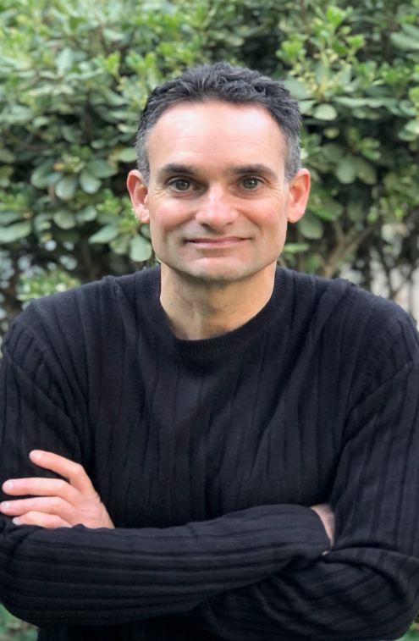
About the Author
Chris Halvorson was born and grew up in Seattle, went to college in Alabama (University of North Alabama), graduate school in New York City (an MFA in Film from Columbia University, and now lives in Culver City, California.
He wrote the screenplay The Boondoggle for producer Joe Roth, the former head of Disney and Fox. It was packaged by CAA with Steve Carr (Mall Cop) attached to direct.
He adapted his novel The Santa Suit for Frank Konigsberg Productions, developed TV and film projects for The Meg producer Ken Atchity, and was hired to rewrite the action spy comedy Best Served Cold that was originally in development with Pierce Brosnan's Irish DreamTime.
With Home Alone producer Scott Rosenfelt, he co-created and produced the TV sitcom pilot Earth Mom.

