Press Kit
The Throwaways: A Jake Savage Mystery
By Elliott Light
Contact Info:
Publisher
Bruce L. Bortz, Publisher
Bancroft Press
PO Box 65360
Baltimore, MD 21209
410-358-0658
410-627-0608 (cell)
bruceb@bancroftpress.com

Author
Elliott Light
Naples, FL 34109
Elight65@gmail.com
(301) 251-9221
URL for radio interview: https://wnbnetworkwest.com/welcome-authors-show

Title Info
Bancroft Press

Fiction/Mystery/Social Issues
ISBN: 978-1-61088-597-3 (hardcover) $25.00
ISBN: 978-1-61088-529-4 (ebook)

Distributor
Baker & Taylor Publisher Services (the premier worldwide distributor of books, digital content, and entertainment products from approximately 25,000 suppliers to over 20,000 customers in 120 countries): 30 Amberwood Parkway Ashland, OH 44805.

Publisher Info
- Been a top-ten indie since its start in 1992
- Publishes 4-6 books a year
- Distributed nationally by Baker & Taylor Publisher Services
- Frontlist and backlist titles represented in Hollywood by Grandview Management (Sean Berad)
- Publishes almost all types of books, from memoirs to mysteries, young adult novels to history and biography
- Bancroft books have received numerous starred reviews—four, in fact, for two 2018 summer books—and have won numerous awards
- The Missing Kennedy, a NYT ebook bestseller, was on the cover of People Magazine when published in 2015
- Recent mystery (Her Kind of Case) received star reviews from all but one of trade review publications
- Published the books of four Pulitzer Prize winners (Alice Steinbach, Stephen Hunter, Elizabeth McGowan, and Mark Johnson)

Quick Overview

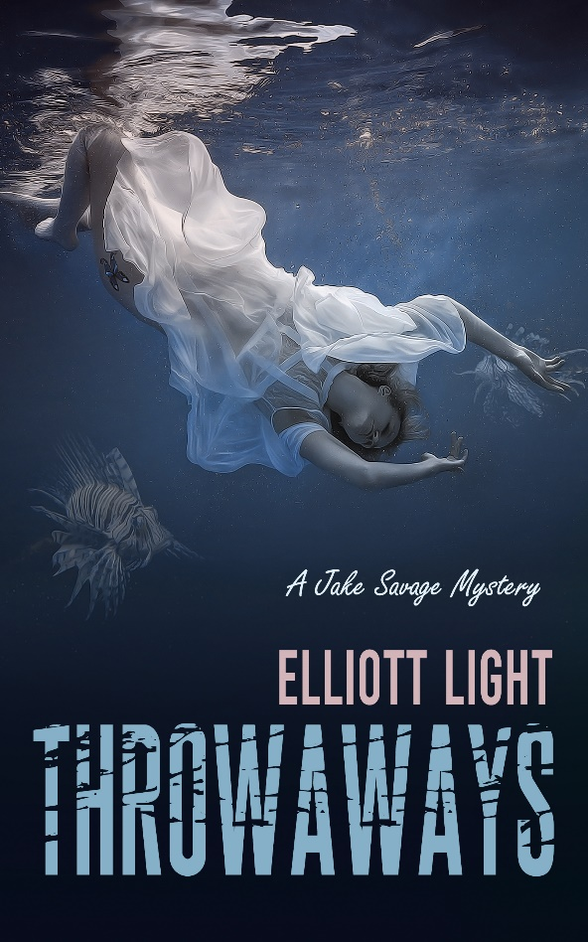
The body of a young girl drifts over a reef where Jake Savage is photographing lionfish, beautiful brown-striped creatures with feathery pectoral fins that could almost make one forget their venomous spines.
For an instant, Jake thinks she might be watching him, but she has no snorkel or mask.
Also, she isn't wearing a swimsuit, but rather is clad in only a shirt and panties.
And she can't have looked at him because she has no eyes.
What has this child done to die so young, to be forgotten and left to drift until consumed by the creatures of the sea?
A voice whispers to let her go, but he can't leave her to the whim of the wind and tide .... a simple decision with deadly consequences.

Longer Description
Jake Savage is doing some underwater photography off Key West when a shadow floats above him. Much to his surprise, it is a young girl, scantily dressed and floating face down. The police are called ... and they are labeling it an accident. Jake takes it upon himself to find out who she is and how she wound up dead. He soon learns that he has all kinds of help .... his elderly step-mother, her caretaker, a cop who is terminally ill, and assorted strangers he happens to bump into. It gets dangerous when he finds that the girl was somehow involved with sex trafficking, a crime committed against someone high up in the government with ties to a crime lord ,and the super-rich (think people like the late Jeffrey Epstein). Attacks come fast and furious .... and Jake and his partners find themselves in deeper trouble than they ever imagined.

Reasons to Read Throwaways
- Throwaways uses the mystery/thriller genre to explore the seedy, dark issue of human trafficking, albeit with sensitivity and even humor. The reader is given a mystery to solve and an issue to think about in a story both entertaining and provocative.
- Readers who purchase a novel expect writing that conveys a story through believable, if not likable, characters, a plot that isn’t contrived, and dialog that feels natural. They also expect the writer to provide a satisfactory experience that justifies the reader’s investment of time and money. No one likes to come to the last page, only to feel cheated. In this regard, Throwaways doesn’t disappoint.
- Readers of Throwaways have posted 85 reviews on Amazon, all of which are four and five stars. Here is a sampling of reader comments:
- “Talented writing with good character development in a believable story.”
- “The characters are memorable and realistic. I was drawn to hate the bad guys, of which there were quite a few. The plot is fast moving with fun twists and turns. Highly recommended.”
- “First, as an author myself, I want to congratulate the writer for the time and effort to produce a compelling novel that has all the ingredients of a thriller genre.”
- “An astonishing and powerful dark story! … The plot is very well structured, the characters are very well developed, and the book is incredible for mystery fans! It keeps you from the beginning to the end!”
- “This is an exceptionally well-written page-turner of a mystery that opens with a brilliant description of a dead girl floating above Jake. Stunning! …[F]inally this reader didn't hear the grinding of the gears of plot, because the story flowed effortlessly and thus beautifully. This guy Light can write …”
- “There’s something calming about the narration. It put me at ease. Elliott Light finds beauty in the darker moments, and that’s really cool and effective. Throwaways is more smooth than it is disturbing, and I appreciated that. It’s a refreshing take on this genre, and no wonder so many people are reviewing this favorably. And so am I. Good job, Elliott.”
- “I appreciate how hard it is to construct a good mystery. You need to get the layers right, the exposition needs to be pinpoint (not too subtle so it's buried and not overly overt as to be too obvious), a spectacular setting that you can imagine yourself in, and the characters have to be strong, believable, flawed, and relatable. Throwaways had all of these elements going for it...and more.”
- “This novel delivers a very important message about power and privilege and the havoc it wreaks upon the most vulnerable and less advantaged in our society. For the latter half of this novel, I couldn't get Jeffery Epstein's snide mug out of my mind, and perhaps that's why I found myself pulling so much for Jake Savage and his band of helpful and even not-so-helpful acquaintances as they try to navigate the waters of the Florida Keys, each of these characters with their own noble agendas, none of them absolutely right, none of them wrong either. That is the quandary of this story. Sometimes when you try to help out (as Jake and others do), it can have unintended consequences.”
- “An incredibly good book, well layered with an inventive plot and great backstories that add to the believability and motivations of the diverse range of characters. Surprisingly well-written for a retired engineer, who’s not expected to write great banter and witty repartee. I look forward to reading more from this author.”
- “Elliot Light has written an engaging and relevant mystery that hits on timely themes. The characters are interesting and bring an element of light to an otherwise dark story. Highly recommend!”
- “This story had me hooked from the beginning, being both intrigued and horrified by Jake’s gruesome discovery. It is a story that reflects the current real-world evils and where most of us feel helpless in the face of such an insurmountable problem. Light created a main character who is relatable and permits the reader to enjoy the vicarious thrill of actually taking action. The plot is well done and the characters are unforgettable. I recommend this story.”
- “The story captured my attention from the opening paragraph. I thought of the Jeffery Epstein case as I read about a discarded young women off the Florida coast. But I didn’t see the ending coming. A great, twist-filled mystery.”
- “Throwaways is great fiction that bears upon real current events. It conjures up all of the emotions of sorrow, hope, and regret. The bit of romance and comedy is a nice relief with such a heavy subject, but written in a very tasteful way. Jake is a hero with a bit of history, which make him and all of the characters very relatable. Since I am from the area of SWFL, I can attest to the fact that the setting in the Florida Keys is very accurately depicted. I could almost smell the salt in the air as I read.”
- “A great read. The author hooks you in right from the beginning. The character development and plot development are great. If you enjoy reading crime novels or mysteries, I would highly recommend this book. I myself am a true crime junkie and I really enjoyed this book.”
- “The seedier side of beach life in the Florida keys is where the story takes place, and the author brings it to grotesque life. I fell in love with this story, and wanted to see the good guy succeed for once. Throwaways had me crying for those lost to such a life, as I grew up around one similar. I can't recommend this enough. Beautifully done, beautifully written, and amazing character development. I can't help but feel attached to this book. Well done.”
- “This was believable. Dark and descriptive with memorable characters. Very tense and suspenseful. Great pacing. Kept me turning pages and reading ‘just one more chapter’ until I found myself at the end.”
- “I think this is the fastest I've gone through a book in ages. If you love crime thrillers, you need to add this to your reading list!
- Throwaways shines because it has been reader-tested. It is a book that transcends the “familiar” mystery structure by respectfully and deftly tackling a social issue without trying to proselytize. It lets the mystery command the reader’s attention.

Praise for the Throwaways
“Great character development keeps the pace of this mystery racing at a break-neck speed. It's a complex plot with hints of deeper, darker crimes committed. The conclusion was unexpected ... and explosive. Five out of five stars.”
—Linda Strong Book Reviews

“Intense and well characterized. Sadly, very worthwhile and pertinent topic: human trafficking. I particularly enjoyed the relationships between the well-written characters. Will be looking for more from this author. Five out of five stars.”
—K. Meyer, author, reviewing on amazon.com

“A new writer and a new series is always a bit of a mystery. You don’t know what kind of story you are getting into. I was hoping for character. I got that; Jake, Ethy, Tess, but especially the relationships between these characters, familial bonds and old mistakes, made them interesting and relatable. I was hoping for setting, and yes, I got some sense of the Keys (a place I’ve always wanted to spend time in), even if I would have liked a little more five-senses writing in the descriptions (something John D. MacDonald was so very good at). I also knew the deep anger of injustice would be there, at a system weighted towards the mean, where the very poor and marginal are trapped by fines and fees they cannot afford and the very rich and powerful are barely touched at all. But until I got to the end, I wasn’t sure where this would end up. Even then, there was a hope Jake would finally snap and go all Mr. Majestyk on their asses. As the list grew of what the untouchable rich guys had done, I would have been happy to see the cloud go up in a nice fireball with all the guests on it. But that wasn’t the direction he was heading. In the end, what happened perfectly fit the way these ‘damaged people’ (Jake’s words, not mine) continue to struggle on, to compromise when they have to but still keep trying to do what is right. Even Alicia’s rescue makes sense. As much as everyone had argued she, like the other throwaways of the title, were beyond redemption, the very example of Murphy, Jake himself, even André (arguably my favorite character) is that everyone is a bit damaged but most make do anyhow. Five out of five stars.”
—Michael D. Sweeney, Top Amazon Contributor

“It might not be an easy read for some, as it’s quite dark and descriptive and it revolves around a social issue that is a part of our reality: child trafficking. The plot starts in Florida, when a photographer discovers the body of a girl in the water. After calling the police, he decides to join the investigation and help find the killer of the child, driven by the murder of his own mother when he was four years old. The plot thickens and brings up the corruption in the system, that rich and powerful people do as they wish without fear of the consequences. The storyline is easy to follow, written in a way that pulls you in from the first pages. I highly recommend it to those who love a good believable crime story. Five out of five stars.”
—Ananta Govinda, reviewing on amazon

“Throwaways is a suspense-filled novel about power and money that takes place in the Florida Keys. Here the wealthy are above the law; all accusations against them roll off as if they are made of Teflon. The throwaways are at their mercy. Jake drifts into this world of the exploited when he finds a girl’s floating corpse while he’s studying lion fish. He naively thinks that justice can be done for this unknown young girl and others like her who’ve been thrown onto the streets to fend for themselves. While he knows they are easy prey for those with power, he believes that he can fight for them. Jake falls into the cross-hairs of the sex-trafficking ring of the wealthy and well-connected. His own life story is inextricably entwined with those being exploited, motivating him to pursue a perilous search for the truth. He gathers unlikely allies, and isn’t always aware of the ones he should fear. The reader is kept on the edge, wondering whom to trust. The story is filled with empathy, hope, and loss. One of the best thrillers ever--you won’t be able to put it down. Five out of five stars/”
—Carol Lynn Luck, Author, Magnolias Don’t Bloom in September

“A well-crafted plot that carries you along and is always clear. The sleuth is likable and perceptive and the treatment of his photographic memory is really believable. Setting the story in the Florida keys kind of gives it a Carl Haissen vibe. It is similarly wild and fun while also a tense and suspenseful mystery. The pacing and plot are pitch-perfect for a mystery series. This seems like the start of a great series of mystery novels.”
—Isaac Paterson, Bend, OR

“I like the complexity of the characters in this and the other mysteries by Elliott Light. Great job!”
—Katy Caselli, Durham, NC

“Great character development keeps the pace of this mystery racing at a break-neck speed. It's a complex plot with hints of deeper, darker crimes committed. The conclusion was unexpected ... and explosive.”
—Booklover, Top 1000 Amazon reviewer

“Having read and enjoyed the three Smalltown mysteries, I have been awaiting Elliott’s next installment recounting Shep Harrington’s adventures. Instead, Elliott has given us Throwaways, a timely story about sex trafficking and a new hero in Jake Savage. Throwaways does not disappoint. It is an interesting read, because Jake wrestles with issues of personal history, justice and fairness, and the very real problem of sex trafficking. While these issues might seem dark on the surface, he balances them on the structure of quirky and amusing characters. I particularly am impressed by Elliott’s portrayal of women, as I was in the Smalltown mysteries. Elliott draws the characters from a feminine perspective and empowers the women in interesting ways. His understanding of the world of young girls and women who are trafficked is especially impressive. Now I am awaiting more Jake Savage stories. Well done, Elliott.”
—Sandy Stahl, associate dean of students and senior lecturer in women’s and gender studies, Vanderbilt University

“Elliott Light once again weaves a fantastic, fast paced tale with a sympathetic, relatable cast of characters that is impossible to put down. I was hooked from the moment I picked up the book and felt truly invested in what happened to the characters through their twisted path in the gorgeous backdrop of Key West.”
—Morgan Swenk, Attorney, Maitland, FL

“The story is written in the past tense PoV of Jake Savage. One feels the pain of a young man who, as a child, found the dead body of the only parent he knew. The descriptions are beautiful and give us a peek into the character and history of Jake. I found myself caring not only for him but also for Detective Trent, for Ethy, so oblique with her affection, for Tess, who is equally twisted in terms of past baggage, and even for Jake’s adoptive father, Maurice Savage, who is dead when the book begins. The setting comes alive with the simplest of words: ‘The sound of my heartbeat and the air escaping my regulator quickly replaced the chatter of human voices. Surrounded by water, the noise in my head subsided.’ Despite knowing zilch about the geography of the place (Key West), I could picture it based on the details provided and I liked the picture my mind built up. I was impressed by the research around oceanography, the currents, tides etc. The details of the boats and the building and renovation feel intuitive and real. The entire story takes place over eight days, from Sunday, October 18, to Saturday, October 24. The author, in the person of Giles and André, kept pushing Jake into one predicament after another. It was well done, and it kept the pace going fast and smooth. I’d first opted to read this book after reading the description and seeing the cover. I was touched by the incongruence of the cover image—the dead girl floating ethereally in the great blue with the lionfish surrounding her. Having suffered at the hands of humans while she was alive, it seems that she is now fodder for another invasive species below. I loved the ending. It felt right, without seeming unbelievable or hurried or even forced… All in all, Throwaways is a great thriller about the world of the rich and powerful and the crass manner in which they indulge their basest desires at the expense of helpless and unfortunate throwaways—youngsters who have run away from home and are unwanted.”
— Cynthia Rodrigues, Blogger, A Few Drops of Ink

“Well-written, fast-paced page turner with mystery piled upon mystery upon mystery. I especially appreciated the link back to the me-too movement and not allowing the hubristic fat cats to get away with their crimes. We should never forget those trafficked and we can’t continue to let that happen. BTW, I especially enjoyed the description of the fattest cat in the story. LOL.
Excellent book! I look forward to it being picked up by a major publisher and made into a movie.”
—Rose Anderson, Denver, Colorado, Reviewing the Book on Amazon.com

“This is an engaging whodunit, made all the more appealing because the main character gets sucked into a web of mystery without any warning, and without having any prior intention of doing so. Jake Savage is photographing fish in the Florida Keys when the corpse of a teenage girl comes floating by. He does the right thing: the authorities are notified and the body is salvaged, but his involvement doesn’t end there. His innate curiosity has been piqued, and it won’t let him rest. Thus begins a relentless quest on his part to find out how and why she was left for dead floating in the Gulf. His search pits him against some morally reprehensible scumbags and uber-wealthy men involved in human trafficking and murder. Set against the backdrop of Key West, this book is a joy to read, not only because of its suspenseful story, but because of its likable, laidback hero, the characters he interacts with, and the smart dialogue that enlivens the action.”
— Raoul Limeres, Los Angeles, California, Reviewing the Book on Amazon.com

Praise for Elliott Light’s Three
Shep Harrington Small Town Mysteries

Lonesome Song
“Unjustly disbarred lawyer-turned-amateur-sleuth Shep Harrington faces the demons of his past while investigating the mysterious death of a famous country singer in Elliott Light’s debut, the first volume in the planned Shep Harrington Smalltown Mystery series called Lonesome Song. It’s a solid mystery with a nostalgiac heart. Its standout feature, however, may be the blurb section in the back – ‘offers more food for thought and literacy than the average,’ raves one reader.”
—Publisher’s Weekly

“A fast-paced read rife with surprises. It sports some engaging characters, notably wry sleuth narrator Shep Harrington, a fair-play plot, and smart dialogue. Author Elliott Light knows his turf. Harrington is a disbarred lawyer who was convicted of a crime he did not commit. Light, a lawyer, was nearly indicted for something he didn’t do. Thus he comes by Harrington’s skepticism honestly.”
- The Virginian-Pilot

“A darkly compelling, splendidly written tale about a country-western singer whose death is abruptly ruled a suicide without investigation . . . A fascinating novel, Lonesome Song is very highly recommended reading for mystery buffs.”
—Midwest Book Review

“Populated with unique characters, a compelling mystery, and an intriguing plot that kept me in suspense right to the end, Lonesome Song is quite a delightful book! Having lived in Northern Virginia (Burke when it was still farmland) and hiked all over hell and gone in Virginia and West Virginia, I could see the settings in my head and only imagine that perhaps I'd driven past a poor farm where the drama played out unseen by me and all the others speeding by, somewhere on I-66.”
—Lewis Perdue, author of the acclaimed mystery-thriller “Daughter of God”

Chain Thinking

"When a writer attempts to introduce a social issue into his fiction, he can almost be sure that he will be accused of some kind of proselytizing. In Chain Thinking, the issue is animal rights, and the fiction is the story of Kikora, a chimpanzee, and Shep Harrington, a lawyer and detective manqué, and his battle not only to solve a murder, but to save the chimp from experimentation. Elliott Light has managed to weave these two parts together, and do it seamlessly."
—Martha Grimes, Best-selling Mystery writer, and Winner of the nero wolfe award (best mystery)

"Those who think that stories about legal rights for nonhuman animals have to be boring, tedious, complicated, or abstract are in for a treat. In Chain Thinking, the plain truths about our inhumanity to other beings with whom we share our world are told in a way both exciting and funny. What animal rights lawyer wouldn't want to be like Shep Harrington (except for the part about going to jail)? And I guessed wrong about whodunnit!”
—Steven M. Wise, Lecturer, Harvard Law School, and author of the books Rattling the Cage: Toward legal Rights for Animals and Drawing the Line: The Case for Animal Rights

“Entertaining and enlightening.”
-- Booklist (The Magazine of the American Library Association)

“The implicit argument for animal rights should elevate the profile of this one.”
–Publishers Weekly

“Within this mystery, Elliott Light's reluctant but interesting detective, Shep Harrington, makes his own case for the need to break ‘Chain Thinking’ and morally look at an important topic for discussion -- the way we treat our fellow creatures.”
—Nevada Barr, Best-selling Mystery Writer, and “one of the most acclaimed mystery writers of our time” (Washington post)

“Elliott Light writes with an elegance that most of us can only manage by quoting others. Luckily, I'm a lot funnier than he is, or I'd have to give up this whole mystery novel thing and take up upholstery. Elliott, you've gained a fan.”
—Jeffrey Cohen, author of For Whom The Minivan Rolls: An Aaron Tucker Mystery , and A Farewell to Legs: Another Aaron Tucker Mystery

The Gene Police
“A strong mystery supported by its powerful treatment of racial injustice.”
—Booklist

“Light’s thought-provoking third mystery features attorney Shep Harrington . . . who learns that Sweetwater Hospital was run at the time by a prominent eugenicist, who shared Nazi beliefs about race. Light’s timely look at an almost forgotten dark chapter of recent American history, when doctors experimented on those considered racially inferior, more than compensates for the routine mystery.”
—Publishers Weekly

“The Gene Police by Elliott Light is an original and simply riveting mystery novel by a master of the genre—one that is especially recommended for community library Mystery/Suspense collections.”
—Midwest Book Review

“Gene Police was what first made me want to read the Shep Harrington Small Town Mystery series; it sounded so wonderful to me, something that I hadn’t read before, at least no series that comes to mind. Not only is the science of eugenics part of this novel, but throw in a murder mystery, and you’ve got a suspenseful, engrossing tale. I give this book 5 out of 5 stars—definitely a keeper here!”
—Comfy Reading (the book blog for the comfy reader)

An Interview with Elliott Light,
Author of Throwaways

Tell us about Throwaways?
Throwaways is mystery wrapped in a moral quest, a classic tale of good versus evil, but with unique twists and surprises that involve sex trafficking.

Set in and around southern Florida, the story begins with Jake Savage photographing lionfish in the shallow waters off of Key West. Suddenly, the sunlight gives way to shadow as something on the surface hovers over him. At first, he’s unsure what he’s looking at. But then he realizes it’s the body of a young girl. Initially, Jake thinks she might be watching him, but she has no snorkel or mask. She isn’t wearing a swimsuit, either, but is clad in only a shirt and panties. And she couldn’t be watching him because she has no eyes.
The light returns as her body slowly drifts away.
A voice inside Jake’s head pleads with him to let her go, but despite being repulsed by the condition of her face, he simply can’t leave her to the whims of the wind and tide.
The decision leads Jake on a quest to find out who she is and how she died. Unknowingly, the decision draws him into the lair of another predator, a human one who preys on the suffering of runaway girls, children without a voice, children that are unseen.
It’s a decision with potentially deadly consequences.

Who did you write Throwaways for?
That question may seem simple, but the answer isn’t.
Writers are generally driven to write what they write because something is bothering them. So in a sense, books are written for the writer—not for the praise that comes with being published but to quiet the voices in his or her head. In this sense, I write for myself and might do so even if the end product never leaves my computer. But in a larger sense, I hope to give voice to victims that may otherwise go heard.
Of course, a writer must know his or her audience. Throwaways was written for an adult audience, for those who enjoy a mystery/thriller with a cast of interesting and compelling characters. That said, I believe that Throwaways uniquely offers something for a broader audience.
The girls depicted in Throwaways could be a daughter, a niece, a sister, or a friend. You don’t have to be female to feel for these children who, for one reason or another, are separated from the protection of a family home. These are innocent victims—children who anyone with a nurturing instinct will feel for.
Readers who enjoy strong, interesting antagonists will have several to choose from. I have a certain affection for André, a clean-up man who has to deal with a form of Tourrettes syndrome. His disability makes his interactions with the protagonist, Jake, all the more interesting.
It’s easy to cheer for a hero. Jake Savage isn’t a superhero; he is flawed and his resolve wobbles as he struggles with his desire to do the right thing while understanding the risk that entails. Jake is, at his essence, an ordinary guy (an everyman) who is thrust into extraordinary circumstances

You said that Throwaways is a mystery wrapped in a moral quest. Explain.
Throwaways is not the first book to deal with the plight of runaway girls, but it offers a unique perspective. The story is not simply an external view of the trials they face but offers insights into how these girls see themselves.
As I described earlier, Throwaways opens with the main character, Jake Savage, surveying the Gulf waters for lionfish, an invasive species that has become the top predator in areas from the Caribbean to South Carolina. Most people don’t know of the damage done by this aquatic predator because it is out of sight, hidden.
The same is true of the sexual predators who live freely in our society and prey upon their invisible victims—young girls living on the street—who we don’t see, or simply choose not to.
As long as we treat these girls as throwaways, they will have no one to advocate for them and they will be at the mercy of those who abuse them.

What do you want a reader to take away from Throwaways?
Perhaps the single most important message is that power only corrupts when it is allowed to.
The privileges enjoyed by people with money and influence arise when we collectively excuse bad behavior simply because someone is rich or powerful and can do something that benefits us.
Jeffrey Epstein was seen as a philanthropist who provided funds for good causes. But his mistreatment of young women wasn’t a secret. His purported good deeds—and his leverage over those who could stop him—were used to justify giving him a pass. The lives he ruined simply cannot be weighed against the supposed good he accomplished.
Without giving away the ending of the book, I’ll say this: When the law is not applied equally, when it fails to protect the defenseless, the law becomes irrelevant and victims will seek other solutions.

What/who inspired you to write?
Story telling has been a tradition in my family for generations. In the 1890s and around the turn of the century, my grandmother wrote short stories for a newspaper and was paid a few dollars for them. It was a lot of money in those days.
My mother loved to recall events by creating a story that embellished the facts. I was surrounded by old folks growing up and a good yarn was something to be proud of.
One of the stories my mother liked to tell was about a rabbit named Mr. Buck. During WWII, families had meat ration tickets. Apparently, the neighbors all pitched in to get a roast that my mother was assigned to cook. Well, she burned it to a crisp. At dinner, while everyone was eating, my brother is said to have inquired if anyone had seen Mr. Buck.
I can still see my mother’s hands as she related this story, her description of the faces of the dinner guests when the question was posed, and the picture she painted with her words.
The telling of the story of Mr. Buck was never the same and never grew old in the telling. People enjoyed the story of Mr. Buck and others she told. I think at some point I decided I wanted to be a teller of stories, too.

How did you come to write the kind of novels that you’ve published?
I took a few writing classes. One was taught by a lawyer who had just gotten published. Of the dozen students, I think eleven were lawyers. The consensus was that practicing law was a good way to make a living, but it wasn’t very satisfying. All my classmates had illusions of writing the next version of The Firm or The Hunt for the Red October.
My first efforts at writing thrillers and spy novels were clumsy. But as bad as they were, it was good practice. Failure is a good teacher and tests your resolve.
I think everyone in that class would have loved to be famous and wealthy. But I also believe they were seeking an outlet for their internal voice.
My inner voice led me to stories told from a first-person point of view. I left behind the fantasy of being Clancy or Grisham and wrote about the people and places I knew. Out of that came my first book, Lonesome Song, a book full of characters whose grievances were far more significant than mine. I missed talking to them so much that I wrote two more books in that series.
Throwaways gives voice to a different character with different issues, but like my previous books, the story is populated with characters drawn from people I’ve known or observed.

How has Throwaways been received so far?
The reviews have been very positive. At this writing, there are twenty-five published reviews on amazon, many of them five-star reviews, and the rest are four-star reviews. I don’t expect that ratio to continue, but it’s very satisfying.
Of course, I enjoy reading a review that conveys a reader’s overall satisfaction with the story. “Great read” and “page turner” are phrases I especially appreciate As we discussed previously, I work hard to create characters who are believable and likeable. It’s extremely gratifying when readers notice my characters:
One reviewer put it this way:

The characters have so much personality so that the reader gets to know them and root for them. (Texas Read, October 26, 2020)

Another observed that

A lot of authors set out to create likable, believable characters, but few succeed to the extent that Elliott Light has with Jake Savage. (William Hansmann, October 23, 2020)

These comments are rewarding, validating, and a bit humbling.

Why mysteries?
I write in the mystery-thriller genre because it offers a vehicle to create a factual puzzle (who did it) while allowing me to muse about why characters behave the way they do. The mystery/thriller category is very broad and tolerates various styles and points of view, so much so that you may find some critics insisting that a particular book isn’t a mystery or a thriller.
A good number of books in this genre are written in the third person with multiple points of view, a kind of cat versus mouse style. The reader gets in the head of the good guy and can watch how he or she is processing the information he receives. The reader also gets in the head of the bad guy and learns how he or she is staying one step ahead of the protagonist. While that style produces an enjoyable read, I prefer to create a more intimate connection between the reader and the protagonist.
I write from a first-person point of view using the eyes of the narrator (who is also the protagonist) because it establishes an intimate relationship between the protagonist and the reader. For example, the protagonist of Throwaways, Jake Savage, sees the world through the eyes of someone whose mother was murdered. This lens helps to establish his motivation.
The reader of Throwaways is also given an intimate understanding of Jake’s struggle. He knows what he wants to do but he isn’t naïve about the dangers that satisfying his moral impulses pose to himself and others.
I think the intimate style places the reader in Jake’s shoes and forces the reader to grapple with the choices he faces in real time.
In addition to characters, I like to use a setting to create a mood. In Throwaways, Key West, with its blue water, historical sites, and easy-going lifestyle offers a contrast to the dark world that lies below the veneer of paradise.
At the end of the book, I want the reader to feel like he or she knows the characters and has been to the places where the action occurs.

How do you create your characters?
Consciously or unconsciously, we all observe interactions between people. Again I’m generalizing, but writers will seek to understand these situations literally or consider how the interaction may have played out differently.
Good characters are a blend of what is gleaned from the real world and what is imagined.
Shep Harrington, the lead character in my SmallTown® Mystery Series, is a disbarred lawyer who went to prison for something he didn’t do. I was almost indicted for crimes I didn’t commit because of lies told by people I thought were my friends. I trusted them and was betrayed. Shep is a projection of what might have happened had the investigation not cleared me.
Jake Savage is also damaged by his childhood. At four, he finds his mother lying in a pool of blood, dead from a gunshot wound. Her killer is never found. He is adopted and loved by his adoptive father but resented (but not hated) by his adoptive mother.
Jake’s attitudes toward justice and fairness are shaped by these events. These attitudes drive him to investigate the death of a young girl when common sense dictates that he leave the matter to the police.
I think readers should always keep in mind that writers are like pack rats. We pick up odds and ends and store them away. You have to be careful around writers because the’re likely to be stealing one of your personal quirks for later use.

Are you more of a character artist or a plot-driven writer?
I’m never sure how to answer this question.
The distinction is usually expressed this way:
Whereas plot-driven stories focus on a set of choices that a character must make, a character-driven story focuses on how the character arrives at a particular choice.
I love good characters. I want to know why they do things. The way to create such characters is to serve them up a bunch of external problems and see what they do.
Before I wrote Throwaways, I interviewed each of the major characters. I let each character tell the story to me as he or she understood it. This process is actually fun and produces some unexpected results (characters don’t always agree on the facts, the timing, who did what to whom, or whether someone deserved what they got; some even lie). These discrepancies can be used to create conflict. Conflict is the fuel that propels a story forward.
When a writer intentionally introduces conflict into a story, it feels artificial. When it arises organically from the characters in reaction to external problems, it’s more believable and revealing.
I’m not sure I answered the question, but I think that’s about as close as I can get.

Who should read Throwaways?
Let me toss out an apparent contradiction: Throwaways, despite the darkness of its subject matter, is a fun read.
Fun and dark don’t seem like obvious partners, but I think it’s what makes Throwaways unique.
The victims are sympathetic, the protagonist is heroic, and the supporting characters quirky but real. The book never loses sight of that fact that its purpose is to entertain.
If you like a good story, a David vs. Goliath story, you will enjoy Throwaways.
If you have a strong nurturing instinct, you will enjoy Throwaways.
If you like a book with a big ending, you will enjoy Throwaways.

Do you have a website?
I do. You can visit me at www.elliottlight.com

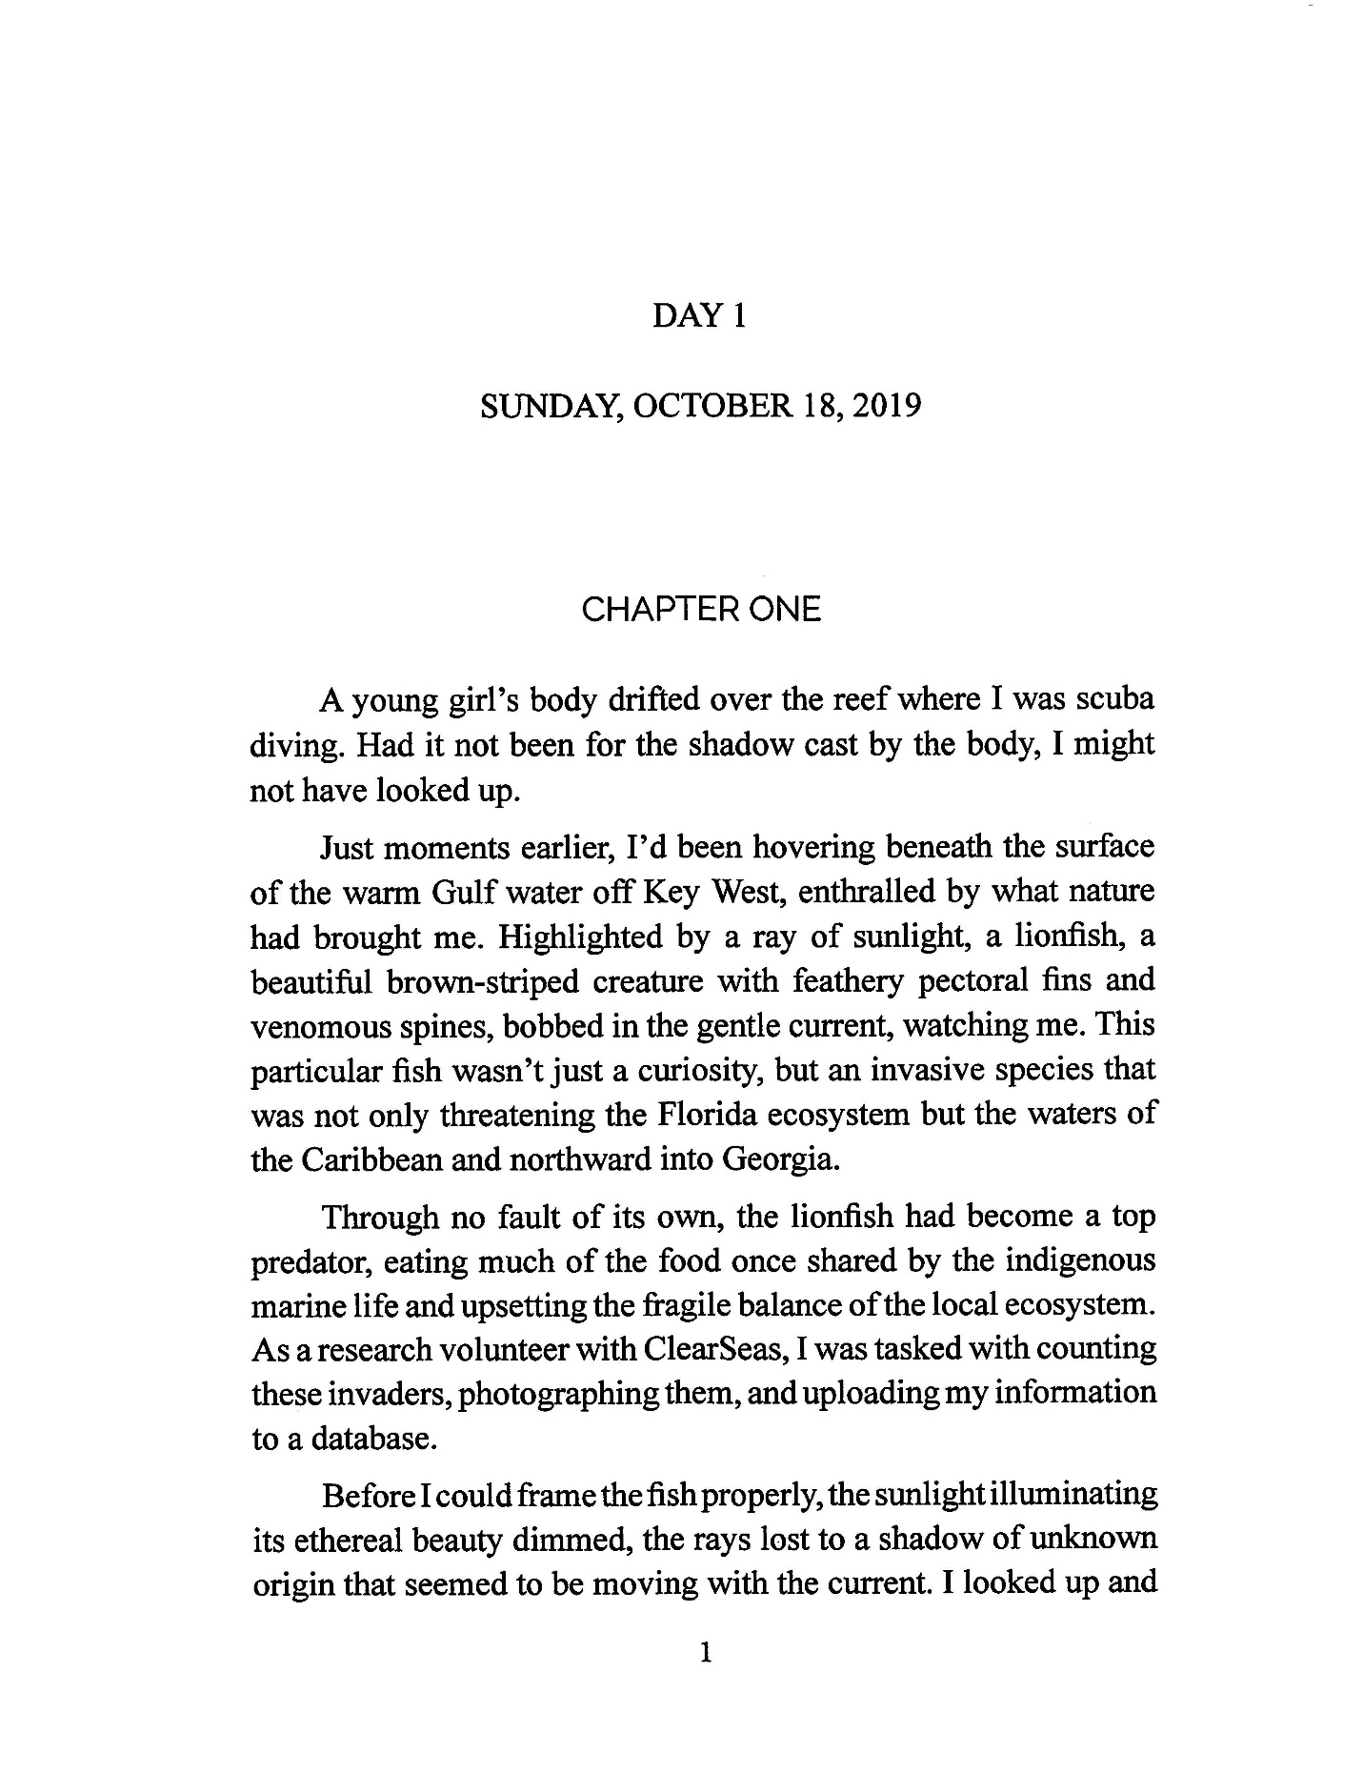

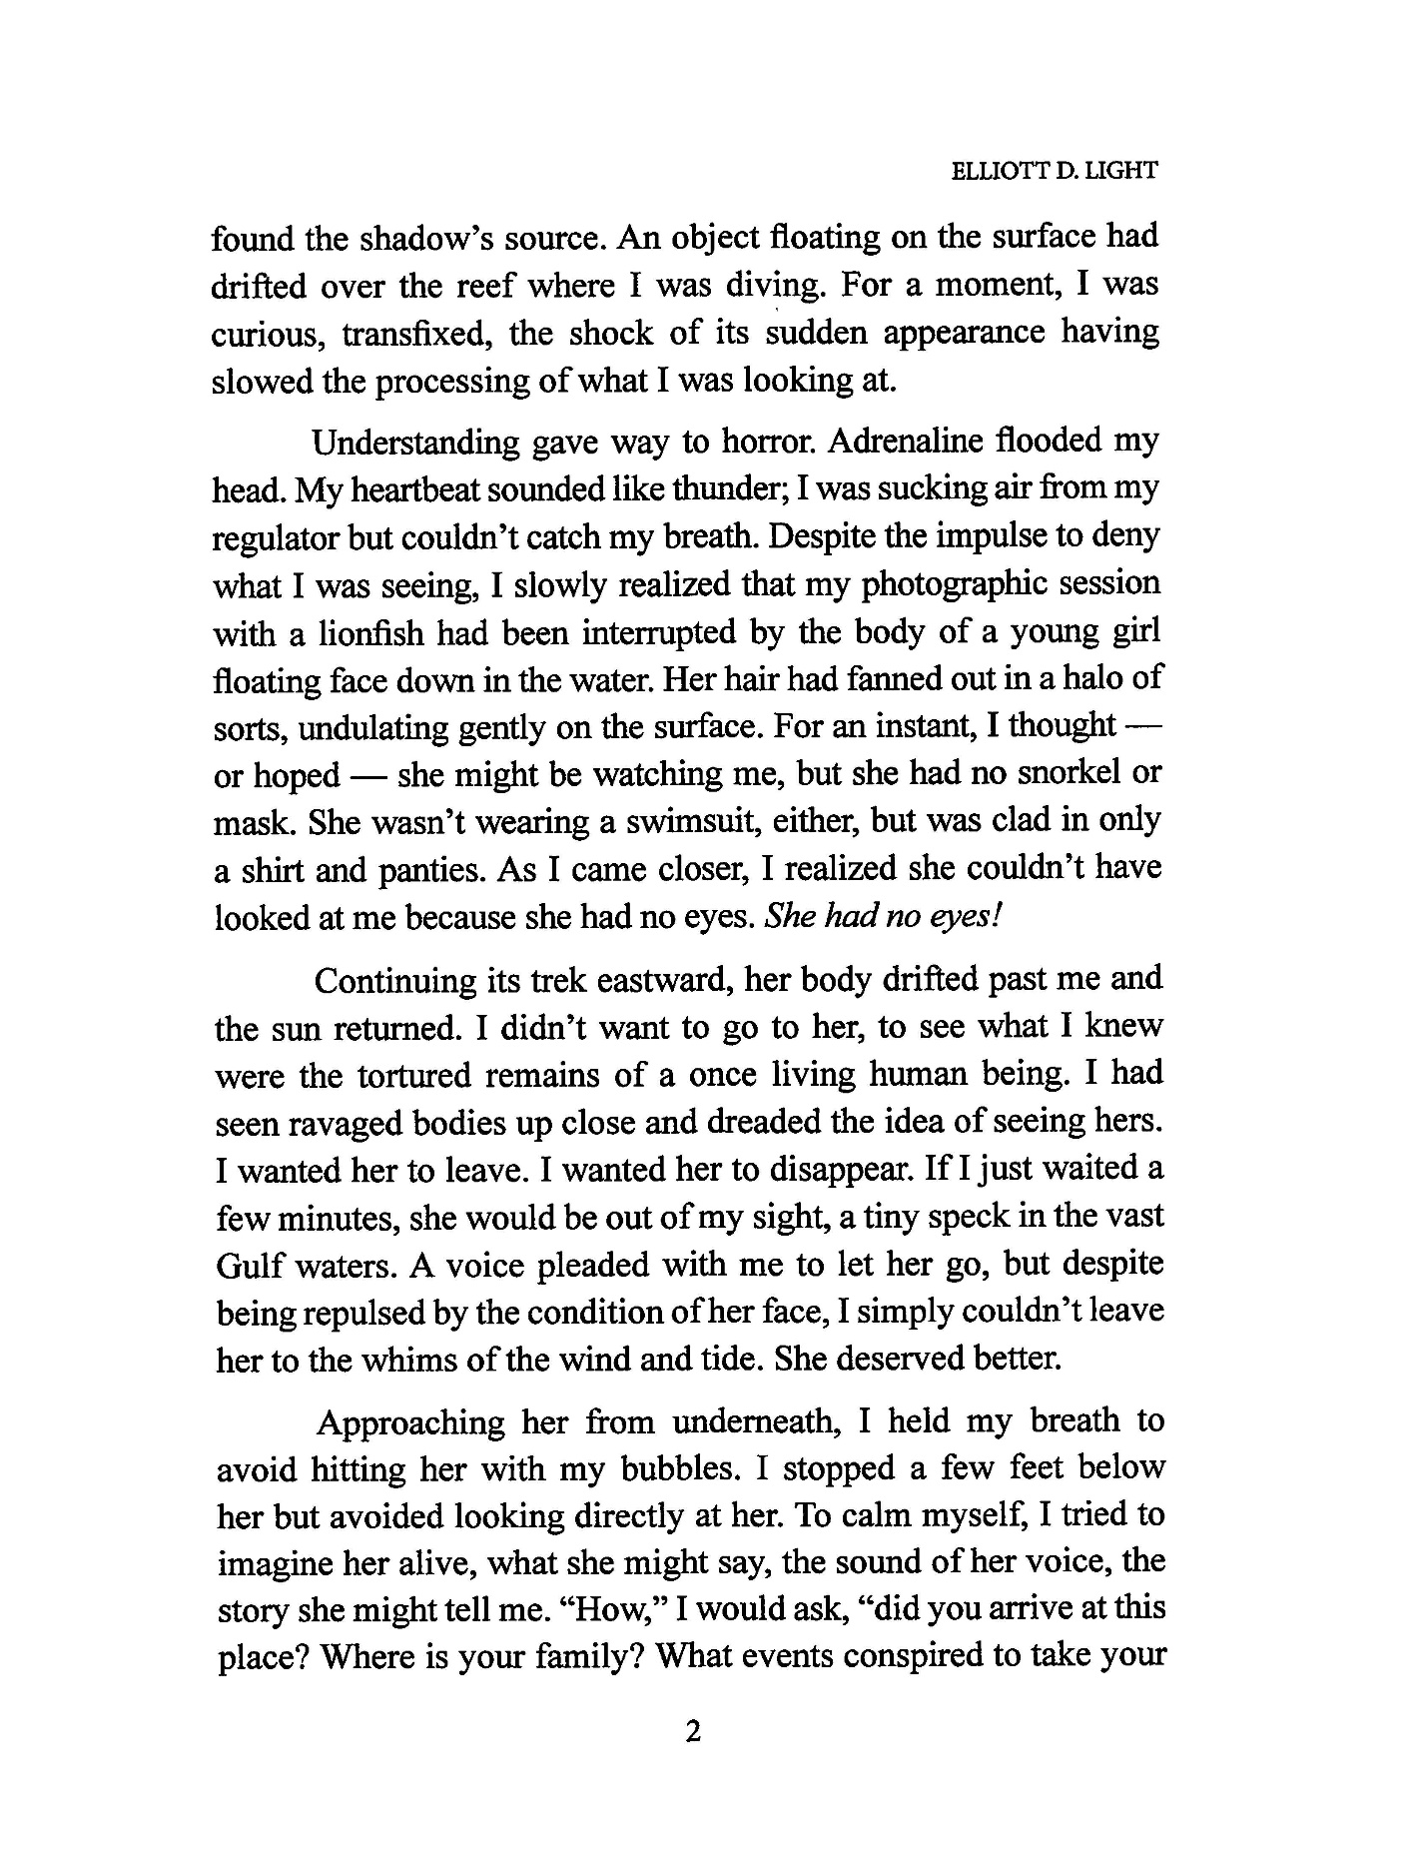

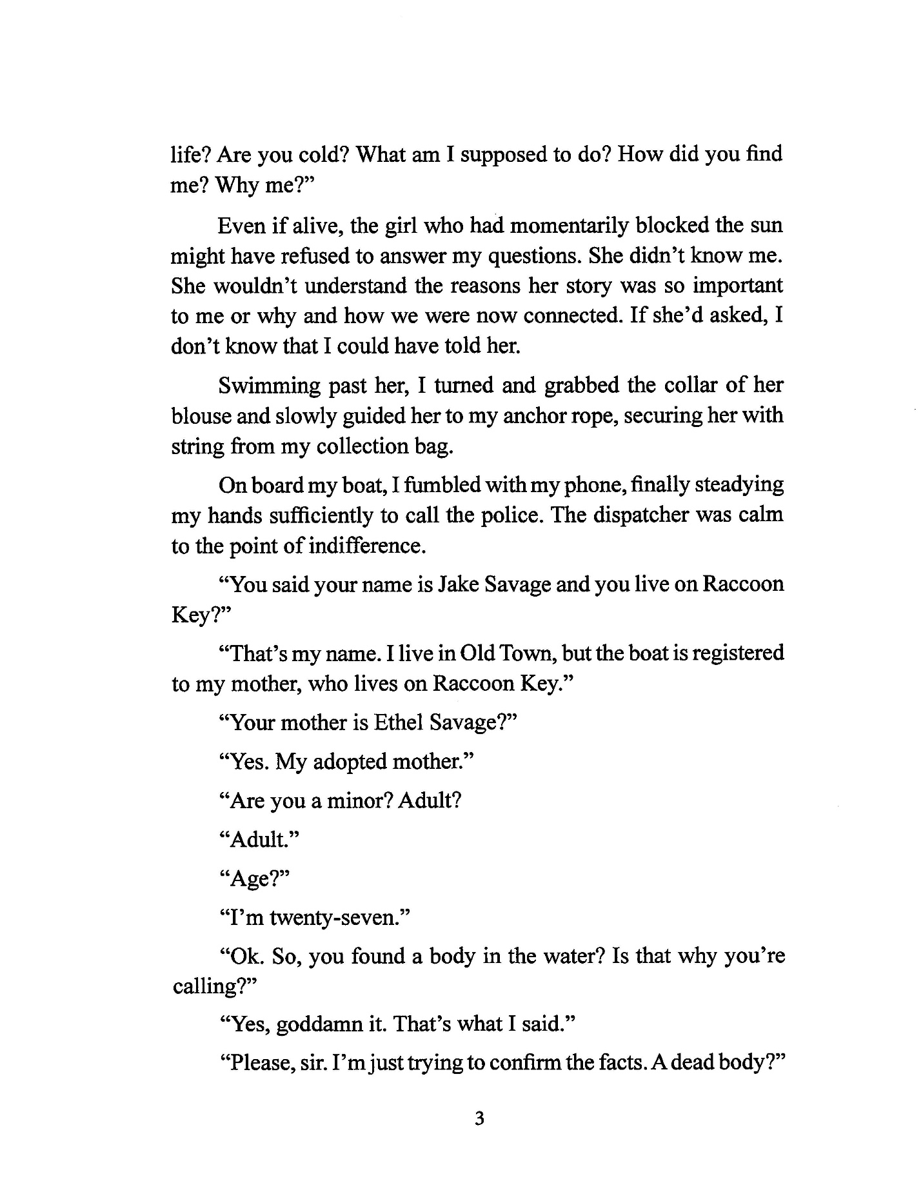
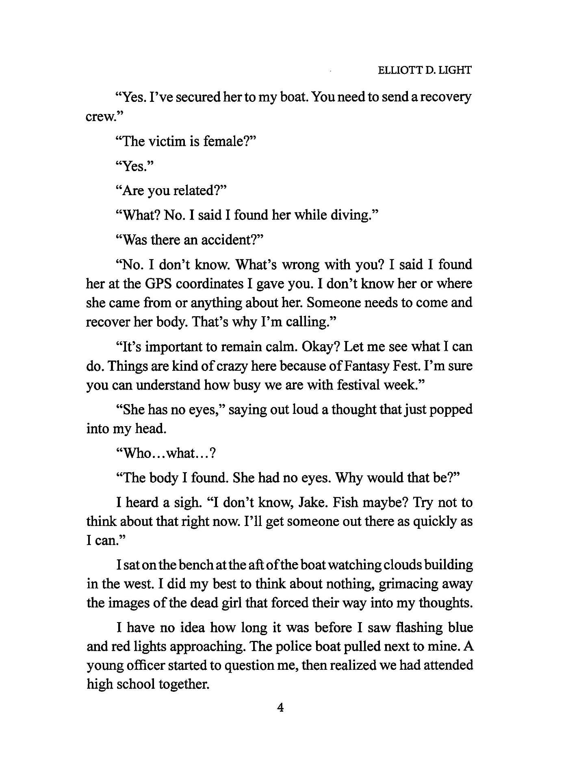

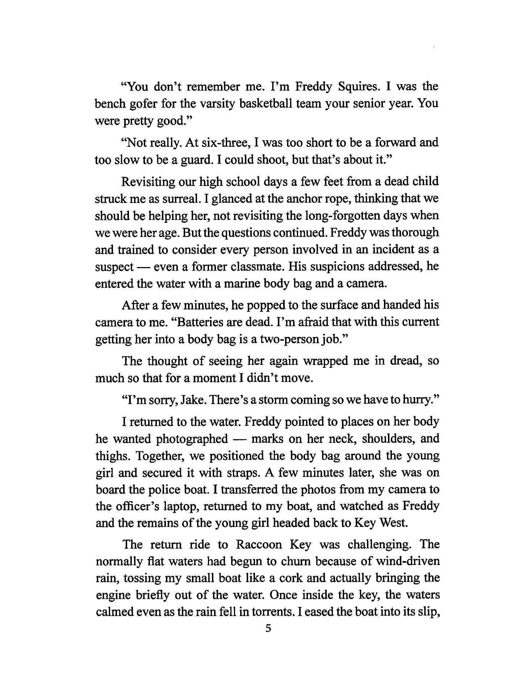

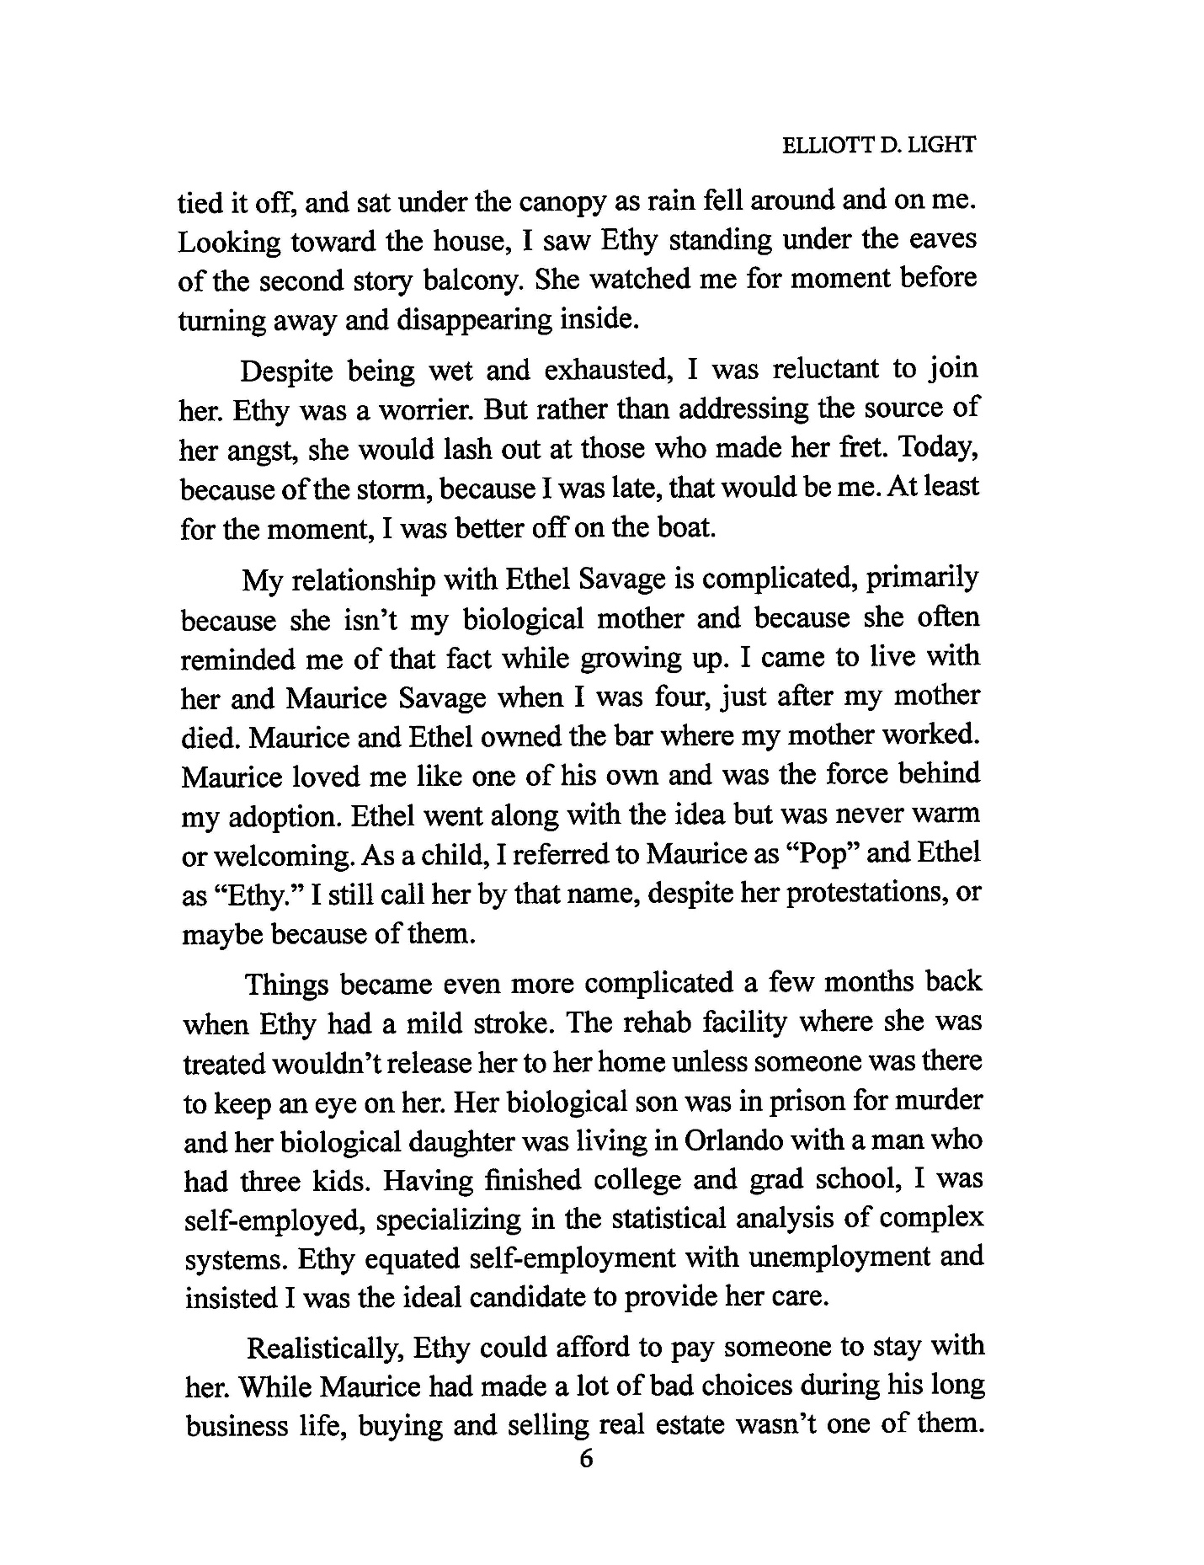

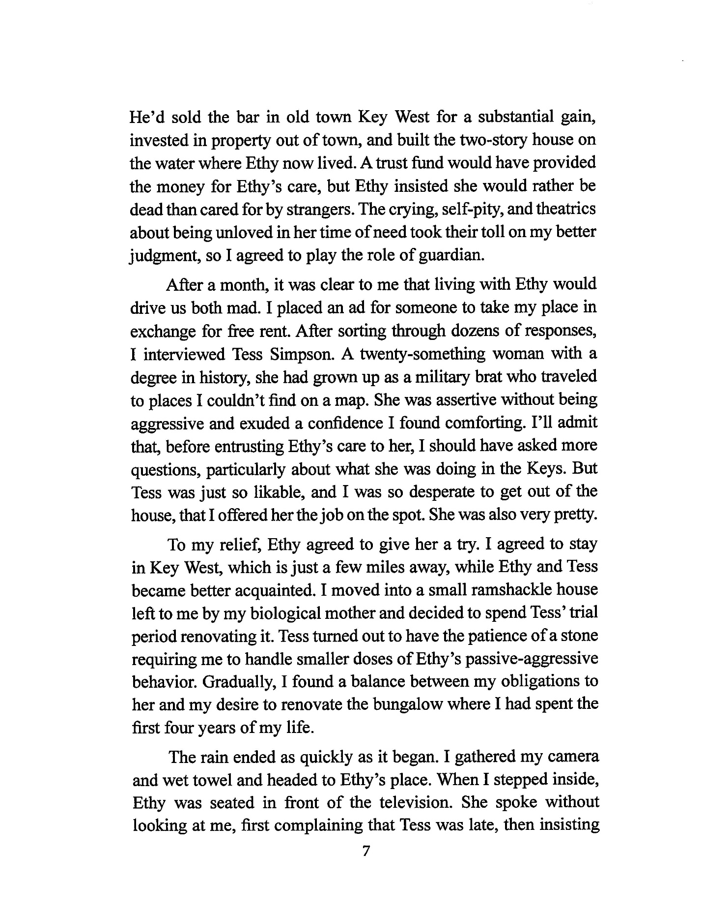

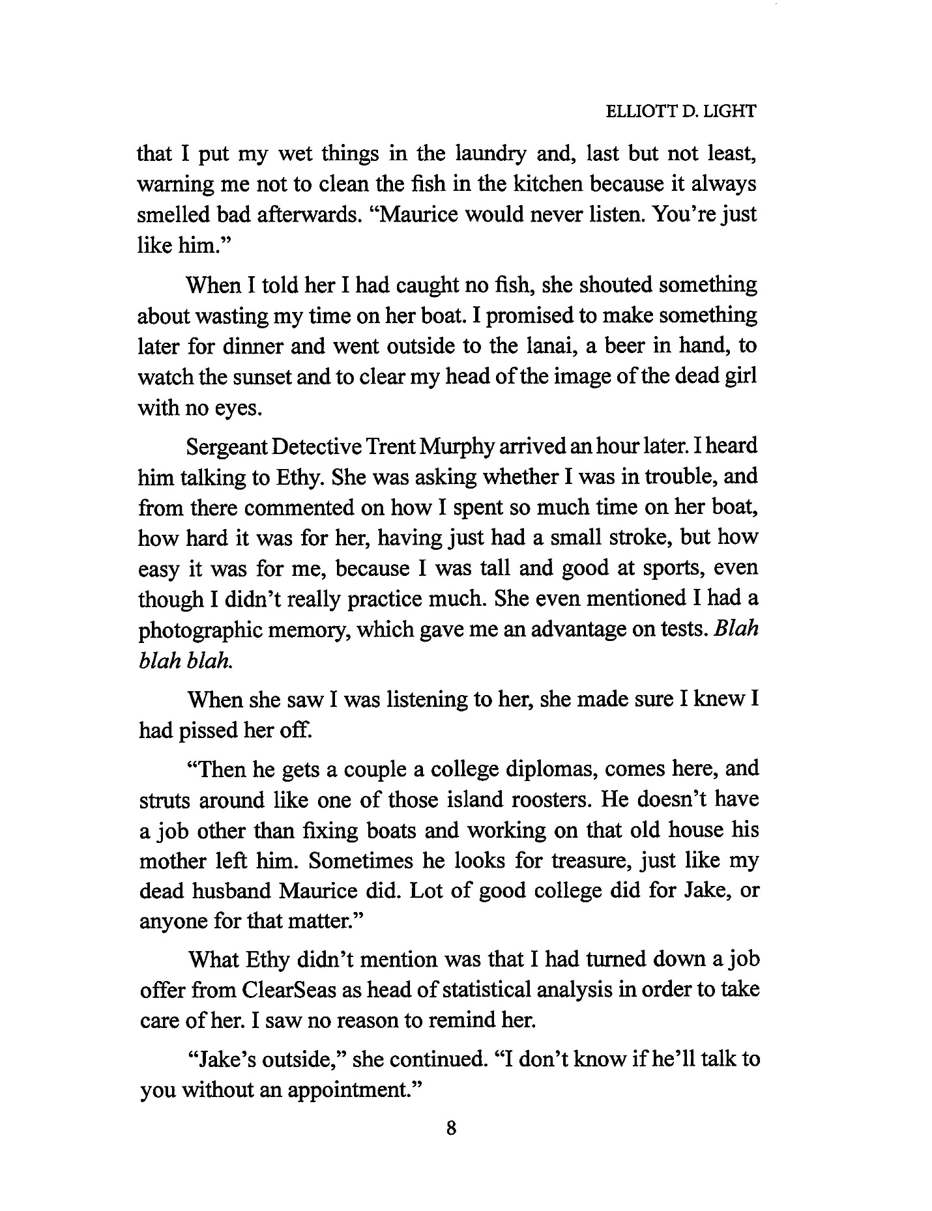

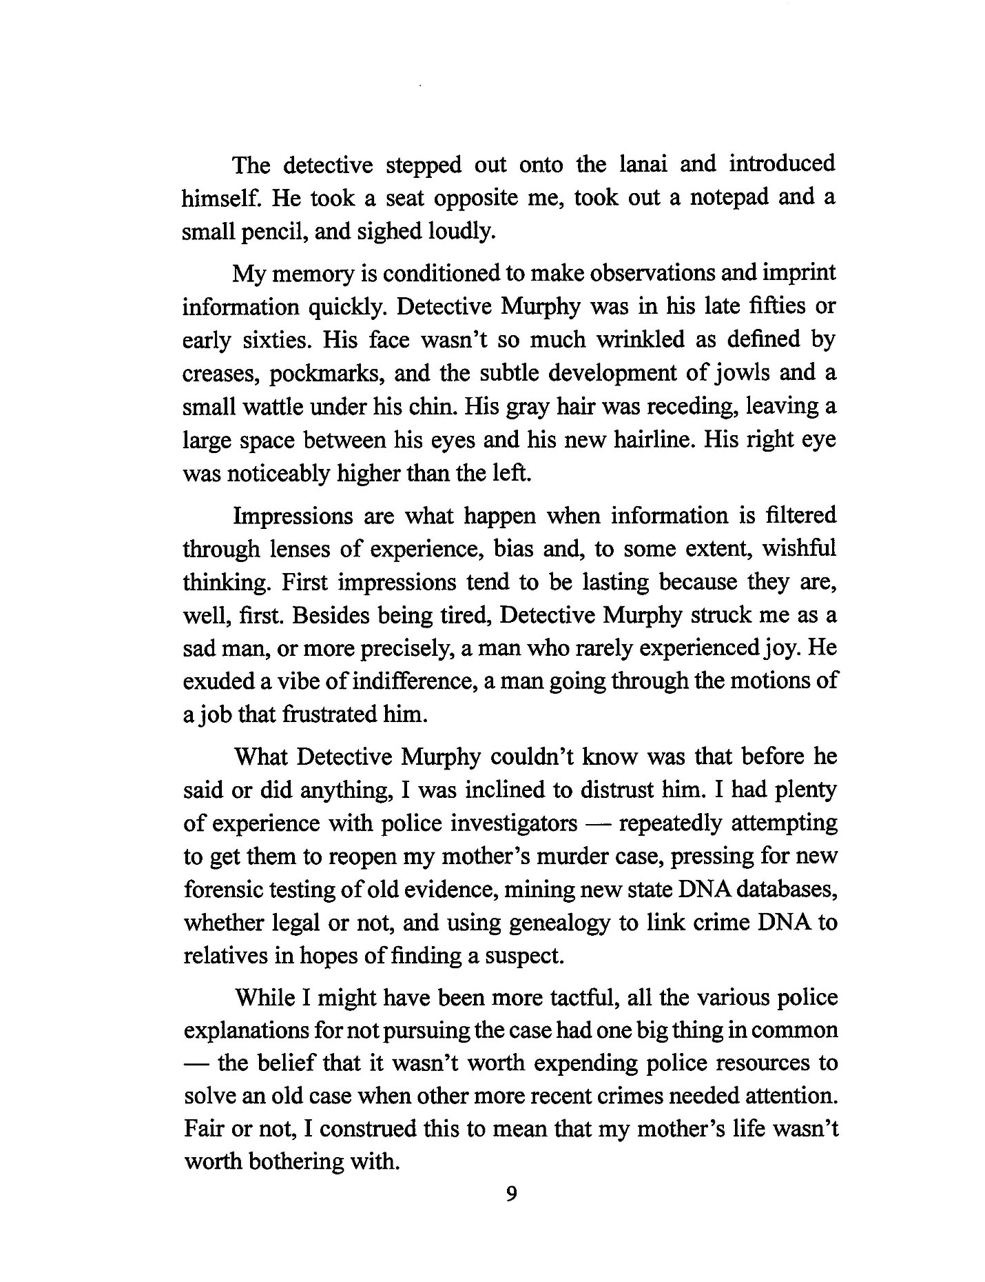

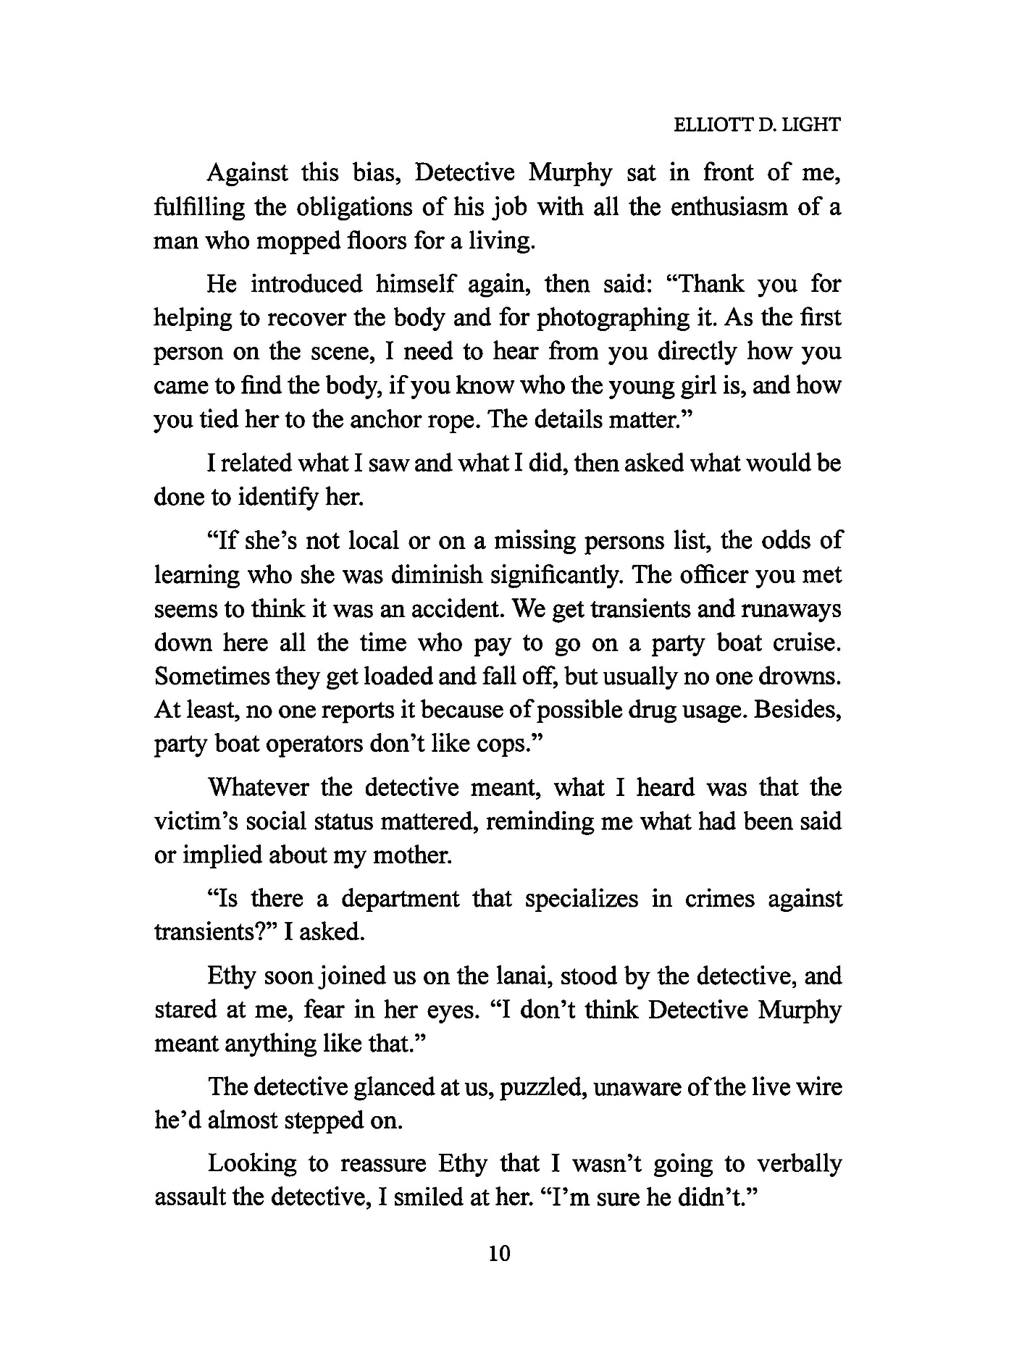

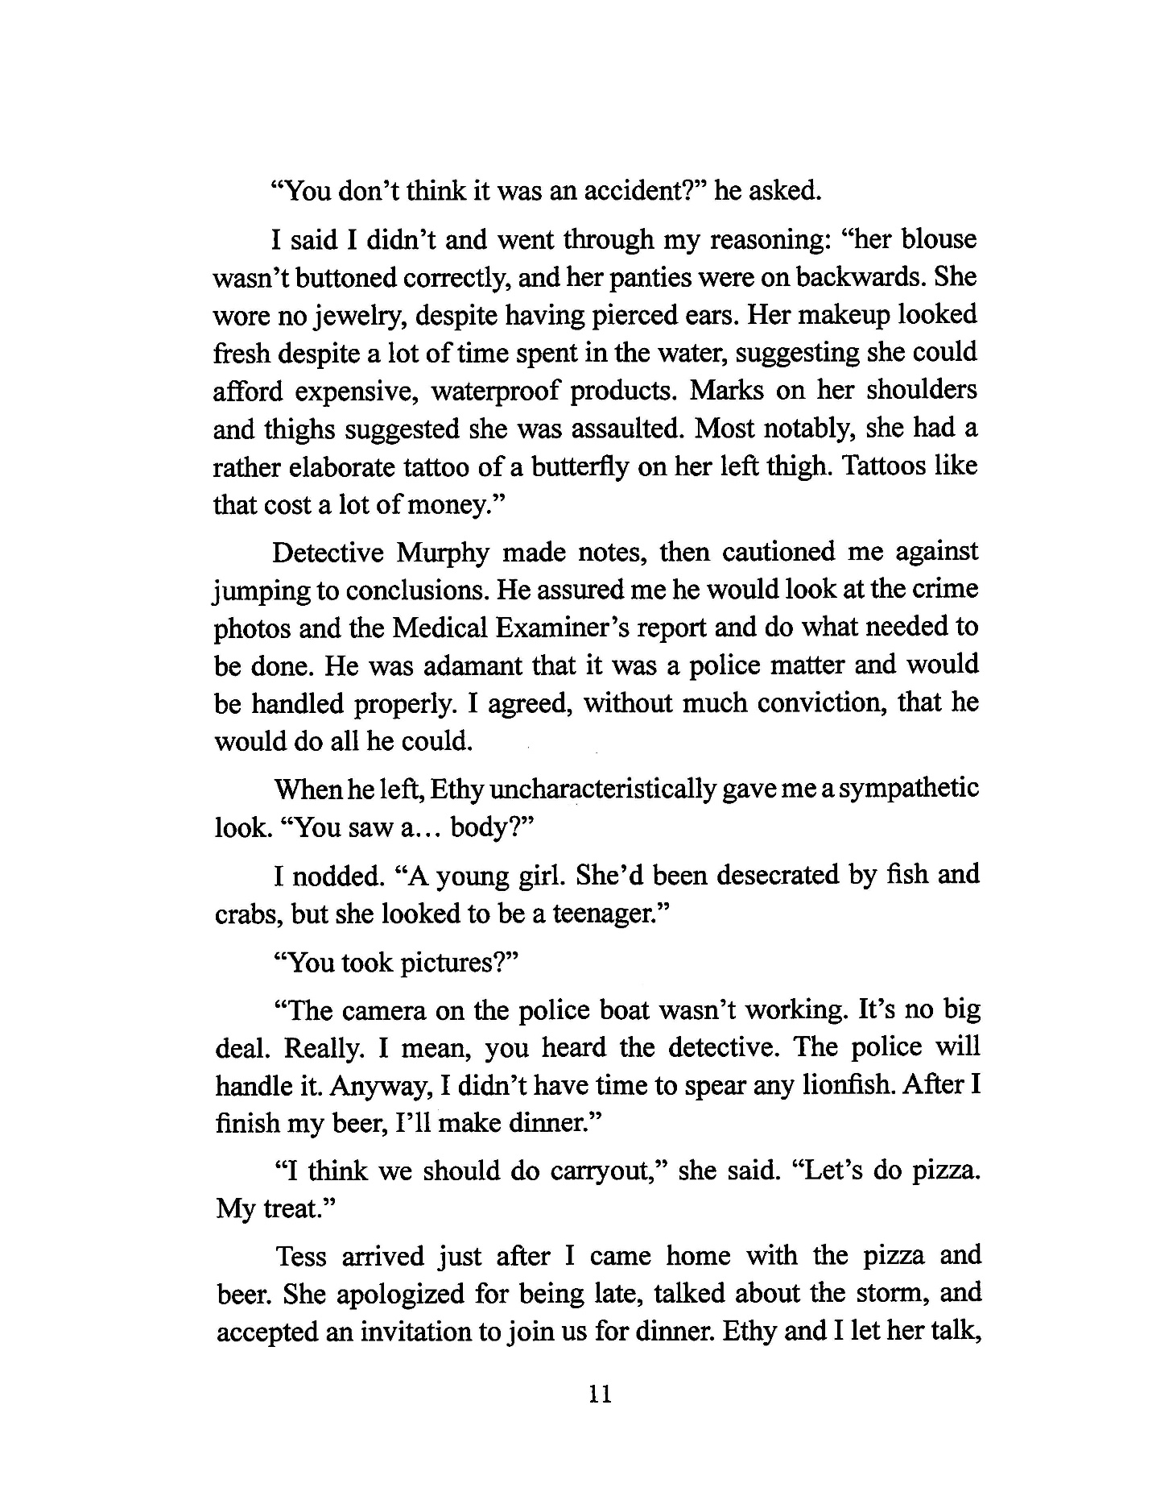

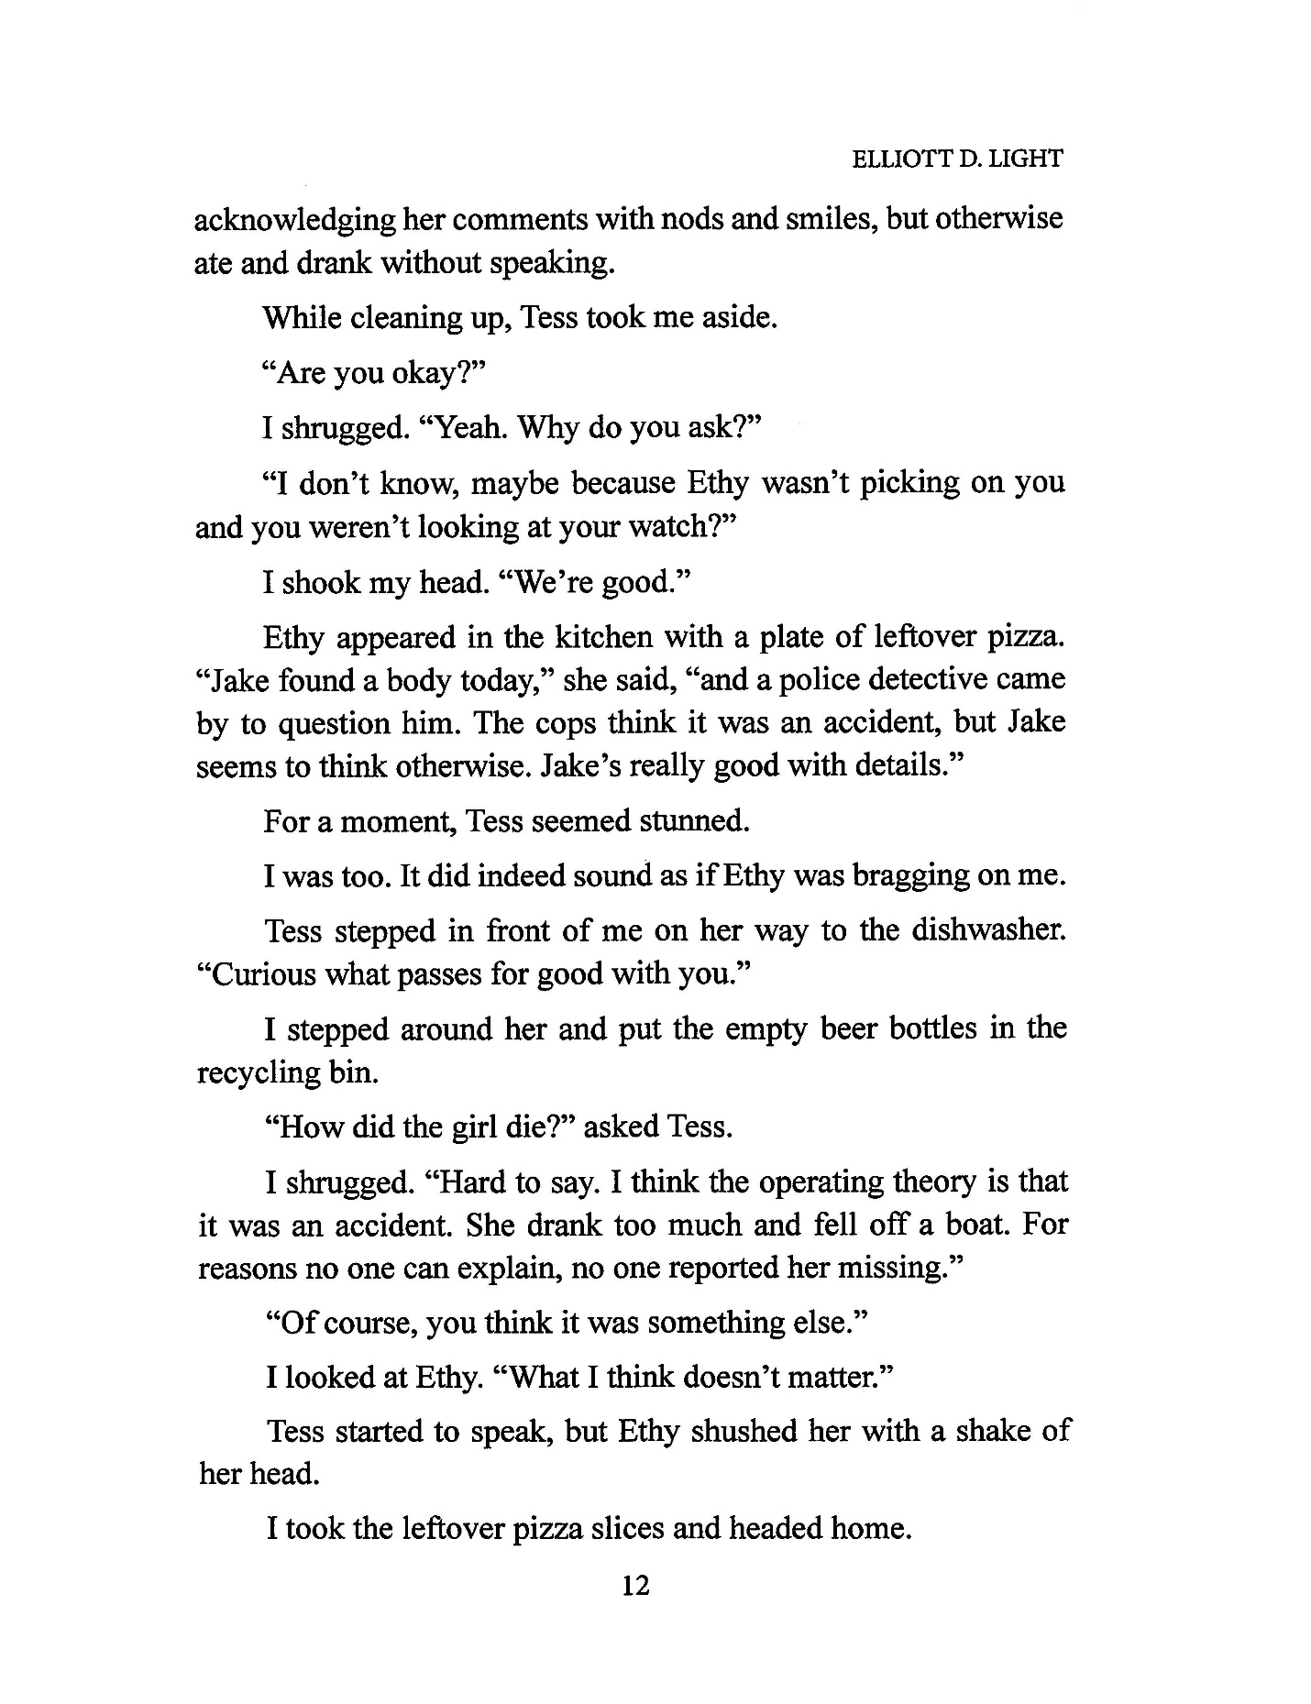

About Elliott Light

Elliott Light grew up outside Washington, D.C. in McLean, Virginia before the beltway encircled the capital city, before farms were turned into housing developments, and before open fields became mega-malls.

He claims Thomas Jefferson, President of the United States and author of the Declaration of Independence, as a cousin; John Marshall, Chief Justice of the U.S. Supreme Court, as an uncle; Robert Morris, signer of the Declaration, the Articles of Confederation, and the Constitution, as a grandfather; and Joe DeJarnette, a prominent eugenicist, as a great-uncle.
Light attended the University of Virginia, receiving degrees in Electrical Engineering and Law. He has several patents to his name.
After stints as an environmental lawyer and a high tech lawyer, he practiced patent law in a private law firm, all in the DC-metro area.
Now retired, he resides in Naples, FL with his wife, Sonya, and their much beloved cats. The Throwaways is his fourth published novel but the first in the Jake Savage Mystery series. He wrote three popular and well-reviewed mystery-thrillers for the Shep Harrington Smalltown Mystery series: Lonesome Song, Chain Thinking, and The Gene Police.

