Press Kit
The Playbook
by Gary E. Parker

Author
Gary E. Parker, Ph.D.
Atlanta, GA
404-917-4311 (cell)
Geparkerdawgs@gmail.com

Publisher
Bruce L. Bortz
Bancroft Press
4527 Glenwood Ave.
La Crescenta, CA 91214
410-627-0608 (cell)
bruceb@bancroftpress.com
bruce.bortz@gmail.com
www.bancroftpress.com

Title Info
The Playbook: A Novel
Bancroft Press
October 29, 2024
Sports Fiction / Drama / Inspirational/Women’s Issues/Young Adult (YA) Fiction / Race Relations
978-1-61088-664-2 (HC) $24.95
978-1-61088-666-6 (Ebook) $9.99
978-1-61088-668-0 (Audiobook)

Distributor
Baker & Taylor Publisher Services (the premier worldwide distributor of books, digital content and entertainment products from approximately 25,000 suppliers to over 20,000 customers in 120 countries) 30 Amberwood Parkway Ashland, OH 44805

Publisher Info
- Been a top-ten indie since its start in 1992
- Profiled by Publishers Weekly
- Publishes 4-6 books a year
- Distributed nationally by Baker & Taylor Publisher Services
- Frontlist and backlist titles frequently optioned or bought by Hollywood producers
- Publishes almost all types of books, from memoirs to mysteries, young adult novels to history and biography
- Bancroft books have received numerous starred reviews—four, in fact, for two 2018 summer books—and have won numerous awards
- The Missing Kennedy, a NYT ebook bestseller, was on the cover of People Magazine when published in 2015
- Published the books of four Pulitzer Prize winners (Alice Steinbach, Stephen Hunter, Elizabeth McGowan, and Mark S. Johnson)
- Operated internship program with colleges and universities around the country each semester (and summer) since 1992

Overview
A guitarist, a philosopher, and a natural-born leader with a ponytail walk onto a football field…
In the heart of a small mountain town where football reigns supreme and tradition casts long shadows, Ms. Chelsea Deal defies the norm. Amid the echoes of clashing helmets and the roar of a crowd, Chelsea, a former big-city lawyer now cast as the interim head coach for the undefeated Rabon Knights, becomes the unexpected mentor for two young players whose dreams echo her own. Palmer, a reclusive teenager brimming with untapped talent, and Ty, an old soul fighting the gravest of battles, join forces with Chelsea to overcome their differences and fight for a championship.
As the season unfolds, so do the lives of these characters as each one strives to defeat personal challenges. Chelsea, with her keen instincts and generous spirit, seeks to rewrite the rules in a town slow to accept her. Palmer, elusive and insecure, navigates the pain of a dysfunctional family and the pull of interests beyond football. And Ty, the quarterback whose bright future is threatened by a deadly adversary, searches for strength in the power of unlikely friendships.
From the smoky aroma of Southern barbecue to the indomitable spirit of a team that refuses to yield, The Playbook captures the essence of what it means to fight for every inch, every down, every dream… as a team. This story reminds us of the possibilities when we allow our instincts to take charge—when the game is no longer just a game, but a catalyst for life-altering experiences.
Join us on the field and beyond, as Chelsea, Palmer, and Ty show us that sometimes, the most profound victories don't come with a score. Sometimes, when we break through our defenses, both literal and metaphorical, we find glory in unexpected places. And, sometimes, the games aren't just played, but felt, and the characters aren't just written, but lived.

Logline for The Playbook
In a Friday Night Lights meets Erin Brockovich drama, Chelsea Deal—a big city lawyer turned first female head football coach in a small Southern town—juggles scandal, love, and a racially diverse team to lead them to a state championship, shattering ceilings and stereotypes along the way.

eight great reasons to read or review THE PLAYBOOK
- Inspiring Story: THE PLAYBOOK is an inspirational sports drama that blends high school sports with life lessons, reminiscent of "Friday Night Lights" and "The Blind Side."​​
- Breaking Barriers: The story features Chelsea Deal, a female football coach in a male-dominated field, providing a progressive look at gender roles and diversity in sports​​.
- Emotional Depth and Complex Characters: The characters in THE PLAYBOOK are well-developed, with personal and professional challenges that add layers to the narrative, making it emotionally resonant and compelling​​.
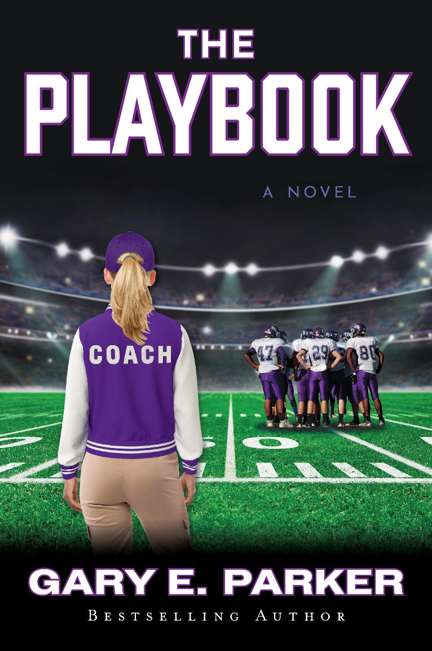
- Social and Cultural Relevance: The story addresses a broad range of complex issues including gender, race, class, and more, reflecting its timeliness and relevance to current societal dialogues​​.
- Motivational and Uplifting: Through its portrayal of overcoming adversity and personal growth, THE PLAYBOOK aims to motivate and uplift readers, demonstrating the power of resilience and determination​​.
- Community and Mentorship: It explores the significant impact of community support and mentorship, illustrating how these elements are crucial in shaping young lives and fostering personal development​​.
- Entertainment and Drama: With a mix of underdog spirit and complex character development, the book offers a balance of entertainment and thoughtful drama, engaging readers with its narrative tension and character interactions​​.
- Educational Value: Beyond its entertainment aspect, THE PLAYBOOK provides educational insights into the workings of team dynamics and leadership, making it a valuable read for those interested in sports management and coaching strategies​​.

FOR IMMEDIATE RELEASE
Contact: Bruce Bortz, Publisher, Bancroft Press, Los Angeles, CA,
410-627-0608/bruceb@bancroftpress.com
Bancroft Press Announces the Launch of “The Playbook” - A Tale of Triumph and Resilience
Los Angeles, CA – Bancroft Press is thrilled to announce the publication of “The Playbook,” slated for release on October 29, 2024. This inspiring novel is penned by Gary E. Parker, who brings to life an enthralling story of perseverance, leadership, and breaking barriers in the world of high school sports.
“The Playbook” follows the journey of Chelsea Deal, a determined and innovative coach who challenges the status quo by leading a high school football team in a male-dominated sport. Through her leadership, Chelsea not only transforms her team but also redefines what it means to be a leader in a challenging environment.
Author Gary E. Parker masterfully weaves a narrative that captures the essence of high school sports while tackling complex themes such as gender equality, racial dynamics, and social change. With a backdrop reminiscent of beloved classics like “Friday Night Lights” and “The Blind Side,” this book is not just about football; it’s about the life lessons learned on and off the field.
Bruce Bortz, publisher at Bancroft Press, expressed his enthusiasm for the novel’s potential impact: "‘The Playbook’ is more than just a sports story; it’s a beacon of motivation and change. We are proud to bring such a compelling and culturally relevant tale to our readers."
“The Playbook” is perfect for fans of dynamic sports narratives and stories that dive deep into the heart of community and personal growth. Prepare to be inspired by a novel that celebrates the spirit of resilience and the power of believing in oneself.
The book will be available for purchase at all major bookstores and online retailers. Join us in celebrating the launch of “The Playbook” – a book that promises to challenge, uplift, and inspire.
For further information, to request a review copy, or to arrange an interview with the author, please contact Publisher Bruce Bortz.
About Bancroft Press: Bancroft Press is an independent publishing house that has been a leader in the industry for nearly 35 years, championing a diverse range of voices and stories with the power to inform, entertain, and inspire. Based in Los Angeles, Bancroft Press continues to be at the forefront of publishing significant and impactful books.

Q&A With PLAYBOOK Author Gary E. Parker
- What inspired you to write "The Playbook"?
  - I was inspired by my experiences as an athlete and the profound impact that my coaches had on my life, as well as the desire to explore themes of resilience and mentorship in sports.
- Can you tell us more about the main character, Chelsea Deal, and what makes her unique?
  - Chelsea Deal is a pioneering female football coach in a male-dominated sport. Her strength and determination to break barriers while nurturing her team make her a compelling and unique character.
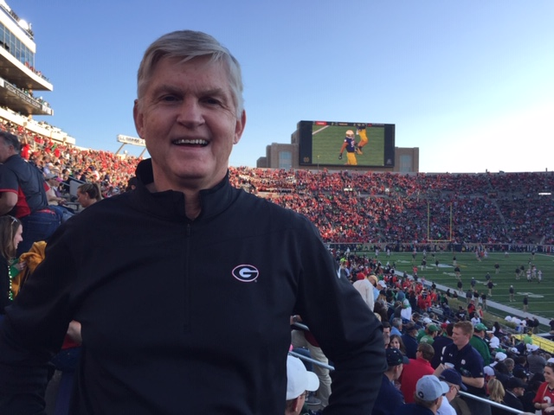
- "The Playbook" tackles themes of gender equality and racial dynamics. Why were these themes important for you to include?
  - These themes reflect ongoing societal issues. Incorporating them into the story highlights the challenges and progress in sports and society, making the narrative relevant and thought-provoking without being political.
- What challenges did you face while writing this book, and how did you overcome them?
  - Balancing the technical aspects of football with the human stories was challenging. I focused on authentic depictions of sports scenes while ensuring the characters' emotional journeys were front and center.
- Which character in "The Playbook" do you most identify with, and why?
  - Though I’m obviously not female, I identify with Chelsea because, like her, I've often been in roles where leading with integrity and nurturing others was essential.
- What message do you hope readers take away from "The Playbook"?
  - I hope readers are inspired by the resilience and courage of the characters and see the power of believing in yourself and others, regardless of the challenges you face.
- Can you share a bit about your writing process for this book?
  - My process involved research into high school football, crafting detailed character backstories, and integrating my own experiences to enhance the authenticity of the story.
- Were there any real-life figures who inspired the character of Chelsea Deal?
  - While Chelsea is a fictional character, her determination and pioneering spirit are inspired by various historical figures in sports who have broken similar barriers.
- What do you believe is the most impactful scene in the book, and why?
  - The scene where Chelsea finally reveals what led her to leave her law practice to become a football coach is a touching episode where her backstory steps to the front and we truly see what makes her tick. It’s a moving event and she and her team are never the same as a result.
- How does "The Playbook" compare to your previous works?
  - This book resembles some of my previous works as a strong female character takes center stage in the story. It’s different however, in using a sports backdrop as the setting for the characters to overcome their struggles and find ultimate triumph. All of my writings carry the underlying theme of hope in the midst of adversity.
- What kind of research did you do to ensure the football scenes were accurately depicted?
  - I used my own experience as a starting point then added to it by studying playbooks and reading articles that focused on football schemes and strategies.
- How do you handle the dynamics of team sports in your narrative?
  - Team dynamics are central to the story. I explored how individual personalities and relationships within the team shape their journey through the season.
- What is next for you after "The Playbook"? Are there more sports-themed novels in the future?
  - I definitely plan to write at least one sequel to The Playbook (perhaps more) since these characters are young and their journey isn’t over. And, I have the idea of writing a narrative non-fiction story for a prominent athlete who’s overcome a lot of adversity to find eventual success in sports and life.
- Any advice for aspiring writers who want to tackle sports in their fiction?
  - My advice would be to focus on the human elements that drive the sport. It’s not just about the game but about the people who play it and their journeys on and off the field.

Film Treatment: The Playbook
Source Background: The Playbook is inspired by the novel of the same name by Gary E. Parker, which revolves around the story of a female football coach in a small-town setting. The tale weaves together themes of sportsmanship, community, personal growth, and overcoming adversity.
Tone Description: The tone of The Playbook is a mixture of inspirational sports drama and a deeper exploration of personal and societal challenges. It combines the emotional pull and underdog spirit of Remember the Titans with the complex character development found in The Blind Side. The film is meant to be uplifting yet grounded, offering a realistic portrayal of overcoming hardships through resilience and unity.
Logline: In the small town of Rabon, Georgia, a female football coach and two athletes from opposite sides of the racial and economic divides struggle against personal and communal adversity to lead their underdog team toward an unlikely championship, discovering their true strengths in the process.
Mission: The Playbook seeks to narrate a compelling tale of transformation and redemption. Its goal is to resonate with audiences by illustrating the profound impacts of mentorship, community support, and the pursuit of excellence against all odds. The film aims to motivate viewers by demonstrating the power of empathy, leadership, and determination in changing lives.
Setting/World of the Film: Set in the fictional rural town of Rabon, Georgia, the film captures the essence of a tight-knit community where high school football is the heartbeat of social and cultural life. The town is characterized by its sprawling fields, modest homes, and a main street that hosts seasonal parades and weekly markets. Football games are the pinnacle of local entertainment and community gathering, reflecting the town's values and unity.
Major Character Breakdown (with casting suggestions):
- Chelsea Deal (suggested casting: Jennifer Lawrence ) - A former attorney turned football coach, determined, compassionate, and fiercely intelligent. Chelsea faces the challenge of gaining respect in a conservative, male-dominated environment.
- Palmer Norman (suggested casting: Jacob Elordi) - A talented but unenthusiastic player, Palmer deals with a troubled family, a learning disability and he loves music more than football. His journey is one of self-discovery and redemption.
- Ty Rogers (suggested casting: Jharrel Jerome) - A charismatic and promising quarterback whose sudden illness serves as a pivotal challenge for the team. Ty’s struggle and resilience become a central theme.
- Coach Dub (suggested casting: Idris Elba) - The wise and supportive previous head coach who mentors Chelsea. His commanding presence and gentle humor bring a sense of gravitas and warmth.
- Villains/Antagonists:
  - Buck (suggested casting: Jon Hamm)—a fellow coach who resents that Chelsea got the head coaching job over him. He’s capable but driven by old-school tendencies that keep him boxed into hurtful patterns. He’ll do whatever it takes to bring Chelsea down.
  - Don and Strick (suggested casting: Joseph Kennedy and Andrew Astor)--Local troublemakers and classmates of Palmer and Ty who harbor bad feelings toward Palmer, who’s the new kid in town. Their disruptive actions add tension and conflict to the narrative.
Story in Three Acts:
Act 1:
Introduction: When the head coach of the Rabon High School football team suffers injuries in a car accident, the school board chooses Chelsea Deal as the interim head coach. Die-hard football boosters in the small Georgia town, along with the entire coaching staﬀ, question the decision but Chelsea’s got even bigger problems to handle.
Inciting Incident: Within a week of becoming head coach, Chelsea finds out that Ty, her starting quarterback, who's created his own unique Playbook, has bone cancer. And Palmer, the backup, struggles with a mama in rehab, a learning disability, and the fact that he loves music more than football. While dealing with her quarterback issues, Chelsea also faces backlash from a fellow coach who feels slighted that he didn’t get the promotion to head coach.
Act 2:
Rising Action: Things quickly go from bad to worse for Chelsea. A loss in her ﬁrst game as head coach creates howls of criticism and a sexual assault of Palmer’s girlfriend Molly afterward creates even bigger heartaches, primarily because Chelsea gives in to Molly's wishes and doesn’t report the assault to authorities.
In spite of her best eﬀorts, Chelsea’s troubles continue to deepen. Romantically, she's torn between Bo, her ﬁancé from her former law ﬁrm, and Dirk, Palmer's sexy, guitar-playing uncle. And, though Ty and Palmer are building an unlikely friendship as Ty teaches Palmer the Playbook, it's a threadbare connection because Ty's cancer keeps getting worse and Palmer decides to quit football to pursue a music career in Texas.
Act 3:

Climax: As the playoﬀs unfold, the national media discovers Chelsea and she becomes an instant sensation. But threats lurk as the stakes ratchet higher. Chelsea's detractors mount a secret sabotage campaign that could get her ﬁred for not reporting the sexual assault. And Palmer might not return from Austin in time to learn The Playbook and play in the last game. And, overshadowing football, Ty is on the verge of death from his cancer.

In a last minute, Hail Mary mission, Chelsea and Molly unite to bring Palmer home as the championship game arrives. But is that enough to win a state championship for Rabon?

The championship game unfolds with high drama as Palmer rises to the occasion in honor of Ty, who’s become a friend he never expected to have. The last seconds tick down and Chelsea, Palmer and Ty wait with bated breath as the last pass is thrown and the outcome of the game hangs in the balance.

Denouement: The scene flashes ten years forward and we find out if Ty lived, if Palmer’s newfound confidence led the team to victory and if Chelsea remained a coach or returned to the practice of law.

About the Author

Gary E. Parker is the best-selling author of 23 published books (19 novels/ novellas), including numerous genre best-sellers and fiction award-winners. Highland Hopes became a Doubleday Book Club Main Selection and a Christy Award finalist.

A BA graduate of Furman University and a Ph.D. graduate of Baylor University, Parker is also the writer of six completed screenplays, including an adaptation of THE PLAYBOOK.

A frequent speaker at national and local conventions and conferences, he currently lives in the Atlanta suburbs.

